
School of Future Tech
Case Study Report
on
Case Study 153: Online Shopping Cart System
Java Programming: Arrays, Loops, Switch, Methods and Conditions
by
Aaryan Keni
150096725197
B.Tech CSE 2025-29 | Java Programming
Semester III

Index
1. Introduction to the Case Study.
2. Problem Statement / Case Background (Abstract).
3. Case Study Design.
4. Methods, Frameworks & Tools Applied in the Case Study.
5. Case Study Implementation Details and Snapshots.
6. Case Study Results and Conclusion.
7. References

1. Introduction to the Case Study
Online shopping has become the default way to buy electronics, and every online store depends on a shopping cart: the place where a customer collects products, decides quantities and sees what the order will cost before paying. This case study builds a basic Online Shopping Cart System in Java for a store selling five electronic products, from a ₹1,500 keyboard to a ₹55,000 laptop.
The application lets a customer view the product list with prices, select a product, enter a quantity and add it to the cart. It keeps a running subtotal, discount and final total on screen, and at checkout it generates an order summary. Its primary syllabus focus is core Java programming: arrays, loops, switch statements, if-else conditions, operators and methods.
The case study shows how these building blocks combine into one working program: data held in arrays, decisions taken with conditions, repeated work handled by loops, and each job in the order flow (display, selection, cart, discount, summary) kept in its own module.

2. Problem Statement / Case Background (Abstract)

Background
An online store needs a shopping cart that customers can trust. Shoppers add several items, change quantities and expect the total to update correctly, including any discount they qualify for. If totals or discounts are calculated wrongly, customers lose trust and the store loses money. A small, well-structured program is a good way to practise the logic behind this process before moving to larger systems.

Problem Statement
An online store requires a basic shopping cart system where customers can select products, specify quantities, and calculate the final order amount.

Objectives
- Display products and prices.
- Allow product selection.
- Calculate cart total.
- Apply discounts.
- Generate an order summary.

Abstract
This report presents the design and implementation of a Java shopping cart application for a five-product electronics catalogue. The design is split into the five expected modules: Product Display, Product Selection, Cart Management, Discount Calculation and Order Summary. Product names and prices are stored in arrays, the cart is processed with loops, the discount is decided with conditional statements and every calculation is placed in a method. The application was tested with five scenarios, from a single ₹3,000 item to a bulk order with a subtotal of ₹41,25,000. The discount moved from 0% to 5% to 15% as the subtotal grew, and in every scenario the subtotal, discount and final amount agreed with a hand calculation.
Note on figures: the product names and prices, the cart quantities and every amount in the test scenarios are taken from the application output shown in Section 5. Discount percentages in the report are worked out from that output (discount ÷ subtotal).

3. Case Study Design
The application is designed as a sequence of small modules, each doing one job and handing its result to the next, built in the following stages:
- Requirement analysis: read the problem statement and list the objectives and modules.
- Data design: choose arrays for the product names and prices.
- Module design: define Product Display, Product Selection, Cart Management, Discount Calculation and Order Summary.
- Logic design: decide the calculation of subtotal, discount and final amount.
- Interface design: a single screen with a product drop-down, quantity field, cart list, totals and buttons.
- Testing: run scenarios with different carts to check every discount level.

3.1 Product Catalogue
The catalogue holds five products. Names and prices are kept in two arrays, so the product number chosen by the customer is used to find both the name and the price.
No. | Product | Price (₹)
1 | Laptop | 55,000
2 | Smartphone | 25,000
3 | Headphones | 3,000
4 | Smartwatch | 5,000
5 | Keyboard | 1,500

3.2 Expected Modules
# | Module | Purpose | Java concepts used
1 | Product Display | Shows every product with its number and price so the customer can choose | Arrays, loop, methods
2 | Product Selection | Takes the chosen product number and the quantity entered by the customer | User input, switch statement
3 | Cart Management | Stores the selected items, keeps the cart list up to date and clears it on request | Arrays, loops, methods
4 | Discount Calculation | Finds the discount slab from the subtotal and works out the discount amount | if-else statements, operators
5 | Order Summary | Prints the cart, subtotal, discount and final amount payable at checkout | Methods, operators

3.3 Discount Policy
The discount depends on the cart subtotal: small orders get no discount and the percentage rises as the order value grows. The slabs below were observed in the test runs (Section 5.2); the discount is always calculated on the subtotal before it is subtracted to get the final amount.
Subtotal seen in test | Discount rate | Interpretation
₹3,000 | 0% | Small cart, no discount
₹9,500 | 5% | Medium cart, entry-level discount
₹89,500 | ₹1,65,000 | ₹41,25,000 | 15% | Large and bulk carts, highest discount

3.4 Application Workflow
# | Step | What the customer or program does | Screen element
1 | Choose product | Customer picks a product from the list of five | Select Product drop-down
2 | Enter quantity | Customer types how many units are wanted | Quantity field
3 | Add to cart | The item is added and the cart list is redrawn with price, quantity and line total | Add to Cart button, Cart Details area
4 | Update totals | Subtotal, discount and final total are recalculated after every addition | Subtotal, Discount Applied, Final Total labels
5 | Clear or continue | Customer adds more products or empties the cart | Clear Cart button
6 | Checkout | A confirmation shows the bill and thanks the customer | Checkout & Generate Bill button, dialog

4. Methods, Frameworks & Tools Applied in the Case Study
Key methods and concepts:
- Arrays – product names and prices stored in arrays and read by index.
- User input – the product choice and quantity are taken from the customer through the input controls on the screen.
- Switch statement – maps the selected product number (1–5) to the correct product.
- Loops – process every item in the cart to build the cart list and add up the subtotal.
- if-else statements – decide which discount slab a subtotal falls into.
- Operators – arithmetic operators for line totals, subtotal, discount and final amount; relational operators for the slab conditions.
- Methods – separate methods for cart handling and billing calculations so each task is written once and reused.
- Testing by hand-calculation – every application result compared with a manual calculation.

Tools Used for the Case
- Programming language: Java, with a graphical user interface for the cart screen.
- Currency display: the rupee symbol (₹) with two decimal places for all amounts.
- Diagram: Python (matplotlib) for the application workflow figure.
- Report format: Word document following the School of Future Tech case study template.

5. Case Study Implementation Details and Snapshots
The application was developed in the following stages: (1) arrays for the product catalogue; (2) product display and selection; (3) cart management with running totals; (4) discount calculation; (5) checkout and order summary; (6) testing with different carts.

5.1 Module-wise Implementation
Module | How it works in the application | Visible in the output
Product Display | The five products and prices are read from the arrays and listed in the drop-down as number, name and price | Drop-down entries such as "3. Headphones (₹3000.0)"
Product Selection | The chosen entry and the typed quantity are read when Add to Cart is pressed | Select Product and Quantity fields
Cart Management | Each added item is stored and the cart is redrawn in a table with product, price, quantity and line total; Clear Cart empties it | Cart Details area with column headings
Discount Calculation | The subtotal is checked against the discount slabs and the discount amount is subtracted to get the final total | Subtotal, Discount Applied and Final Total labels
Order Summary | Checkout displays the subtotal, discount and final amount payable with a thank-you message | "Order Processed Successfully!" dialog

5.2 Test Scenarios and Verification
Five scenarios were run. For each one, the expected values were worked out by hand and compared with what the application displayed.
# | Cart contents | Subtotal (₹) | Discount | Discount amount (₹) | Final total (₹)
1 | Headphones × 1 | 3,000 | 0% | 0 | 3,000
2 | Headphones, Smartwatch, Keyboard × 1 each | 9,500 | 5% | 475 | 9,025
3 | All five products × 1 each | 89,500 | 15% | 13,425 | 76,075
4 | Laptop × 2, Smartphone × 1, Headphones × 2, Smartwatch × 3, Keyboard × 6 | 1,65,000 | 15% | 24,750 | 1,40,250
5 | Bulk order at checkout | 41,25,000 | 15% | 6,18,750 | 35,06,250

Hand check of scenario 4: 2 × 55,000 = 1,10,000; 1 × 25,000 = 25,000; 2 × 3,000 = 6,000; 3 × 5,000 = 15,000; 6 × 1,500 = 9,000. The sum is ₹1,65,000, 15% of which is ₹24,750, leaving ₹1,40,250. This agrees with the screen.
Hand check of scenario 3: 55,000 + 25,000 + 3,000 + 5,000 + 1,500 = ₹89,500; 15% is ₹13,425; the final total is ₹76,075. This also agrees with the screen.

Snapshots
The following exhibits show the application workflow and the actual program output for each test scenario.
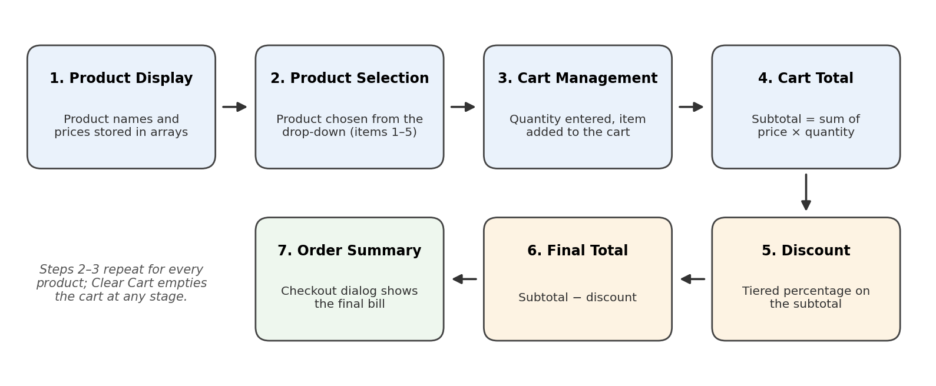
Figure 1: Application workflow of the shopping cart system
Shows the seven steps from product display to the order summary, with the product and cart steps repeating for each item.
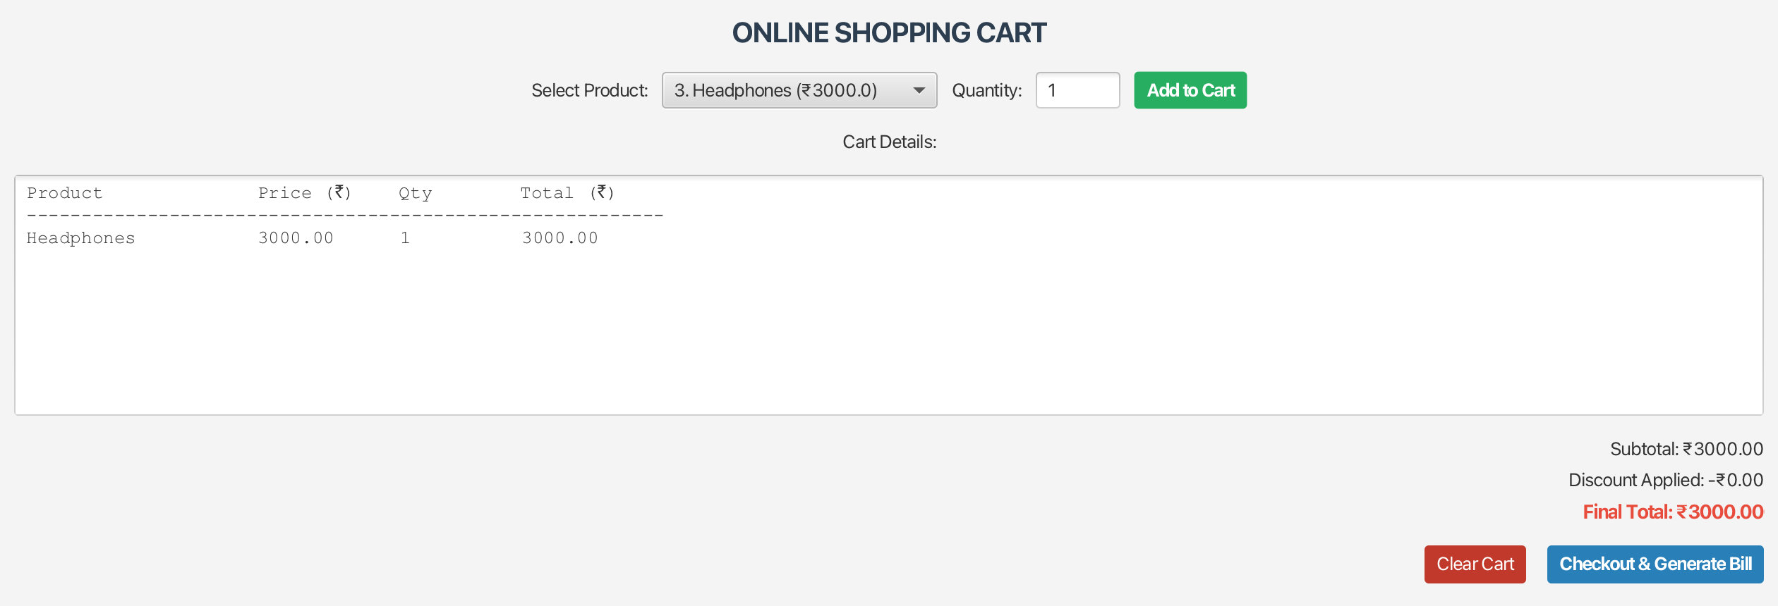
Figure 2: Cart with one item (no discount)
One pair of Headphones: subtotal ₹3000.00, discount ₹0.00, final total ₹3000.00.
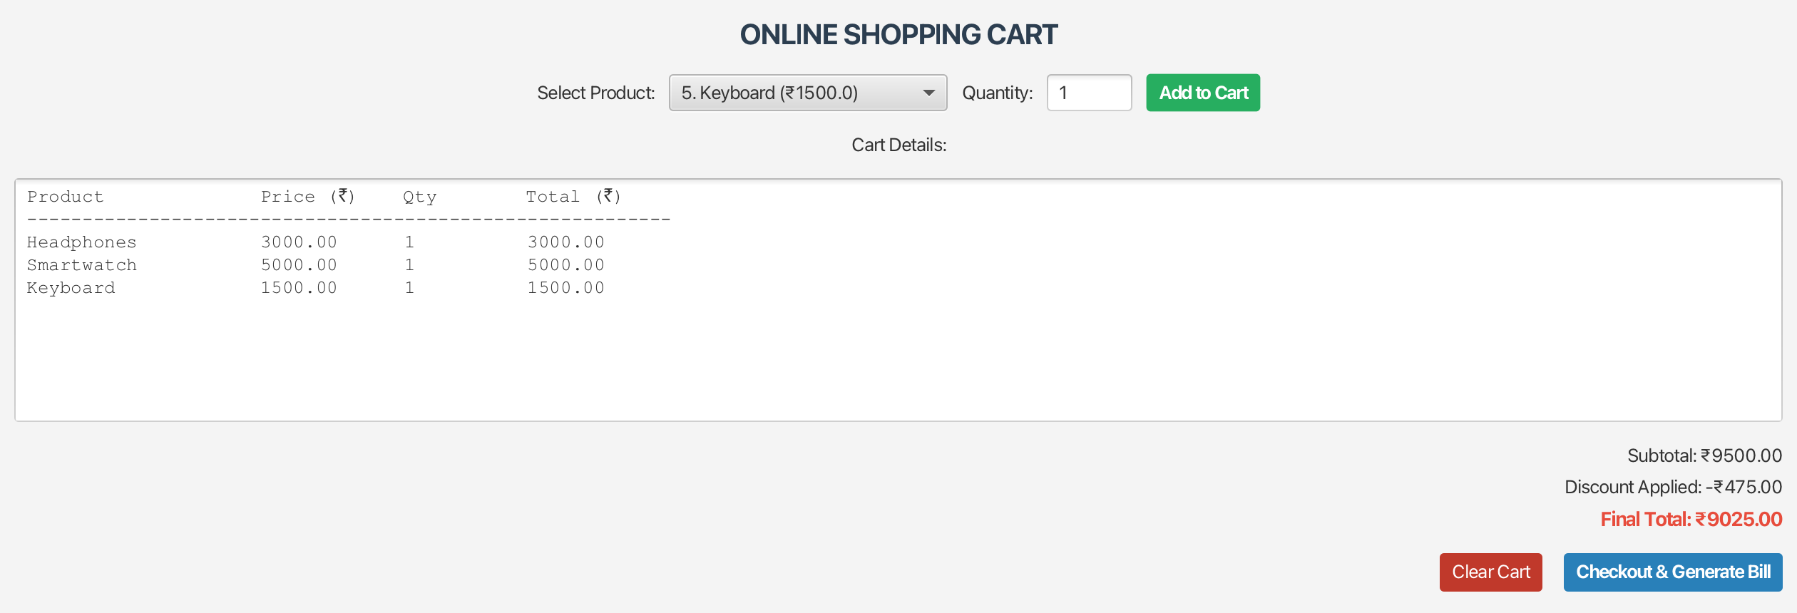
Figure 3: Cart with three items (5% discount)
Headphones, Smartwatch and Keyboard: subtotal ₹9500.00, discount ₹475.00, final total ₹9025.00.
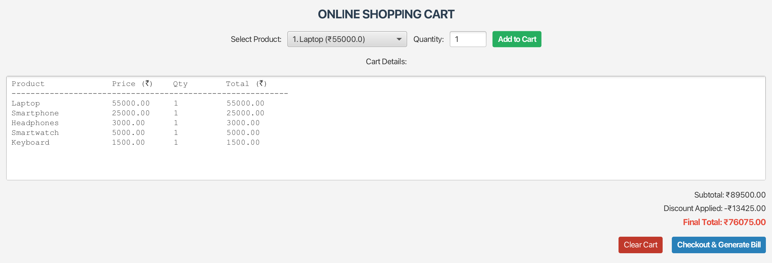
Figure 4: Cart with all five products (15% discount)
One of each product: subtotal ₹89500.00, discount ₹13425.00, final total ₹76075.00.
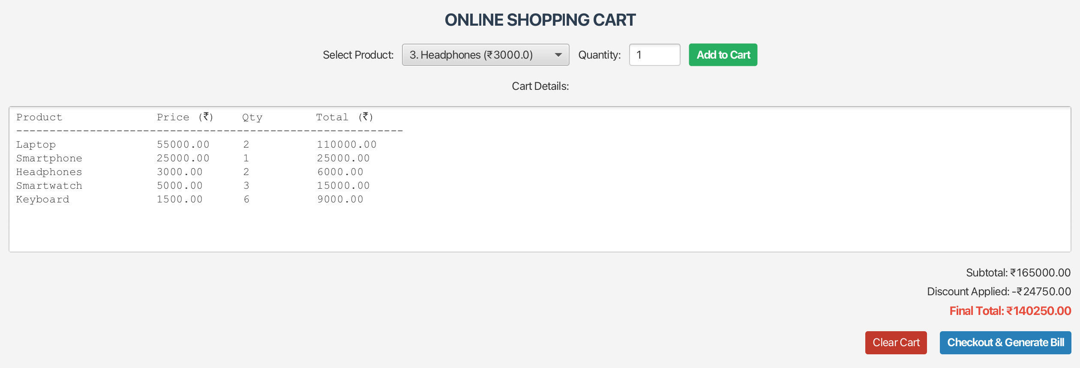
Figure 5: Cart with multiple quantities (15% discount)
Laptop × 2, Smartphone × 1, Headphones × 2, Smartwatch × 3, Keyboard × 6: subtotal ₹165000.00, discount ₹24750.00, final total ₹140250.00.
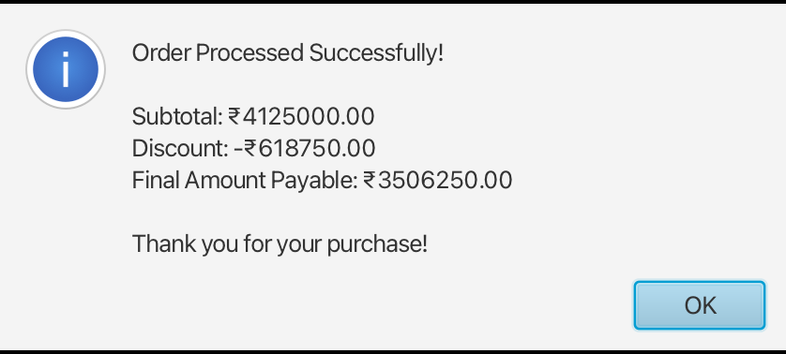
Figure 6: Checkout order summary
Confirmation after checkout: subtotal ₹4125000.00, discount ₹618750.00, final amount payable ₹3506250.00.

6. Case Study Results and Conclusion

Findings
- All five expected modules (Product Display, Product Selection, Cart Management, Discount Calculation and Order Summary) work together in one application.
- The cart updates its subtotal, discount and final total after every addition, so the customer always sees the current bill.
- The discount moved from 0% (₹3,000 cart) to 5% (₹9,500 cart) to 15% (₹89,500 and above), matching the slab design.
- In all five scenarios the application output equalled the hand-calculated values, including the multi-quantity cart and the ₹41,25,000 bulk order.
- Amounts are shown in rupees with two decimal places, and the checkout dialog gives a clear confirmation with subtotal, discount and amount payable.
- Keeping calculations in methods and data in arrays made it simple to test each part separately.

Conclusion
This case study shows that a complete shopping cart can be built with core Java concepts alone. Arrays store the catalogue, loops process the cart, conditions choose the discount, operators do the arithmetic and methods keep each module separate and reusable. The test results confirm that totals and discounts are calculated correctly for small, medium, large and bulk orders, so the application meets all five objectives of the problem statement.

Scope for Improvement
- Add a Remove Item option so one product can be taken out without clearing the whole cart.
- Validate the quantity field so blank, zero and negative entries are rejected with a clear message.
- Add tax and delivery charges to the final bill.
- Save orders to a file or database so a history of bills is kept.

7. References
- Case Study no. 153: Online Shopping Cart System, Java Programming, School of Future Tech, ITM Skills University, B.Tech CSE 2025-29, Semester III.
- Oracle, The Java Tutorials: arrays, control flow statements, operators and methods.
- OpenJFX documentation for building the graphical user interface.
- Course material on Java Programming, Semester III.

