PROJECT SYNOPSIS

On

**“****Online Course Certification System”**

**Indira College of Commerce and Science**

**TY - BBA(CA)**

Project Guide: Project By:

Pro. Shivendu Bhushan Aaryan Ojha

Pro. Shubhangi Chavan. Pranav Malwatkar

(TY–BBA–CA Sec-I)

**\*Introduction: -**

Discover the Future of Learning with “SkillNinja” Online Course Certification System. Education transcends traditional boundaries on our platform, where dynamic online courses meet personalized certification pathways. Immerse yourself in engaging content curated by experts, designed to equip you with practical skills applicable to real-world scenarios. As you complete courses, watch your knowledge evolve and gain the confidence to thrive in your chosen field. Our globally recognized certifications validate your accomplishments, signalling your expertise to employers and peers alike. Join us in reshaping education - dive into a new era of knowledge acquisition with the Online Course Certification System.

**\*Existing System:**

The existing Course Certification System involves a manual and paper-based process for managing and awarding course certifications. Students participate in various educational courses and upon completion, their progress and achievements are recorded on paper documents. These documents then undergo a verification process by administrators, involving cross-referencing with course records and grading criteria. Once verified, certificates are manually generated, printed, and distributed to the students. This system is time-consuming, prone to errors, and lacks efficiency in terms of data management and retrieval. Most of the courses and certification providing system available online are paid and require a specific amount to be paid.

* **Disadvantages Of Existing System:**

1. The system relies heavily on manual data entry, verification, and certificate generation, leading to inefficiencies, errors, and delays.

2. The manual nature of the process makes it time-consuming, as administrators need to cross-reference records, verify completion, and generate certificates individually.

3. Many online courses focus on theoretical concepts, which may not effectively translate into practical skills without hands-on experiences and real-world applications.

4. Many online available courses are paid and not very cost effective, hence it is difficult for some users to get their certifications.

**\*Proposed System:**

The proposed system aims to address the limitations of the existing online Course Certification System by introducing innovative features and improvements to enhance the learning experience. By making it cost-effective and providing a user-friendly interface we aim to achieve all the requirements that are necessary.

* **Advantages of Proposed System:**
* Tailored learning paths based on individual progress and learning styles cater to diverse needs, optimizing the learning journey for each participant.
* New system is decreasing the chances of error.
* New system should work smoothly and fast.
* New system saving time and workforce.
* The system is user friendly and anyone having computer knowledge can handle it easily.
* **Drawbacks of Proposed System:**
* The only drawback this system has that it has less resources as of now and we do not have proper certification authority.

**\*Feasibility study: -**

* Economical Feasible: -

As our website is free to use website so it helps user to browse and earn their certifications without paying a single rupee. It is also entirely computer-based system which reduces man-work and workload as everything can be done on your personal computers using our standalone application.

* Operational Feasible: -

In the existing system there is lot of written paperwork. So that is very time consuming and expensive process. As our proposed system is computerised system that will be very user friendly and cost effective. Our admin panel keeps track of all the records in a systematic way and effective way. In our proposed system we used HTML as front-end software as it is very easy to operate the forms of system by user.

* Technical Feasible: -

In our proposed system we use operating system as ‘Microsoft Windows’ that can be available all the time. In this system we used backend software as ‘PHP and MySQL’ which is available on Microsoft windows. In proposed system we have hardware's like LCD monitor, normal keyboard and compatible mouse which are available on every pcs. To run our system, we used software's like HTML, CSS and JavaScript as front-end software.

**\*Function Specification: -**

* User: -
* Registration & Login
* Browse Courses
* Enrol for Courses
* Learning & Certification
* Admin: -
* Login
* Adding Courses
* Manage Courses
* Issue Certificates

**\*Software and Hardware Requirements: -**

|  |  |
| --- | --- |
| **Software Requirement** | |
| Operating System | Microsoft windows |
| **Software: -** | |
| Front –End Software | HTML, CSS, JS |
| Back-End Software | MySQL |
| **Hardware Requirement** | |
| Processer: | Intel core i5 2.60GHz |
| RAM: | 2GB or More |
| Monitor: | LCD monitor |
| Keyboard: | Normal keyboard |
| Mouse: | Compatible mouse |

**Use Case :**

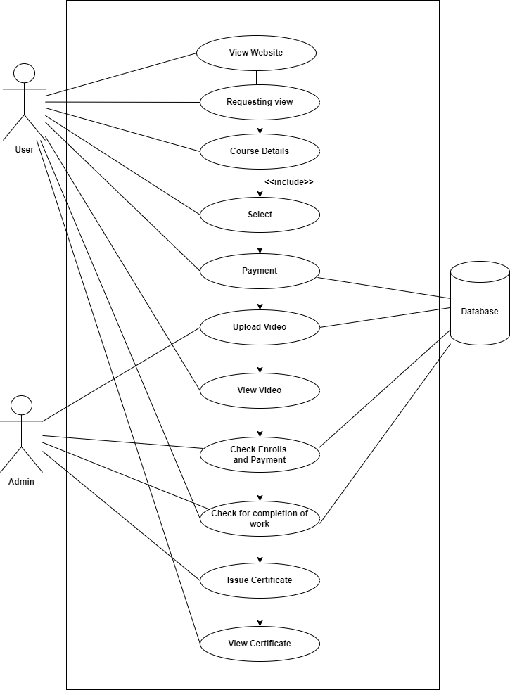

**Sequence Diagram:**

