PROJECT REPORT
Student Performance Management System

1. Cover Page
VIT BHOPAL UNIVERSITY
Project Report
STUDENT PERFORMANCE MANAGEMENT SYSTEM
Submitted as a part of Python Project
Submitted by:
Name: Aaryan Patle
Registration: 26MIM10257
Academic Year: 2026–27
Technologies Used
- Python
- JSON
- VS Code / Python IDE

2. Introduction
The Student Performance Management System is a Python-based application developed to manage and calculate student academic performance.
In a traditional system, teachers or students may calculate total marks, percentage, and grades manually. Maintaining multiple student records manually can also become difficult. This project provides a simple solution for storing student information and automatically calculating their academic performance.
The system allows the user to enter a student's roll number, name, and marks in five subjects. It calculates the total marks, percentage, and grade automatically. Student records are stored in a JSON file and can be searched using the roll number.
The project is developed using multiple Python modules. Each module performs a specific task, making the program easier to understand and maintain.

3. Problem Statement
Managing student academic records manually can be time-consuming and may result in calculation or record-keeping errors.
The main problem is to develop a simple system that can:
- Store student information.
- Store marks for different subjects.
- Calculate total marks automatically.
- Calculate percentage.
- Assign grades.
- Save student records.
- Search for a particular student.
- Display a clear performance report.
The proposed Student Performance Management System provides these basic functions using Python.

4. Functional Requirements
Functional requirements describe what the system should do.
4.1 Add Student
The system should allow the user to enter:
- Roll number
- Student name
- Marks for five subjects
4.2 Store Student Data
The system should save student information in a JSON file.
4.3 Calculate Total
The system should calculate the total marks obtained in all five subjects.
4.4 Calculate Percentage
The system should calculate the percentage using the total marks.
4.5 Calculate Grade
The system should assign a grade according to the percentage.
Percentage | Grade
90–100 | A+
80–89 | A
70–79 | B
60–69 | C
50–59 | D
Below 50 | F
4.6 Display Student Report
The system should display:
- Roll number
- Name
- Subject marks
- Total
- Percentage
- Grade
4.7 Search Student
The user should be able to search for a student using their roll number.
4.8 Input Validation
The system should reject marks below 0 or above 100 and handle invalid numerical input.

5. Non-Functional Requirements
5.1 Usability
The system should be simple and easy to use.
5.2 Reliability
The system should correctly calculate total marks, percentage, and grades.
5.3 Maintainability
The program should be divided into separate modules so that individual parts can be modified easily.
5.4 Performance
The system should provide results quickly for the number of records handled by the project.
5.5 Portability
The project should run on any system with Python 3.x installed.
5.6 Simplicity
The implementation should use basic Python concepts and avoid unnecessary complexity.

6. System Architecture
The project follows a simple modular architecture.
┌─────────────────────┐
│ User │
└──────────┬──────────┘
│
▼
┌─────────────────────┐
│ main.py │
│ Main Controller │
└──────────┬──────────┘
│
┌──────────────┼──────────────┐
│ │ │
▼ ▼ ▼
┌────────────┐ ┌────────────┐ ┌────────────┐
│ student.py │ │calculator.py│ │ grade.py │
└────────────┘ └────────────┘ └────────────┘
│ │ │
└──────────────┼──────────────┘
▼
┌──────────────┐
│ report.py │
└──────┬───────┘
│
▼
┌──────────────┐
│ database.py │
└──────┬───────┘
│
▼
┌──────────────┐
│students.json │
└──────────────┘
Architecture Explanation
- main.py controls the application.
- student.py manages student objects.
- calculator.py calculates marks and percentage.
- grade.py determines the grade.
- report.py displays the final report.
- database.py manages data storage.
- students.json stores student records.

7. Design Diagrams
7.1 Use Case Diagram
┌─────────────────────────────┐
│ Student Performance System │
│ │
│ (Add Student) │
User ───────────►│ │
│ (View Students) │
User ───────────►│ │
│ (Search Student) │
User ───────────►│ │
│ (View Report) │
User ───────────►│ │
│ (Exit System) │
User ───────────►│ │
└─────────────────────────────┘
Actors
User: Interacts with the system to add, view, search, and manage student information.

7.2 Workflow Diagram
START
│
▼
Display Main Menu
│
▼
Enter Choice
│
┌────────┼─────────┐
│ │ │
▼ ▼ ▼
Add Student View Search
│ Students Student
│ │ │
▼ ▼ ▼
Enter Details Display Enter Roll
│ Reports Number
▼ │ │
Enter Marks │ ▼
│ │ Find Student
▼ │ │
Calculate │ ┌────┴────┐
Total/Grade │ │ │
│ │ Found Not Found
▼ │ │ │
Save Data │ Report Message
│ │
└──────────┴──────────┐
▼
Main Menu
│
▼
EXIT

7.3 Sequence Diagram
User main.py Student Database Calculator
│ │ │ │ │
│ Add Student │ │ │ │
├────────────►│ │ │ │
│ │ Create │ │ │
│ ├────────────►│ │ │
│ │ │ │ │
│ │ Add Data │ │ │
│ ├───────────────────────────►│ │
│ │ │ │ │
│ │ │ │ Save JSON │
│ │ │ │ │
│ │ Calculate Marks │ │
│ ├──────────────────────────────────────────►│
│ │ │ │ │
│ │◄─────────────────────────────────────────┤
│ │ │ │ │
│◄────────────┤ Display Result │ │
│ │ │ │ │

7.4 Class / Component Diagram
┌──────────────────────────┐
│ Student │
├──────────────────────────┤
│ - roll_no │
│ - name │
│ - marks │
├──────────────────────────┤
│ + get_details() │
└────────────┬─────────────┘
│
▼
┌──────────────────────────┐
│ calculator.py │
├──────────────────────────┤
│ + find_total() │
│ + find_percentage() │
└──────────────────────────┘

┌──────────────────────────┐
│ grade.py │
├──────────────────────────┤
│ + find_grade() │
└──────────────────────────┘

┌──────────────────────────┐
│ database.py │
├──────────────────────────┤
│ + load_students() │
│ + save_students() │
│ + add_student() │
│ + find_student() │
└──────────────────────────┘

┌──────────────────────────┐
│ report.py │
├──────────────────────────┤
│ + show_report() │
└──────────────────────────┘

┌──────────────────────────┐
│ main.py │
├──────────────────────────┤
│ + main() │
│ + add_new_student() │
│ + display_all_students() │
│ + search_student() │
└──────────────────────────┘

7.5 ER Diagram
Since the project stores student information in a JSON file, an ER-style representation can still be included to show the stored data structure.
┌──────────────────────────────┐
│ STUDENT │
├──────────────────────────────┤
│ Roll_No (Primary Key) │
│ Name │
│ Marks │
└──────────────┬───────────────┘
│
│ has
▼
┌──────────────────────────────┐
│ MARKS │
├──────────────────────────────┤
│ Subject 1 │
│ Subject 2 │
│ Subject 3 │
│ Subject 4 │
│ Subject 5 │
└──────────────────────────────┘
The actual implementation stores the complete student record as a JSON object in students.json.

8. Design Decisions & Rationale
8.1 Python
Python was selected because it is simple to learn and provides built-in support for file handling, data structures, functions, and object-oriented programming.
8.2 Modular Programming
The program was divided into multiple modules instead of putting all the code into one file.
This makes the project:
- Easier to understand
- Easier to debug
- Easier to modify
- More organized
8.3 JSON Storage
JSON was selected for storing student information because it is simple, lightweight, and does not require installing a database server.
8.4 Separate Grade Module
Grade calculation was kept in a separate file so that grading logic can be changed without changing the rest of the application.
8.5 Separate Calculation Module
Total and percentage calculations are placed in calculator.py to keep calculation-related operations together.

9. Implementation Details
The project contains six Python modules.
main.py
Acts as the main controller of the application and provides the menu.
student.py
Contains the Student class and stores:
- Roll number
- Name
- Marks
calculator.py
Contains functions for:
- Total marks
- Percentage
grade.py
Contains the grade calculation logic.
database.py
Handles:
- Reading JSON data
- Saving JSON data
- Adding students
- Searching students
report.py
Uses the calculation and grade modules to generate the student's performance report.
Data Storage
Student information is stored in:
students.json
Python's built-in json module is used to read and write the data.

10. Screenshots / Results
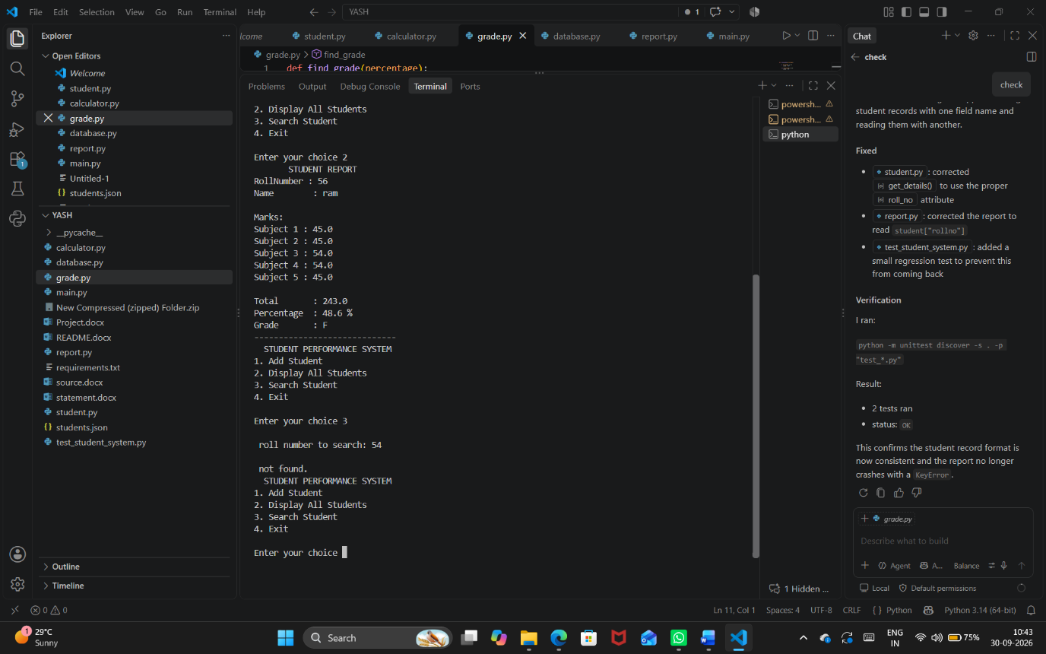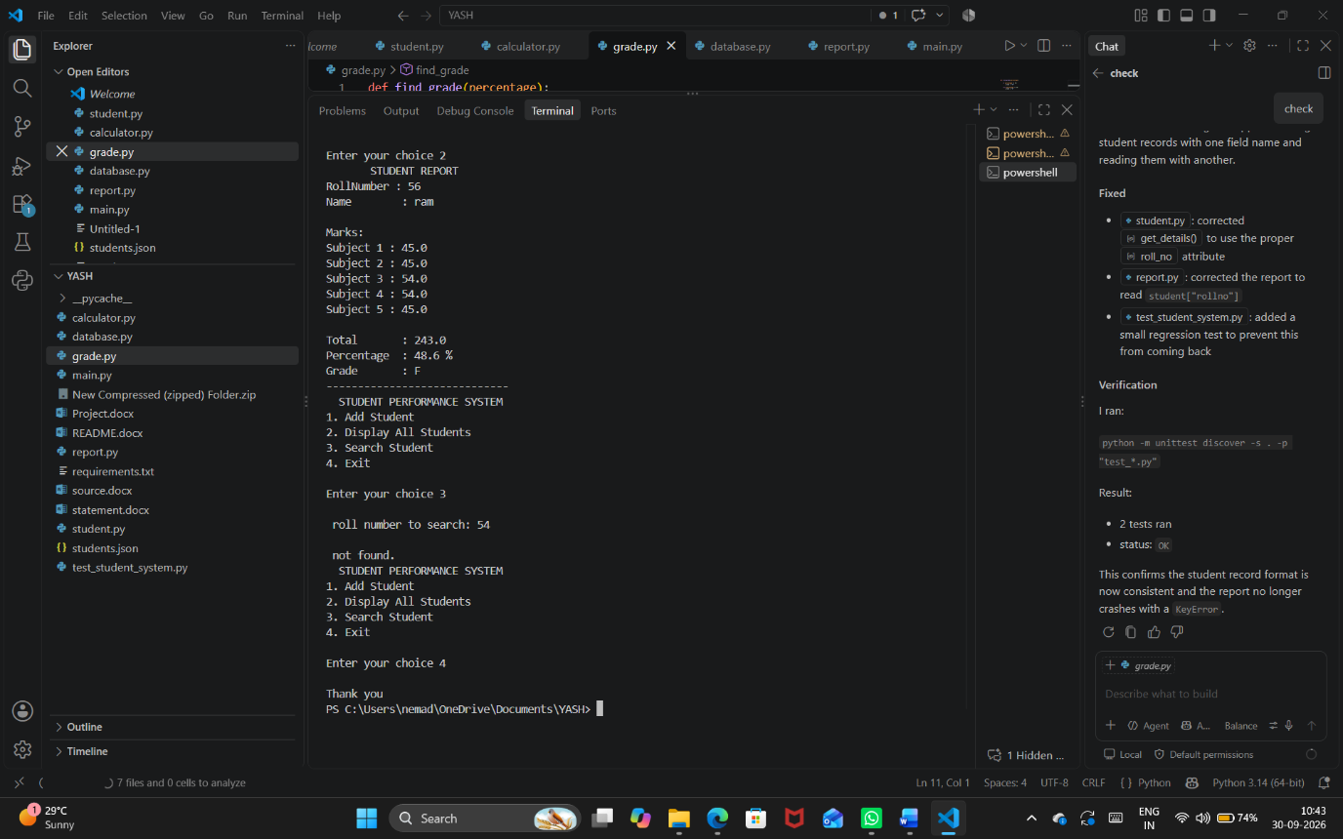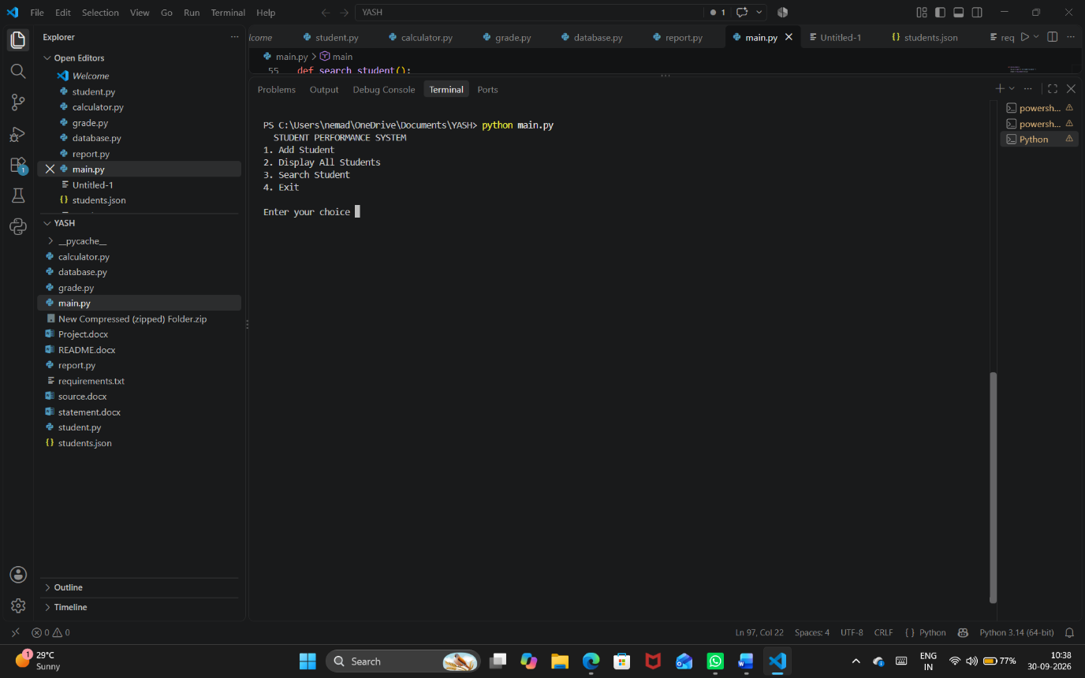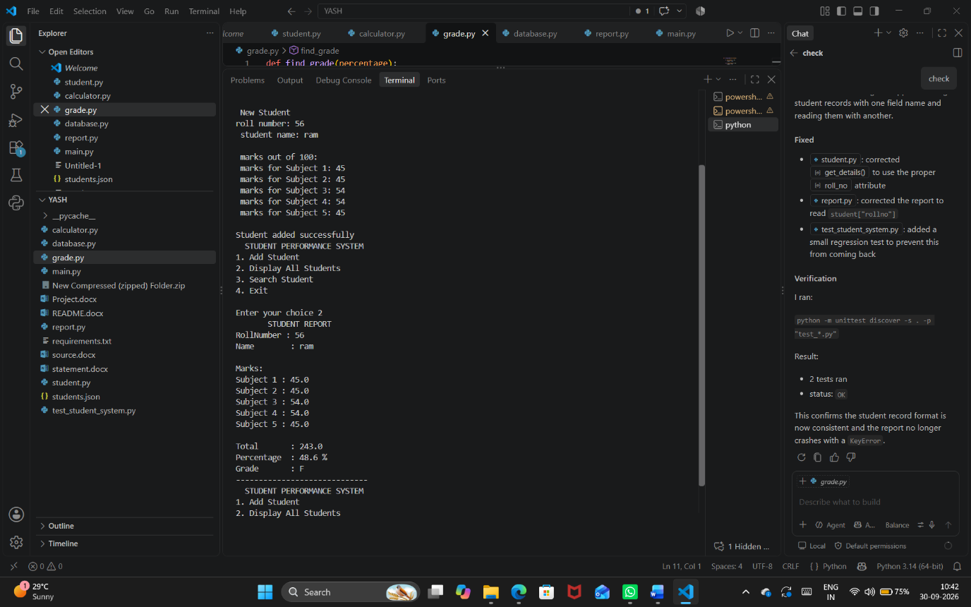
11. Testing Approach
Testing was performed by providing different types of inputs to check whether the system works correctly.
Test Case | Input | Expected Result
Add student | Valid student details | Student added
Marks calculation | 85, 78, 91, 88, 80 | Total = 422
Percentage | Total = 422 | 84.4%
Grade | 84.4% | A
Invalid marks | 120 | Error message
Invalid marks | -5 | Error message
Invalid input | abc | Error message
Search existing student | Roll No. 101 | Student report
Search unknown student | Roll No. 999 | Student not found
Empty database | No records | No students message
Testing Result
The basic test cases were performed successfully. The system was able to accept valid information, reject invalid marks, calculate performance, store data, and search for student records.

12. Challenges Faced
During the development of the project, some challenges were faced.
12.1 Understanding Modules
Initially, connecting different Python files using import was slightly difficult.
Solution: Each module was given a specific responsibility and imported into main.py or other required files.
12.2 File Handling
Reading and writing student data to a JSON file required understanding Python file handling.
Solution: The built-in json module was used with open().
12.3 Input Validation
Users may enter letters instead of numbers or marks outside the valid range.
Solution: try-except was used for invalid numerical input, and conditions were added to check the marks range.
12.4 Connecting Different Modules
The calculation, grade, database, and report modules needed to work together.
Solution: Functions were kept simple and imported only where required.
12.5 Maintaining Student Data
The program needed to retain student records after the program was closed.
Solution: Student information was stored in students.json.

13. Learnings & Key Takeaways
Through this project, the following Python concepts were learned:
- How to create and use Python modules.
- How to import functions from another file.
- How to create classes and objects.
- How to use functions for different tasks.
- How to use lists and dictionaries.
- How to work with JSON files.
- How to read and write files.
- How to handle errors using try-except.
- How to validate user input.
- How to design a simple modular application.
- How different Python files can work together as one project.
The project also helped in understanding how a simple real-world problem can be converted into a working Python application.

14. Future Enhancements
The current project can be improved in several ways.
14.1 Graphical User Interface
A GUI can be added using Tkinter or another Python framework.
14.2 Database
The JSON file can be replaced with a proper database such as SQLite or MySQL.
14.3 More Subjects
The system can be modified to support any number of subjects.
14.4 Update Student Records
An option can be added to edit existing student information.
14.5 Delete Student
The user can be given an option to remove a student record.
14.6 Attendance
Attendance information can be added along with academic performance.
14.7 Performance Charts
Graphs can be added to show student performance visually.
14.8 Login System
A login system can be added for teachers or administrators.
14.9 Class Statistics
The system could calculate:
- Class average
- Highest marks
- Lowest marks
- Number of students in each grade

15. References
- Python Documentation – Python programming language documentation.
- Python json module documentation – Used for storing and reading JSON data.
- Python file handling concepts – Used for reading and writing files.
- Python classes and objects – Used to implement the Student class.
- Python exception handling – Used for validating user input.
References/Links
Python Documentation
Python JSON Module

Final Report Order
Your PDF should follow exactly this order:
1. Cover Page
2. Introduction
3. Problem Statement
4. Functional Requirements
5. Non-functional Requirements
6. System Architecture
7. Design Diagrams
├── Use Case Diagram
├── Workflow Diagram
├── Sequence Diagram
├── Class/Component Diagram
└── ER Diagram
8. Design Decisions & Rationale
9. Implementation Details
10. Screenshots / Results
11. Testing Approach
12. Challenges Faced
13. Learnings & Key Takeaways
14. Future Enhancements
15. References

