README.md
Student Performance Management System
1. Project Title
Student Performance Management System
2. Overview of the Project
The Student Performance Management System is a simple Python-based project designed to store and manage student academic information.
The user can enter a student's roll number, name, and marks in five subjects. The program calculates the total marks, percentage, and grade. It also allows the user to view all student records and search for a particular student using their roll number.
The project is divided into multiple Python modules to make the program organized and easy to understand.
3. Features
- Add a new student
- Enter marks for five subjects
- Calculate total marks
- Calculate percentage
- Automatically calculate the grade
- Display all student records
- Search for a student using roll number
- Store student information in a JSON file
- Validate marks between 0 and 100
- Handle invalid input
- Modular Python program using multiple files
4. Technologies and Tools Used
Programming Language
- Python
Python Concepts Used
- Classes and Objects
- Functions
- Modules
- if-elif-else conditions
- for loops
- Lists
- Dictionaries
- File handling
- Exception handling
- JSON data storage
Tools
- Visual Studio Code / PyCharm / IDLE
- Python 3.x
Libraries
The project mainly uses Python's built-in json module.
No external Python packages are required.
5. Project Structure
Student_Performance_System/
│
├── main.py
├── student.py
├── calculator.py
├── grade.py
├── database.py
├── report.py
├── students.json
├── requirements.txt
└── README.md
Description of Files
File | Purpose
main.py | Runs the main menu and controls the program
student.py | Contains the Student class
calculator.py | Calculates total and percentage
grade.py | Calculates the student's grade
database.py | Saves and loads student information
report.py | Displays the student's performance report
students.json | Stores student data
requirements.txt | Lists project requirements
README.md | Project documentation
6. Installation and Setup
Step 1: Install Python
Download and install Python 3.x on your computer.
Check whether Python is installed by opening the terminal and running:
python --version
Step 2: Download or copy the project
Create a folder named:
Student_Performance_System
Put all the project files inside this folder.
Step 3: Open the project
Open the project folder in VS Code, PyCharm, or another Python editor.
Step 4: Check the JSON file
Make sure students.json contains:
[]
Step 5: Run the project
Open the terminal inside the project folder and run:
python main.py
The main menu will appear.
7. How to Use the Project
After running the program, the following menu is displayed:
==============================
STUDENT PERFORMANCE SYSTEM
==============================
1. Add Student
2. Display All Students
3. Search Student
4. Exit

Enter your choice:
To Add a Student
Enter:
1
Then enter the student's:
- Roll number
- Name
- Marks for five subjects
Example:
Enter roll number: 101
Enter student name: Rahul

Enter marks out of 100:
Enter marks for Subject 1: 85
Enter marks for Subject 2: 78
Enter marks for Subject 3: 91
Enter marks for Subject 4: 88
Enter marks for Subject 5: 80
The student information will be saved in students.json.
To Display Students
Select:
2
The program will display the stored student information along with:
- Total marks
- Percentage
- Grade
Example:
-----------------------------
STUDENT REPORT
-----------------------------
Roll Number : 101
Name : Rahul

Marks:
Subject 1 : 85.0
Subject 2 : 78.0
Subject 3 : 91.0
Subject 4 : 88.0
Subject 5 : 80.0

Total : 422.0
Percentage : 84.4 %
Grade : A
-----------------------------
To Search for a Student
Select:
3
Enter the student's roll number:
Enter roll number to search: 101
The student's complete performance report will be displayed.
To Exit
Select:
4
The program will close.
8. Testing Instructions
The project can be tested using the following cases.
Test Case 1: Add Student
Input:
Roll Number: 101
Name: Rahul
Marks: 85, 78, 91, 88, 80
Expected Result:
The student should be added successfully and saved in students.json.

Test Case 2: Calculate Percentage
Input:
85, 78, 91, 88, 80
Expected Result:
Total: 422
Percentage: 84.4%

Test Case 3: Search Student
Input:
Roll Number: 101
Expected Result:
The program should display the student's complete report.

Test Case 4: Invalid Marks
Input:
Enter marks for Subject 1: 120
Expected Result:
Please enter marks between 0 and 100.

Test Case 5: Invalid Input
Input:
Enter marks for Subject 1: abc
Expected Result:
Please enter a number.

Test Case 6: Student Not Found
Input:
Enter roll number to search: 999
Expected Result:
Student not found.
9. Screenshots
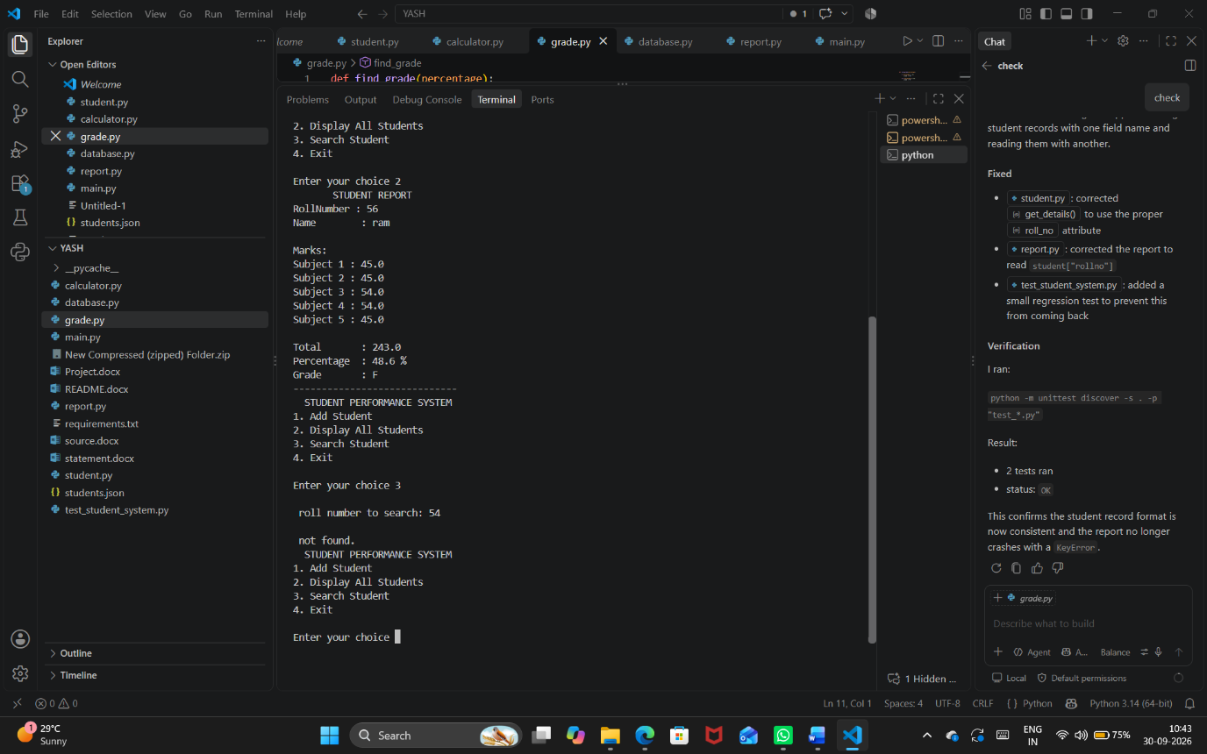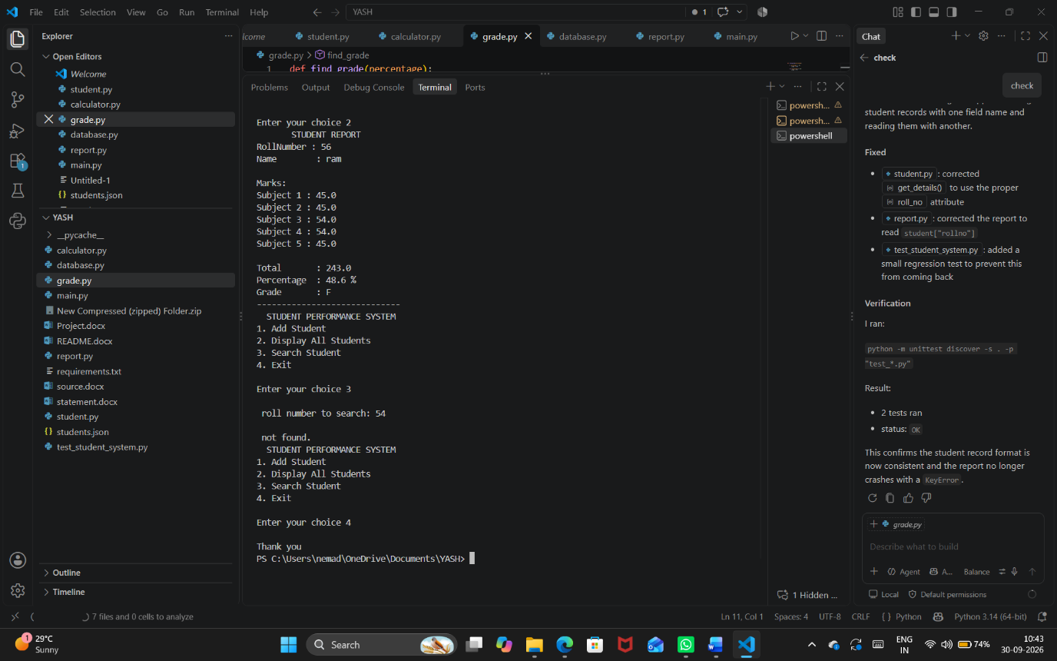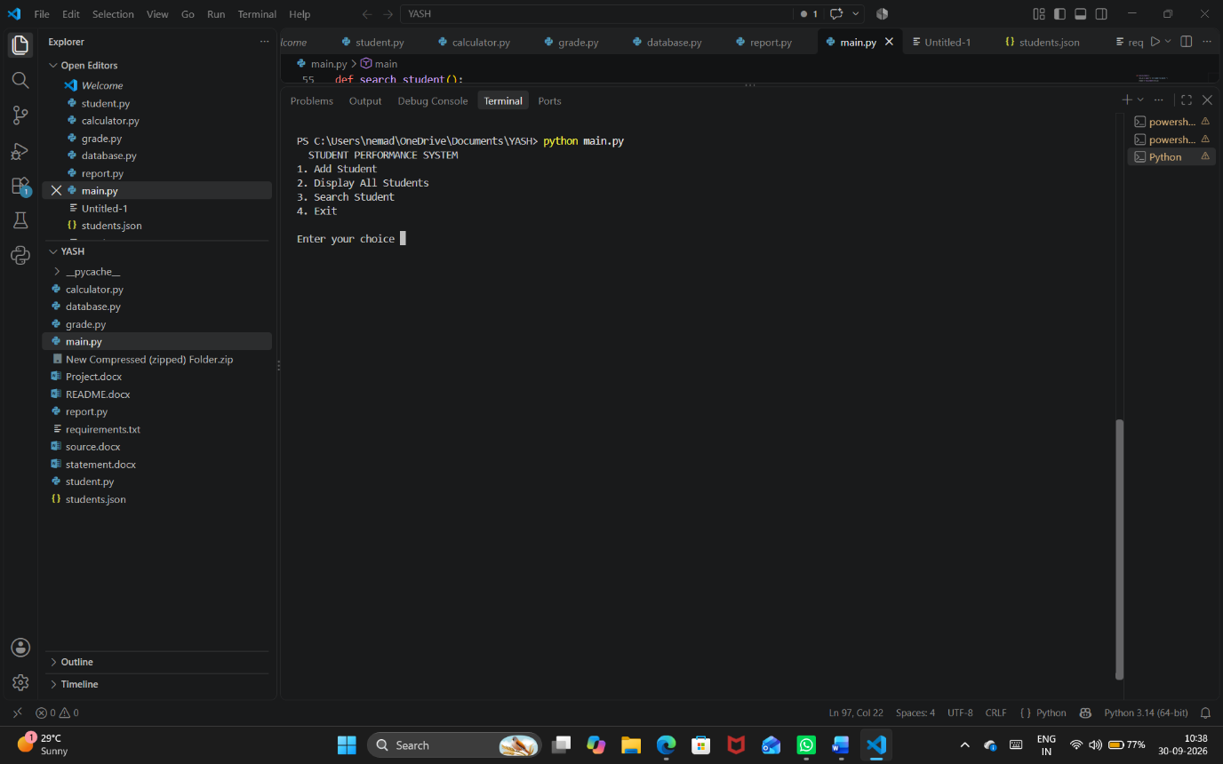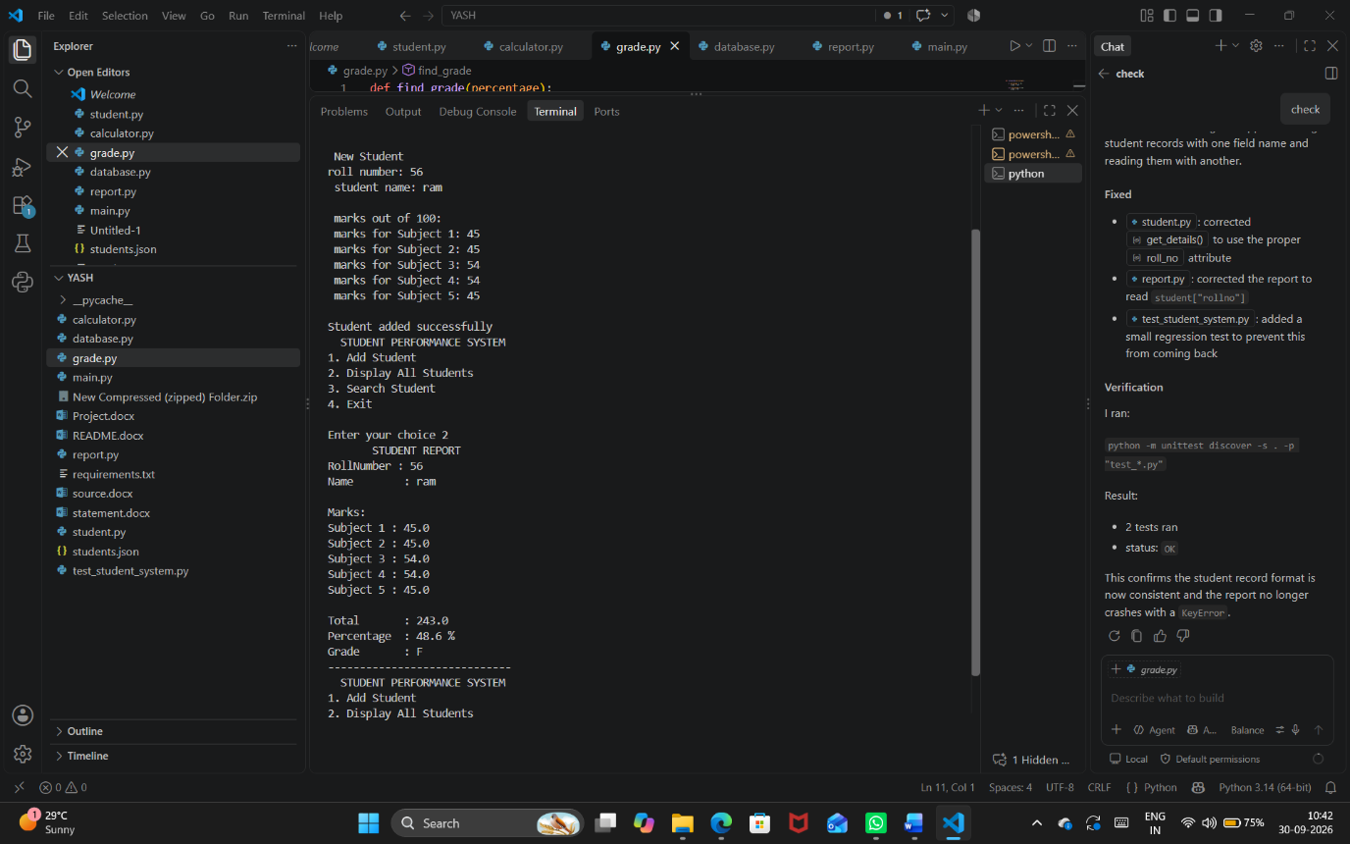10. Conclusion
The Student Performance Management System demonstrates how Python can be used to create a simple and useful application. The project also demonstrates modular programming by dividing different tasks into separate Python files.
The project can be further improved by adding features such as updating student records, deleting records, calculating class averages, and creating a graphical user interface.

