HTML & CSS Assignment
Student Name: Aryan Pokharel
Student ID : 2602412430
Assignment Title: Html and Css Assignment

Project Description
This project is a small website called "My Personal Webpage". It has a navigation bar, a single course card, a section with four course cards, and footer. I made it to practice the HTML and CSS I learned in the first weeks of college. The files are:
- index.html - the complete page
- screenshot
- images
- css/style.css- all the styling

Technologies Used
- HTML
- CSS

Learning Resources
No. | Resource | Topic Learned | What I Learned | How I Used It
1 | Teacher's class notes | CSS selectors | How element, class and id selectors pick different elements. A class can be used many times but an id is used once. | Used .course-card for all cards and #nav-bar for the one navigation bar.
2 | Teacher's class notes | HTML structure | How header, nav, main, section, article and footer organize a page. | Used them to build the page layout in index.html.
3 | W3Schools - CSS Navbar  https://www.w3schools.com/css/css_navbar.asp | Navigation bar | How to remove bullets from a list with list-style-type: none and make links look like buttons using display: block and padding. | Styled my menu links and made the hover color change.
4 | MDN - The box model  https://developer.mozilla.org/en-US/docs/Learn_web_development/Core/Styling_basics/Box_model | Margin, padding, border | Padding is the space inside the border, margin is the space outside it. | Used padding inside the cards and margin between the cards.
5 | W3Schools - CSS Float  https://www.w3schools.com/css/css_float.asp | Float and clear | Float moves an element to the left or right so elements can sit side by side. Clear stops the next element from wrapping around it. | Floated the cards so 3 sit in one row, and used clear: both on the footer.
6 | MDN - object-fit  https://developer.mozilla.org/en-US/docs/Web/CSS/object-fit | Image properties | object-fit: cover fills the image box without stretching the picture. | Used it on the card images so they all have the same size.
7 | W3Schools - CSS Rounded Borders  https://www.w3schools.com/css/css_border_radius.asp | Border radius | border-radius makes the corners of a box round. | Used it on the cards and buttons.

Screenshots

Navigation Bar

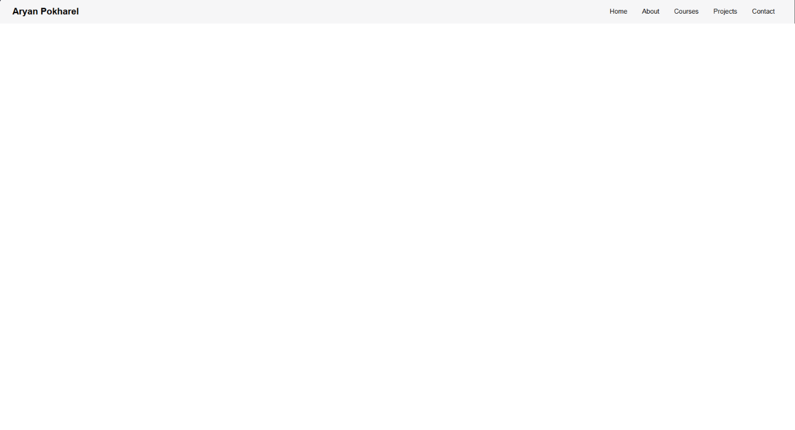Single Card

Multiple Cards

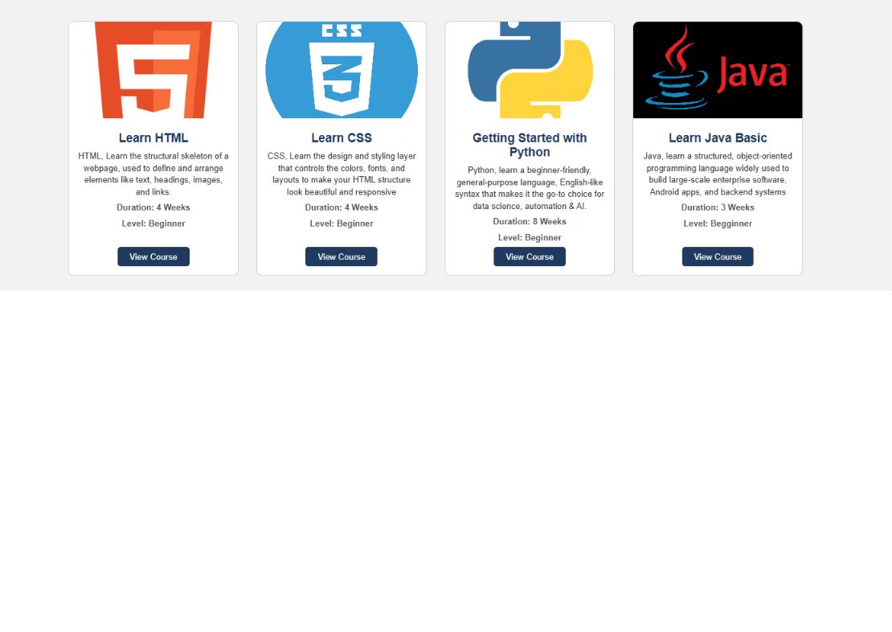Complete Website

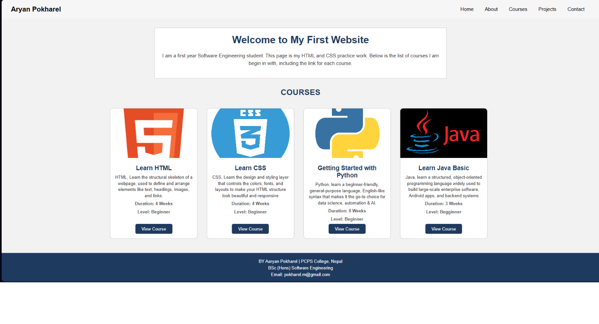What I Learned
- HTML page structure: Every page needs html, head and body. The CSS file is linked inside head.
- Semantic HTML: Tags like header, nav, section, article and footer show what each part of the page is for.
- CSS selectors: I used element, class and id selectors. Class selectors are good for things that repeat, like the cards.
- Colors and units: I used hex colors and px units for sizes.
- Typography and text properties: I used font-family, font-size, font-weight, line-height and text-align.
- Image properties: I set the image width to 100% and a fixed height, then used object-fit: cover.
- Margin and padding: Margin is the space outside a box and padding is the space inside it. margin: 0 auto with a fixed width centers a box.
- Border and border radius: Borders show the edge of the card and border radius rounds the corners.
- Hover effects: a:hover changes the look of a link when the mouse is on it. I used it on the menu links, card buttons and cards.
- Basic positioning: I used float and clear to place the menu and the cards side by side.

Challenges and Solutions
Challenge 1: My navigation links were standing in a vertical list with bullet points.
Solution: I used list-style-type: none and floated the li items to the left so they sit in one line.
Challenge 2: The cards had different heights because the descriptions had different lengths, so the buttons were not in a straight line.
Solution: I gave the .card-body a fixed height so every card has the same size.
Challenge 3: The footer moved up beside the floated cards.
Solution: I learned that floated elements leave the normal flow. I added overflow: hidden on the card area and clear: both on the footer.
Challenge 4: The images looked stretched inside the cards.
Solution: I used object-fit: cover after reading about it on MDN.

AI Usage
I used Claude (an AI tool) while working on this assignment.
- What I asked for: Help with the layout of the page, the code for the navigation bar and cards, and the structure of this README.
- What I learned: How float and clear work, why overflow: hidden is used on a parent of floated items, and how object-fit works.
- What I changed myself: [Write honestly here, for example: I changed the colors, the course names and descriptions, the footer text, and I tested every part in the browser.]
I read through all the code and I can explain it.

