When Help Becomes a Hindrance: How Simplified Biological Diagrams Create Systemic Misconceptions
Aaryan Samanta, Legend College Preparatory
ABSTRACT
Simplified biological diagrams are common in educational contexts, helping students grapple with complex biological systems presented in digestible visuals - but do these simplifications come at a cost, one of activating biases and misinterpretations of processes they are meant to explain? In this project I will take a look at how simplified biology diagrams do (and don’t) form students’ mental models and create systemic misconceptions, and explore mechanisms of how visuals both help and hinder understanding—e.g., are dynamic processes diagrammed statically, linearly, overly “cleanly” etc.? I would implement isolated interventions with tightly controlled post measures of student understanding and retention exposed to standard simplified diagrams compared to redesigned clarification-enhanced versions. Deliverables would include (1) a Misconception–Diagram Feature map for 2-3 high impact topics, (2) a set of classroom-ready “standard vs. redesigned” diagram pairs, and (3) evidence-based guidelines along with a few short visual-literacy prompts. I would evaluate success if I see a reduced rate of misconceptions on direct measures as well as conceptual transfer on a post-test and drawing task.
MOTIVATION AND APPROACH——IDEA
Biology education relies heavily on visuals to convey biological processes and structures (Sundararajan & Adesope, 2020; Menendez, Rosengren, & Alibali, 2022). As powerful teaching tools, these visuals can be problematic if mis-designed or misperceived because they risk creating systematic errors in understanding [1-2]. In some cases, instructional figures encode incorrect details or emphasize incorrect proportions, which students then adopt “as is,” despite being factually wrong [3-4]. A common example is simplified cell diagrams in textbooks that inaccurately convey cells as having a static, tidy arrangement of a few oversized organelles; students thus overlook the dynamic, relative nature and variability on that scale in a real cell [5]. Coloring conventions and symbols can also be misconstrued – perhaps most memorably students believing human blood in veins is blue because blue is the color sometimes used for veins when diagrammed in textbooks, although deoxygenated blood in reality is far closer to dark red. When learners draw or explain a biological process, their responses often reveal the diagram’s visual grammar (its symbols, layout, implied sequence) more than they reveal the scientific reality, allowing minor design choices to scale into significant and persistent errors (Aleknavičiūtė, Lehtinen, & Södervik, 2023; Coley & Tanner, 2015).
A more common problem is misreading diagrammatic symbols and mappings. Much diagramming makes use of arrows and segments showing how different bits relate to one another in terms of a process. Without careful instruction, a student may confuse such abstract representations with dynamic things. For example, a student may grasp that there’s something about DNA to RNA in the central dogma figure [8] but mistakenly think of it as the DNA becoming RNA, rather than transcription. More generally, novices may see the parts of a diagram as the literal manifestation (literal colors, literal shapes, literal sequence) and be less likely to see them as hints to the underlying phenomena. For example, if life cycles are presented in a cycle, students may assume that it represents a perfectly periodic cycle, or that all species are present in equal amounts of time (which they aren’t). Further, such initial misconceptions can persist and become a barrier to learning advanced topics (Arneson & Offerdahl, 2018; Uminski, Newman & Wright, 2025). Thus, even if the learner is not a novice, those misconceptions can persist and prove an obstacle to engaging with sophisticated knowledge or using specific concepts to inform novel approaches to novel scenarios [9]. So, the driving motivation for this project is to track down exactly how and why these simplifications of biology fail to instantiate scientific truth, so that we can do a better job of designing biology education materials. Prior work supporting such design, particularly in science education, shows that well-designed material can improve comprehension and interest [10], while poorly done visuals mislead. Yet very few empirical studies have isolated factors about design (e.g., arrow styles, variability omission, missing scale cues) in biology figures and quantified experimentally how these affect misconception frequency and transfer—this is precisely the gap my project targets.
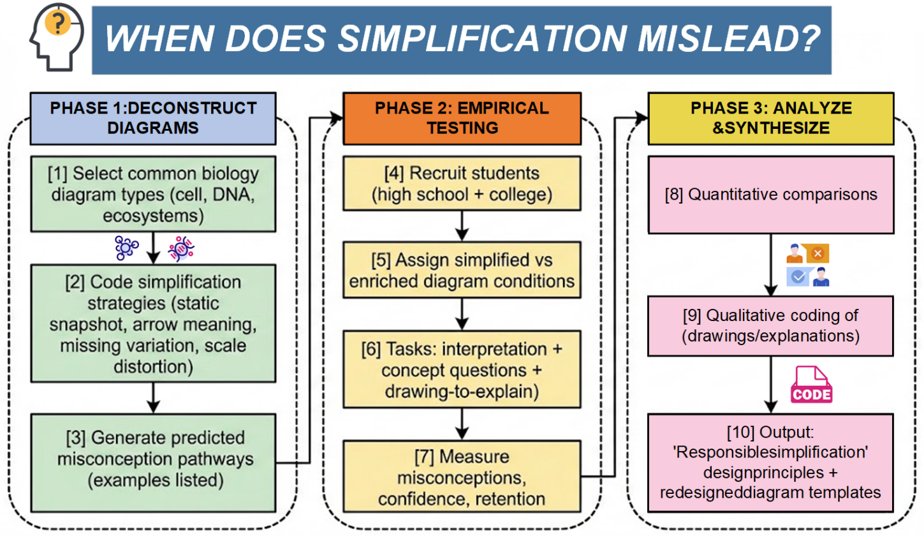
Proposed Solution: I suspect that slight, deliberate tweaks to the design of diagrams (perhaps coupled with slight additional prompting) can reduce certain misconceptions without substantially adding to cognitive load. Markers of scale or variability might fix false impressions of constancy in cell diagrams, while clarifying what arrows mean (and don’t mean) when zooming into genetics figures might help us cut down on literal interpretations. I’m going to do something hybrid - a bit of education research mixed with iterative design. First, I’ll identify 2-3 types of diagrams that I suspect drive misconceptions using a short literature scan and minor misconception survey. For each diagram, I’ll design an alternative diagram that preserves its instructional purpose, but adds clear scientifically useful elements (scale, variability, symbol legend, “things this diagram does not convey” notes, etc). Then I’ll test a pair of these diagrams by doing a controlled comparison: Group A studies with the standard diagram. Group B studies with the altered diagram. The learning goals, time on task, and assessment items will be the same. Do we see an observable reduction in misunderstanding frequency? Accumulated understanding? Drawing/explanation accuracy?
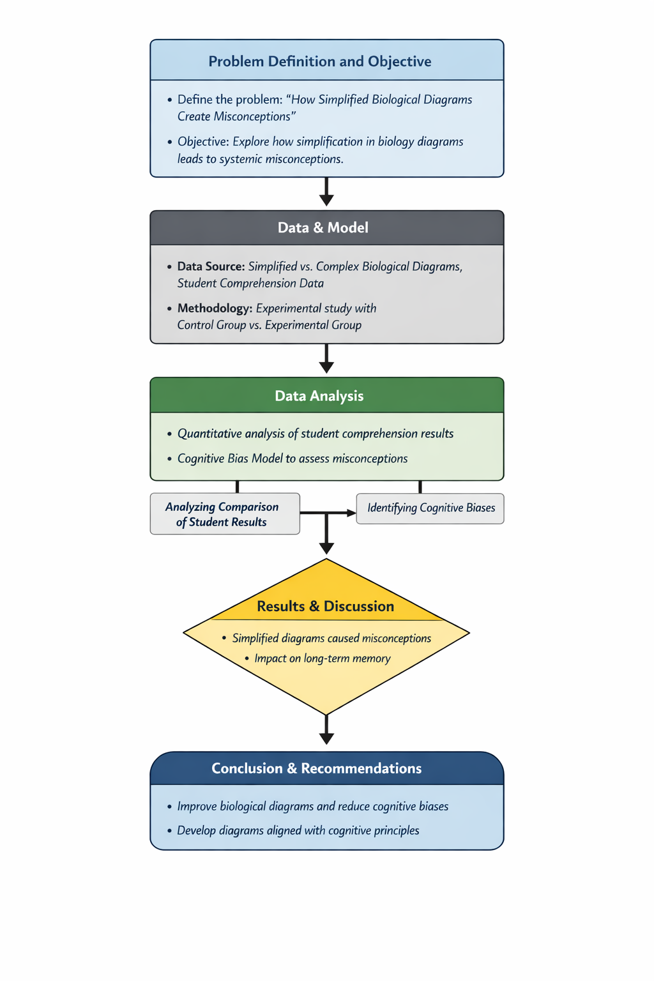
PROJECT LOGISTICS AND ORGANIZATION——PLAN
Approach: The work will be conducted in phases. The first phase will be a misconception survey, to gather initial data about which biology figures and topics typically confuse students. This process will involve taking some short quiz or questionnaire of high school biology students where they are asked to explain certain diagrams & answer questions that tap into common known misconceptions (i.e., “what does the arrow in this diagram mean happens to the DNA?” or “draw and label a plant cell from memory”) and I will investigate what misconceptions I can correlate back to specific features of diagrams, what patterns I can find in that and focus on a handful of high-impact areas of biology (cell structure, flow of genetic information, etc.) where misconceptions are common (and documented in the literature), and are likely diagram-driven. I will also review literature about what design elements experts have critiqued/identified as problems in standard biology figures [12-14].
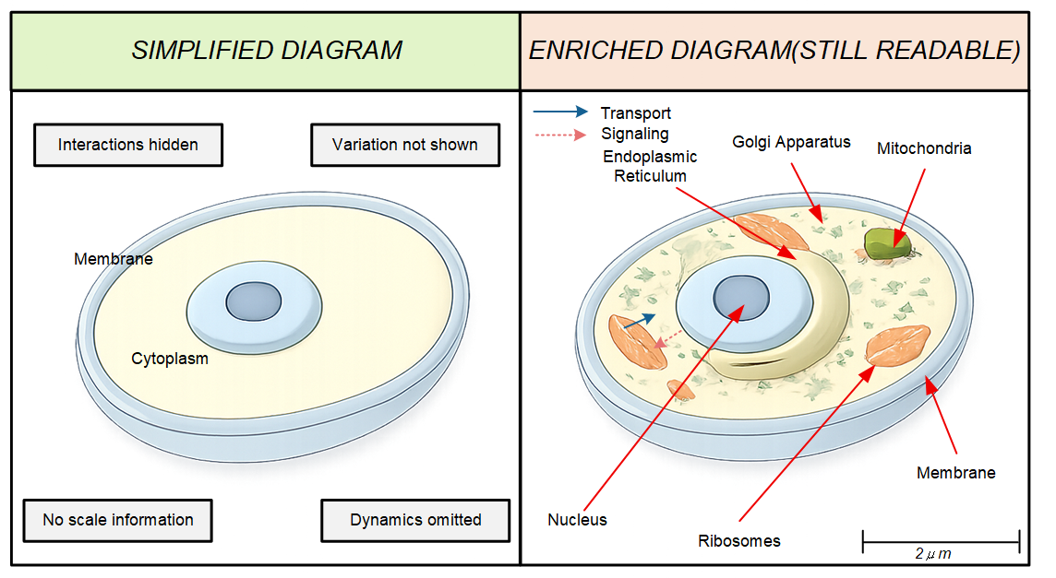
Taking insights from these studies and surveys, the next phase would be to begin to design revised diagrams. I’d re-draw or digitally adjust the target diagrams to address the problems we choose to begin with. If, for example, students come to consider that mitochondria float off into space, thanks to some clean spacing in textbook images, a revised diagram might include a size variation, or transparency, to indicate crowdedness. If a pathway diagram is causing students to mis-infer that it sequences correctly, I’d ensure it includes explanatory notes or change the style of the arrows (dotted lines for “leads to” vs. solid lines for “converts into,” for example) to ensure that it’s less susceptible to that mis-inference. I’ll get feedback from a biology teacher/mentor so that my redesigned diagrams are still pedagogically clear and accurate instruments. Where feasible, I plan to incorporate multiple views, or a brief sequence of images, instead of just one static image, to more faithfully represent dynamic processes without overwhelming the student learner in the process. These modifications would be grounded in cognitive load theory / visual learning theory considerations and applied to rectify the diagrammatic inaccuracies without adding extraneous complexity [5]. By the end of this phase, I’ll have re-designed a set of pairs of traditional vs. modified diagrams.
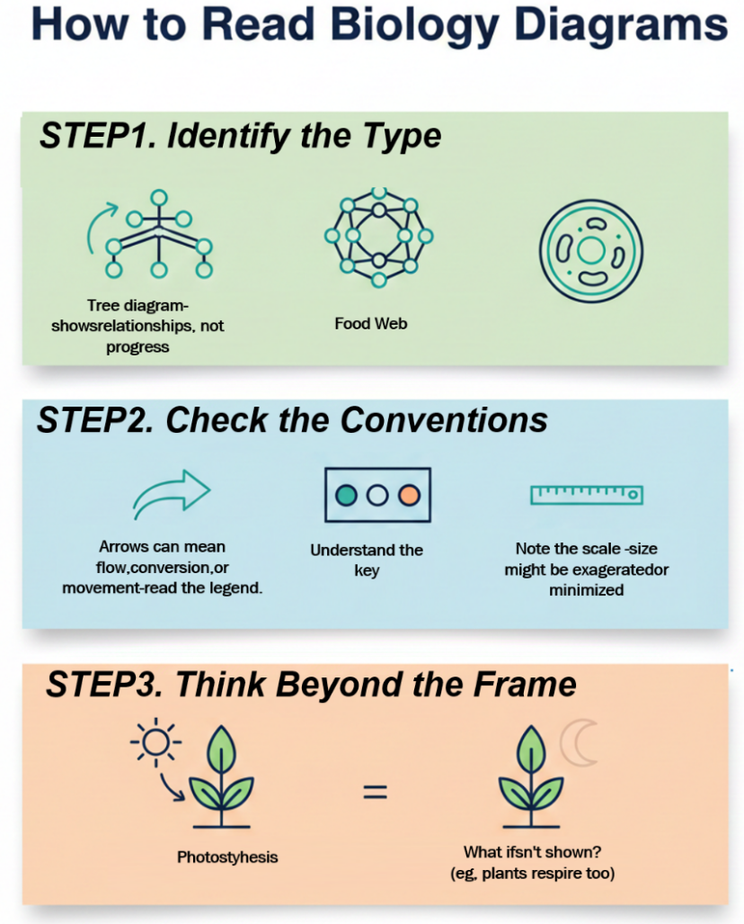
In the third phase I will conduct a comparative study of the effectiveness of the modified diagrams. Two separate groups of student participants will be taught identical content using either the standard textbook diagram or my redesigned diagram. They will then be asked the same assessment questions of both to measure their understanding. These will include some factual questions, as well as application questions that typically elicit misconceptions. For example, after a unit on human circulation, I might ask, “What color is blood on the veins? Why is it different in the diagram?” and see if the kids realize that the idea of blue blood is figurative. I’ll have the test questions evaluate conceptual understanding rather than recall. I’ll run statistical measures (means, frequency of misconceptions in each group) to see if any differences are statistically significant. Also, I’ll do some qualitative interviews with a sample of the students, which would tell me more regarding which visual cues were most revealing or confounding.
Resources: I will need access to some students or classrooms to survey and test: Permissions and ethics (informed consent from students or parents, anonymity of their responses) will be coordinated with the school administration. I will create the diagrams with graphic design software (Adobe Illustrator, or free alternatives). I have access to basic equipment, so no major purchases are necessary. I will need a mentor from this THINK program or a science education professor to help me refine my study design and analysis of my findings. The funding from MIT THINK will support primarily resources, and logistics of the study. This budget may cover printing, handouts, and small incentives for participants. All in all, my resource needs are pretty minimal and attainable; my project’s feasibility is relatively high, drawing on relatively existing school settings and common tools.
Goals and Evaluation: Success in this project will be measured by how well the new diagrams convey the idea I intend them to convey. Before I run the study, I will outline criteria I will use to evaluate student understanding. One specific target will be getting a significant reduction in the proportion of students in a target population that have a particular misconception that normal diagrams with a sort of traditional basic figure commonly elicit. E.g., if 60% of students develop the misconception when presented with the old figure, then I might also target an improvement in overall (not just particular misconception-elimination) statistics of ~0.4 SD or Cohen’s d ≥ 0.4, or 20% gain on concept-transfer items, and use for testing of differences. I might use a chi-square test (for difference in misconception proportions) and/or a t-test or non-parametric equivalent as appropriate for comparing scores in general. I might also look at qualitative indicators: do students sourcing a modified diagram provide a more biologically accurate explanation in an open-ended comparison question? Do their own drawings / sketches / mental models look biologically accurate? If some misconceptions do persist even with the modified diagram, that will also tell me something, potentially, about deeper conceptual issues that need addressing in ways other than diagram modifications (which may be more teaching strategy or practice-based issues). I plan to keep ongoing research log and run some statistics (like chi-square or t-tests, as relevant) to confirm the results are due to the diagram explanations as I suspect. Of course, success will not only be of the type: a diagram design is effective but potentially lead to design principles that we can generalize. For example, the study might result in a principle that just showing multiple examples of a concept (to show variation in examples) always assists understanding, or that certain types of annotations always eliminate misinterpretation. These principles would lead to good guidelines for teachers and textbook illustrators of good diagrams. The ultimate goal will be if I walk away from here with some principles of actual use & of actual use in improving how biology is taught to potentially thousands of students beyond this tiny study.
Potential Challenges and Mitigation:
- Risk: One problem is ensuring enough students in total to come to an actual conclusion. If I only have a few in a small class, the data won’t be useful. Mitigation: I will appeal to other classes or even other schools that may collaborate on the study. I would even contemplate doing the experiment in two different high school biology classrooms (with their permission). I know some people through a regional chapter of the science teacher’s association who can help me recruit.
- Controlling for Prior Knowledge: Students come with different backgrounds; a student’s prior knowledge might mean a diagram helps some and confuses others, ruining their results. Mitigation: I will give a short pre-test before the lesson to establish baseline levels of understanding and make sure they are comparable, then look at the results using techniques that incorporate pre-test score (deriving and comparing gain scores in the pre/post test) so that one is less confused about whether this is simply a function of differences rather than the diagram with students.
- Diagram Effect vs. Instructor Effect: If significant differences in teaching occur between the teacher for the control and the teacher for the experimental groups, this could influence the results. Mitigation: I will minimize this by testing different classes with the same teacher or teachers. If multiple teachers are used, I will provide a standard script/lesson plan in advance so as to vary instructional differences as little as possible. I will also focus the questions for evaluation on concepts which are tightly linked to the diagrams in the lesson, so that I can isolate the visual factor as much as possible.
- Data Interpretation and Bias: There is a risk of unwittingly “reading into” the data to support my hypothesis (confirmation bias). Mitigation: I will use blind grading on the written responses (removing indicators about which group a student was in) so I or another evaluator can score answers without preconception. I will ask my project mentor or some statistics teacher on campus how best to analyze the data so that I don’t blind myself to what is actually there with my expectations.
- Timeline Constraints: For anyone hoping to do research within a single semester - working around the school calendar for interventions and tests can be painfully slow. Make sure you have a plan. Mitigation: I’ve sketched a timeline in detail and have a timeline below. To start with, I will simply begin my preparations (getting permissions, drafting materials) earlier, even before my official project start date. Additionally, if any phase looks to be delayed I will “cut my losses” by getting rid of the least crucial study pairing (for example, two diagrams instead of three), to ensure that I get a meaningful study done within my window of time.
Item | Quantity | Estimated Cost (USD) | Purpose
Printing and handouts | 300 pages | $120 | Surveys and instructional materials
Participant incentives | 120 students | $360 | Encourage participation
Graphic design software/tools | 1 license | $120 | Diagram redesign
Data analysis & transcription | — | $100 | Coding and analysis
Miscellaneous/contingency | — | $100 | Unforeseen expenses
Total |  | $800 | Within MIT THINK budget
Timeline and Milestones: Deliverables include research instruments by end of Month 2; completion of initial data collection by Month 6; completion of intervention tests by Month 9; and report delivery by Month 10. I’ve mapped these tasks to a timeline (see below); leave slack time in case of delays (for example, extra time for recruitment, since it’s always hard to get enough people). I’ve also scheduled analysis while they are doing late data collections (to speed turn around). That is what I’m going to use as my timeline.
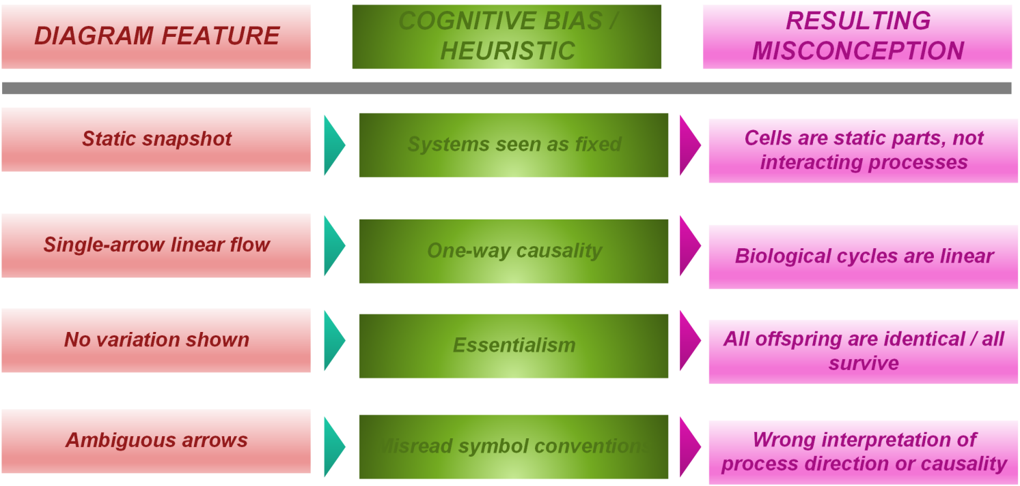
Months 1–2: Literature review, diagram selection, ethics preparation
Month 3: Pilot testing of surveys and instruments
Months 4–6: Main data collection (high school and college cohorts)
Months 6–7: Quantitative and qualitative analysis
Months 8–9: Diagram refinement and follow-up testing
Month 10: Synthesis of findings and final report preparation
CURRENT PROGRESS Need FOR MIT THINK SUPPORT—PERSONAL INTEREST
I am a visual learner who often doodles biology processes, and I’ve seen how a “clean” diagram can both help and mislead - while tutoring, I found that students often remember the diagram more than what process it represents. I want to study this problem because it’s amenable to a practical solution: a simple design change or a couple of good habits around diagram literacy could eliminate months to years of misunderstanding. I would want MIT THINK mentorship to design a rigorous study and make sure we translate our findings into tools that teachers can use right away.
REFERENCES
Aleknavičiūtė, V., Lehtinen, E., & Södervik, I. (2023). Thirty years of conceptual change research in biology – A review and meta-analysis of intervention studies. Educational Research Review, 41, 100556. DOI: 10.1016/j.edurev.2023.100556
Allred, Z. D. R., & Bretz, S. L. (2019). University chemistry students’ interpretations of multiple representations of the helium atom. Chemistry Education Research and Practice, 20(2), 358–368. DOI: 10.1039/c8rp00296g
Arneson, J. B., & Offerdahl, E. G. (2018). Visual literacy in bloom: Using Bloom’s taxonomy to support visual learning skills. CBE—Life Sciences Education, 17(1), ar7. DOI: 10.1187/cbe.17-08-0178
Coley, J. D., & Tanner, K. D. (2015). Relations between intuitive biological thinking and biological misconceptions in biology majors and nonmajors. CBE—Life Sciences Education, 14(1), ar8. DOI: 10.1187/cbe.14-06-0094
Dees, J. P., Momsen, J. L., Ni, X., Bray Speth, E., & Long, T. M. (2018). Further effects of phylogenetic tree style on student comprehension in an introductory biology course. CBE—Life Sciences Education, 17(2), ar17. DOI: 10.1187/cbe.17-08-0198
Landin, J. M., & Cozart, A. J. (2024). Redesign of a life cycle figure improves student conceptions of ecology and evolution. Education Sciences, 14(4), 403. DOI: 10.3390/educsci14040403
Menendez, D., Mathiaparanam, O. N., Liu, D., Seitz, V., Alibali, M. W., & Rosengren, K. S. (2020). Representing variability: The case of life cycle diagrams. CBE—Life Sciences Education, 19(3), ar49. DOI: 10.1187/cbe.19-11-0251
Menendez, D., Rosengren, K. S., & Alibali, M. W. (2022). Do details bug you? Effects of perceptual richness in learning about biological change. Applied Cognitive Psychology, 36(1), 93–107. DOI: 10.1002/acp.3698
Quillin, K., & Thomas, S. (2015). Drawing-to-learn: A framework for using drawings to promote model-based reasoning in biology. CBE—Life Sciences Education, 14(1), es2. DOI: 10.1187/cbe.14-08-0128
Sundararajan, N. K., & Adesope, O. O. (2020). Keep it coherent: A meta-analysis of the seductive details effect. Educational Psychology Review, 32(3), 707–734. DOI: 10.1007/s10648-020-09516-w
Uminski, C., Newman, D. L., & Wright, L. K. (2025a). Probing visual literacy skills reveals unexpected student conceptions of chromosomes. CBE—Life Sciences Education, 24(1), ar17. DOI: 10.1187/cbe.24-07-0176
Uminski, C., Wright, L. K., & Newman, D. L. (2025b). Sketchy understandings: Drawings reveal where students may need additional support to understand scale and abstraction in common representations of DNA. Journal of Microbiology & Biology Education, 26(2), e00070-25. DOI: 10.1128/jmbe.00070-25
Vydra, M., & Kováčik, J. (2025). A global review of biology textbook analyses: Exploring the trends, gaps, and silences across topics. Review of Education, 13(3), e70124. DOI: 10.1002/rev3.70124
Wright, L. K., Cardenas, J. J., Liang, P., & Newman, D. L. (2018). Arrows in biology: Lack of clarity and consistency points to confusion for learners. CBE—Life Sciences Education, 17(1), ar6. DOI: 10.1187/cbe.17-04-0069

