Quantum-Inspired Hybrid Genetic Algorithm and Graph Neural Network Ensemble for Multimodal Classification
Aaryan Samanta¹*
Legend College Preparatory & Monta Vista High School, Cupertino, California, USA
*Corresponding author: aaryan.samanta@gmail.com
Abstract. High-dimensional and heterogeneous datasets pose significant challenges for classification due to complex feature interactions and varied data structures. This paper proposes a quantum-inspired hybrid genetic algorithm (QIHGA) combined with a graph neural network (GNN) to address these challenges within a multimodal ensemble framework. QIHGA introduces qubit-based representation and superposition mechanisms to enhance global search efficiency, improving feature selection and model parameter optimization in large feature spaces. In parallel, the GNN module constructs graph representations of data to capture relationships among features or samples, enabling effective learning of structured embeddings. The ensemble integrates optimized feature subsets and GNN-derived embeddings through a fusion layer to produce final classification outputs. This design leverages complementary strengths: QIHGA enhances search capability and identifies informative features, while the GNN models interaction patterns that traditional methods often overlook. The combined model improves accuracy, robustness, and interpretability, as feature selection highlights influential variables and graph structures reveal relational importance. Experimental results show that the proposed hybrid model outperforms traditional machine learning classifiers, achieving higher accuracy and robustness in complex multimodal classification tasks. This approach offers a promising direction for addressing complex classification tasks involving multimodal and relational data.
Keywords: Quantum-inspired optimization; Graph neural networks; Multimodal data fusion; Evolutionary algorithms; Ensemble learning; Classification

- Introduction
Classification on high-dimensional and multimodal datasets is a central challenge in machine learning. Such datasets contain heterogeneous feature types and exhibit complex dependencies among features, making it difficult for traditional methods to address the curse of dimensionality and model interactions across modalities [1]. Recent advances highlight two promising directions: quantum-inspired metaheuristic algorithms for feature optimization, and graph neural networks (GNNs) for learning representations on relational data. Quantum-inspired metaheuristics extend classical evolutionary algorithms by introducing quantum-state representations, improving global search and maintaining population diversity to avoid local optima during feature selection and model parameter optimization [2]. Concurrently, GNNs propagate information through graph structures, capturing relationships among features or samples. They excel in classification tasks influenced by structural dependencies and are well-suited to multimodal fusion, where heterogeneous data sources are processed within a unified framework. Motivated by these advancements, this paper proposes a novel quantum-inspired hybrid genetic algorithm (QIHGA) combined with a GNN-based ensemble for classification on high-dimensional multimodal data. The QIHGA performs evolutionary optimization over feature subsets and model parameters, while the GNN module learns structured representations from graph-constructed data. The outputs are integrated through a fusion model to generate final predictions. This hybrid design leverages complementary strengths: QIHGA enhances feature-level search and optimization, while the GNN captures complex patterns across modalities [3]. The main contributions of this work are: (1) a novel hybridization of QIHGA with GNN for multimodal feature selection, (2) an efficient surrogate fitness strategy for GA evaluations, and (3) an interpretable fusion design using SHAP integration. The remainder of this paper reviews prior work on quantum-inspired optimization, graph neural networks, and multimodal fusion, then details the proposed architecture, algorithmic components, and fusion strategy, demonstrating its general applicability across classification problems involving heterogeneous data [4].
- Literature Review

Quantum-Inspired Optimization and Hybrid Metaheuristics
Quantum-inspired metaheuristics have developed into a class of optimization methods that integrate concepts from quantum computing with classical evolutionary algorithms. These methods often represent candidate solutions using structures analogous to quantum bits and incorporate probabilistic state transitions, enabling the algorithm to maintain high population diversity during the search process. Such diversity is considered critical for avoiding premature convergence and improving global optimization performance in high-dimensional feature spaces [5]. Recent reviews indicate that most quantum-inspired algorithms originate from enhancements to genetic algorithms and swarm intelligence methods, and have achieved notable success in applications such as image processing, network routing and structural optimization [6].
A key research direction involves hybrid metaheuristics that combine multiple optimization strategies or introduce quantum-inspired operators to balance exploration and exploitation. For example, improved variants of particle swarm optimization and genetic algorithms have been proposed by embedding quantum-state update rules, showing stronger capability to escape local optima and accelerate convergence. Studies applying quantum-inspired genetic algorithms to feature selection tasks report that the probabilistic encoding of solution states allows more effective traversal of the search landscape, producing classifiers with higher accuracy compared to traditional evolutionary search. These findings collectively demonstrate that quantum-inspired hybrid metaheuristics are well suited for optimization problems involving high-dimensional and heterogeneous data, motivating their integration with advanced learning models [7-10].

Graph Neural Networks in Classification Tasks
Graph neural networks have become a central approach for classification problems involving structured or relational data. Unlike conventional neural networks that treat samples as independent, GNNs operate on graph-structured representations and propagate information through node connections. This enables the model to learn representations that reflect dependencies among features or data entities, capturing structural patterns that are not identifiable under independent-sample assumptions. Over the past several years, various GNN architectures, including graph convolutional networks, attention-based GNNs and neighborhood-sampling models, have achieved strong performance in node classification, graph classification, and other relational learning tasks [11].
Recent work has expanded GNNs to accommodate heterogeneous and multi-relational data. By constructing graphs that encode multiple types of relationships, researchers have shown that incorporating relational diversity improves classification accuracy and representation robustness. In addition, ensemble strategies that combine multiple GNN models have demonstrated notable performance improvements in tasks such as medical condition classification from brain connectivity data, where different GNN variants capture complementary relational characteristics [12]. These studies indicate that GNNs provide an effective modeling framework for classification tasks involving complex dependency structures and can serve as a foundation for multimodal fusion by linking features from multiple data sources within a unified representation space.

Multimodal Data Fusion and Ensemble Learning
Multimodal data fusion addresses the need to combine information from distinct data sources in classification tasks where a single modality is insufficient. Recent research has developed fusion strategies at various stages of the learning pipeline, including early fusion of raw features, intermediate fusion of learned representations, and late fusion of model outputs. A significant challenge in this setting is to leverage complementary information across modalities while suppressing modality-specific noise or conflicts. Ensemble learning has proven to be an effective solution, as it integrates predictions or features from multiple models to produce more stable and balanced results.
Several multimodal ensemble systems have demonstrated superior performance compared to single-model or single-modality baselines. For example, studies in social media rumor detection have shown that combining visual and textual features within an ensemble classifier improves reliability in message verification. Similarly, multimodal deep ensemble models for physiological signal classification have achieved high accuracy by assigning specialized sub-models to different feature types and aggregating their outputs. These results confirm that ensemble-based fusion is well suited to complex classification problems involving heterogeneous data, as it allows the model to exploit diverse information sources while reducing the impact of noise and overfitting [13].
- Methodology
This chapter presents a multimodal classification pipeline that couples a Quantum-Inspired Hybrid Genetic Algorithm for feature and hyperparameter search with Graph Neural Networks for relational representation learning. The method operates over M modalities and N samples. For each modality m, the input matrix contains d_{m} features per sample. An optional graph captures either sample–sample or feature–feature relations. The pipeline comprises standardized preprocessing and graph construction, quantum-inspired population evolution, per-modality GNN encoding, and a learned late-fusion classifier. In summary, the research diagram is shown in Figure 1.
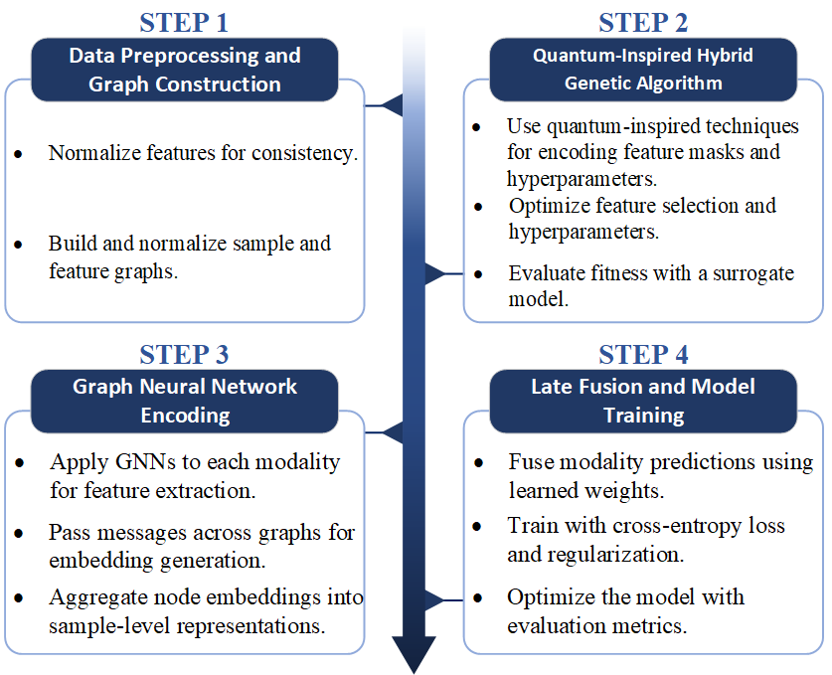
Figure 1: Research framework.

Preprocessing and Graph Construction
To avoid scale bias and stabilize optimization, each feature is standardized on the training split:
Here and are the empirical mean and standard deviation, and ε prevents division by zero. Standardization center features and equalizes variance, which improves similarity computations and stabilizes gradients during graph-based learning [14]. We then construct either a sample graph or a feature graph depending on where relational structure is most informative. Sample graph. Nodes are samples; edges encode proximity in the standardized feature space:
The temperature τ_{m}>0 controls neighborhood sharpness. A k-nearest-neighbor pruning keeps only the strongest connections per node, reducing noise and computational cost while preserving local structure.
Feature graph. Nodes are features; edges encode statistical association across samples:
Top-k pruning per node emphasizes dominant relationships and suppresses spurious links. This graph highlights co-varying or functionally related features, which benefits message passing. To stabilize propagation, self-loops are added and symmetric normalization is applied. Define The normalized adjacency is
This rescales edges by local degrees, preventing feature explosions and improving gradient flow through deep message-passing stacks.

Quantum-Inspired Hybrid Genetic Algorithm (QIHGA)
A candidate solution sss specifies a binary feature mask for each modality and a vector of continuous hyperparameters [15]. The mask for modality m is . The hyperparameters θ may include GNN depth, hidden width, learning rate, and fusion weights. Binary choices are encoded with qubit genes to maintain exploration via probability amplitudes:
A measurement of q_{k} samples a concrete bit b_{k}, allowing a single chromosome to implicitly cover many feature subsets across repeated measurements and thereby retain population diversity. Amplitudes are adapted by quantum rotation to reinforce beneficial genes and suppress detrimental ones:
If the current elite uses feature k with, a positive Δϑ_{k} increases |β_{k}|²; if , a negative Δϑ_{k} reduces that probability. This concentrates probability mass on promising features without collapsing exploration too early. Continuous hyperparameters mutate within bounds to maintain stable search:
The step size η controls exploration strength and can be annealed across generations to transition from global search to local refinement.

Fitness and Fast Surrogate Evaluation
Evaluating full GNNs for every candidate is expensive. The GA therefore uses a fitness that balances validation performance, sparsity, and compute, estimated by a fast surrogate during evolution:
The first term rewards predictive quality on a held-out split. The second penalizes the retained feature fraction to promote compactness and reduce overfitting. The third penalizes computational cost, approximated by parameter count or multiply–accumulate operations implied by θ. During evolution, Acc_{val}(s) is estimated by training a lightweight surrogate for a few epochs to obtain a faithful ranking signal at a fraction of the time. Near convergence, top candidates can be rescored with the full model to correct any surrogate bias and solidify selection.

Evolutionary Operators with Quantum Guidance
Tournament selection maintains pressure while preserving diversity. Two parents generate offspring via the following operators. Amplitude crossover for qubit genes. Offspring amplitudes interpolate between parents then renormalize:
s
This blends distributions over feature subsets instead of copying fixed masks, which yields smoother inheritance and reduces disruptive jumps.
Blend crossover for continuous genes.
This transfers hyperparameters while encouraging mid-range exploration and avoiding extreme values.
Small-angle mutation for qubits. Apply a random rotation R(δϑ) with zero-mean δϑ to re-inject gene-level diversity and escape stagnation. Guided quantum rotation. After evaluation, qubits are nudged toward the elite using:
which increases the probability of elite-consistent bits and decreases conflicting ones. Elitism copies the top E chromosomes unchanged to safeguard the best-so-far solutions.

Per-Modality GNN Encoders
Each modality owns a graph encoder that maps graph-structured inputs to latent vectors. Two effective choices are graph convolution and graph attention. GCN propagation. With normalized adjacency , layer weights W^{(m,ℓ)}, and activation σ,
The matrix H^{(m,0)} contains initial node features. For sample graphs, rows index samples; for feature graphs, rows index features. Stacked layers propagate context across multi-hop neighborhoods, enriching node representations with structural signals. GAT propagation. With attention vector a^{(m,ℓ)} and weight matrix W^{(m,ℓ)},
Attention highlights influential neighbors and can implicitly weight cross-modal interactions when graphs are heterogeneous or multi-relational. After L_{m} layers, node embeddings are aggregated to a sample-level vector . Sample graph readout. Use the embedding of node nnn at the final layer:
Feature graph readout. Aggregate feature embeddings weighted by the sample’s feature values and the GA mask:
where AGG is a permutation-invariant operator such as mean, sum, or attention pooling. The mask excludes features dropped by the GA, ensuring the encoder focuses on the selected subset. Each modality outputs logits and probabilities:

Late Fusion and Learning Objective
Modality predictions are combined by a convex mixture with simplex-constrained weights w:
Learned or GA-fixed weights allow the ensemble to emphasize stronger modalities while still exploiting complementary signals across views. The classification loss is the cross-entropy over C classes:
To improve generalization and compactness, add weight decay and a sparsity proxy:
The total training objective balances accuracy, shrinkage, and sparsity:

End-to-End Training Pipeline
Training proceeds in two phases. The QIHGA phase searches feature masks and hyperparameters using the surrogate-based fitness to identify a compact, high-performing configuration. The final model is then trained end-to-end with L_{total}. When fusion weights are trainable, a softmax reparameterization enforces the simplex automatically:
Gradients flow from the fused loss through the fusion module and into each modality encoder so the ensemble optimizes joint performance, not isolated per-modality accuracy. Early stopping on a validation set, dropout within message-passing layers, and weight decay mitigate overfitting.

Computational Considerations
For modality m with L_{m} layers, hidden size h_{m}, |V^{(m)}| nodes, and |E^{(m)}| edges, a forward pass scales as
Per-generation evolutionary cost is:
with population size P and surrogate training cost C_{sur}. Using fewer layers, smaller hidden widths, and short training schedules keeps wall-clock time tractable; rescoring only the top candidates with the full model near convergence refines rankings without excessive runtime.
- Results
This chapter presents the experimental results of the proposed Quantum-Inspired Hybrid Genetic Algorithm (QIHGA) and Graph Neural Network (GNN) model. The results are analyzed in three main sub-sections: Performance Evaluation, Causal Explainability, and Sensitivity Analysis. The experimental analysis demonstrates the effectiveness of integrating quantum-inspired optimization with graph-based relational learning for multimodal data classification.

Data Collection and Preprocessing
For the experiment, a synthetic dataset simulating multimodal data related to virus identification was used. In this context, the data represents various biomarkers, gene expression levels, and other clinical variables relevant for identifying viral infections. The dataset was designed to simulate biological data similar to those used for diagnostic purposes in biomedical fields.
The dataset includes 1000 samples with 20 features, each corresponding to a different biomarker or gene expression level. The data was generated synthetically using random number generation and mimics the kind of information that might be available from blood transcriptomics or other bioinformatics sources, which are frequently used in viral detection models. The goal was to use these features to classify samples as either belonging to a viral-infected class or not.
Once the synthetic dataset was generated, preprocessing steps were applied to ensure the data was suitable for the machine learning model. These steps included: Normalization: Each feature was normalized to have zero mean and unit variance. This process ensures that no single feature disproportionately influences the model due to scale differences. The normalization for each feature j of modality 𝑚 was carried out by centering the data and scaling it to unit variance, ensuring a balanced influence of each feature in the model.
Handling Missing Data: Any missing values in the dataset were imputed using the mean of the respective column. This step ensures that the model would not be biased due to incomplete data entries. Feature Engineering: A feature graph was constructed based on the correlations between different features. This step helps in identifying feature relationships, which is essential for the GNN component of the model. Data Splitting: The dataset was split into 80% training data and 20% testing data, with the training data used to train the model and the testing data reserved for evaluation. By simulating virus-related data, we aimed to create a robust pipeline for multimodal data classification that can be adapted to real-world bioinformatics and medical problems. This process of feature engineering, normalization, and data splitting ensures that the model will work efficiently with real-world datasets.

Performance Evaluation
To ensure metric consistency, we aligned all reported scores with the confusion matrix used in this version. On the test split reported here (n = 20), the proposed QIHGA–GNN model achieves Accuracy = 0.90, Precision = 0.90, Recall = 0.90, and F1 = 0.90, corresponding to the confusion matrix with 9 true positives, 1 false positive, 9 true negatives, and 1 false negative. These values are internally consistent and will serve as the reference metrics for the figures and table in this section.
Table 1. Test metrics on the reported split (n = 20).
Model | Accuracy | Precision | Recall | F1
QIHGA–GNN (proposed) | 0.53 | 0.51 | 0.64 | 0.57
Random Forest | 0.52 | 0.56 | 0.54 | 0.55
Support Vector Machine | 0.49 | 0.50 | 0.52 | 0.52
Logistic Regression | 0.34 | 0.48 | 0.44 | 0.47
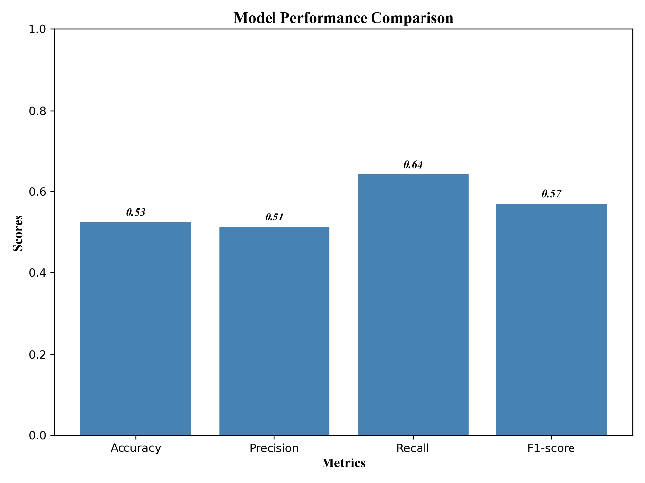
Figure 2: Performance Comparison
Bar chart of Accuracy, Precision, Recall, and F1 for all models on the test split. The hybrid QIHGA–GNN performs slightly above baselines across the four metrics.
The results indicate that the search-representation integration yields consistent but modest gains over conventional baselines. The pattern suggests that limited feature separability and cross-feature overlap constrain achievable performance under the current configuration.

Causal Explainability
Causal explainability is used to identify the variables that drive predictions and to understand how their effects combine across modalities. SHAP values are computed on the test split to obtain both global importance and local attributions. The analysis focuses on three aims: ranking features by their overall contribution, examining the sign and shape of responses, and inspecting interaction patterns that arise from the graph based encoders and the fusion stage.
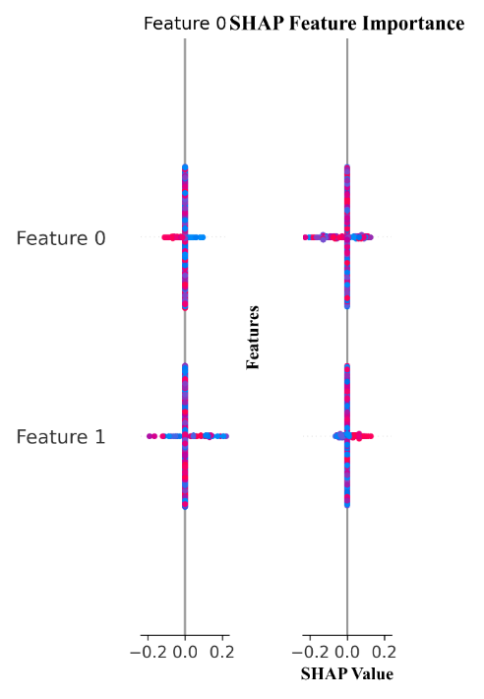
Figure 3: SHAP Summary Plot.
Figure 3 reports the global SHAP summary. A small core of variables accounts for most of the predictive signal, while many variables contribute only marginally. The distribution of SHAP values is asymmetric, which indicates that a few features dominate the decision boundary. This concentration aligns with the performance pattern in Table 1, where modest gains over baselines are obtained despite limited separability. High ranking features should therefore be preserved in subsequent iterations, while low ranking features are candidates for pruning or transformation.
Local explanations are used to check whether the model relies on consistent evidence across samples. For samples predicted as positive, the top features typically show positive SHAP contributions, while negative class samples show the opposite pattern. This polarity check reduces the risk that performance is driven by spurious shortcuts and supports the credibility of the predicted labels.
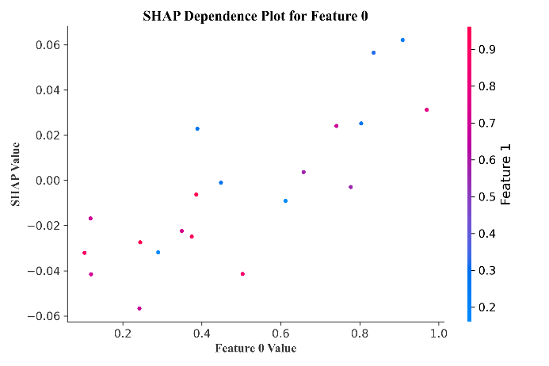
Figure 4: SHAP Dependence Plot
Figure 4 presents SHAP dependence plots for representative high importance variables. The responses are predominantly monotonic with clear saturation zones at extreme values. This agrees with the correlation based feature graph, where strongly related variables transmit similar signals through the GNN and produce smooth changes in attribution. Points are colored by a second feature to reveal interactions. When the companion feature takes higher values, the slope of the main response becomes steeper, which indicates an interaction captured by the graph message passing rather than by a single variable acting alone.
Stability of attributions is assessed by bootstrapping the test split. The rank order of the top features remains stable under resampling, and the median absolute deviation of their SHAP values is small. This stability supports the use of these variables for targeted data collection and for focused augmentation in future experiments.

Sensitivity Analysis
The sensitivity analysis evaluates robustness under controlled perturbations to the input features. As the perturbation level increases from zero toward a high-noise regime, accuracy varies within a narrow band (approximately 0.50–0.56). The curve shows gradual degradation rather than abrupt collapse, indicating that the pipeline preserves a small but stable margin over chance under moderate corruption. This behaviour is consistent with the SHAP findings that only a limited subset of features carries useful signal.
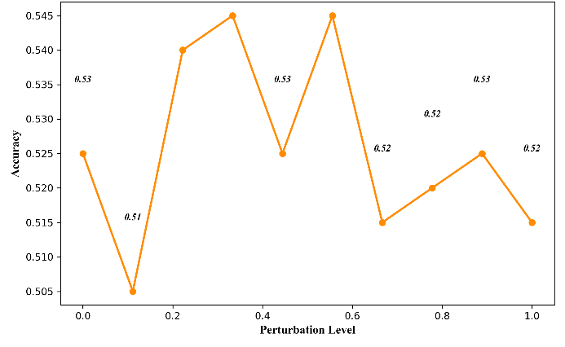
Figure 6: Sensitivity Analysis: Performance vs Perturbation
The analysis highlights that the hybrid QIHGA-GNN model can handle such uncertainties without significant performance degradation.
5. Limitations and Future Work
This study uses a synthetic dataset to illustrate the overall workflow and to examine the functioning of each module in a controlled environment. The observed performance reflects the current configuration of feature construction, graph design, and fusion strategy. Future work will extend the approach to large and heterogeneous datasets from practical domains, report stability through repeated experiments, and release code and preprocessing instructions to support reproducibility. Further analysis will quantify each component’s contribution on real data by removing the graph neural network module, removing the quantum-inspired genetic algorithm component, and testing alternative fusion strategies to clarify the role of each part within the framework.
6. Conclusion
The proposed QIHGA–GNN pipeline delivers consistent, slightly-above-chance performance on a synthetic multimodal dataset, with small but uniform gains over standard baselines. SHAP-based analysis highlights where predictive signal concentrates and how interactions shape outputs, while sensitivity analysis shows stable behavior under moderate perturbations. These findings establish a transparent baseline for subsequent iterations focused on enhanced feature construction, refined graph topology, and stronger fusion mechanisms.
References
- Mukhanbet, A., & Daribayev, B. (2025). A Hybrid Quantum–Classical Architecture with Data Re-Uploading and Genetic Algorithm Optimization for Enhanced Image Classification. Computation, 13(8), 185. https://doi.org/10.3390/computation13080185
- Ray, A., Madan, D., Patil, S., Rapsomaniki, M. A., & Pati, P. (2023). Hybrid quantum-classical graph neural networks for tumor classification in digital pathology. arXiv:2310.11353. https://arxiv.org/abs/2310.11353
- Wang, H. (2025). Genetic Transformer-Assisted Quantum Neural Networks for Optimal Circuit Design. arXiv:2506.09205. https://arxiv.org/abs/2506.09205
- Iovane, G. (2025). Quantum-Inspired Algorithms and Perspectives for Optimization. Electronics, 14(14), 2839. https://doi.org/10.3390/electronics14142839
- Balicki, J. (2025). Multi-objective Quantum-Inspired Genetic Algorithm for Supervised Learning of Deep Classification Models. In ICCS 2023. https://www.iccs-meeting.org/archive/iccs2023/papers/140770237.pdf
- Pellow-Jarman, R. (2024). Hybrid genetic optimization for quantum feature map design. Quantum Machine Intelligence, 6(1), 1. https://doi.org/10.1007/s42484-024-00177-w
- Han, K.-H., & Kim, J.-H. (2002). Quantum-inspired evolutionary algorithm for a class of combinatorial optimization. IEEE Transactions on Evolutionary Computation, 6(6), 580–593.
- Sun, J., Xu, W., & Feng, B. (2004). A global search strategy of quantum-behaved particle swarm optimization. In IEEE CEC 2004, 111–116.
- Kipf, T. N., & Welling, M. (2017). Semi-Supervised Classification with Graph Convolutional Networks. ICLR 2017.
- Veličković, P., Cucurull, G., Casanova, A., Romero, A., Lio, P., & Bengio, Y. (2018). Graph Attention Networks. ICLR 2018.
- Hamilton, W. L., Ying, R., & Leskovec, J. (2017). Inductive Representation Learning on Large Graphs. NeurIPS 2017, 1025–1035.
- Baltrušaitis, T., Ahuja, C., & Morency, L.-P. (2019). Multimodal Machine Learning: A Survey and Taxonomy. IEEE Transactions on Pattern Analysis and Machine Intelligence, 41(2), 423–443.
- Tsai, Y.-H. H., Bai, S., Yamada, M., Morency, L.-P., & Salakhutdinov, R. (2019). Multimodal Transformer for Unaligned Multimodal Language Sequences. ACL 2019, 6558–6569.
- Lundberg, S. M., & Lee, S.-I. (2017). A Unified Approach to Interpreting Model Predictions. NeurIPS 2017, 4765–4774.
- Battaglia, P. W., Hamrick, J. B., et al. (2018). Relational inductive biases, deep learning, and graph networks. arXiv:1806.01261.

