 ***Database Management System***

***UE21CS351A***

**PROJECTREPORT**

***PES CANTEEN PRE-BOOKING SYSTEM***

|  |  |  |
| --- | --- | --- |
| ***SEMESTER:* 5** |  |  |
| ***SECTION:* A** |  |
| ***TEAM NUMBER:* 23** |  |
| ***TEAM:*** | ***SRN:*** |
| ***1. AARYAN SHETTY*** |  | ***PES1UG21CS010*** |
| ***2. ADITHYA MAHESH*** |  | ***PES1UG21CS032*** |

1. ***Mini World/Application Description:***

The Canteen Prebooking Management System is a web application designed to streamline the process of ordering food from various canteens within a university campus. It caters to both customers and canteen owners, providing a user-friendly interface for placing orders, managing menus, and handling transactions. Users can log in, view menus from different canteens, place orders, and confirm them. Canteen owners have additional functionalities, including viewing current orders, adding menu items, and tracking total sales.

By implementing a canteen pre-booking system, the project aims to:

Reduce Overcrowding: By allowing users to pre-order food, the system aims to reduce long queues and overcrowding in the canteens during peak hours.

Save Time: Users can save valuable time by pre-booking their meals, minimizing waiting times and allowing for quick and convenient meal pickups.

Enhance Ordering Convenience: The system will make it easier for users to browse menus, place orders, and make payments through a user-friendly interface, accessible via web.

Improve Canteen Management: Canteen staff will benefit from streamlined order processing and better inventory management, leading to increased efficiency and reduced wastage.

1. ***User Requirement Specification :***
2. Customer Requirements:
3. User Authentication:

* Users (both customers and canteen owners) can log in using their credentials (email and password).
* New users can sign up by providing necessary details.

1. Customer Functions:

* Customers can view menus from different canteens.
* Customers can place food orders by selecting items and specifying quantities.
* Confirmation of placed orders is available to customers.

1. Canteen Owner Requirements:
2. User Authentication:

* Users (both customers and canteen owners) can log in using their credentials (email and password).
* New users can sign up by providing necessary details.

1. Canteen Owner Functions:

* Canteen owners can view the current orders for their canteens.
* Canteen owners can add new menu items with details such as item name, description, and price.
* Total sales for a canteen can be viewed by canteen owners.

1. Order Management:
2. Placed Orders:

* Placed orders are stored in a database with relevant details.

1. User Confirmation:

* Users (customers) can confirm placed orders.

1. ***List of Functionalities of the Application:***
2. Login and Signup:

* Users can log in with their credentials.
* New users can sign up by providing necessary information.

1. Customer Functions:

* Customers can view menus from different canteens.
* Customers can place food orders by selecting items and specifying quantities.
* Confirmation of placed orders is available to customers.

1. Canteen Owner Functions:

* Canteen owners can view the current orders for their canteens.
* Canteen owners can add new menu items with details such as item name, description, and price.
* Total sales for a canteen can be viewed by canteen owners.

1. Order Management:

* Placed orders are stored in a database with relevant details.
* Users (customers) can confirm placed orders.

1. User Management:

* Users can be deleted from the system.

1. Database Interaction:

* The system interacts with a MySQL database to store and retrieve user data, menus, orders, and other relevant information.

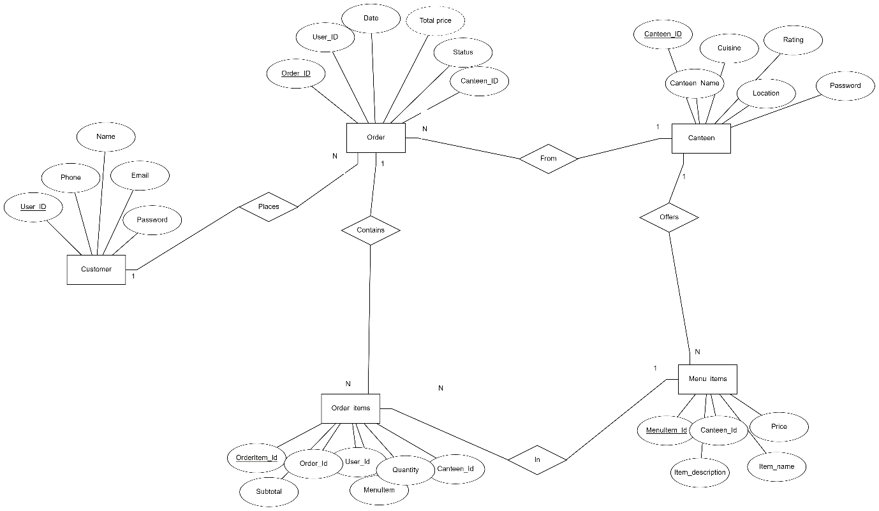***4. ER DIAGRAM***

***5. RELATIONAL SCHEMA:***

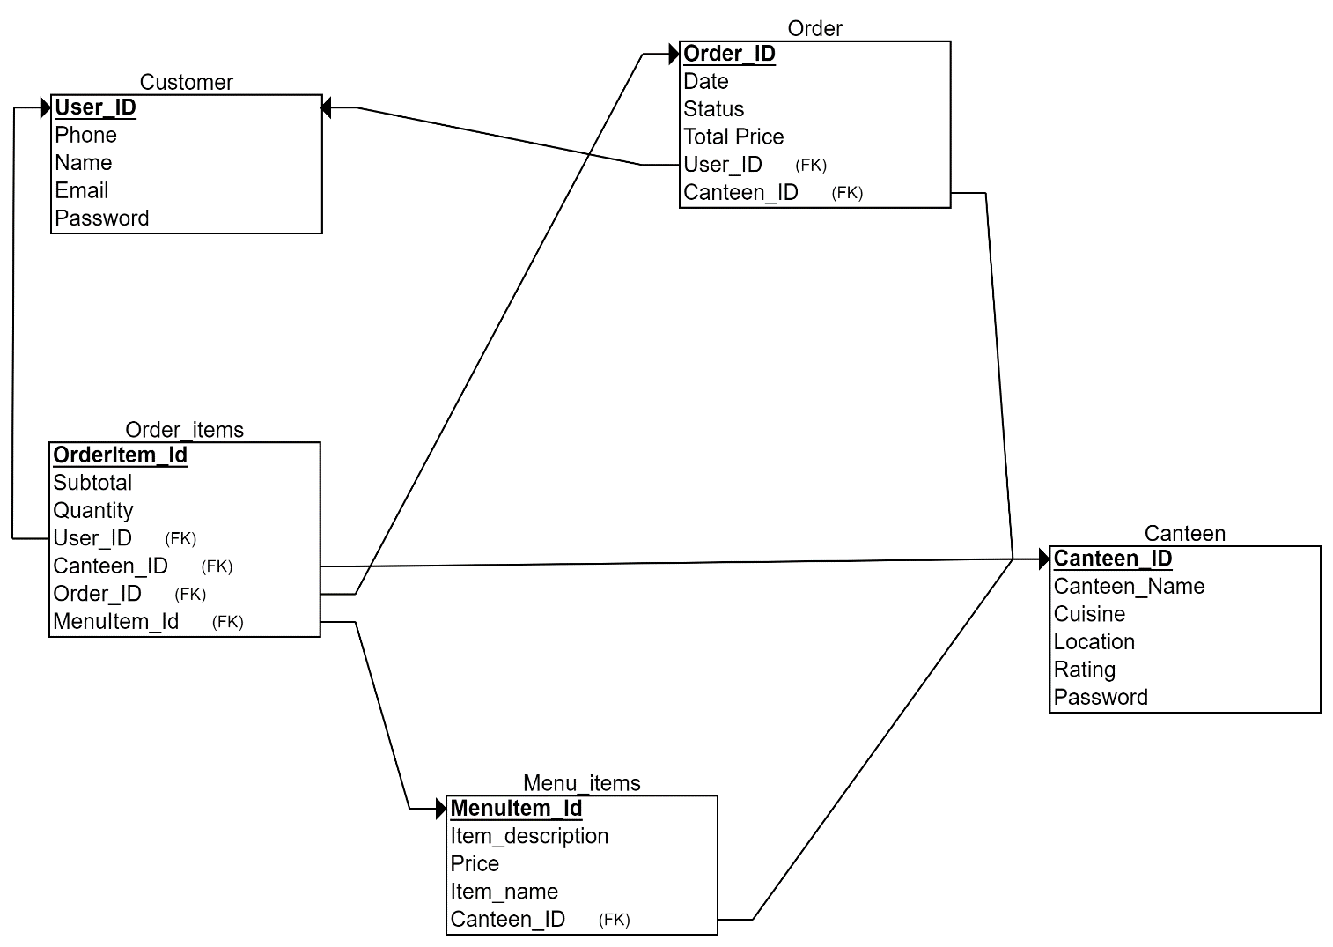

* + 1. ***SCREENSHOTS ACCORDING TO THE RUBRICS:***

1. 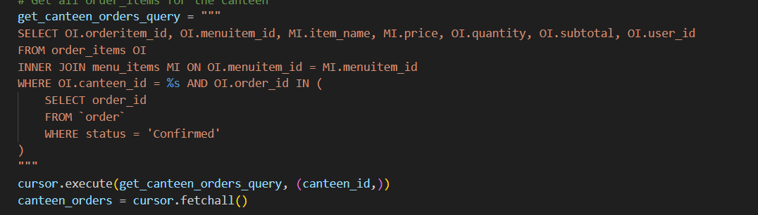NESTED QUERY:
2. JOIN QUERY;

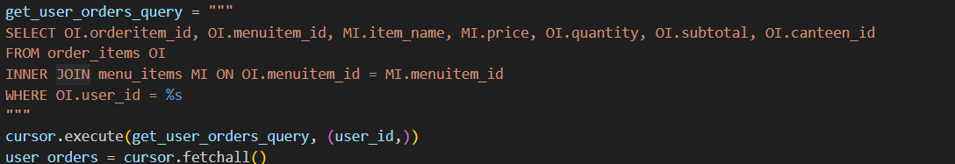

1. AGGREGATE QUERY:

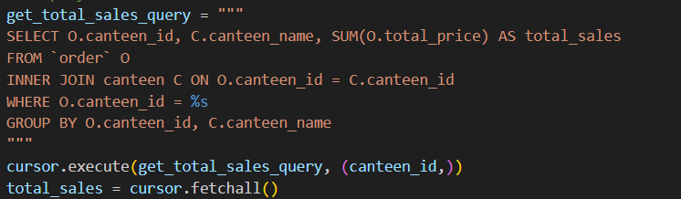

1. TRIGGERS:

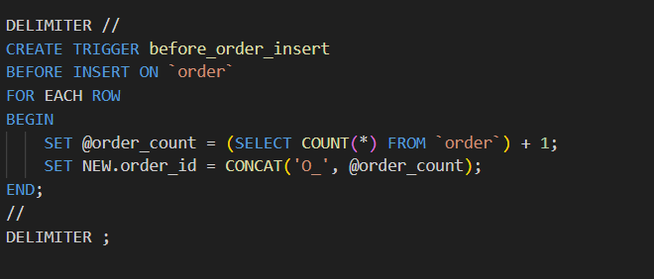

1. PROCEDURES:

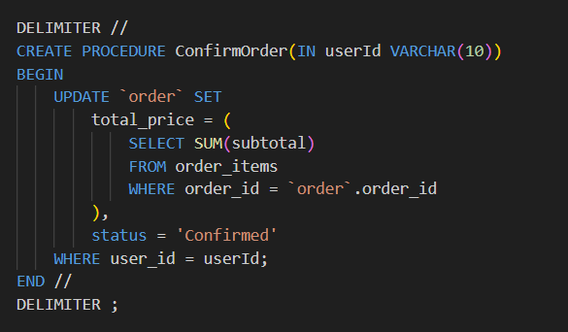

1. FUNCTIONS:

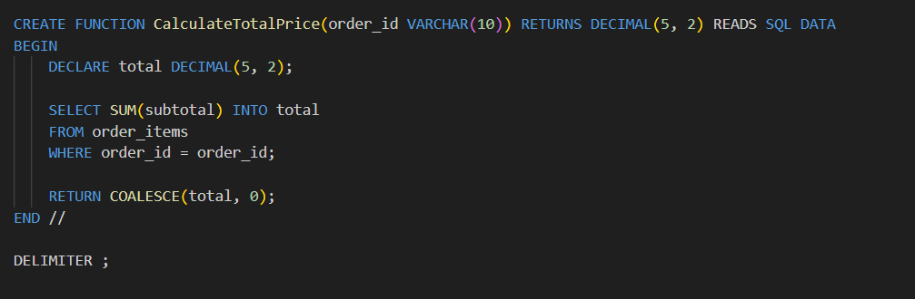

1. ***SCREENSHOTS:***

