CIE
COPYRIGHT INFORMATION EXTRACTION FORM
TITLE: AMOT: Ransomware & Forensics Analyser
SCHOOL: Chitkara University, Rajpura, Punjab
DETAIL OF THE STUDENT/MENTOR WHO UPLOADED THE COPYRIGHT ON GOVT PORTAL NEED TO SHARE LOGIN AND PASSWORD WITH MENTORS
Name: Aaryan Shyam
Roll No/ Employee Code: 2210991121

All MEMBERS DETAILS INCLUDING SUPERVISOR
NAME | EMP CODE/ROLL | ADDRESS WITH EMAIL AND MOBILE NO.
Aaryan Shyam | 2210991121 | aaryan1121.be22@chitkara.edu.in
Dr. Preeti Saini | Mentor | preeti.saini@chitkara.edu.in

ABSTRACT
  - Problem Background
Ransomware and other forms of malicious software have evolved significantly in both complexity and sophistication over the past decade, making them increasingly difficult to detect using traditional cybersecurity mechanisms. Conventional antivirus systems primarily rely on signature-based detection techniques, which involve identifying known patterns or hashes of previously discovered malware. While effective against established threats, this approach fails when confronted with zero-day attacks, polymorphic malware, or obfuscated payloads that continuously change their signatures to evade detection.
Moreover, modern enterprise environments generate an overwhelming volume of security alerts from intrusion detection systems, endpoint protection tools, and network monitoring platforms. A large proportion of these alerts are false positives, which leads to alert fatigue among security analysts.
Therefore, there is a strong and urgent requirement for an intelligent, multi-layered analysis system that can evaluate suspicious files using diverse methodologies.

  - Objective of the Project
The primary objective of this project is to design and develop an advanced ransomware detection and forensic analysis platform capable of providing accurate, fast, and automated threat evaluation. The system aims to eliminate the need for manual, time-consuming investigation processes by integrating multiple detection mechanisms into a single cohesive pipeline.
Specifically, the platform is intended to analyse suspicious files by leveraging machine learning algorithms for predictive behaviour analysis, YARA-based rule matching for signature detection, and online threat intelligence sources for reputation verification.
Another key objective is to enhance decision-making efficiency for cybersecurity analysts by presenting results in a clear, structured, and interpretable format. The system will generate detailed reports that include threat classification, confidence scores, and actionable insights, thereby enabling rapid response and mitigation strategies

1.3 Proposed Solution / System Overview
The proposed system is designed as a multi-stage analytical pipeline that processes each uploaded file through a sequence of well-defined detection mechanisms. This layered architecture ensures comprehensive evaluation by examining both the static properties and dynamic behaviour of the file.
The first stage involves static analysis, where the internal structure of the file is inspected without executing it. This includes examining file headers, metadata, entropy levels, and embedded resources to identify anomalies or suspicious patterns. Following this, a machine learning model—trained using supervised learning techniques—analyses extracted features to predict the likelihood of malicious behaviour based on historical data.
The third stage utilizes YARA rule-based pattern matching to detect known malware signatures. YARA rules are highly customizable and allow the system to identify specific byte patterns, strings, or structural indicators associated with malware families.
Finally, the system performs an OSINT (Open-Source Intelligence) check by querying public threat intelligence databases using the file’s cryptographic hash. This step helps verify whether the file has been previously reported as malicious or benign by the global security community.

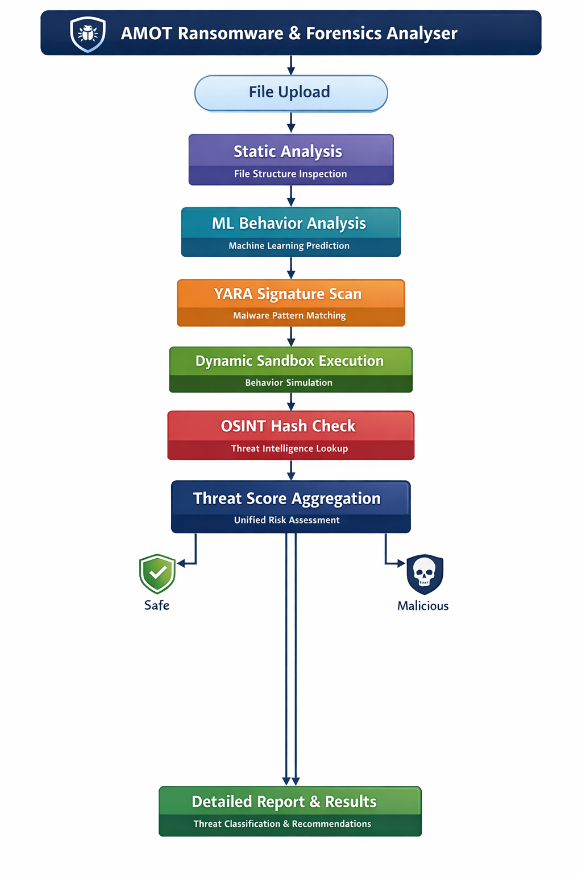

1.5 Technology / Method Used
The system architecture is built upon a robust and scalable technology stack designed to support high-performance analysis and seamless user interaction. The backend is developed using Python 3.10 in conjunction with the Fast API framework, which provides asynchronous request handling and high throughput for concurrent file analysis operations.
For data persistence, SQLite is utilized as a lightweight relational database to store historical analysis records, including file metadata, threat scores, and detailed reports. This enables traceability, auditing, and future reference for security investigations.
On the frontend, the user interface is implemented using React.js, which allows for dynamic and responsive component-based design. Framer Motion is incorporated to enhance user experience through smooth animations and transitions,
From a detection standpoint, multiple specialized libraries and frameworks are integrated. YARA-Python is employed for signature-based malware detection, enabling rule-based scanning of file contents. Feature extraction is performed using Pandas and NumPy, which facilitate efficient manipulation and analysis of structured data derived from file attributes.
Additionally, Python’s subprocess module is used to execute files in a controlled sandbox environment, ensuring safe behavioural observation. The Requests library is utilized to interact with external APIs for OSINT-based hash lookups, allowing the system to retrieve real-time threat intelligence from publicly available databases

1.6 Expected Outcome & Benefits
The implementation of this system is expected to significantly reduce the time required for malware detection and analysis, transforming what traditionally takes several minutes into a process that can be completed within seconds. By automating complex analysis tasks, the system minimizes human intervention and reduces the likelihood of errors or oversight.
Security analysts will benefit from a comprehensive yet easy-to-understand report that includes a quantified threat score, classification of the file (e.g., benign, suspicious, malicious), and recommended mitigation actions.
Organizations adopting this platform will gain improved protection against ransomware attacks by identifying threats at an early stage, thereby preventing lateral spread and potential data breaches. Furthermore, the system maintains a detailed log of all analysed files, which can be used for compliance reporting, forensic investigations, and auditing purposes.

1.7 Original Contribution Statement
The uniqueness of this project lies in its integrated approach to malware detection, where multiple analytical techniques are combined into a single unified framework. Unlike conventional tools that rely solely on either signature-based detection or behavioural analysis, this system incorporates machine learning, YARA rule matching, sandbox simulation, and real-time threat intelligence within a cohesive pipeline.
This hybrid methodology enables the detection of both known and unknown threats, improving overall detection accuracy and reducing false positives. Additionally, the system consolidates results from different analysis stages into a single, interpretable output, eliminating the need for analysts to manually correlate data from multiple tools.
By bridging the gap between advanced detection capabilities and user-friendly design, this project delivers a comprehensive and practical solution for modern cybersecurity challenges.

Result
