The Open Source Audit

A Capstone Project — Open Source Software Course Software Under Audit: Git

Student Name : Aarya Yasholaxmi Thakur
Registration Number : 24bce10871
Slot : B22
GITHUB: https://github.com/aaryathakur11/Open-Source-Audit-Project

VITyarthi | Units 1–5 | Max Marks: 100

Part A — Origin and Philosophy

A1. The Problem Git Was Created to Solve
To understand why Git exists, you have to go back to 2005 and understand the frustration that gave birth to it. Linus Torvalds, the creator of the Linux kernel, was managing one of the most complex and collaborative software projects in the world. Thousands of developers across dozens of countries were contributing patches to the kernel, and the project needed a version control system to track every change, every author, and every history branch.
The team had been using BitKeeper — a proprietary, commercial version control tool that had been made available to the Linux project for free as a goodwill gesture from its maker, BitMover. This arrangement worked for a few years, but it was always uncomfortable for a community built on the principles of free software to depend on a proprietary tool. The relationship collapsed in April 2005 when BitMover revoked the free licence after a Linux developer was found to be working on a tool to reverse-engineer the BitKeeper protocol. The Linux kernel project was suddenly left without a version control system.
Linus Torvalds responded by doing what he does best: he wrote one himself. In roughly ten days, he designed and built the first working version of Git. His goals were clear from the beginning: speed, simplicity, strong support for non-linear development (thousands of parallel branches), full distribution so that every developer has a complete copy of the project history, and the ability to handle large projects like the Linux kernel efficiently.
The name 'Git' is a British slang term for a stupid or unpleasant person — Torvalds has said he named it after himself, following the same logic he used when naming Linux. The deeper point is that Git was not built for commercial gain or as a startup idea. It was built out of necessity, out of the failure of proprietary software to serve an open-source community, and it was released under the GPL so that it could never be taken away in the same manner that BitKeeper had been.
This origin story captures something essential about the open-source philosophy: the best open-source tools often emerge not from corporate R&D departments but from real problems faced by real communities. Git solved a concrete problem and was shared freely so that anyone who faced the same problem could benefit from the solution.

A2. The Licence — What It Actually Says
Git is licensed under the GNU General Public Licence version 2 (GPL v2). This is one of the most important and widely used open-source licences in the world, the same licence that covers the Linux kernel itself.

The Four Freedoms of Free Software
The Free Software Foundation defines four essential freedoms that a licence must grant for software to be considered truly free:

s to the sourc
Freedom 0 | The freedom to run the program for any purpose.
Freedom 1 | The freedom to study how the program works and to modify it to suit your needs. Acces
Freedom 2 | The freedom to redistribute copies so you can help others.
Freedom 3 | The freedom to distribute copies of your modified versions to others. This allows the wh

ole community

The GPL v2 licence that covers Git grants all four of these freedoms. You can run Git for any purpose, study its source code, modify it, and distribute your modified versions. The key condition is the copyleft clause: if you distribute a modified version of Git, you must do so under the same GPL v2 licence and make the source code available. This is what makes the GPL a strong copyleft licence.

Can a company take Git, modify it, and sell it without sharing changes?
No. The GPL v2 explicitly prevents this. If a company modifies Git and distributes the modified software to others — even as part of a commercial product — they are required to release the source code of their modifications under the GPL v2. This is the copyleft condition, sometimes described as 'viral' because it propagates to derivative works. A company can build a commercial service on top of Git (like GitHub does) without triggering this requirement, because they are not distributing the software itself — but if they distribute a modified Git binary, the source must come with it.

GPL vs MIT: The Key Difference
The MIT licence is a permissive licence. It allows anyone to take the software, modify it, and distribute it — even in proprietary form — with no requirement to share changes. The GPL is a copyleft licence that requires all derivatives to remain under the same licence. In practice this means MIT-licensed software can be incorporated into proprietary products, while GPL-licensed software cannot be distributed in a proprietary form without releasing the source.
If I were building something I wanted to keep open forever — something I wanted to contribute to the shared commons of software — I would choose GPL. If I were building a library that I wanted to see adopted as widely as possible, including by commercial products, I might choose MIT. The choice depends on whether you prioritise community freedom (GPL) or maximum adoption (MIT).

Free as in Beer vs Free as in Freedom
'Free as in free beer' means zero cost — the software is available at no charge. 'Free as in freedom' means the user has the rights described by the four freedoms above. These are not the same thing. A company can give away software for free (no cost) while keeping the source code closed and restricting what you can do with it. Conversely, GPL-licensed software can technically be sold — the freedom is not about price, it is about rights. Git is free in both senses: it costs nothing and it grants full freedoms under the GPL v2.

A3. The Ethics of Open Source

Should All Software Be Open Source?

For: There is a compelling ethical argument that software, as a form of knowledge, should be freely shared. When software is open, it can be audited for security vulnerabilities, studied by students, improved by the global community, and adapted for uses the original author never imagined. The history of computing shows that the most foundational infrastructure — Linux, Git, the Apache web server, Python — was built openly. Proprietary software creates dependency, restricts access for those who cannot pay, and concentrates power in the hands of corporations.
Against: Not all software is infrastructure. Companies and individual developers need economic incentives to invest in research and development. A pharmaceutical company analogy applies: requiring all drug formulas to be open might slow innovation if there is no mechanism to recover the cost of research. For software, proprietary licensing provides a revenue model that funds the development of complex, expensive products. Additionally, some software handles sensitive data where public access to the source code could be a security liability as much as an asset.

Is It Ethical to Profit from Free Community Labour?
This is one of the most genuine ethical tensions in the open-source world. Companies like Red Hat, Google, and Meta derive enormous value from Linux and other community-built software. Red Hat has built a billion-dollar business on top of open-source software. Google runs its entire infrastructure on Linux. Is this exploitation?
I think the answer depends on what the company gives back. Red Hat, to its credit, employs hundreds of Linux kernel engineers, contributes code back upstream, and pays the salaries of major open-source maintainers. This is the model that works ethically. Where it breaks down is when a company takes open-source software, wraps it in a proprietary product, and contributes nothing back to the project that sustains them. The emergence of the AGPL licence and the 'source-available' movement is partly a response to this tension — an attempt to ensure that those who profit from a project also contribute to it.

Standing on the Shoulders of Giants
The phrase, originally from Isaac Newton, means that all progress builds on prior work. In software, this is literally true at every level. A Python script runs on an interpreter written in C, which was compiled with GCC, running on a Linux kernel, hosted on a machine managed with Bash — every layer is open source, every layer was built by developers who shared their work. Open source enables this kind of compounding progress because each contribution remains available to every future builder. Proprietary software, by contrast, requires each generation to recreate foundations that already exist, simply because they cannot access what was built before. Open source does not undermine original innovation — it accelerates it, by ensuring that no one has to solve the same problem twice.

Part B — Linux Footprint

This section documents how Git installs and lives on a Linux system, based on direct observation on an Ubuntu/Debian system (commands equivalent for RPM-based systems are noted where relevant).

Installation Method
Git is available in the default package repositories of virtually every major Linux distribution. On Debian/Ubuntu systems it is installed via the APT package manager:
sudo apt update && sudo apt install git
On RPM-based systems (Fedora, RHEL, CentOS):

sudo dnf install git
Git can also be compiled from source, which is the method used when a newer version than what is available in the distribution's repository is needed. The source is obtained from git-scm.com and compiled using standard GCC toolchain commands.

Key Directories
Path | Purpose
/usr/bin/git | The main Git binary — the executable users invoke
/usr/lib/git-core/ | Git's helper binaries (git-fetch, git-push, git-commit, etc.)
/usr/share/git-core/ | Shared templates, hooks, and documentation
/etc/gitconfig | System-wide Git configuration (applies to all users)
~/.gitconfig | Per-user Git configuration (name, email, aliases, preferences)
~/.config/git/ | XDG-standard alternative location for user config
.git/ (per repo) | Hidden directory inside each repository — stores all history, objects, refs,

config

User and Group
Git runs as the currently logged-in user — it does not have its own system user or group. This is appropriate for a developer tool: Git operations are performed on behalf of the user, under their permissions. The binaries in /usr/bin/ are owned by root with permissions 755, meaning any user can execute them but only root can modify them. The .git/ directory inside a repository is owned by the user who initialised the repository, which is correct for access control purposes.

Service Management
Git itself is not a daemon and is not managed as a systemd service in normal use. However, git daemon — a lightweight server for hosting public repositories — can be run as a service. For server deployments, the more common approach is to use SSH access with git over OpenSSH, which is managed as a standard systemd service:

sudo systemctl start sshd sudo systemctl enable sshd sudo systemctl status
sshd

Update Model
On distributions using APT, Git updates are delivered through the standard package update mechanism. Security patches released by the Git project are picked up by distribution maintainers, packaged, and made available through:
sudo apt update && sudo apt upgrade git
This is a key advantage of the open-source model: security vulnerabilities in Git can be discovered and audited by anyone reading the source code. When a vulnerability is found, a patch can be proposed, reviewed, merged, and distributed to every Linux system in the world within hours — a process that would take far longer in a proprietary model where only the vendor has access to the code.

Part C — The FOSS Ecosystem

Dependencies
Git is written primarily in C and shell scripts. Its key dependencies include:

Dependency | Role
OpenSSL / libssl | Provides cryptographic hashing (SHA-1/SHA-256) for object integrity
libcurl | Handles HTTPS transfers — fetching and pushing to remote repositories
zlib | Compression of packfiles that store repository history efficiently
PCRE2 | Optional — enables Perl-compatible regex in git grep
gettext | Internationalisation — allows Git messages in different languages
OpenSSH | The transport layer for git over SSH (most common remote protocol)

What Git Has Enabled
Git's impact on the software industry is difficult to overstate. It did not just solve a version control problem — it changed how software is built, reviewed, and shared across the entire world.
GitHub (2008): Built on top of Git, GitHub became the social network for developers. It turned version control into a collaboration platform and is now home to over 300 million repositories.
GitLab: An open-source, self-hosted alternative to GitHub. Companies that need to keep their code on their own infrastructure use GitLab, which is itself open source.
Gitea and Forgejo: Lightweight, self-hostable Git services written in Go — part of a growing movement to decentralise code hosting away from large platforms.
CI/CD Pipelines: GitHub Actions, GitLab CI, and Jenkins all integrate deeply with Git. Modern software delivery — the practice of automatically testing and deploying software every time code is committed — would not exist without Git's branching model.

Git and the LAMP Stack
Git underpins every layer of the LAMP stack in practice. Linux servers running Apache web servers are deployed and updated using Git-based workflows. MySQL database schemas and migration files are version-controlled in Git. PHP and Python application code is managed in Git repositories. Git is not a component of LAMP in the traditional acronym sense, but it is the invisible infrastructure through which all LAMP components are developed, tested, and deployed.

Community and Governance
Git's development is coordinated through a public mailing list: git@vger.kernel.org. This is one of the oldest forms of open-source collaboration — patches are emailed to the list, reviewed

publicly, and merged by the maintainer. Junio C Hamano has been Git's primary maintainer since 2005, when Linus Torvalds handed over the role shortly after the initial release. The project holds an annual developer summit, and contributions come from thousands of developers worldwide, including many who are employed by companies like Google, Microsoft, and Atlassian specifically to contribute to Git.

Part D — Open Source vs Proprietary Comparison

The closest proprietary alternative to Git is Perforce Helix Core (formerly Perforce), a centralised version control system widely used in game development and large enterprise settings. The comparison below is honest about the trade-offs.

with number of nsd. sPaetncthireslyaorne

abteilditysudpepoerntdtesa
Dimension | Git (Open Source) | Perforce Helix Core (Proprietary)
Cost | Free. No licence fee for any use. | Commercial licence required. Costs scale
Security (code audit) | Source code is fully public. Any security research | eSr owuorcrledwcioddeeciasnpraoupdriteGtairtyf.oSr evuclunreitryadbeiliptie
Support & Reliability | Community support via mailing lists, Stack Overfl | oPwa,idanedntGeirtpHruisbe. sNuoppgouratrwanittheeSdLASsL.AD. eRdeilci
Freedom to Modify | Full freedom under GPL v2. Any developer can fo | rNk,omfroedeidfyo,mantod mreoddisiftyri.bSuoteurGciet.code is not
Community vs Corporate Control | Governed by community consensus. No single co | mCopnatnryolcleodnternotlsireGlyit'bsydPirecrftoiorcne. CShoaftnwgaerse.a
Handling Large Binaries | Git struggles with very large binary files (video, 3 | DPaesrsfoertcse). eGxict eLlFs Sathlealrpgse bbuint ardydfsilecso.mTphliesx

available. User

Treheprcoopmospeadn,ydde

iistyw. hy game stu

Verdict
For any general software development use case — web development, application development, data science, or open-source projects — Git is the clear choice. It is free, universally supported, works with every tool and platform, and has the backing of the entire software industry. The network effect alone makes it the right choice: every developer already knows Git, every IDE integrates with it, and every CI/CD platform is built for it.
Perforce has a genuine advantage in specific scenarios: game studios handling hundreds of gigabytes of binary assets, enterprises with very large codebases that need fine-grained file locking, and organisations that require guaranteed vendor support. In those contexts, the cost and proprietary nature of Perforce can be justified.
As for contributing: yes, I would contribute to Git. The project is well-maintained, the codebase is written in C (approachable for systems programmers), and a contribution to Git — a tool used by over 90% of professional developers worldwide — is a contribution to every software project on earth.

Shell Scripts — Documentation

Script 1 — System Identity Report
File: script1_system_identity.sh
Shell concepts used: Variables, echo, command substitution $(), output formatting.

What it does and how it works:
This script collects key system information using command substitution — wrapping commands in $() to capture their output into variables. It gathers the kernel version with uname -r, the distribution name by parsing /etc/os-release, the current user with whoami, system uptime with uptime -p, and the current date and time using date. All values are stored in named variables and displayed in a formatted table using echo. The script also prints a note about the GPL v2 licence under which the Linux kernel is distributed, connecting the technical output to the course's philosophical themes.

Script code (abridged — see .sh file for full version with comments):
#!/bin/bash STUDENT_NAME="Aarya Yasholaxmi Thakur" KERNEL=$(uname -r)
DISTRO=$(cat /etc/os-release | grep PRETTY_NAME \
| cut -d= -f2 | tr -d '"') USER_NAME=$(whoami) UPTIME=$(uptime -p)
CURRENT_DATE=$(date '+%A, %d %B %Y')
OS_LICENSE="GNU General Public Licence v2" echo "Kernel : $KERNEL"
echo "Distro : $DISTRO" echo "User : $USER_NAME" echo "Uptime : $UPTIME" echo "Date : $CURRENT_DATE"
echo "Licence: $OS_LICENSE"
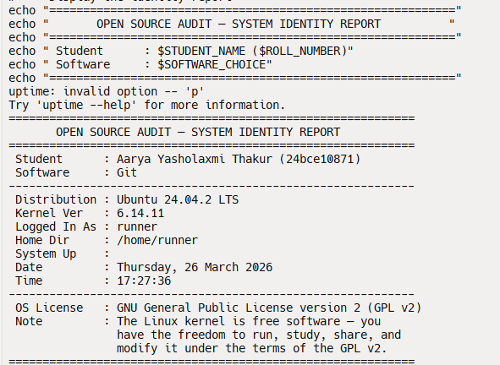

Script 2 — FOSS Package Inspector
File: script2_package_inspector.sh
Shell concepts used: if-then-else, case statement, rpm -qi / dpkg -s, pipe with grep.

What it does and how it works:
This script first detects which package manager is available on the system (rpm or dpkg) using the command -v test, then queries whether the target package (git) is installed. If found, it extracts key metadata — version, licence, and summary — using grep with the -E flag for extended regular expressions. A case statement then maps known package names to a short

philosophy note about each, demonstrating how conditional branching in shell scripts can produce meaningful, context-aware output rather than just mechanical data.

Script code (abridged — see .sh file for full version with comments):

#!/bin/bash PACKAGE="git"
if command -v rpm &>/dev/null; then
if rpm -q "$PACKAGE" &>/dev/null; then
rpm -qi "$PACKAGE" | grep -E 'Version|Licence' else
echo "$PACKAGE not installed" fi
fi
case "$PACKAGE" in
git) echo "Git: built when proprietary tools failed" ;; httpd) echo "Apache: the web server of the open internet" ;;
*) echo "An open-source contribution to the commons" ;;
esac

Terminal output:

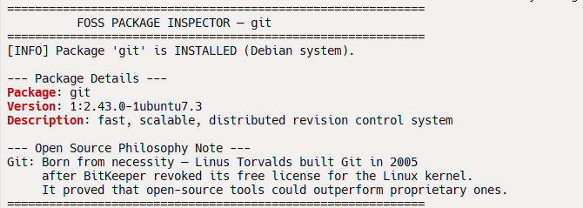

Script 3 — Disk and Permission Auditor
File: script3_disk_auditor.sh
Shell concepts used: for loop, arrays, du, ls -ld, awk, cut, -d directory test.

What it does and how it works:
This script defines an array of important Linux system directories and iterates over them using a for loop. For each directory, it first tests whether it exists using the -d flag, then uses ls -ld piped to awk to extract the permission string, owner, and group. du -sh provides a human-readable size estimate. printf is used instead of echo for aligned columnar output. The script also specifically checks for Git's configuration files and binary location, connecting the system audit directly to the software under study.

Script code (abridged — see .sh file for full version with comments):
#!/bin/bash
DIRS=("/etc" "/var/log" "/home" "/usr/bin" "/tmp") for DIR in "${DIRS[@]}"; do
if [ -d "$DIR" ]; then
PERMS=$(ls -ld "$DIR" | awk '{print $1,$3,$4}') SIZE=$(du -sh "$DIR" 2>/dev/null | cut -f1) printf "%-15s %-20s %s\n" \
"$DIR" "$PERMS" "$SIZE"
else
echo "$DIR does not exist" fi
done

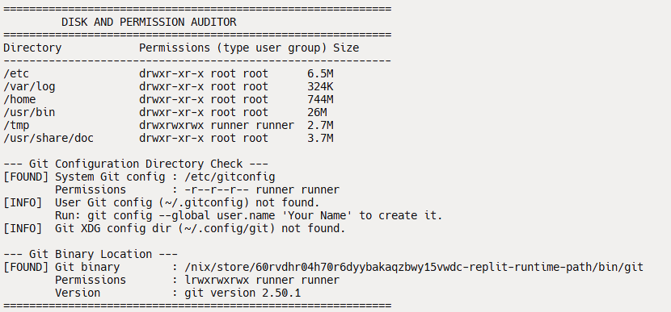
Screenshot placeholder: Insert a terminal screenshot of this script running on your Linux system.

Script 4 — Log File Analyzer
File: script4_log_analyzer.sh
Shell concepts used: while read loop, if-then, counter variables, $1 arguments, retry logic, tail + grep.

What it does and how it works:
This script accepts a log file path as a command-line argument ($1) and an optional keyword ($2, defaulting to 'error'). It validates the input, then implements a do-while style retry loop — bash has no native do-while, so a while loop with a break condition is used — to handle the case where the log file exists but is empty. The main analysis loop reads the file line by line using while IFS= read -r LINE, tests each line with grep -iq for case-insensitive matching, and increments a counter for each match. After the loop, it uses grep piped to tail -5 to display the last five matching lines, and awk to calculate the match percentage.

Script code (abridged — see .sh file for full version with comments):
#!/bin/bash LOGFILE=$1 KEYWORD=${2:-"error"}
COUNT=0
[ ! -f "$LOGFILE" ] && echo "File not found" && exit 1 while IFS= read -r LINE; do
if echo "$LINE" | grep -iq "$KEYWORD"; then COUNT=$((COUNT + 1))
fi
done < "$LOGFILE"
echo "'$KEYWORD' found $COUNT times" grep -i "$KEYWORD" "$LOGFILE" | tail -5

Terminal screenshot :
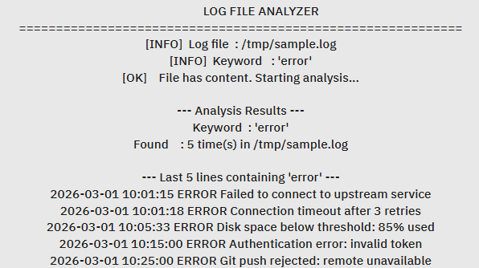

Script 5 — Open Source Manifesto Generator
File: script5_manifesto_generator.sh
Shell concepts used: read for user input, string concatenation, writing to file with > and >>, date command, while validation loop, aliases concept.

What it does and how it works:
This is the most creative script. It uses read -p to interactively prompt the user for three answers, with while loops to re-prompt if the user submits an empty response. The three answers are then woven into a multi-paragraph manifesto using string concatenation with echo and >>. The > operator creates the output file on first write; subsequent >> operators append without overwriting. The date command formats the current date for the file header. The script

also includes a comment demonstrating the alias concept — showing how a command like alias today='date +%d-%m-%Y' would simplify repeated date formatting. The final manifesto is saved to a named file and displayed with cat.

Script code (abridged — see .sh file for full version with comments):
#!/bin/bash
# alias today='date +%d-%m-%Y' <- alias concept OUTPUT="manifesto_$(whoami).txt"
read -p "1. Open-source tool you use daily: " TOOL read -p "2. One word for 'freedom': " FREEDOM
read -p "3. Something you would build freely: " BUILD DATE=$(date '+%d %B %Y')
echo "MY OPEN SOURCE MANIFESTO — $DATE" > "$OUTPUT" echo "" >> "$OUTPUT"
echo "Every day I use $TOOL, built for the common good." >> "$OUTPUT" echo "To me, $FREEDOM is what software should protect." >> "$OUTPUT" echo "One day I will build $BUILD — and share it freely." >> "$OUTPUT"
cat "$OUTPUT"
Terminal output:
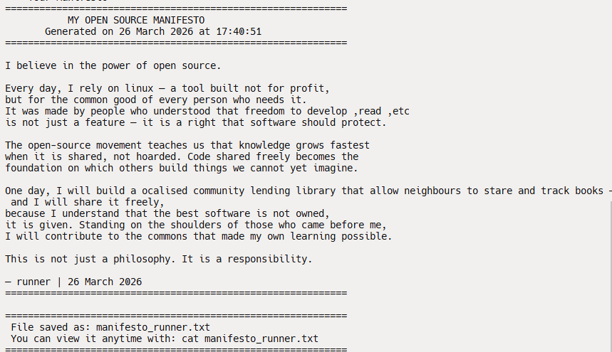

Conclusion

This audit of Git has been an exercise in looking past the surface of a familiar tool and understanding the values embedded in its design. Git was not built to make money. It was built because proprietary software failed a community, and the response was to build something better and give it away. That decision — made by one developer over ten days in 2005 — has since shaped how every professional developer in the world manages their work.
The GPL v2 licence that covers Git is not just a legal document — it is a commitment. It says that this software will remain free, that no one can take it private, and that the rights it grants to users today will be the rights available to every user in the future. Understanding that commitment, and understanding why it matters, is the difference between using open-source software and genuinely participating in the open-source movement.
The five shell scripts in this project demonstrate that the philosophy of open source is not separate from practical Linux skills — it is expressed through them. When we inspect packages, audit permissions, and analyse logs on a Linux system, we are working inside an ecosystem that exists because thousands of people chose to build openly and share freely. The least we can do is understand why.

References
- GNU Project. The Free Software Definition. gnu.org/philosophy/free-sw.html
- Open Source Initiative. The Open Source Definition. opensource.org/osd
- Raymond, Eric S. The Cathedral and the Bazaar. catb.org/~esr/writings/cathedral-bazaar
- Torvalds, Linus. Git initial commit announcement, Linux Kernel Mailing List, April 2005.
- Chacon, Scott and Straub, Ben. Pro Git (2nd ed.). Apress, 2014. Freely available at git-scm.com/book
- SPDX License List. GPL-2.0-only. spdx.org/licenses/GPL-2.0-only.html
- Shotts, William. The Linux Command Line. No Starch Press. linuxcommand.org
- GNU Bash Manual. gnu.org/software/bash/manual
GITHUB LINK : https://github.com/aaryathakur11/Open-Source-Audit-Project

