Name- Aarya Thorat
D15A - 63
Experiment - 1

1. Dataset Source
The dataset used for this experiment is a synthetic student performance dataset commonly used for demonstrating data preprocessing and exploratory data analysis techniques in machine learning.
Dataset Source:
student_performance.csv

2. Dataset Description
The dataset contains academic performance records of students and is used to analyze relationships between study habits, attendance, and examination scores.

Dataset Characteristics
- Number of Records: ~100–500 students (varies by version)
- Type: Structured, tabular data
- Domain: Education / Academic Analytics

Features (Independent Variables)
Feature Name | Description
Hours_Studied | Number of hours spent studying
Attendance | Attendance percentage of the student
Assignment_Score | Score obtained in assignments
Midterm_Score | Score obtained in midterm examination

Target / Analysis Variable
- Midterm_Score (used for statistical analysis and visualization)

Derived Categorical Feature
- Performance – classified based on Attendance:
  - High (≥ 85%)
  - Medium (70–84%)
  - Low (< 70%)

3. Mathematical Formulation of the Algorithm
This experiment does not use a predictive machine learning algorithm.
Instead, it focuses on statistical analysis and data normalization, which are foundational steps in ML pipelines.

Statistical Measures
- Mean
𝜇=1𝑁∑𝑖=1𝑁𝑥𝑖μ=N1​i=1∑N​xi​
- Median
The middle value of the sorted dataset.
- Standard Deviation
𝜎=1𝑁∑𝑖=1𝑁(𝑥𝑖−𝜇)2σ=N1​i=1∑N​(xi​−μ)2​

Min-Max Normalization
Used to scale values between 0 and 1:
𝑋𝑛𝑜𝑟𝑚=𝑋−𝑋𝑚𝑖𝑛𝑋𝑚𝑎𝑥−𝑋𝑚𝑖𝑛Xnorm​=Xmax​−Xmin​X−Xmin​​
This technique is widely used in machine learning preprocessing to ensure uniform feature scaling.

4. Algorithm Limitations
Since this experiment relies on Exploratory Data Analysis (EDA) techniques rather than predictive models, the following limitations apply:
- No predictions or classifications are performed
- Cannot be used to infer causality
- Visual interpretations may vary depending on dataset size
- Sensitive to outliers in normalization and correlation analysis
- Not suitable for automated decision-making without a trained ML model
EDA is descriptive, not prescriptive or predictive.

5. Methodology / Workflow

Step-by-Step Workflow
- Dataset Loading
  - Loaded CSV file using Pandas
- Data Inspection
  - Checked shape, columns, and missing values
- NumPy Operations
  - Converted Midterm_Score into NumPy array
  - Calculated mean, median, standard deviation
  - Applied Min-Max normalization
- Feature Engineering
  - Created Performance category based on attendance
- Data Visualization
  - Line plot: Assignment Score vs Midterm Score
  - Histogram: Distribution of Midterm Scores
  - Scatter plot: Attendance vs Midterm Score
  - Heatmap: Correlation between numerical features
  - Boxplot: Performance category vs Midterm Score

Workflow Diagram
Dataset → Cleaning → Statistical Analysis → Feature Engineering → Visualization → Insights

6. Performance Analysis
Since no predictive model is trained, traditional ML metrics such as accuracy, precision, recall, or RMSE are not applicable.

Analytical Observations
- Strong positive correlation observed between:
  - Assignment_Score and Midterm_Score
  - Attendance and academic performance
- Students with High attendance tend to score higher in midterm exams
- Normalized scores enable fair comparison across students
- Heatmap reveals inter-feature dependencies useful for future model selection
This analysis helps determine feature importance for downstream machine learning tasks.

7. Hyperparameter Tuning
Hyperparameter tuning is not applicable in this experiment because:
- No machine learning model is implemented
- No training or optimization process is involved
However, this experiment serves as a preparatory step for ML pipelines where:
- Feature scaling parameters
- Model hyperparameters
- Feature selection thresholds
would be tuned in subsequent experiments.
Conclusion
This experiment successfully demonstrated the use of NumPy, Pandas, Matplotlib, and Seaborn for data handling, normalization, and exploratory data analysis. By modifying the parameters and analysis focus, deeper insights into student academic behavior were obtained. The results emphasize the importance of EDA as a foundational step before applying machine learning algorithms.

Exercise 1 –

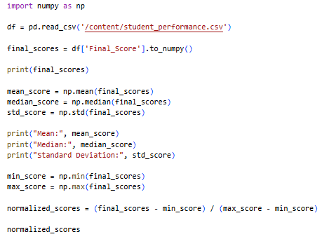
Output -
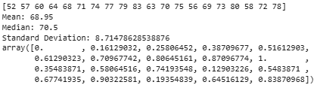

Exercise 2 –

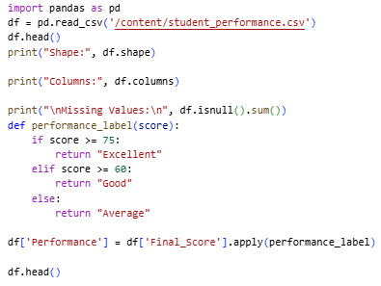
Output -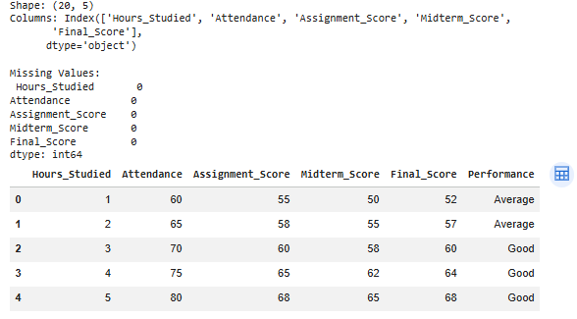

Exercise 3 -

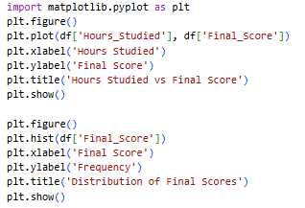
Output -
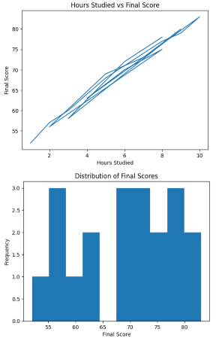

Exercise 4 -

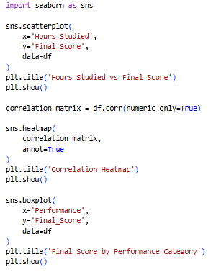
Output -
