Aurex Visuals Website Redesign Plan
Metallic Black and Matte Orange Direction

Prepared for collaboration with Aaryav Tech
This plan defines a complete visual and technical redesign of the Aurex Visuals website. The recommended result is a faster, static-first experience that keeps the brand bold, young, and creatively distinctive without relying on heavy animation.

EXECUTIVE DIRECTION

The proposed redesign
Rebuild the site around a disciplined metallic-black and matte-orange system. The experience should feel like a fashion editorial crossed with an industrial design catalogue: oversized typography, tactile still imagery, asymmetrical composition, concise copy, and unmistakable hierarchy.

Core decision
Motion is no longer the primary source of personality. Visual identity will come from composition, typography, material texture, contrast, and section-specific still imagery. Interaction is limited to essential hover, focus, navigation, and disclosure states.

Success looks like
- A fast landing page that performs well on mid-range Indian mobile devices and slower networks.
- A distinctive Gen Z aesthetic without neon, decorative particles, scroll choreography, or autoplay media.
- Clear package comparison and direct routes to WhatsApp, email, Instagram, and a discovery call.
- A maintainable component system that Aaryav Tech can extend without recreating visual rules.

What will be removed
Remove | Reason | Replacement
Continuous marquees and animated backgrounds | Adds paint cost and distracts from conversion | Static editorial bands and sharp section cuts
Scroll reveal sequences | Delays content and adds script cost | Immediate rendering with strong hierarchy
Floating particles and decorative objects | Adds DOM weight and visual noise | One optimized image per major section
Always-on blur effects | Expensive on lower-end GPUs | Solid surfaces and thin gunmetal borders
Duplicated large assets | Inflates transfer size | Responsive AVIF and WebP sources

DESIGN SYSTEM

Metallic black and matte orange
Token | Value | Use
Carbon Black | #080808 | Primary page background
Metal Black | #151515 | Cards, navigation, raised surfaces
Gunmetal | #2B2B2B | Borders and secondary surfaces
Matte Orange | #E76522 | Primary actions and focal planes
Burnt Orange | #A83F16 | Selected states and image depth
Warm Ivory | #F1EDE6 | Primary text on black
Steel Gray | #9A9690 | Secondary text and metadata

Typography
Use one expressive display family and one practical sans serif. Recommended pairing: Unbounded or Space Grotesk for display with Inter or Manrope for interface and body copy. Reserve display type for short headlines, prices, and section numbers. Body copy remains at least 16 px on mobile.

Layout language
- Twelve-column desktop grid, four-column mobile grid, generous outer margins, and deliberate asymmetry.
- Large but controlled headings with no overflow at a 320 px viewport.
- Alternating image-led and type-led sections instead of one repeated card template.
- Thin gunmetal rules, hard corners, and occasional clipped orange planes. Avoid glass cards and excessive rounding.
- Art-directed image crops with solid text backing whenever an image area is visually busy.

Interaction standard
Keep hover transitions below 160 ms and limit them to color, border, and a one-to-two pixel shift. Respect prefers-reduced-motion. Do not use parallax, canvas effects, smooth-scroll libraries, autoplay video, cursor followers, or animated counters.

SECTION 01

Hero and Navigation
Purpose: Establish a premium creative studio immediately and present one clear conversion action.
Layout direction | Content system | Performance rule
Full-viewport composition with headline in the dark negative space and the orange metallic structure on the right. Compact sticky navigation becomes solid black after the first section. | Headline, one-line value proposition, Work With Us action, View Packages secondary action, and compact India and Est 2024 metadata. | One art-directed AVIF with WebP fallback. Preload only the correct breakpoint. No video, canvas, or animation library.

SECTION 02

Brand Story
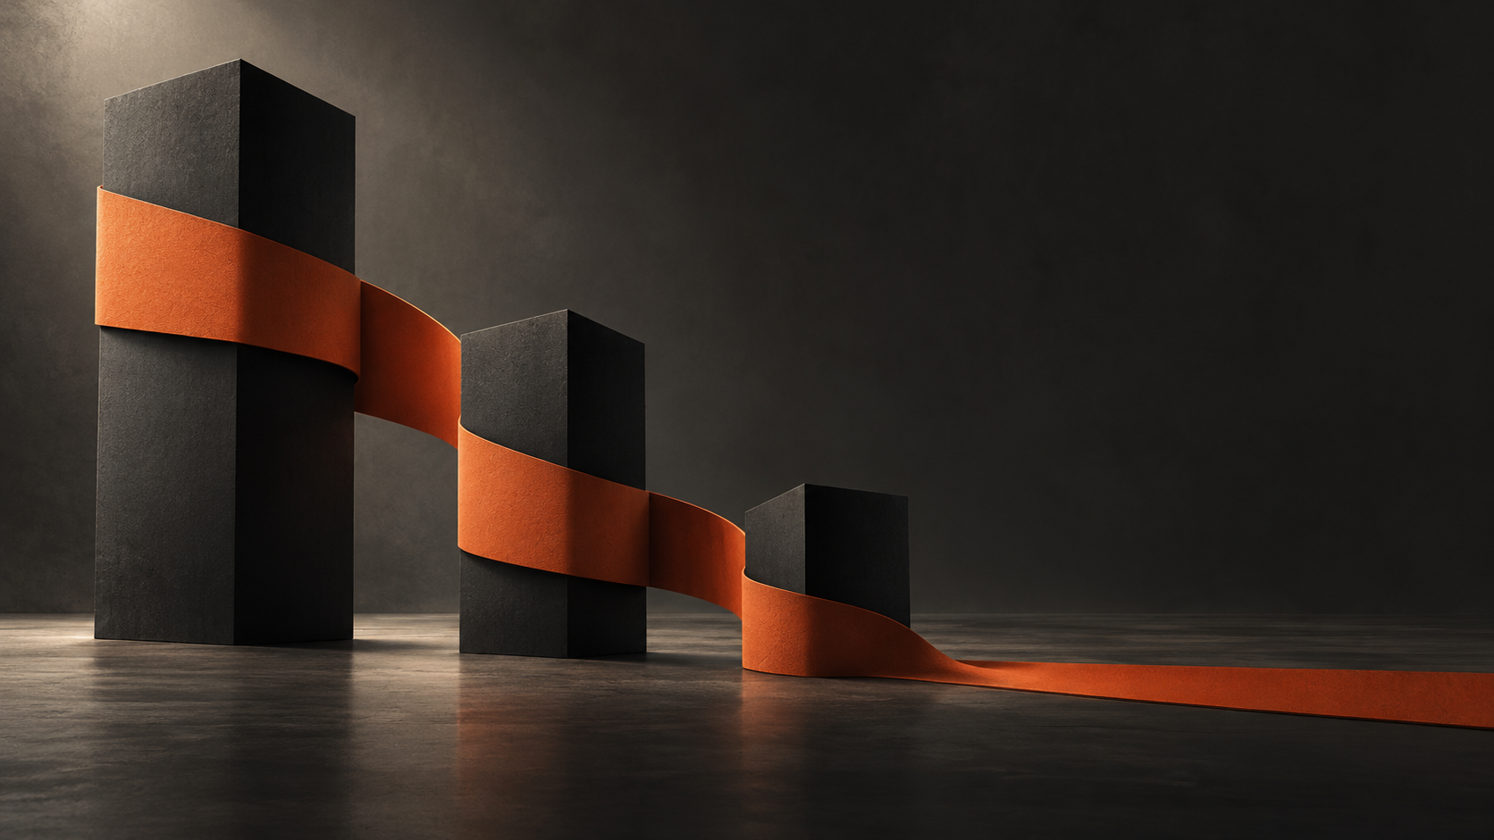
Purpose: Explain the agency point of view and make the brand feel memorable rather than generic.
Layout direction | Content system | Performance rule
Two-column editorial spread. Image occupies about 55 percent; short narrative and three proof pillars use the remaining column. | A concise brand story followed by Creative Content, Brand Growth, and Visual Storytelling as typographic markers. | Lazy-load the image and set width and height to prevent layout shift. Do not add separate decorative textures.

SECTION 03

Services

Purpose: Show six connected capabilities as one coherent operating system.
Layout direction | Content system | Performance rule
Use the six-object image as the section anchor, followed by a responsive two-column service index. Mobile uses native disclosure controls. | Social management, photography, reels, graphic design, influencer outreach, and analytics and ads, each rewritten around the client outcome. | No slider library, animated cards, or icon package. Use native details and summary elements on mobile.

SECTION 04

Packages
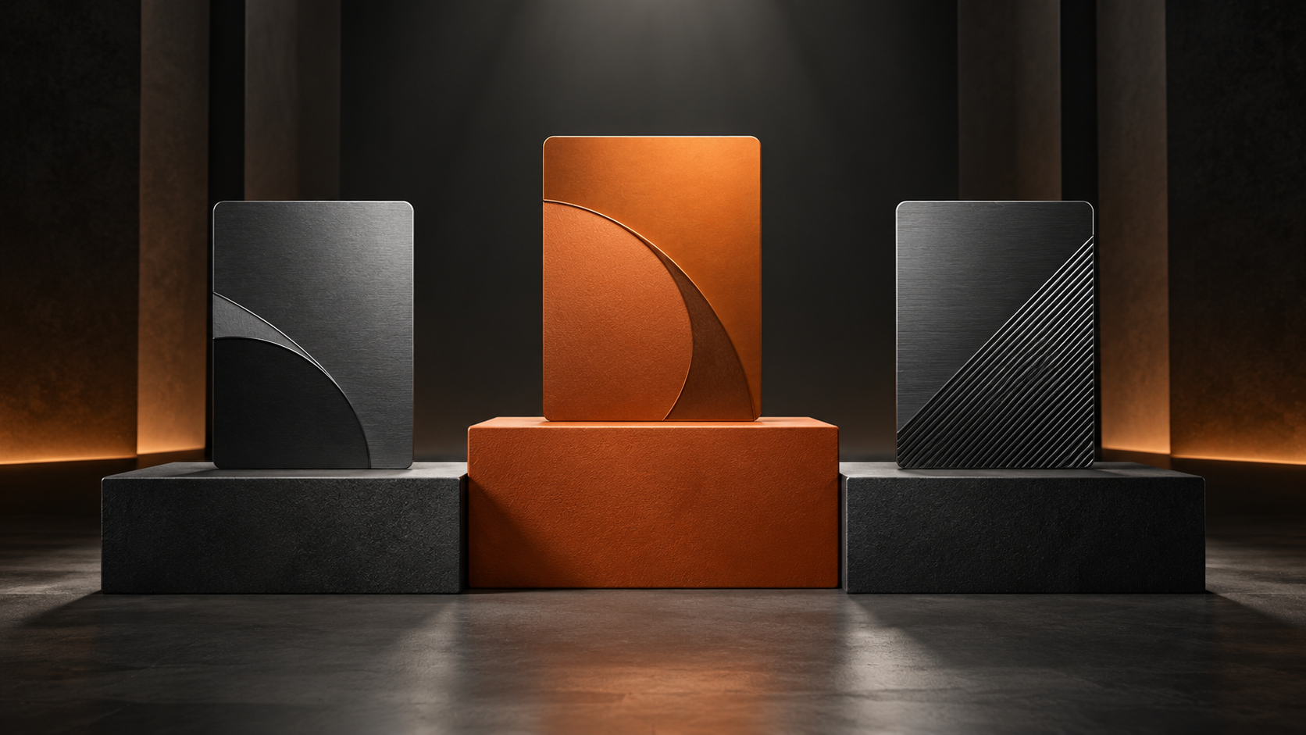
Purpose: Make the three monthly plans easy to compare and make Signature the obvious recommendation.
Layout direction | Content system | Performance rule
Three columns on desktop and stacked plans on mobile. The middle tier uses matte orange; the other tiers use metal black. | Essential, Signature, and Elite with a short outcome statement, price, five inclusions, and a direct inquiry action. | Render pricing in HTML for search and accessibility. Use CSS grid with no carousel or measurement script.

SECTION 05

Why Aurex

Purpose: Turn six differentiators into credible reasons to choose the studio.
Layout direction | Content system | Performance rule
Place the modular visual beside a numbered proof list. Finish with client, post, retention, and turnaround metrics. | Results-driven strategy, creative-first execution, dedicated management, transparent reporting, fast turnaround, and Indian-market fluency. | Metrics remain static text. Do not animate counters. Keep every proof item keyboard readable.

SECTION 06

Testimonials
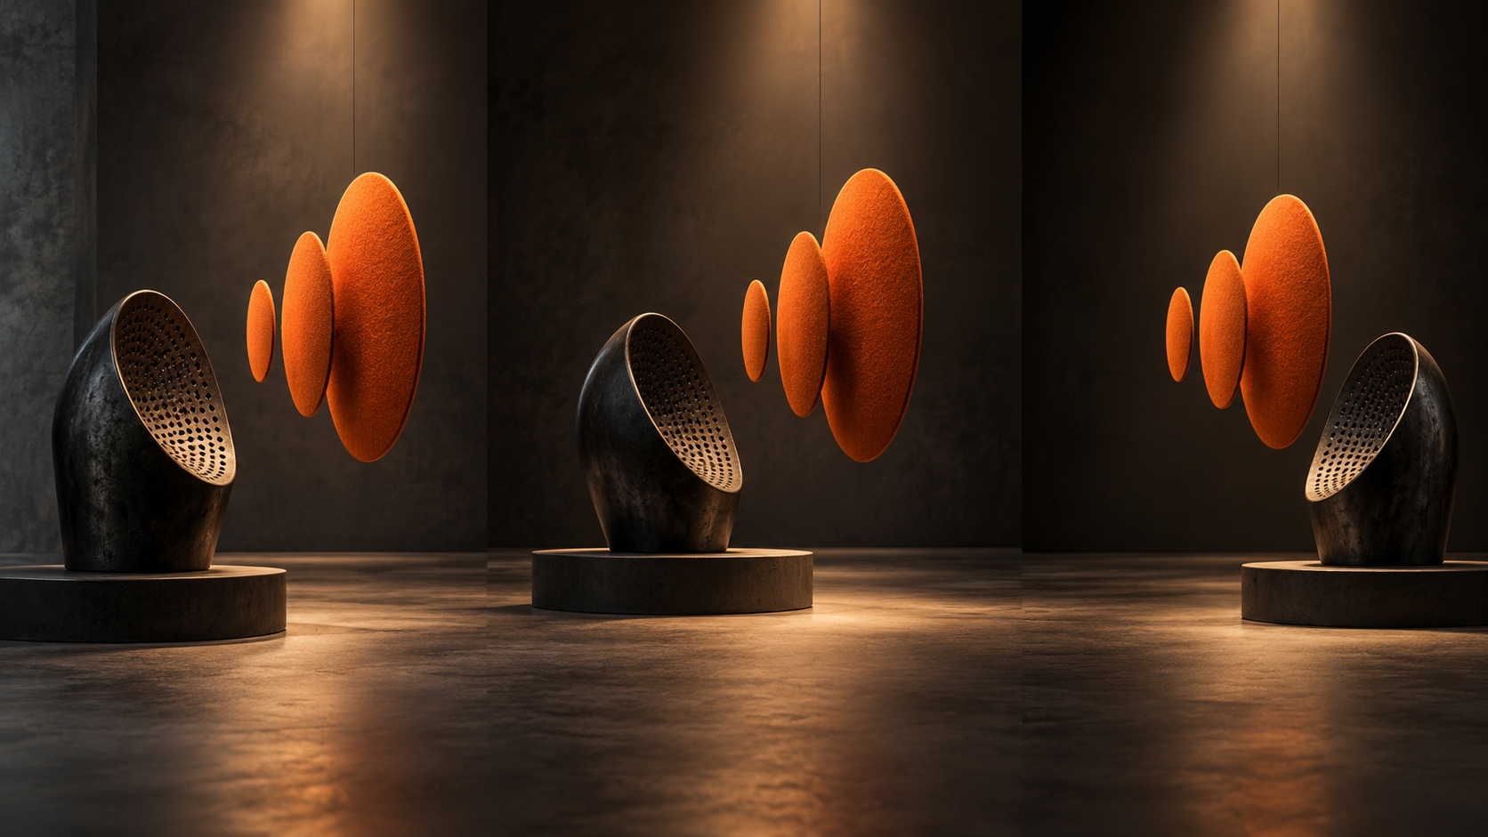
Purpose: Add social proof while preserving the gallery-like tone.
Layout direction | Content system | Performance rule
Three quotes form a static editorial grid aligned with the three listening forms. Stack all quotes on mobile. | Lead with the strongest client claim, then the name and business type. Use genuine statements only. | No carousel JavaScript. Keep quote content in semantic blockquote elements and lazy-load the image.

SECTION 07

Contact and Footer
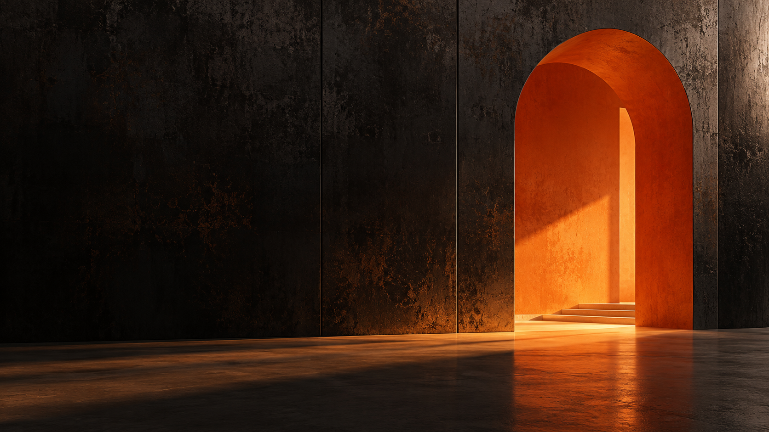
Purpose: End with a decisive next step and make direct contact effortless.
Layout direction | Content system | Performance rule
Use the left negative space for the final headline and actions while the orange portal anchors the right. Follow with a compact contact directory and reduced footer. | Book a Free Call, WhatsApp, email, phone, and Instagram. Display response-time claims only when operationally accurate. | Use ordinary accessible links. Avoid an embedded scheduler and third-party scripts on initial load.

AARYAV TECH COLLABORATION

Delivery model
Workstream | Aurex Visuals | Aaryav Tech | Shared approval
Brand and content | Voice, offers, testimonials, imagery approval | Content model and implementation support | Final copy and claims
UX and visual design | Creative direction and brand judgment | Responsive system, interaction states, accessibility | Desktop and mobile prototypes
Engineering | Acceptance feedback | Components, asset pipeline, analytics, deployment | Performance and browser QA
Conversion | Lead handling process | CTA tracking and contact routing | Funnel and success events

Recommended phases
Phase | Focus | Output | Gate
1 Discover | Content and analytics audit | Sitemap, copy inventory, conversion events | Scope sign-off
2 Design | Mobile-first static prototypes | Section system, pricing, contact, responsive states | Design sign-off
3 Build | Semantic frontend and optimized assets | Reusable components and CMS-ready model | Feature complete
4 Validate | Device, accessibility, SEO, and speed QA | Issue log and release candidate | Launch approval
5 Launch | Deployment and measurement | Production release, dashboards, rollback plan | Stable release

Decision cadence
Use two short reviews each week: one for brand and content decisions, and one for implementation and quality. Compare unresolved visual options in static side-by-side frames rather than adding motion.

TECHNICAL STANDARDS

Performance and quality budget
Metric | Target | Implementation rule
Largest Contentful Paint | Under 2.5 s at p75 | Responsive hero, limited fonts, critical CSS
Interaction to Next Paint | Under 200 ms at p75 | Minimal client JavaScript and no animation libraries
Cumulative Layout Shift | Under 0.10 | Explicit image dimensions and stable font fallbacks
Initial JavaScript | Under 70 KB gzip | Progressive enhancement and a static-first landing page
Initial image transfer | Under 450 KB | AVIF first, WebP fallback, correct responsive source
Accessibility | WCAG 2.2 AA | Keyboard, focus, contrast, semantics, reduced motion

Build recommendations
- Keep the page static-first. The current Vite foundation is sufficient unless content-management needs justify a framework.
- Self-host two variable font files or use a system fallback. Subset unused characters and avoid more than four active weights.
- Convert the concept PNG files into AVIF and WebP variants at 1600, 960, and 640 px widths.
- Use semantic landmarks, real buttons and links, visible focus states, and native disclosure controls.
- Defer analytics until consent and avoid overlapping trackers. Track only primary contact and package-intent events.
- Compress responses, fingerprint assets, use immutable caching, and test on slow 4G.

APPROVAL CHECKLIST

Definition of done
Area | Acceptance criteria
Brand | Metallic black and matte orange are consistent; legacy green is removed; Aaryav Tech credit is placed only where approved.
Responsive | No overflow at 320, 375, 768, 1024, and 1440 px; packages remain readable without horizontal scrolling.
Performance | The performance budget passes on a production-like build and mid-range Android device.
Accessibility | Keyboard navigation, focus, contrast, headings, links, forms, and reduced-motion behavior pass review.
Content | Prices, testimonials, contact details, response claims, and offer terms are approved by Aurex Visuals.
Conversion | Every primary call to action routes correctly and agreed events are recorded once.
Operations | Aaryav Tech receives source, optimized assets, environment notes, deployment steps, and rollback instructions.

Immediate next step
Approve the visual direction and select the final font pairing. Aaryav Tech can then convert the seven section concepts into responsive static prototypes before code changes are merged.

