ASSIGNMENT No: 5
Name: Aarushi Raizada
PRN: 25070122002
Batch-A1
TITLE: Develop a Java application demonstrating the use of ArrayList, Vector, and StringBuffer for dynamic data storage, management, and string manipulation.
Problem Statement: Develop a Java application demonstrating the use of ArrayList, Vector, and StringBuffer for dynamic data storage, management, and string manipulation. Learning Objectives To implement dynamic data storage and string manipulation using ArrayList, Vector, and StringBuffer.
Theory: ArrayList and Vector are dynamic array implementations provided by the Java Collections Framework. ArrayList offers faster performance in single-threaded applications, whereas Vector provides synchronized operations for thread safety. StringBuffer is a mutable sequence of characters that allows efficient string modification without creating new objects. These classes are commonly used in applications requiring dynamic memory allocation and efficient string processing.
Exercise
1. Create a To-Do List application using ArrayList to store tasks and StringBuffer to display tasks.
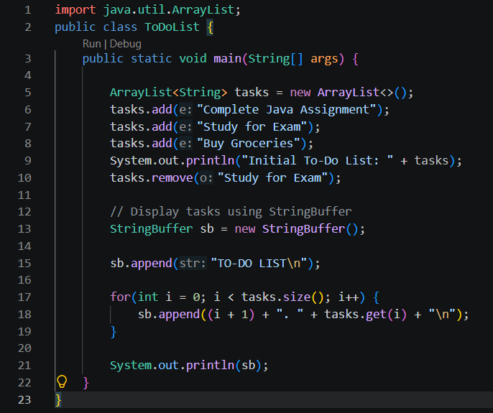

OUTPUT: 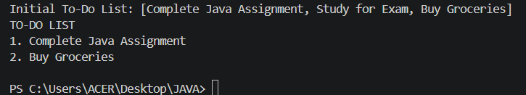

2. Create a Student Course Registration System using ArrayList to store the list of courses registered by a student and StringBuffer to generate and display the registered course list. The application should allow users to add, remove, and view registered courses.

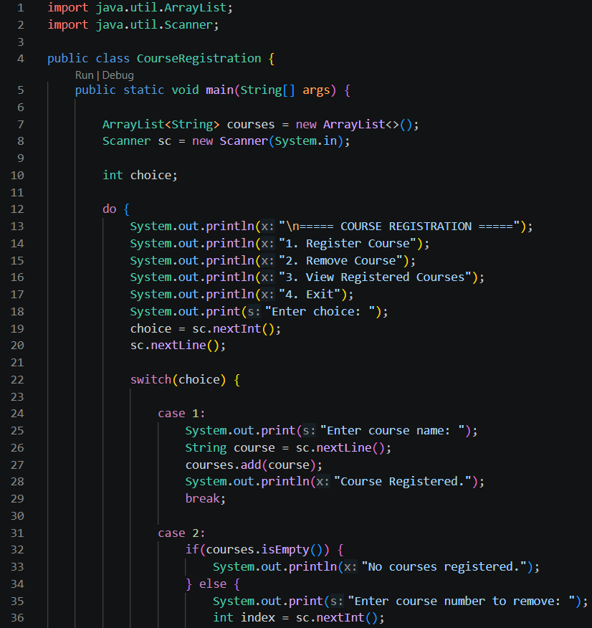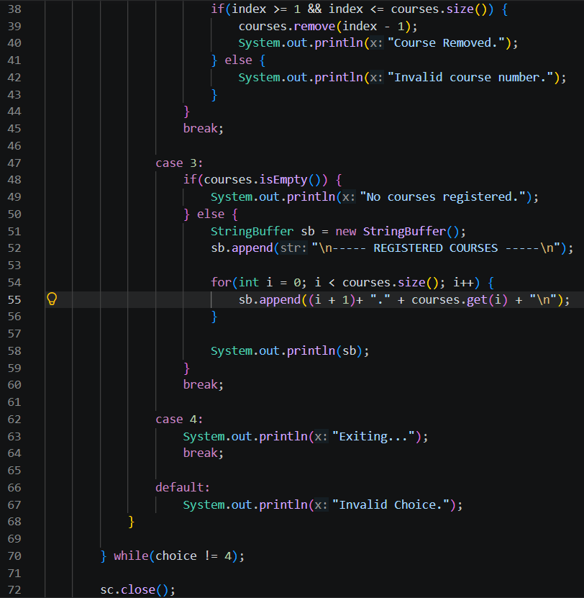

OUTPUT:
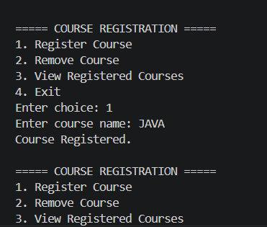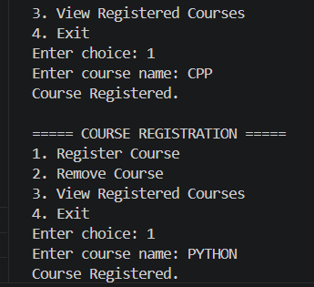
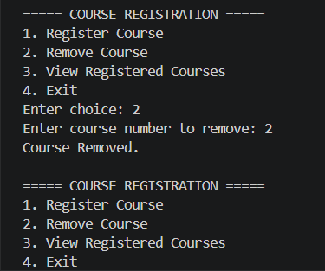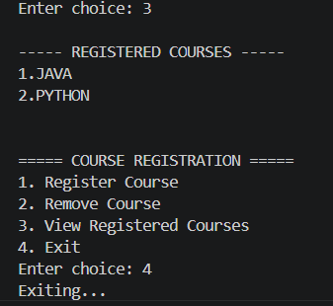

Conclusion:
In this experiment, we implemented a To-Do List application and a Student Course Registration System using ArrayList for dynamic data storage and StringBuffer for efficient string manipulation. The programs demonstrated basic operations such as adding, removing, and displaying data, enhancing understanding of Java Collection Framework and mutable string handling.

