
Symbiosis Institute of Technology, Pune
Faculty of Engineering
CSE- Academic Year 2026-27
Java Programming – Lab Batch 2025-29
Lab Assignment No:- 4
Name of Student | AARUSHI RAIZADA
PRN No. | 25070122002
Batch | 2025-29
Class | A1
Academic Year & Semester | 2026-27 SEM III
Date of Submission | 11th July,2026
Title of Assignment: | Develop a Java application demonstrating the use of wrapper classes for conversion between primitive data types and objects, and performing basic operations on wrapped values.
Theory:  Practice questions | Wrapper classes are predefined classes that encapsulate primitive data types into objects. Java provides wrapper classes such as Integer, Double, Character, and Boolean for every primitive type. They support autoboxing, unboxing, parsing, and conversion methods. Wrapper classes are widely used in Java Collections Framework and when object representation of primitive values is required.  1.Create a program to convert student marks from String format to Integer and calculate total marks  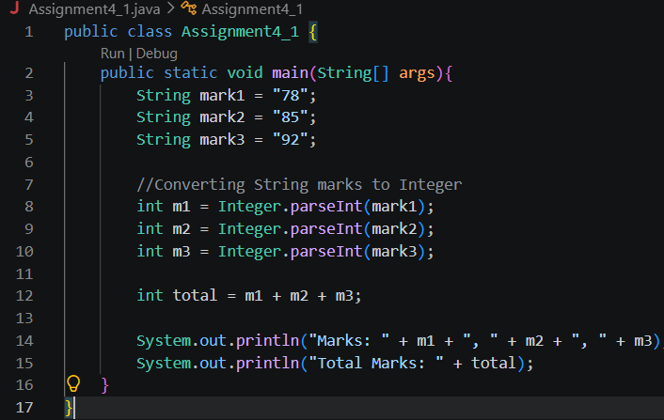  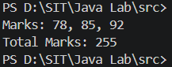  2. Develop an Employee Payroll System that accepts employee IDs, basic salary, and bonus amounts from the user. Convert the entered values into wrapper objects and perform validation operations to ensure valid salary values before calculating the net salary.  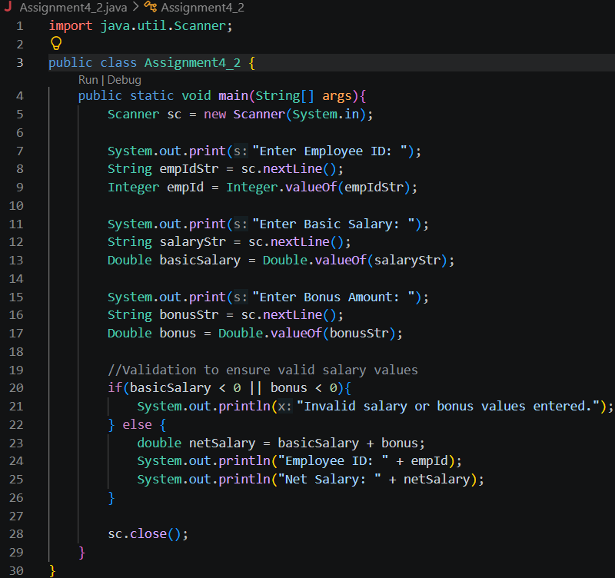  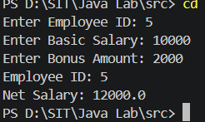
Output Screenshots (if applicable) | 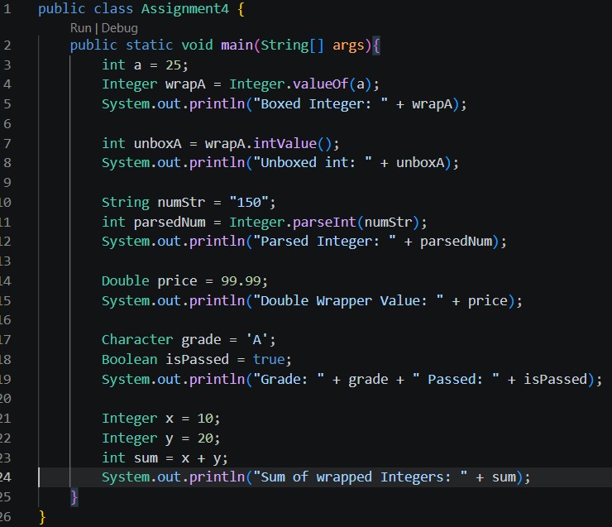  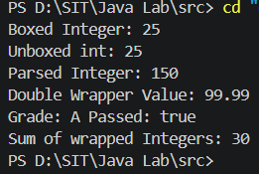
Conclusion | Through this assignment, we understood how wrapper classes in Java act as a bridge between primitive data types and objects. We saw how Integer, Double, Character, and Boolean allow primitive values to be treated as objects, which is essential when working with collections and other object-based APIs. We also implemented autoboxing and unboxing, along with parsing methods like Integer.parseInt() and Double.valueOf(), to convert String input into usable numeric values. Applying these concepts in the student marks program and the Employee Payroll System helped us see how wrapper classes are used practically to validate and process user input before performing calculations, ensuring that only proper values are used in real-world applications like payroll processing.

