ASSIGNMENT No: 6
Name: Aarushi Raizada
PRN: 25070122002
Batch: A1
TITLE: Write a Java program to demonstrate the use of an inner class, an anonymous class. Problem Statement Write a Java program to demonstrate the use of an inner class, an anonymous class.
Learning Objectives: To implement inner classes and anonymous classes for improving encapsulation and event handling in Java.
Theory: An inner class is a class defined inside another class and has access to all members of the enclosing class, including private members. Inner classes help improve code organization and logical grouping of related classes. Anonymous classes are unnamed inner classes that are instantiated only once and are mainly used for implementing interfaces or abstract classes. They simplify code by eliminating the need for separate class definitions. These concepts are widely used in Java GUI programming and event handling
Exercise
1.Create a Vehicle program where an inner class displays vehicle details and anonymous class performs an action.
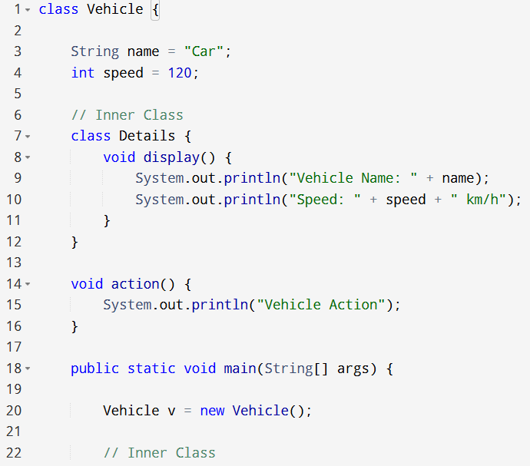
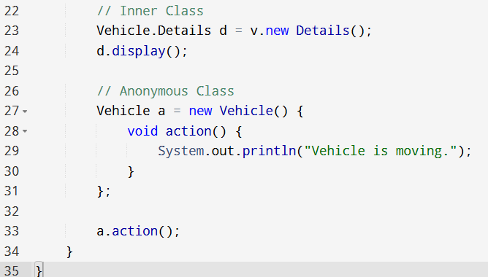

OUTPUT:
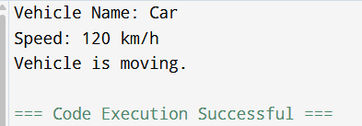

2. Develop a Food Delivery Application where an inner class handles order details and anonymous classes handle delivery status updates.
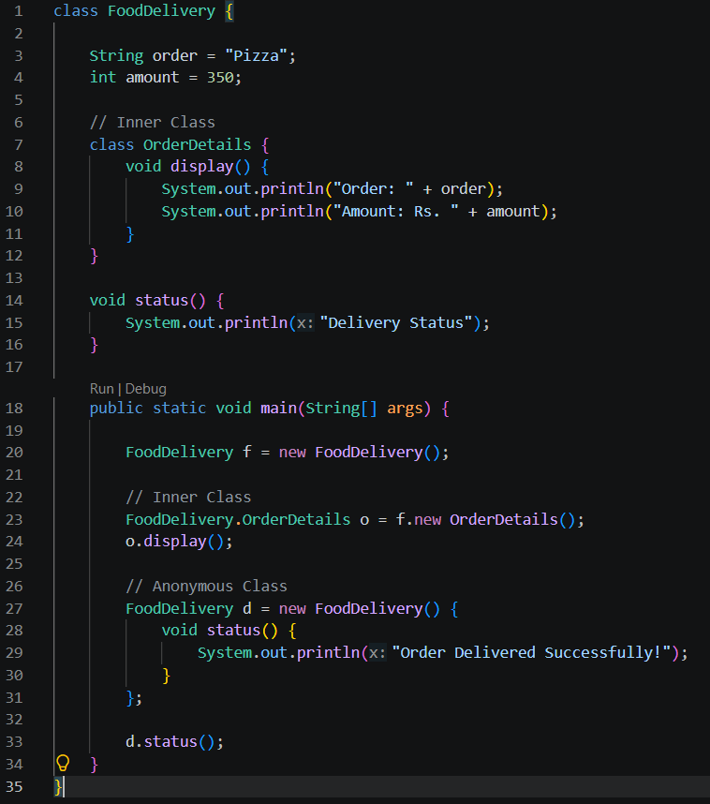

OUTPUT:
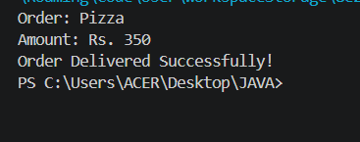
Conclusion:

In this experiment, we learned how to use inner classes to organize related functionality within a class and anonymous classes. These concepts help make Java programs more modular, readable, and efficient.

