2739 — Total Distance Traveled
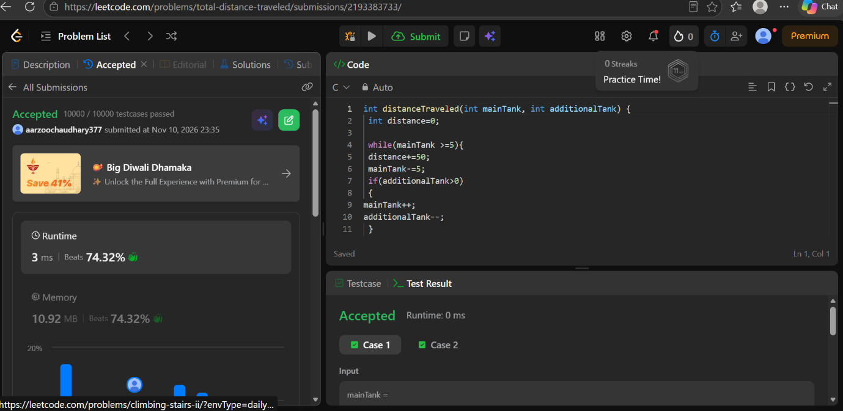
CODE
int distanceTraveled(int mainTank, int additionalTank) {
int distance=0;

while(mainTank >=5){
distance+=50;
mainTank-=5;
if(additionalTank>0)
{
mainTank++;
additionalTank--;
}

