2651 — Calculate Delayed Arrival Time
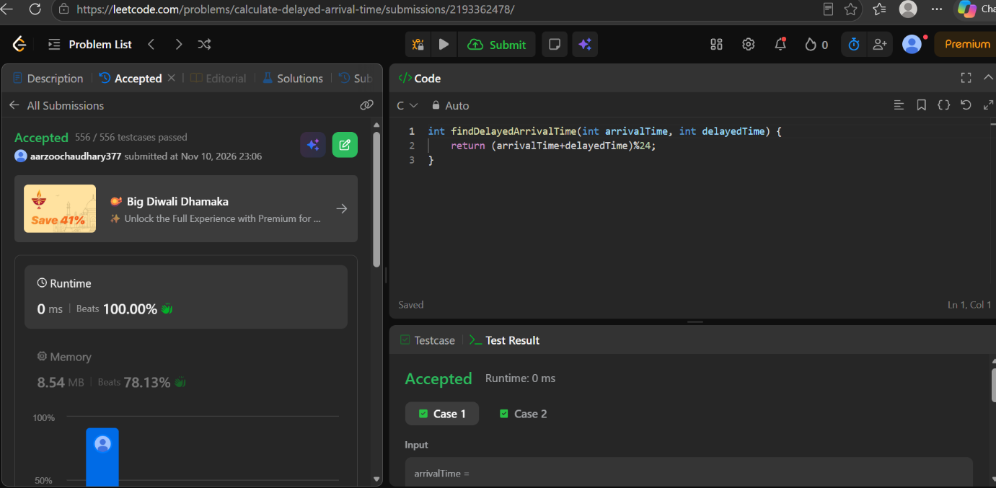
CODE
int findDelayedArrivalTime(int arrivalTime, int delayedTime) {
return (arrivalTime+delayedTime)%24;
}

