2413 — Smallest Even Multiple
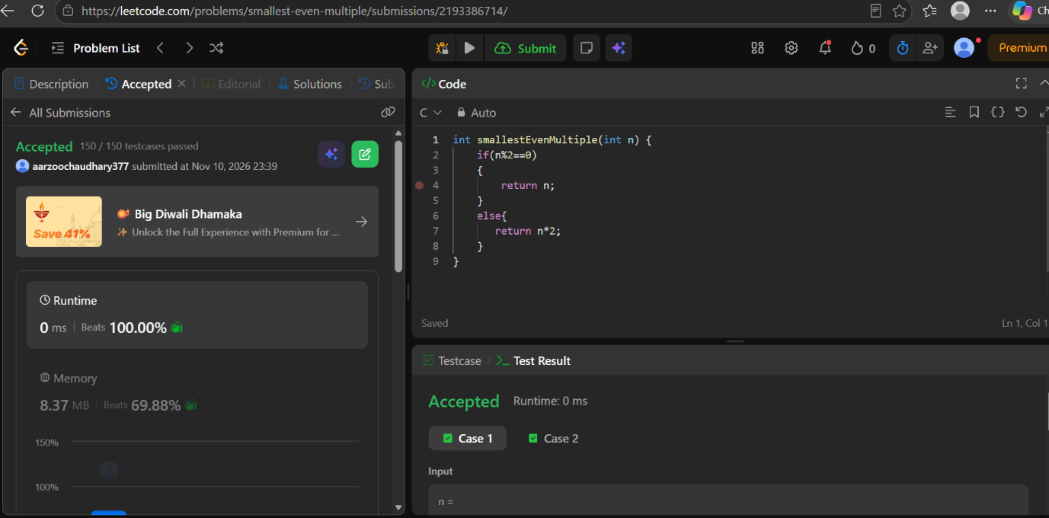
CODE
int smallestEvenMultiple(int n) {
if(n%2==0)
{
return n;
}
else{
return n*2;
}
}

