2235 — Add Two Integers

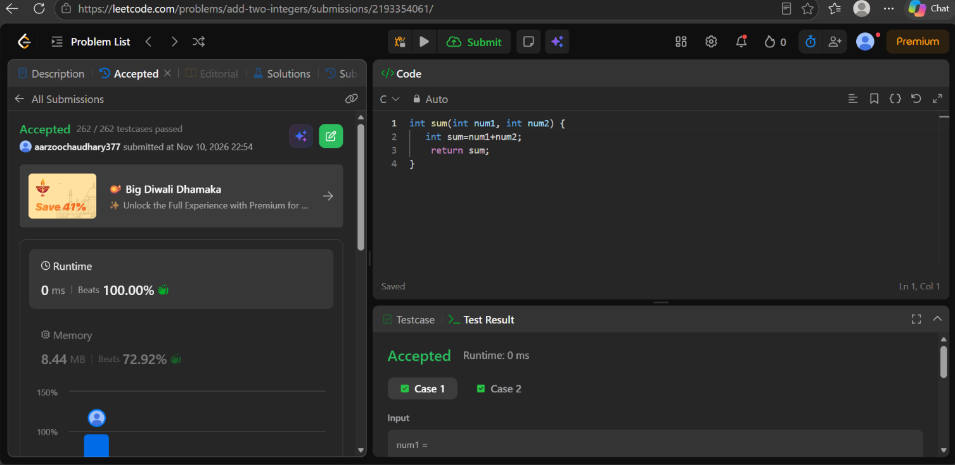

code
int sum(int num1, int num2) {
int sum=num1+num2;
return sum;
}

