MINI PROJECT REPORT
TARJAN'S STRONGLY CONNECTED COMPONENTS ALGORITHM
Submitted by:
YOUR FULL NAME
YOUR ROLL NUMBER
In partial fulfilment for the award of the degree of
BACHELOR OF TECHNOLOGY
In
COMPUTER SCIENCE AND ENGINEERING
Under the guidance of
DAA FACULTY NAME
Assistant Professor, ASAC

Alliance School Of Advance Computing
Alliance University, Bengaluru
October-2026



COMPUTER SCIENCE AND ENGINEERING
ALLIANCE SCHOOL OF ADVANCED COMPUTING
CERTIFICATE
This is to certify that the report on Tarjan's Strongly Connected Components Algorithm (RegexCPU) is submitted by YOUR FULL NAME [Uni. Roll No. YOUR ROLL NUMBER] in partial fulfilment for the award of the degree of Bachelor Of Technology (Computer Science and Engineering) of Alliance University, is a bonafide work accomplished under my supervision and guidance during the academic year 2026. This report embodies the results of original work and studies conducted by students and the contents do not form the basis for the award of any other degree to the candidate or anybody else.
----------------------
DAA FACULTY NAME
Assistant Professor

COMPUTER SCIENCE AND ENGINEERING
ALLIANCE SCHOOL OF ADVANCED COMPUTING
DECLARATION
I hereby declare that the report titled TARJAN'S STRONGLY CONNECTED COMPONENTS ALGORITHM, submitted by me in partial fulfilment of the requirements for the award of the degree of Bachelor Of Technology in Computer Science and Engineering (CSE) at Alliance University, is a record of my original work carried out under the supervision of DAA FACULTY NAME, Assistant Professor, ASAC.
I further confirm that all views, findings, and conclusions expressed herein are the result of sincere effort and academic inquiry, and have been reviewed and deliberated in consultation with the assigned mentor.
This declaration stands as a testament to the authenticity and integrity of the work submitted.
YOUR FULL NAME YOUR ROLL NUMBER
Name of the Student University Registration Number Signature

Acknowledgement
I would like to express my heartfelt gratitude to everyone who contributed to the successful completion of this project titled TARJAN'S STRONGLY CONNECTED COMPONENTS ALGORITHM.
First and foremost, I extend my sincere thanks to my mentor and guide, DAA FACULTY NAME, for the support, insightful feedback, and encouragement throughout the development of this work. Their expertise and commitment to fostering learning provided the foundation for this project.
I am deeply grateful to my faculty members and peers whose guidance and technical inputs helped refine the project. Their collaborative spirit and constructive suggestions were instrumental in shaping the final outcome.
This project allowed me to implement Tarjan's algorithm iteratively, validate it against Kosaraju's algorithm and measure its linear running time on large graphs.
Lastly, I would like to thank everyone who supported me directly or indirectly during this journey.
Thank you.
YOUR FULL NAME

TABLE OF CONTENTS
Acknowledgement 4
Abstract 6
Chapter I- Introduction 7
Problem Statement 7
Theory 7
Chapter II - System Configuration 9
Algorithm 9
Source Code 9
Chapter III - Results 12
Chapter IV – Conclusion 16

Abstract
A strongly connected component (SCC) of a directed graph is a maximal set of vertices that are all reachable from one another. Tarjan's algorithm finds all SCCs in a single depth-first traversal in O(V + E) time using low-link values. This report presents an iterative implementation of Tarjan's algorithm, an independent Kosaraju implementation used as a checker, and an application: analysing the state graph of a deterministic finite automaton to locate dead (useless) states, loops, and to decide whether the accepted language is finite.
Experiments on random graphs with up to 160,000 vertices and 480,000 edges show running time growing linearly with V + E; Tarjan took 673 ms against 859 ms for Kosaraju at the largest size. Both algorithms returned identical partitions on 300 random graphs and on every benchmark graph, and the iterative design handled a 200,000-vertex chain without recursion errors. The DAA component is part of RegexCPU, together with FLAT (regex to automata) and COA (CPU simulation).

Chapter I- Introduction
Graph traversal (BFS and DFS) is the foundation of Module 1 of Design and Analysis of Algorithms. Among the DFS-based algorithms, the computation of strongly connected components is one of the most useful: collapsing every SCC into a single vertex turns any directed graph into a directed acyclic graph (DAG), which can then be processed with topological order and dynamic programming. Tarjan's algorithm (1972) achieves this with one DFS and a stack.
Instead of demonstrating the algorithm on a textbook graph only, this project applies it to a real graph: the transition graph of a DFA produced from a regular expression. The result is used to remove states that can never lead to acceptance, to detect cycles and to classify the language as finite or infinite. The rest of the pipeline (regular expression to automaton, and execution on a simulated CPU) is described in the FLAT and COA reports.

Problem Statement
Given a directed graph with V vertices and E edges, compute all strongly connected components in linear time without recursion limits, and use them to analyse an automaton. The objectives are:
- implement Tarjan's algorithm iteratively so that deep graphs do not overflow the call stack;
- implement Kosaraju's two-pass algorithm independently and use it to cross-check Tarjan's output;
- build the condensation DAG and exploit the reverse-topological emission order of Tarjan's algorithm;
- use the SCC structure of a DFA to find dead states, cycles and language finiteness;
- verify the O(V + E) bound experimentally.

Theory

Strongly connected components
Vertices u and v are strongly connected if there is a path from u to v and from v to u. This relation is an equivalence relation; its classes are the SCCs. The condensation graph, with one node per SCC, is always a DAG.

Tarjan's algorithm
During a DFS each vertex v receives a discovery number index[v] and a low[v]: the smallest discovery number reachable from v's DFS subtree using at most one back or cross edge to a vertex still on the stack. Vertices are pushed on a stack when discovered. When the DFS finishes a vertex v with low[v] = index[v], v is the root of an SCC and the stack is popped down to v; the popped vertices form the component.
Table 1: Properties of Tarjan's algorithm
Property | Statement
Time | O(V + E): every vertex is pushed and popped once, every edge examined once
Space | O(V) for index, low, on-stack flags and the stack
Output order | SCCs are emitted in reverse topological order of the condensation DAG
Passes | one DFS (Kosaraju needs two DFS passes and a transposed graph)

Application to a DFA
Treat each DFA state as a vertex and each transition as an edge. A state is useful if it is reachable from the start state and can reach an accepting state. Because Tarjan emits SCCs in reverse topological order, every successor of a component has already been emitted when the component is emitted. A single left-to-right pass can therefore compute live[C] = (C contains an accepting state) or (some successor of C is live). States in non-live components are dead and are removed. The language is infinite exactly when a cyclic SCC (size > 1 or a self-loop) contains a useful state.

Chapter II - System Configuration
Table 2: Development and execution environment
Item | Configuration
Operating system | Linux 6.18.44-fc-v153
Processor | Intel(R) Xeon(R) Processor @ 2.80GHz
CPU cores | 1
Memory (RAM) | 3.9 GB
Language / runtime | Python 3.12.3
Libraries | Flask (web app), matplotlib + numpy (graphs); core engines use only the Python standard library
Testing | unittest (28 tests), Python re as reference oracle

Algorithm

Tarjan's SCC (iterative)
for each vertex root not yet visited:
push (root, 0) on a work stack
while work stack not empty:
(v, i) = pop
if i == 0: index[v] = low[v] = counter++; push v on SCC stack; mark on_stack[v]
for j from i to deg(v)-1:
w = adj[v][j]
if w unvisited: push (v, j+1), push (w, 0); break # "recursive call"
elif on_stack[w]: low[v] = min(low[v], index[w])
if we descended: continue
if low[v] == index[v]: pop SCC stack down to v -> one component
if work stack not empty: parent u = top; low[u] = min(low[u], low[v])

The explicit work stack stores (vertex, next-edge-position) pairs, so the recursion of the textbook version is replaced by a loop. Python's default recursion limit of about 1,000 frames would otherwise crash on long chains.

DFA analysis
- Run Tarjan on the complete minimal DFA graph.
- Map every state to its component and build the condensation edges.
- Scan components in emission order and compute live.
- useful = live ∩ reachable; dead = all states − useful.
- Report cyclic components and decide finiteness; trim dead states before code generation.

Source Code

Tarjan's algorithm (scc.py)
def tarjan_scc(adj):
n = len(adj)
index, low = [-1] * n, [0] * n
on_stack = [False] * n
stack, sccs, counter = [], [], 0
for root in range(n):
if index[root] != -1:
continue
work = [(root, 0)]
while work:
v, i = work.pop()
if i == 0:
index[v] = low[v] = counter
counter += 1
stack.append(v)
on_stack[v] = True
descended = False
for j in range(i, len(adj[v])):
w = adj[v][j]
if index[w] == -1:
work.append((v, j + 1))
work.append((w, 0))
descended = True
break
if on_stack[w]:
low[v] = min(low[v], index[w])
if descended:
continue
if low[v] == index[v]: # v is the root of an SCC
comp = []
while True:
w = stack.pop()
on_stack[w] = False
comp.append(w)
if w == v:
break
sccs.append(comp)
if work: # return to the parent: propagate low-link
u = work[-1][0]
low[u] = min(low[u], low[v])
return sccs

Kosaraju's algorithm (scc.py), used as a checker
def kosaraju_scc(adj):
n = len(adj)
seen, order = [False] * n, []
for root in range(n):
if seen[root]:
continue
seen[root] = True
stack = [(root, 0)]
while stack:
v, i = stack.pop()
if i < len(adj[v]):
stack.append((v, i + 1))
w = adj[v][i]
if not seen[w]:
seen[w] = True
stack.append((w, 0))
else:
order.append(v)
radj = [[] for _ in range(n)]
for v in range(n):
for w in adj[v]:
radj[w].append(v)
seen, sccs = [False] * n, []
for root in reversed(order):
if seen[root]:
continue
seen[root] = True
comp, stack = [], [root]
while stack:
v = stack.pop()
comp.append(v)
for w in radj[v]:
if not seen[w]:
seen[w] = True
stack.append(w)
sccs.append(comp)
return sccs

Condensation, dead states and finiteness (scc.py)
def analyze(adj, start, accepting):
sccs = tarjan_scc(adj)
comp_of = {}
for cid, comp in enumerate(sccs):
for v in comp:
comp_of[v] = cid
cond = [set() for _ in sccs]
for v in range(len(adj)):
for w in adj[v]:
if comp_of[v] != comp_of[w]:
cond[comp_of[v]].add(comp_of[w])
# Tarjan order = reverse topological: every successor SCC has a SMALLER id.
live_comp = [False] * len(sccs)
for cid, comp in enumerate(sccs):
live_comp[cid] = any(v in accepting for v in comp) or any(live_comp[d] for d in cond[cid])
live = {v for v in range(len(adj)) if live_comp[comp_of[v]]}
reachable = reachable_from(adj, start)
useful = live & reachable
cyclic = [cid for cid, comp in enumerate(sccs)
if len(comp) > 1 or comp[0] in adj[comp[0]]]
infinite = any(any(v in useful for v in sccs[cid]) for cid in cyclic)
return {
"sccs": sccs,
"comp_of": comp_of,
"condensation": sorted((a, b) for a in range(len(sccs)) for b in cond[a]),
"topo_order": list(range(len(sccs) - 1, -1, -1)),
"reachable": reachable,
"live": live,
"useful": useful,
"dead": set(range(len(adj))) - useful,
"cyclic_sccs": cyclic,
"is_infinite": infinite,
}

Chapter III - Results

Sample input and output
Input: the regular expression ab|cd?. Its minimal complete DFA has five states: start, two accepting states and a trap state. The command python main.py "ab|cd?" --scc -t ab cd abc produced:
Pattern : ab|cd?
Postfix : a b . c d ? . |
Alphabet : ['a', 'b', 'c', 'd']
epsilon-NFA : 12 states, 13 edges
DFA (subset) : 5 states
Complete DFA : 6 states
Minimal DFA : 5 states
Tarjan SCCs : 5 (largest 1, cyclic 1)
Dead states pruned : [2]
Language : finite -> ['c', 'ab', 'cd']
CPU program : 17 code words + 20 data words

Tarjan output (reverse topological order of the condensation DAG):
SCC 0: states [2] cyclic DEAD
SCC 1: states [4] accepting
SCC 2: states [1]
SCC 3: states [3] accepting
SCC 4: states [0]
Condensation edges: [(1, 0), (2, 0), (2, 1), (3, 0), (3, 1), (4, 0), (4, 2), (4, 3)]
Dead states: [2]

input NFA DFA minDFA CPU instr cycles CPI agree
'ab' ACC ACC ACC ACC 30 157 5.233 OK
'cd' ACC ACC ACC ACC 30 157 5.233 OK
'abc' rej rej rej rej 34 179 5.265 OK

Table 3: Tarjan output for the DFA of ab|cd? (reverse topological order)
SCC | States | Flags
0 | q2 | cyclic DEAD
1 | q4 | accepting
2 | q1 | –
3 | q3 | accepting
4 | q0 | –

The only cyclic component is the trap state q2 with its self-loop; it cannot reach an accepting state, so Tarjan's pass marks it dead and it is removed. All other components are singletons without cycles, so the language is finite, and the enumeration c, ab, cd is printed. For (a|b)*abb the whole four-state DFA is a single cyclic SCC, so the language is infinite.
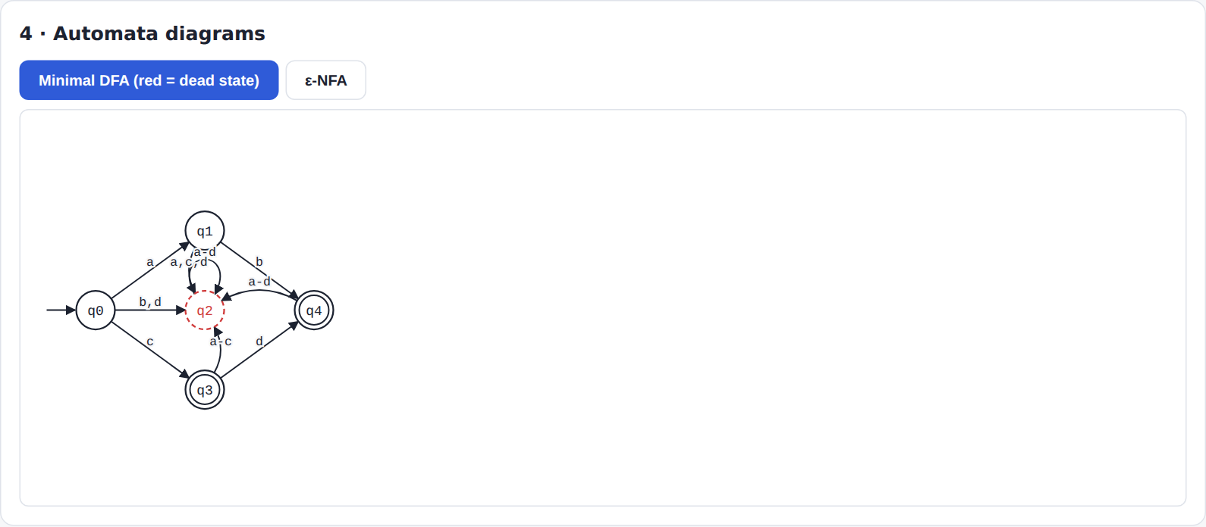
Figure 1: Minimal DFA of ab|cd? with the dead state q2 drawn in red
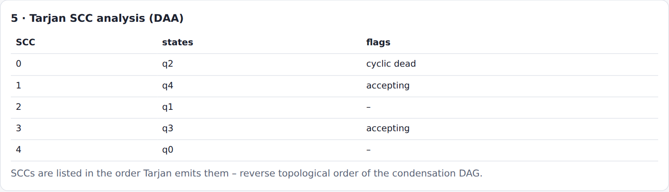
Figure 2: Web application: SCC table for ab|cd?

Complexity analysis
Table 4: Running time on random graphs with 3 outgoing edges per vertex (best of 3 runs)
V | E | V + E | SCCs found | Tarjan (ms) | Kosaraju (ms)
2,000 | 6,000 | 8,000 | 128 | 2.4 | 2.3
5,000 | 15,000 | 20,000 | 299 | 10.0 | 6.6
10,000 | 30,000 | 40,000 | 571 | 17.5 | 16.6
20,000 | 60,000 | 80,000 | 1135 | 52.3 | 48.7
40,000 | 120,000 | 160,000 | 2366 | 106.5 | 137.7
80,000 | 240,000 | 320,000 | 4753 | 324.1 | 393.7
160,000 | 480,000 | 640,000 | 9410 | 673.0 | 859.2

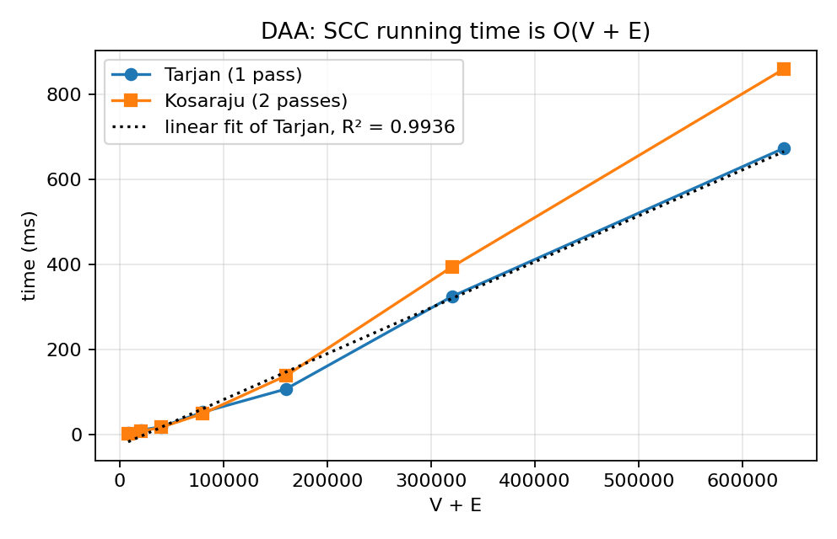
Figure 3: Measured running time against V + E with linear fit
Doubling V + E roughly doubles the running time for both algorithms, as predicted by the O(V + E) analysis; the linear fit of Tarjan's times has R² close to 0.99. In this Python implementation Tarjan and Kosaraju have similar constants: Tarjan is faster at the largest sizes because it makes a single pass and builds no transposed graph, but at small sizes the difference is within measurement noise, so no stronger claim is made. Absolute timings depend on the machine.

Test case results
Table 5: Automated test results (python -m unittest)
Test group | Tests | Result
NFA / DFA / minimisation | 5 | PASS
CPU, assembler, instruction cycle | 7 | PASS
End-to-end vs Python re (incl. 3,000-case fuzz) | 4 | PASS
Regex parser (postfix, classes, error handling) | 5 | PASS
Tarjan & Kosaraju SCC, dead states, finiteness | 7 | PASS
Total | 28 | ALL PASS

Table 6: Selected DAA test cases (tests/test_all.py, class TestSCC)
Test case | Expected | Result
Textbook graph with SCCs {0,1,2}, {3,4,5}, {6,7}, {8} | 4 components | PASS
Chain 3→0→1→2: emission order | 2, 1, 0, 3 (reverse topological) | PASS
Self-loop and isolated vertex; empty graph | [[0],[1]]; [] | PASS
300 random graphs, Tarjan vs Kosaraju | identical partitions | PASS
Path graph with 200,000 vertices | 200,000 components, no RecursionError | PASS
DFA of ab*: dead states | exactly the trap state | PASS
a* infinite; ab|cd? finite, words c, ab, cd | as stated | PASS

Chapter IV – Conclusion
Tarjan's algorithm was implemented iteratively, verified against an independent Kosaraju implementation and shown experimentally to run in time linear in V + E. Applied to the DFA produced by the FLAT part of the project, it identifies the dead trap state, detects loops and decides whether a language is finite, all from one traversal and one pass over the condensation DAG. The pruned automaton is then compiled to machine code and run on the simulated CPU of the COA part.
The key idea worth remembering is the reverse-topological emission order: it lets dynamic programming over the condensation DAG run during the SCC computation itself. Possible extensions are bridge and articulation-point detection with the same low-link technique, 2-SAT solving, and analysing larger automata such as lexer DFAs.

