Single User OS
PC DOS --> IBM
MS DOS --> MicroSoft CUI

MS Windows --> GUI
Multi-user OS
Unix, Linux

C Program
Dennis Richie --> 1972 --> AT & T Bell Labs

BCPL (B) --> Ken Thomson

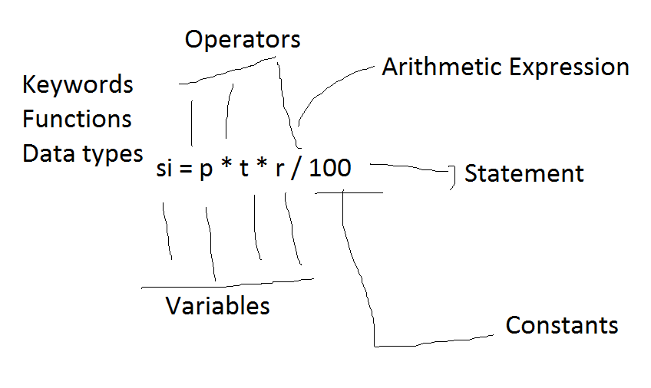

Constants
1. Numeric
Integer
10
-122
+100
Real (float)
10.0
-10.7

2. Non- Numeric
Character
'a'
'7'
'@'
String --> Sequence of characters
password
"Anirudh@123"
Variable
It is one type of identifier.
It is a container
It is a reference to memory location

Identifier
User defined words

Rules to define identifier
1. It can contains alphabets (Lower case & Upper case), Digits & _(Underscore).
2. It should not start with digit
3. It should not be keywords
4. Case sensitive
5. Length may be anything

C has 32 keywords

Operators

Arithmetic
+ Addition
- Substraction
* Multiplication
/ division
% Modulus

#include <stdio.h>

int main()
{
printf("%d", 10 % 16);

return 0;
}

#include <stdio.h>

int main()
{
printf("%f", 10.5%2.5); //Error

return 0;
}

#include <stdio.h>
#include <math.h>
int main()
{
printf("%.2f", fmod(10.5,2.5));

return 0;
}

#include <stdio.h>
#include <math.h>
int main()
{
printf("%g", fmod(10.5,2.5));

return 0;
}
Relational
>
>=
<
<=
==
!=
#include <stdio.h>
int main()
{
int a = 10, b = 20;

printf("%i", a>=b);

return 0;
}

Logical --> Short circuit operators
&&
||
!

#include <stdio.h>
int main()
{
int a = 10;
int b;
b = !a;
printf("%i", b);

return 0;
}

#include <stdio.h>
int main()
{
int a = 0;
int b;
b = !a;
printf("%i", b);

return 0;
}

Increment/Decrement
++/--

a++ ==> a = a + 1 (Post)
++a ==> a = a + 1 (Pre)

#include <stdio.h>
int main()
{
int a = 7;
int b, c;
b = ++a;
c = a++ + --b;
printf("%d %d %d", a,b,c);

return 0;
}

Ternary or Conditional

?:

Syntax:
<condition>?<true>:<false>;

#include <stdio.h>

int main()
{
int x, y;
scanf("%d %d", &x, &y);
// x>y?printf("%d is greater", x):printf("%d is greater", y);

printf("%d is greater", x>y?x:y);

// if (x > y)
// printf("%d is greater", x);
// else
// printf("%d is greater", y);

return 0;
}
/*
Good program
1. Time complexity
2. Space complexity
3. Code optimization
*/

#include <stdio.h>
//Program to print biggest of three values
int main()
{
int x, y, z;
scanf("%d,%d,%d", &x, &y, &z);
printf("%d", x > y && x > z ? x : (y>z?y:z));

return 0;
}

#include <stdio.h>
//Program to check whether the given number is odd or even
int main()
{
int x;
scanf("%d", &x);
printf(x%2?"Odd":"Even");

// if ( x % 2 == 0)
// printf("Even");
// else
// printf("Odd");
return 0;
}

Bitwise
& AND
a = 5
b = 9
c = a & b ==> Output is 1 if both inputs are 1 otherwise is 0.

0000 0000
a 0000 0101
b 0000 1001 (&)
=========
0000 0001
=========

| OR

a = 5
b = 9
c = a | b ==> Output is 0 if both inputs are 0 otherwise is 1.

0000 0000
a 0000 0101
b 0000 1001 (|)
=========
0000 1101
=========

^ XOR

a = 10
b = 8
c = a ^ b ==> Output is 0 if both inputs are same otherwise is 1.

0000 0000
a 0000 1010
b 0000 1000 (^)
=========
0000 0010
=========

~ NOT, Negation, 1's complement

>> Right shift
<< Left shift

Decimal Binary Octal Hexa
0 0 0 0
1 1 1 1
2 10 2 2
3 11 3 3
4 100 4 4
5 101 5 5
6 110 6 6
7 111 7 7
8 1000 10 8
9 1001 11 9
10 1010 12 A
11 1011 13 B
12 1100 14 C
13 1101 15 D
14 1110 16 E
15 1111 17 F
16 10000 20 10

Assignment:
1. Program to check character is vowel or not using ternary
2. Program to check character is digit or not
3. Program to check whether the given is lower case or not
4. Program to check whether the given is upper case or not

#include <stdio.h>

int main()
{
int x;
scanf("%d", &x);

if ( x % 2 == 0)
printf("Even");
else;
printf("Odd");

return 0;
}

/*
Control Structures
1. Sequential
2. Selective
if statement
if (<condition>){
<statements>
}
[else if (<condition>){
<statements>
}
[else {
<statements>
}]
]

switch statement
3. Iterative
*/

#include <stdio.h>

int main()
{
int x;
scanf("%d", &x);

if ( x % 2 == 0)
printf("Even");
printf("Odd");

return 0;
}

/*
Control Structures
1. Sequential
2. Selective
if statement
if (<condition>){
<statements>
}
[else if (<condition>){
<statements>
}
[else {
<statements>
}]
]

switch statement
3. Iterative
*/

#include <stdio.h>

int main()
{
int x=10;

if ( x = 20){
printf("Jeevan is sooo handsome!");
}
else
printf("Mano is soooo hansome!");

return 0;
}

/*
Control Structures
1. Sequential
2. Selective
if statement
if (<condition>){
<statements>
}
[else if (<condition>){
<statements>
}
[else {
<statements>
}]
]

switch statement
3. Iterative
*/

#include <stdio.h>

int main()
{
int x=10;

if ( x = 20, x=0){
printf("Jeevan is sooo handsome!");
}
else
printf("Mano is soooo hansome!");

return 0;
}

/*
Control Structures
1. Sequential
2. Selective
if statement
if (<condition>){
<statements>
}
[else if (<condition>){
<statements>
}
[else {
<statements>
}]
]

switch statement
3. Iterative
*/

#include <stdio.h>

int main()
{
int x=10;

if ( x = (20,10,-1)){
printf("Jeevan is sooo handsome! %d", x);
}
else
printf("Mano is soooo hansome!");

return 0;
}

/*
Control Structures
1. Sequential
2. Selective
if statement
if (<condition>){
<statements>
}
[else if (<condition>){
<statements>
}
[else {
<statements>
}]
]

switch statement
3. Iterative
*/

#include <stdio.h>
int main(){
char product_name[20];
int quantity;
float price, bill_amount, discount, net_amount;
printf("Product Name : ");
scanf("%s", product_name);
printf("Quantity : " );
scanf("%d", &quantity);
printf("Price : ");
scanf("%f", &price);
bill_amount = quantity * price;
if (bill_amount >= 5000)
discount = bill_amount * 15 / 100;
else
discount = 0;
net_amount = bill_amount - discount;
printf("Bill Amount : %010.2f\n", bill_amount);
printf("Discount : %010.2f\n", discount);
printf(" ************\n");
printf("Net Amount : %010.2f\n", net_amount);
printf(" ************\n");
/*
Bill Amount : 10000.00
Discount : 1500.00
**********
8500.00
**********
%[width][.precision]<type_character>

----------
100.00
1200.50

*/

return 0;
}

/*
Control Structures
1. Sequential
2. Selective
if statement
if (<condition>){
<statements>
}
[else if (<condition>){
<statements>
}
[else {
<statements>
}]
]

switch statement
3. Iterative
*/

#include <stdio.h>
#include <math.h>
int main(){
float op1, op2, result;
char opr;
scanf("%f %c %f", &op1, &opr, &op2);
switch(opr){
case '+': // if (opr == '+')
result = op1 + op2; break;
case '-':
result = op1 - op2; break;
case '*': case 'x': case 'X':
result = op1 * op2; break;
case '/':
result = op1 / op2; break;
case '%':
result = fmod(op1, op2); break;
default:
printf("Invalid operation!");
return 0;
}
printf("%g %c %g = %g", op1, opr, op2, result);

return 0;
}
// input:
// 10 + 30

// output:
// 10 + 30 = 40

/*
Control Structures
1. Sequential
2. Selective
if statement
if (<condition>){
<statements>
}
[else if (<condition>){
<statements>
}
[else {
<statements>
}]
]

switch statement
switch(<expression>){
case <value1>:
<statements>
break;
case <value2>:
<statements>
break;
....
....
case <valueN>:
<statements>
break;
default:
<statements>
}
3. Iterative
*/

