Peltier coefficient form *Qc-remove*/*Ip* vs. *Ip*

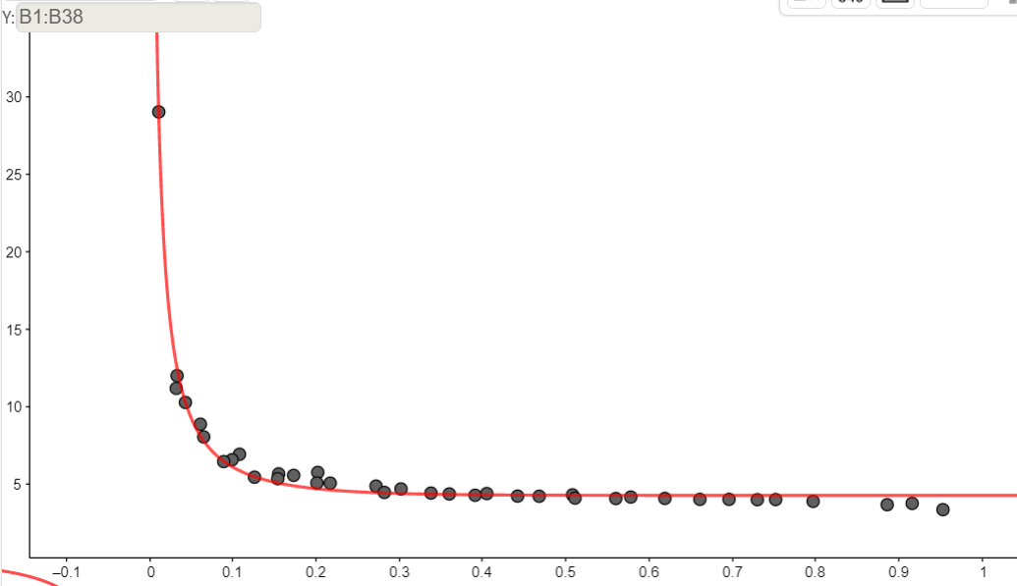

Current *Ip* from applied voltage on Peltier cell (amperes)

*Qc-remove*/*Ip* (volts)