**FACIAL HYGIENE**

Hygiene is a series of practices performed to preserve health. It refers to maintain health and prevent the spread of diseases. Facial Hygiene refers to maintaining the face’s cleanliness. Many people equate hygiene with ‘cleanliness’ but hygiene is a broad term. It includes such personal habit choices as how frequently to take shower or bath and wash face. People with poor facial hygiene could potentially face medical consequences including rashes, infections and acne. People may not realize it, but their faces get relatively dirty throughout the day. People should wash their face every day.

Our skin is alive with bacteria which we cannot see or feel, therefore maintaining a good facial hygiene is vital. Build-up bacteria forms on our skin while we go about doing our day-to-day activities, from talking on the phone at work to taking a public transportation. Skin that is left unclean can lead to an overload of dead cells, dirt and microbes. Skin needs moisture and lipids to create a protective barrier function and this can ultimately be achieved through good facial hygiene. A common benefit of facial cleansing is the removal of dirt, oil, and other unwanted debris. Throughout the day the skin on your face is continually covered with bacteria, pollutants, viruses, dirt and dead skin cells. Daily facial washing removes these impurities to give the skin a fresh look. It is also an important factor in helping the skin maintain a proper level of hydration. It helps manage PH levels of the skin enabling sufficient water and product retention. Proper skin cleansing clears pores of debris to prevent dirt buildup, it decreases the chances of a breakout. It also keeps your skin looking radiant and healthy and helps maintain proper pore size. It is very essential because it removes dead cells and oxygenate the skin, for a brighter, smoother face. The face is often the place on the body with the most oils. Whether with warm water and soap or a face cleanser, skin will remain clean and healthy. Those who develop a facial hygiene routine now will likely maintain the same routine throughout the years.

If someone stopped washing their face their pores would become clogged resulting in the development of serious acne. Their skin could also experience a combination of severe redness, dryness and irritation from insufficient hydration. Finally, their skin would generally appear dirty, oily, greasy and significantly aged. Most likely it would develop an incredible itchiness to the point where you would be forced to constantly scratch your face. This could lead to breaks of the skin which serve as entry points for infection. It’s not only how you wash your face that makes the difference, but also when and how often. Always remember that cleaning the face daily gives the skin the time to naturally heal and recover from daily wear and tear.

**ANATOMY OF THE FACE**

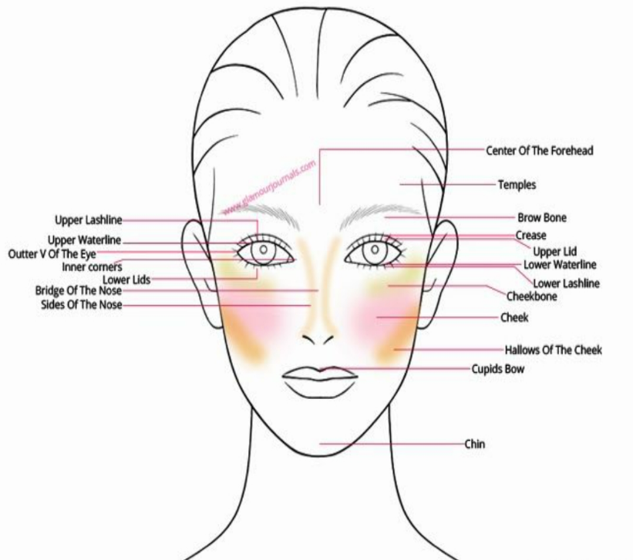 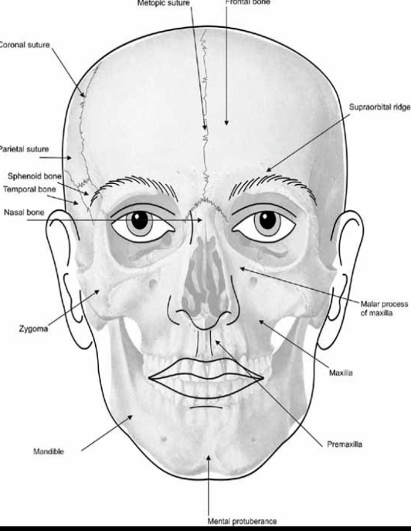



Washing your face daily may seem like an unnecessary chore, but it’s one of those good habits that improve your overall sense of hygiene. Sometimes it feels okay to skip out on. You may be too tired or running late to school or work. However, washing your face is something that shouldn’t be left forgotten. Your face is what people first look at when they met you. You want them to get a clean impression of yourself. And also let’s not forget that appropriate facial hygiene practices include not only washing the face but also properly caring for teeth, mouth, eyes and ears. But did you know that there is actually a specific way you should wash your face? Doing so will ensure you’re getting the good quality and ensure you will get radiant clean skin every time!

**STEP ONE: CLEANSE THE SKIN**

* Wash your face with water and a gentle cleanser.
* Use warm water instead of hot as it can be dying to the skin. Using warm water will help to lift dirt out of the skin.
* Massage your face with the cleanser in a circular motion, focusing most of your time on the T-zone, jaw line and the hairline.
* Rinse off all cleanser by splashing water on your face and use your hands to remove any excess cleanser.
* Finish by dabbing your face with a towel.

**STEP TWO: USE A TONER**

* Apply your favorite toner using a cotton pad or ball.
* Using a cotton pad or ball distribute the toner evenly on your skin.

**STEP THREE: DON’T FORGET YOUR EYES**

* The under eye area is the thinnest and most delicate part of your skin, so it’s important you moisture thus area separately as it can become quite dry and more prone to wrinkles.
* Use an eye cream to boost collagen production and elastin.

**STEP FOUR: APPLY A SERUM**

* Use one or two pumps of your serum product and message into clean skin.

It can be that simple for some people but figuring out how to properly wash your face for your specific skin takes a little more work than that. But it is also worth the effort to get it right. Never forget that proper facial cleansing prevents acne breakouts, can improve skin health, and may even reduce skin inflammation.