Analysis of Tweet Sentiment Pertaining to Opinions of 2020 Presidential Election   
Candidates (Biden and Trump) Using NLP and Naïve Bayes for Classification (Good, Bad)

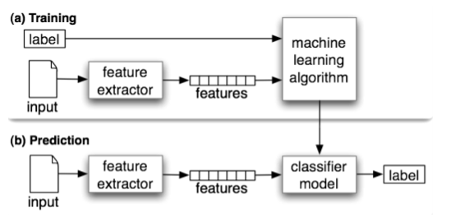

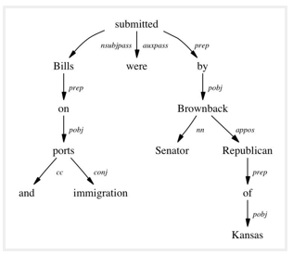

**References**

(Cover Image) Bansal S., Ultimate Guide to Understand and Implement Natural Language Processing (with codes in Python), January 12, 2017. Accessed: 5/2/2021. <https://www.analyticsvidhya.com/blog/2017/01/ultimate-guide-to-understand-implement-natural-language-processing-codes-in-python/>