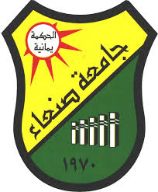=

Sana'a University

Faculty of Engineering

Mechatronics Engineering Department

Fifth Level

Mechatronics System Design

**Mask Detection System Using Convolutional Neural Networks (CNN)**

**Done by:**

Aasem Nasir Aldgree

202170208

General System

Group NO.3

**Supervised by:**

Eng. Najm Al-Dain

**Abstract**

This project presents the development of a mask detection system using **Convolutional Neural Networks (CNN)** and **OpenCV** for real-time face detection. The system is designed to classify individuals as either wearing or not wearing a mask, a key safety measure during public health crises such as the COVID-19 pandemic. The dataset consists of images labeled into two categories: with a mask and without a mask. The images were preprocessed, resized, and split into training and testing sets. A CNN model was built and trained using **TensorFlow/Keras**, achieving high accuracy in distinguishing between the two classes. The system was integrated with a real-time video stream, where faces were detected using **Haar Cascades**, and predictions were made on whether a person was wearing a mask. This real-time detection system can be deployed in public spaces to ensure compliance with mask-wearing protocols. The model demonstrates promising results, with potential for further optimization and deployment in various environments.

Contents

Introduction 2

Project Objectives 2

Data Used 2

Flowchart 3

Key Steps of the Project 6

Project Results 7

Training Plots: 7

Conclusion 8

# Introduction

This project aims to develop a system capable of detecting whether individuals are wearing a mask or not using **Convolutional Neural Networks (CNN)** and **OpenCV** for real-time face detection. This system is particularly useful in public health environments and locations where mask-wearing is mandatory to limit the spread of infectious diseases.

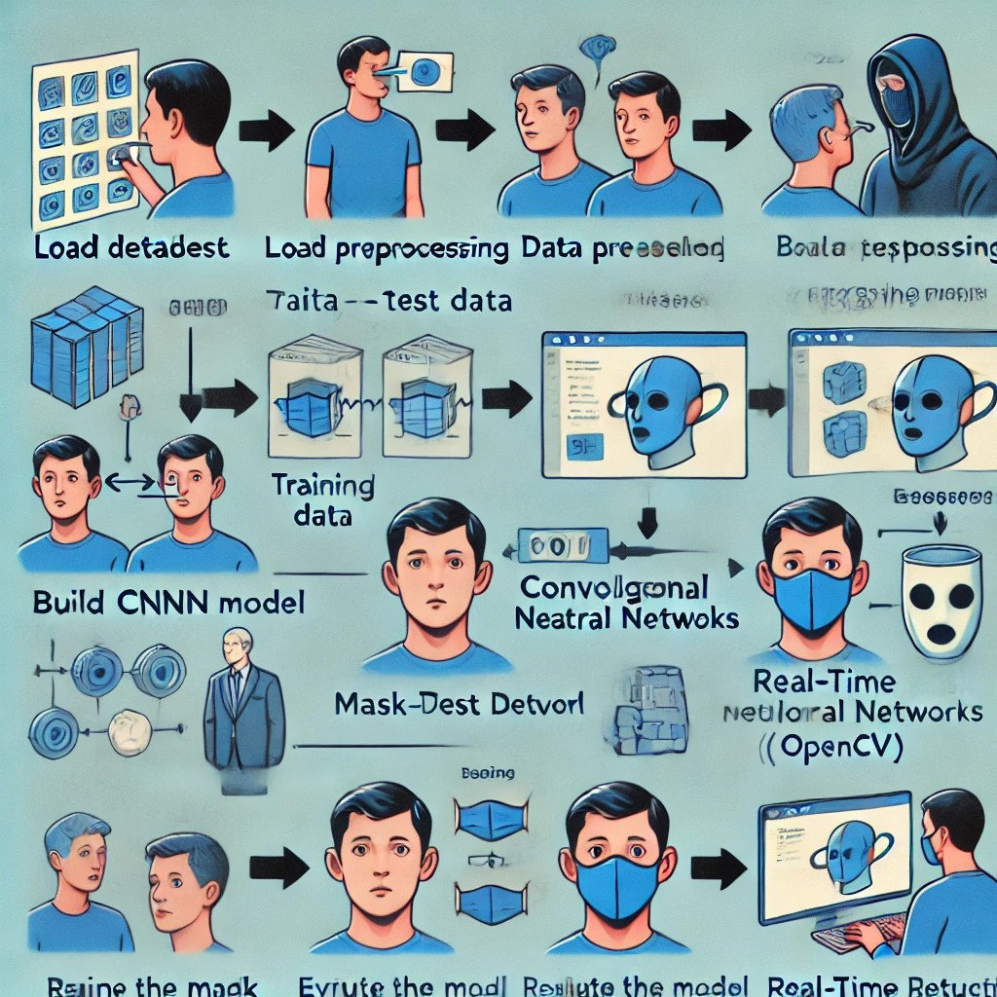

# Project Objectives

1. Build an AI model capable of classifying images into two categories: individuals wearing a mask and individuals not wearing a mask.
2. Use deep learning to create a CNN model trained on image data.
3. Integrate the model with a real-time camera to detect mask usage and issue alerts when a person is not wearing a mask.

# Data Used

* **Data Source:** The project uses two sets of data:

1. **Images with masks**: A collection of images of people wearing masks.
2. **Images without masks**: A collection of images of people without masks.

* **Number of Images:**
* With mask: 889 images.
* Without mask: 826 images.
* **Labels:**
* Label (1) is assigned to images of people wearing masks.
* Label (0) is assigned to images of people not wearing masks.

# Flowchart

* **Training the model**

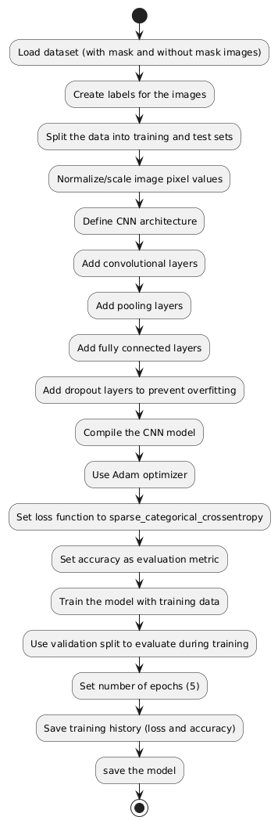

* **Main Code:**

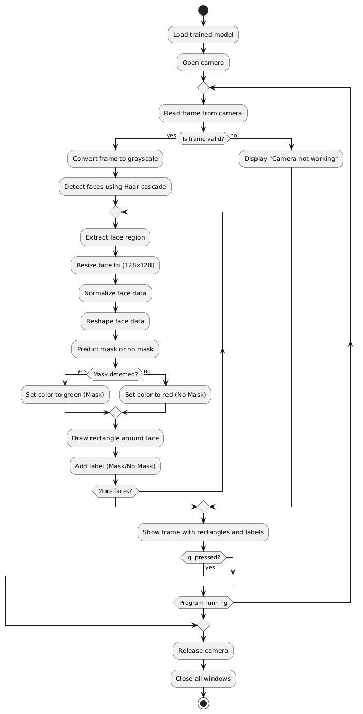

# Key Steps of the Project

1. **Importing Required Libraries**

Key libraries such as **NumPy**, **OpenCV**, **PIL**, **Matplotlib**, and **TensorFlow/Keras** are used to build the model and process the image data.

1. **Loading and Labeling Data**

Images are loaded from directories containing "with mask" and "without mask" categories, and appropriate labels are assigned to each dataset.

1. **Image Preprocessing**

The following steps were applied to the images:

* **Resizing**: All images were resized to 128×128 pixels for uniformity.
* **Conversion to NumPy Arrays**: The images were converted into NumPy arrays, making them ready for use in neural networks.

1. **Splitting Data**

The dataset was split into two sets: a training set (80%) and a testing set (20%) using the **Scikit-Learn** library.

1. **Building the CNN Model**

A CNN model was created using the **TensorFlow/Keras** library. The model comprises convolutional layers, pooling layers, and dense (fully connected) layers for final prediction.

**Model Architecture:**

* **Convolutional Layers (Conv2D)**: To extract features from the images.
* **Pooling Layers (MaxPooling2D)**: To reduce image dimensionality and prevent overfitting.
* **Dropout Layers**: To prevent overfitting during training.
* **Final Dense Layer**: To provide a binary output (mask/no mask).

1. **Training the Model**

The model was trained over 5 epochs using the **Adam optimizer** and **cross-entropy loss function**.

1. **Model Evaluation**

After training, the model was evaluated on the test set:

* **Accuracy**: The model achieved high accuracy in detecting whether a person is wearing a mask or not.

1. **Real-time Mask Detection**

**OpenCV** was used to capture video from the camera, and **Haar Cascades** were employed to detect faces. Detected faces were resized, preprocessed, and passed through the trained model to determine if the individual was wearing a mask. The results were displayed in real-time on the video feed.

# Project Results

* **Model Accuracy on the Test Set**: The model achieved high accuracy in mask detection.
* **Real-time Performance**: The system successfully detected faces and provided immediate feedback regarding mask usage.

# Training Plots:

* **Loss Plot**: Shows the reduction in model loss over time for both the training and validation sets. 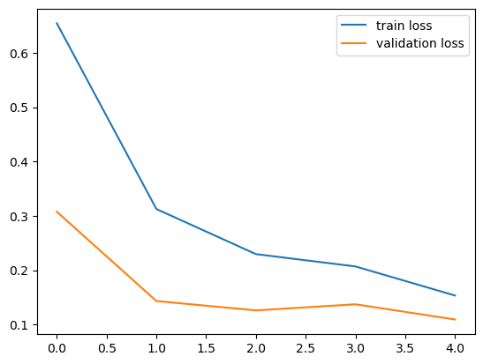
* **Accuracy Plot**: Shows the improvement in model accuracy over time for both the training and validation sets. 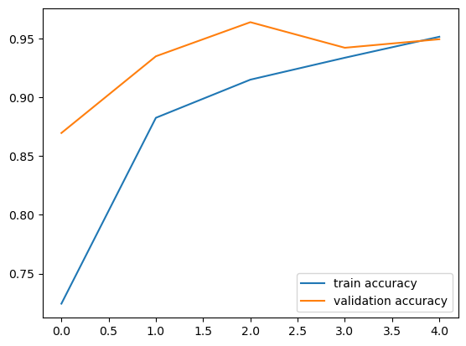

# Conclusion

This project demonstrates an effective solution for real-time mask detection using deep learning and AI technologies. The system can be deployed in public places to ensure individuals comply with mask-wearing guidelines, especially during pandemics. The model can be further improved and optimized for broader applications in different environments.