This Project Planning has been made in both methodologies: classic (Microsoft® Project) and agile (Atlassian® Jira + Scrum Poker).
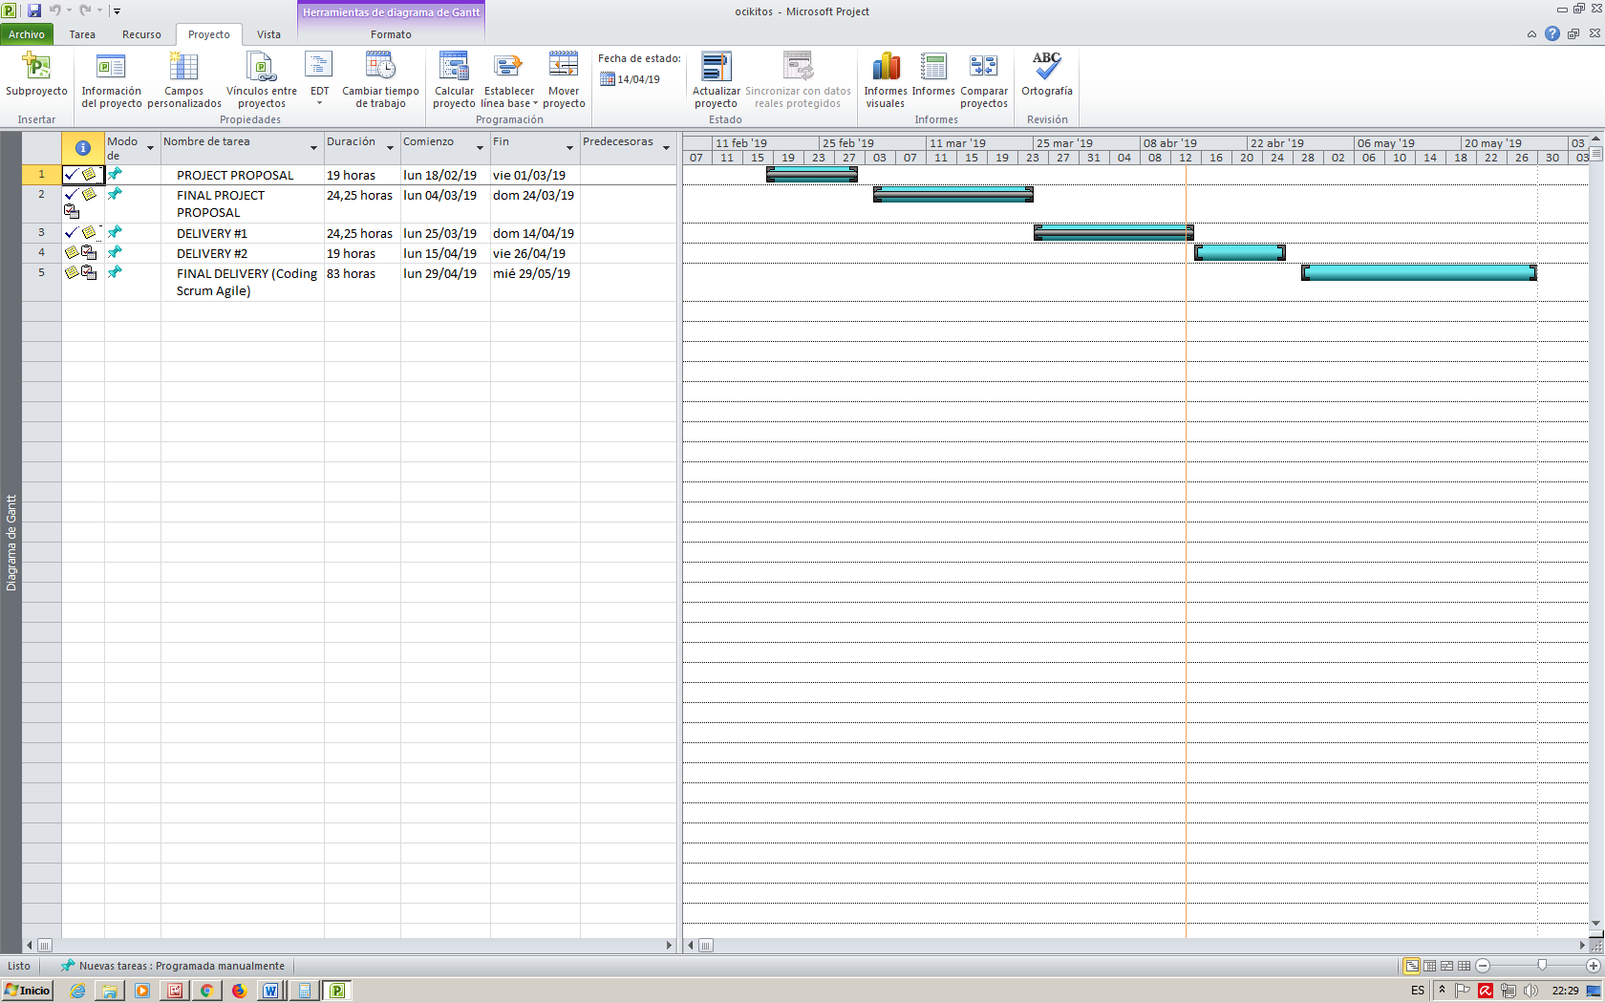

Gantt - tasks

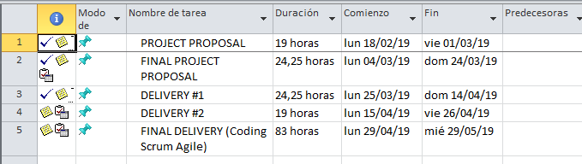

Gantt - diagram
* We have expanded the coding task 5 in an agile methodology with Atlassian® Jira (see later in this document).

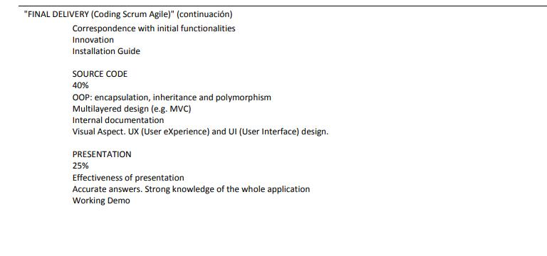
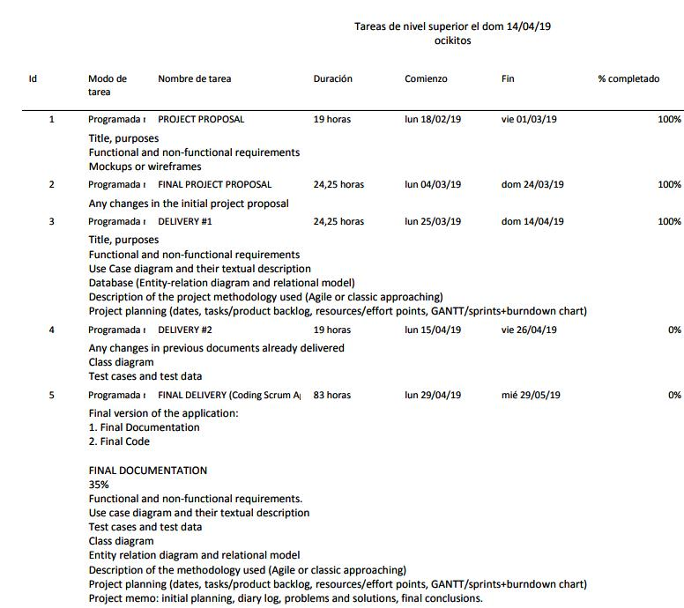

Gantt – calendar
The working time values ​​of the Proven1 calendar have been used for stages 1,2,3 and 4 (without specific time for project in teaching hours) and specifications of the Proven 2 calendar for stage 5 with time in class for project.
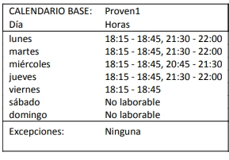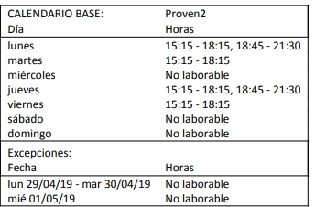

Gantt - costs

The project costs will be determined in the final delivery when we have evaluated all the resources directly and indirectly dedicated.

Sprints Planning
We are going to do 4 sprints, and each sprint is going to take 1 week.
First, the Product Backlog (this is, the User Stories) is created at Atlassian® Jira.

Product Backlog
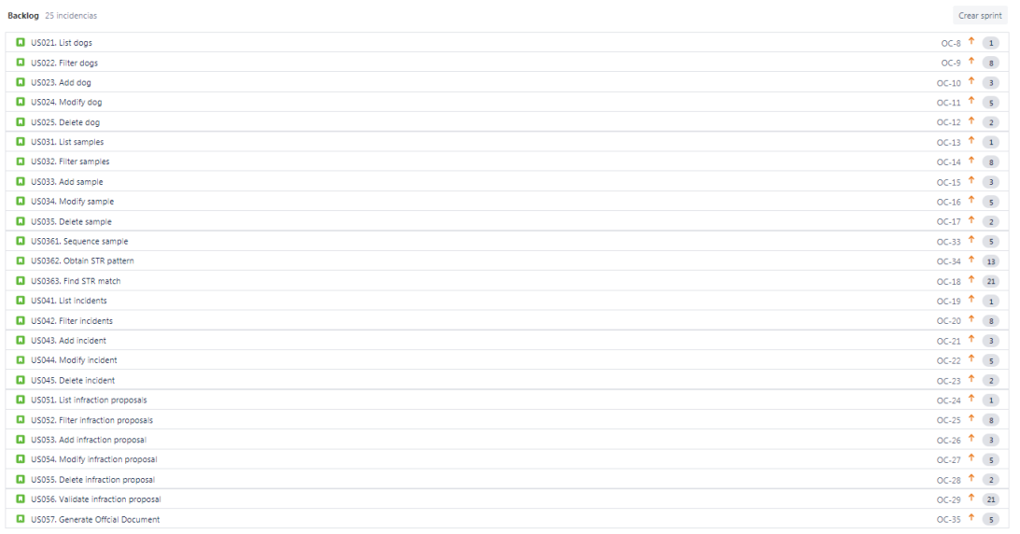

Sprints
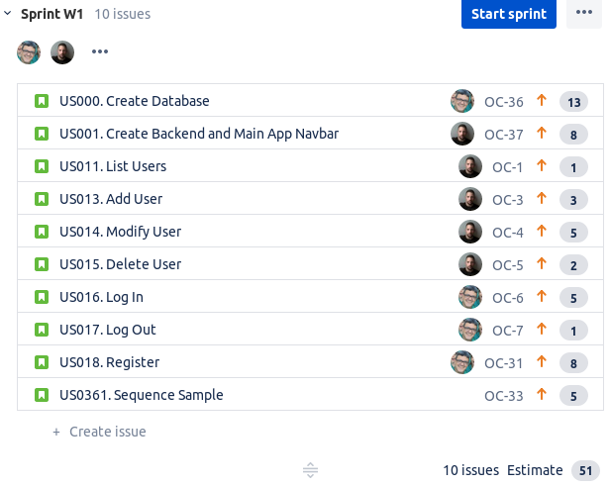
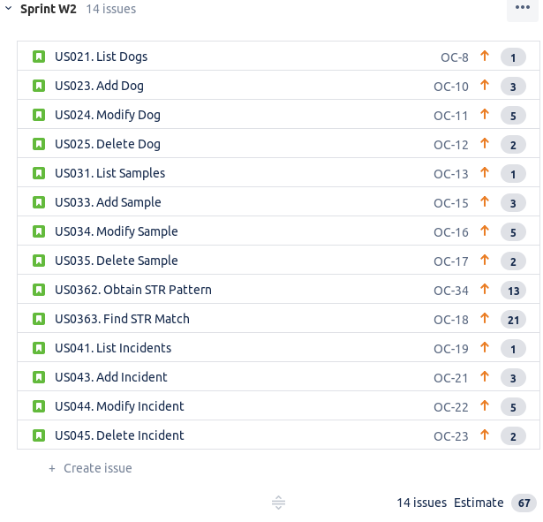
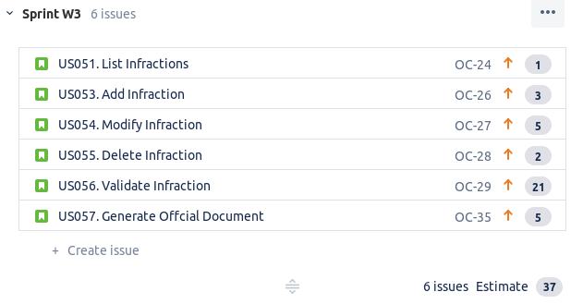
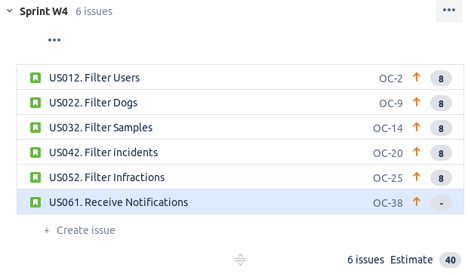
Effort points

Out of a total of 194 points of effort we have estimated an approximate average of 50 weekly to have finished the project.

We have estimated that the first sprint will be on 28/04/2019 at 05/05/2019, with 54 effort points and tasks assigned in the following way.

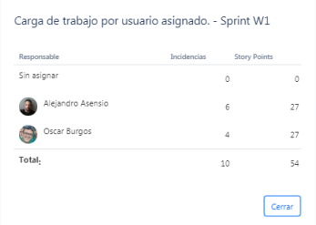

We can not evaluate the burndown chart since we have not started the first sprint. From the first sprint we will make the daily meeting (daily scrum) to follow up and expose the problems that arise. At the end of the sprint we will do the sprint review to see the finished tasks and we will do a retrospective sprint where we will evaluate the improvements for the following sprints.

