DNA-based Dog Identification
Final Project

Authors
Asensio, Alejandro
Burgos, Óscar

Center
Institut Provençana
Carrer Sant Pius X, núm 8
08901 L'Hospitalet de Llobregat, Barcelona
Curs 2018-2019

Accomplished on
29th May 2019

Studies
CFGS Desenvolupament d’Aplicacions Web -
perfil professional Bioinformàtica
(DAWBIO)

Module
M12 Project

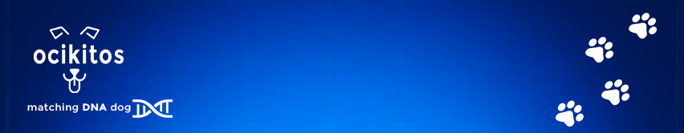

Table of Contents

Abstract 3
Use Case Diagram 5
Workflow 6
Functional Requirements 7
Define user roles 7
FR00. Database and Backend Set Up 7
US000. Create Database 7
US001. Create Backend and Main App Navbar 7
FR01. User Management 8
US011. List Users 8
US012. Filter Users 8
US013. Add User 8
US014. Modify User 8
US015. Delete User 8
US016. Log In 8
US017. Log Out 8
US018. Register 8
FR02. Dog Management 8
US021. List Dogs 8
US022. Filter Dogs 9
US023. Add Dog 9
US024. Modify Dog 9
US025. Delete Dog 9
FR03. Sample Management 9
US031. List Samples 9
US032. Filter Samples 9
US033. Add Sample 9
US034. Modify Sample 9
US035. Delete Sample 9
US036. Analyze Sample 10
US0361. Sequence Sample 10
US0362. Obtain STR Pattern 10
US0363. Find STR Match 10
FR04. Incident Management 10
US041. List Incidents 10
US042. Filter Incidents 10
US043. Add Incident 10
US044. Modify Incident 10
US045. Delete Incident 11
FR05. Infraction Management 11
US051. List Infractions 11
US052. Filter Infractions 11
US053. Add Infraction 11
US054. Modify Infraction 11
US055. Delete Infraction 11
US056. Validate Infraction 11
US057. Generate Official Document 11
FR06. Notification Management (pending) 12
US061. Receive Notifications 12
Non Functional Requirements 12
NFR01. Hardware 12
NFR02. Operating System 12
NFR03. Server 12
NFR04. Software 12
Project Planning and Developing Methodology 13
Global Tasks 13
Timeline Diagram 13
Higher Level Tasks 14
Calendar 15
Product Backlog 16
Sprints Planning 17
Effort Points 20
Burndown Chart 25
Entity-Relationship Diagram 26
Class Diagram 27
Use Case Specification 28
Test Data 35
Conclusions 39
Personal Conclusions by Alejandro 39
Personal Conclusions by Oscar 39
Bibliography 41
Annexes 44
Annex 1 – API Documentation 44
API Routes 46

Abstract
The main idea of ​​our project arose from the detection of a problem that we saw increased in our municipality lately: the large amount of dog droppings in the city, caused by the social incivility of its owners.

In order to find a solution, the local council spends large amounts of money each year trying to alleviate this incivility and have a more clean and livable city, with sensitizing campaigns.

Our idea and business model passes through the collaboration with the city council, being we in charge of the management of the process as a company of contracted services and also the application of a new municipal law.

This idea is based on the detection of the dog that has left the excrement in the street without its owner picking it up. To be able to proceed with this detection, we will need to analyze these excrements through the STR of the dog's DNA and thus be able to identify it through the stored identification data of the dogs registered in the municipality.

Currently, dog owners are required to register their pets at the town hall and implant a chip for their identification control.

This project aims to use bioinformatics’ tools along with web developing to identify a certain dog by its Short Tandem Repeats (STR) pattern, located among the different chromosomes of its DNA. That identification may have several uses, and one of them is helping towns and cities to maintain the streets clean from dogs' droppings.

To accomplish that mission, we are building a web application with Laravel 5.8 for a RESTful API backend, Angular 7 for the frontend, Python for the scripts, and MySQL as relational database for persistence.

The following points describe the expected workflow of our web app:

- Veterinarian registers a new Dog with chip number, owner's DNI and saliva sample into a Kit.
- Bioinformatics Technician sequences the DNA from the saliva sample, getting the fasta file and the STR pattern.
- Street Agent takes a sample of a dog's droppings found in street, introduces the sample into the Kit, and registers the Incident into the app, storing the location, a photo as evidence and the Kit's barcode number.
- Bioinformatics Technician sequences the DNA from the droppings sample, getting the fasta file and the STR pattern, which will reveal if it matches with some existing saliva sample. This method allows us to uniquely identify a certain dog. If there is no match, a new "Suspected non-registered Dog" log is automatically stored in our database.
- A Police Officer validates the evidences: photo + location + STR matching patterns. If everything is considered as correct, a new Infraction Proposal is generated and sent to Town Administration, which will proceed with the corresponding monetary fine to the dog's owner.

Use Case Diagram

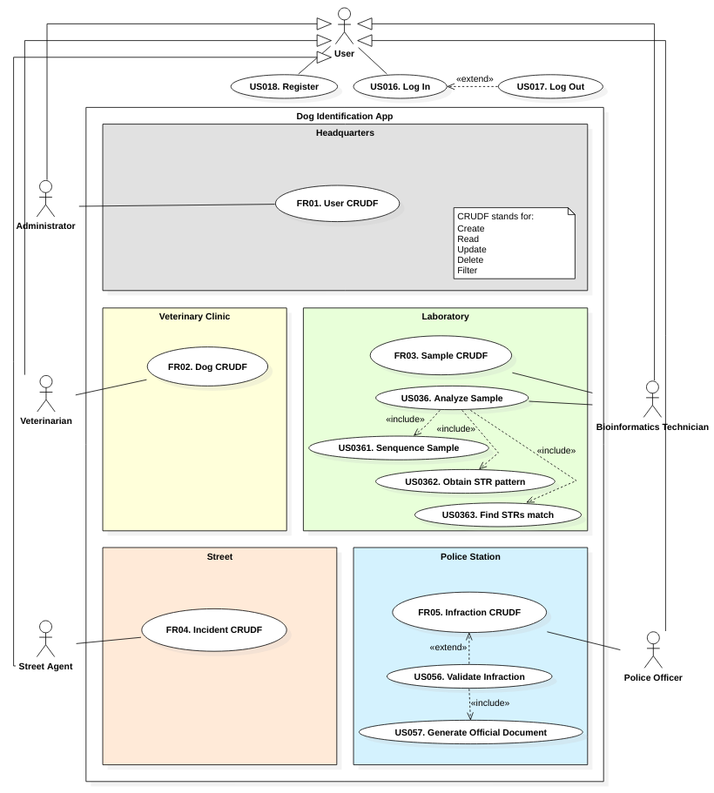

Workflow

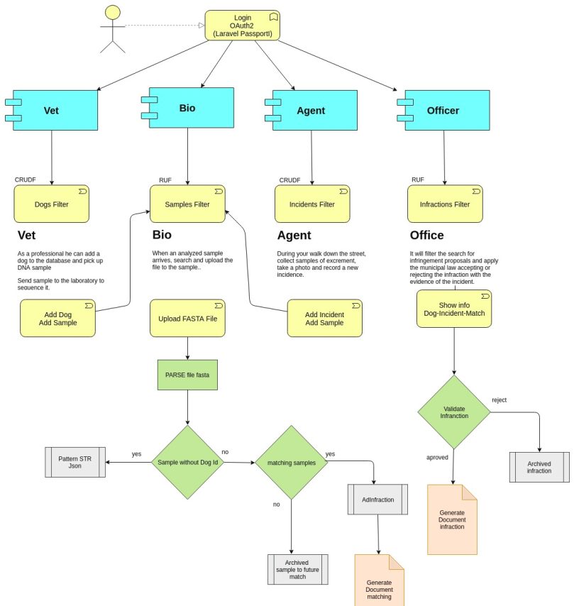

Functional Requirements
This document has the purpose of defining the Functional Requirements (FR) of the project. In order to accomplish that, we are going to break them into User Stories (US), which will be implemented afterwards, in the code developing stage.

Define user roles
As the Product Owner, I want to define the basic user roles for the application, so that I can decide which tasks are performed by which role(s). The roles are:
- Application Administrator, admin, who has permission to manage the users, as well as all the actions inside the application; for instance, the massive load of Kits for samples (barcode as id).
- Veterinarian, vet, who is able to create or modify a Dog entry, injecting the chip into the dog's skin and taking a sample of dog's saliva into the Kit.
- Bioinformatics Technician, bio, who is able to create a Sample entry, which contains its DNA sequence info, such as the fasta and STR's files; as well as determine if two samples are from the same dog (match).
- Street Agent, agent, who is able to create an Incident entry, taking the dog droppings sample into the Kit and uploading a photo of them.
- Police Officer, officer, who is able to validate, invalidate or ask for more evidences about the droppings street Incident. By validating the Incident,
- Final User, dog, who is able to log in from the dog perspective, this is, and list the Infractions of its human owner, as well as modify some customizable fields, such as the alias, the password or the profile photo.
In this project we are implementing the CRUD (Create, Read, Update, Delete) system for every object type in our app, plus the Filter function; so we call it CRUDF.

FR00. Database and Backend Set Up

US000. Create Database
As an admin, I want to create the MySQL database structure and the needed tables, so that I can store the information of the app.

US001. Create Backend and Main App Navbar
As an admin, I want to create the backend project using the Laravel framework and the main navbar in blade syntax, so that I can start developing and placing the functionalities on the app.

FR01. User Management

US011. List Users
As an admin, I want to list all the users, so that I can check their info and know the total amount of users in the app.

US012. Filter Users
As an admin, I want to filter the users list, so that I can search for an specific user.

US013. Add User
As an admin, I want to create a new user with an specific role, so that I can give the correct permissions to use the app.

US014. Modify User
As any user role, I want to modify the editable fields of my user, such as my password, so that I can maintain my account updated and secure.

US015. Delete User
As an admin, I want to delete a wrong user entry, so that I can maintain clean the users table in database.

US016. Log In
As any user role, I want to log in the app, so that I can use its functionalities, depending on my role.

US017. Log Out
As any user role, I want to log out from the app, so that I can leave the site securely.

US018. Register
As a new user, I want to register into the app, so that I can be assigned an specific role by the admin and start contributing to the app.

FR02. Dog Management

US021. List Dogs
As a vet, I want to list all the dogs, so that I can check their info and know the total amount of dogs in the app.

US022. Filter Dogs
As a vet, I want to filter the dogs list, so that I can search for an specific dog.

US023. Add Dog
As a vet, I want to create a new dog entry, so that I can register its new chip number, body features and the Kit's barcode; that Kit is made for taking a saliva sample from dog. This is the START of our workflow.

US024. Modify Dog
As vet, I want to modify a dog entry, so that I can update any change what is needed. For example, if a dog dies, we are not deleting it, but modifying its status field.

US025. Delete Dog
As a vet, I want to delete a wrong dog entry, so that I can maintain clean the dogs table in database.

FR03. Sample Management

US031. List Samples
As a bio, I want to list all the samples, so that I can check their info and know the total amount of samples in the app.

US032. Filter Samples
As a bio, I want to filter the samples list, so that I can search for an specific sample.

US033. Add Sample
As a bio, I want to create a new sample entry, so that I can register its sequenced DNA as a fasta file and the obtained STR's, which identifies the dog uniquely.

US034. Modify Sample
As a bio, I want to modify a sample entry, so that I can update any change what is needed. For example, if the sequentiation process has to be repeated, the fasta file must be overwritten.

US035. Delete Sample
As a bio, I want to delete a wrong sample entry, so that I can maintain clean the samples table in database.

US036. Analyze Sample
As a bio, I want to analyze a sample, so that I can sequence it, obtain its STR pattern and find a possible STR match among our database. This user story is complex, so it has been split in three sub-tasks.

US0361. Sequence Sample
As a bio, I want to sequence a sample, so that I can store it as a FASTA file as an attribute of the sample register.

US0362. Obtain STR Pattern
As a bio, I want to obtain the STR pattern of a sample, so that I can identify a unique dog by that pattern of Short Tandem Repeats of DNA.

US0363. Find STR Match
As a bio, I want to find a possible STR match, so that I can uniquely identify a certain dog that was previously registered in our database. If the match occurs, an Infraction proposal is automatically emitted to the Police Officers; if no match is found, this anonymous sample is stored and our workflow reaches its END.

FR04. Incident Management

US041. List Incidents
As an agent, I want to list all the incidents, so that I can check their info and know the total amount of incidents in the app.

US042. Filter Incidents
As an agent, I want to filter the incidents list, so that I can search for an specific incident.

US043. Add Incident
As an agent, I want to create a new incident entry, so that I can register the location, an attatched photo of the evidence, along with the Kit barcode, where the dog droppings sample is taken.

US044. Modify Incident
As an agent, I want to modify an incident entry, so that I can update the attatched photo or re-scan the Kit barcode.

US045. Delete Incident
As an agent, I want to delete a wrong incident entry, so that I can maintain clean the incidents table in database.

FR05. Infraction Management

US051. List Infractions
As an officer, I want to list all the infraction proposals, so that I can check their info and know the total amount of infraction proposals in the app.

US052. Filter Infractions
As an officer, I want to filter the infraction proposals list, so that I can search for an specific infraction proposal.

US053. Add Infraction
As an officer, I want to add an infraction proposal entry manually.

US054. Modify Infraction
As an officer, I want to modify an infraction proposal entry manually. so that I can fix any possible wrong information.

US055. Delete Infraction
As an officer, I want to delete a wrong infraction entry, so that I can maintain clean the infractions table in database.

US056. Validate Infraction
As an officer, I want to validate an Infraction proposal. In one hand, I may want to approve an existing infraction proposal entry, so that I can confirm the evidences; in this case, the infraction status changes to "approved". In the other hand, I may want to reject an existing infraction proposal entry, so that I can refuse the evidences as non-conclusive (maybe due to a non-accurate droppings photo or an inconsistency between owner address and Incident address); in this case, the infraction status changes to "rejected".

US057. Generate Official Document
As an officer, I want to emit an automated generation of an offical document, so I can proof my approval or rejection of an Infraction proposal. That document will be sent to the corresponding Town Administration. At this point, our workflow reaches its END.

FR06. Notification Management (pending)

US061. Receive Notifications
As any user role, I want to receive a notification when a certain task is pending to be done by my user role, so that I can get my work done on time and when it's needed. For example, when a sample is sent to the lab, the bio role will receive a notification to analyze that sample. Other example is: when an infraction proposal is created and is pending to be validated, the officer role will receive a notification to accept or reject that infraction proposal.

Non Functional Requirements
This section has the purpose of defining the Non Functional Requirements (NFR) of the project. In other words, the infrastructure we need to build our application.

NFR01. Hardware
We need a computer for each one of us, with a minimum requirements: a decent processor like an Intel i5/i7 and 8GB RAM.

NFR02. Operating System
We need a Linux-based operating system, such as Ubuntu, with a set of software tools to implement the source code and test the application.

NFR03. Server
We need a Linux-based server, such as Ubuntu Server, with a set of software tools to deploy the application and perform tests in a real environment.

NFR04. Software
We need certain packages to write and test our code, such as programming language compilers and/or interpreters (PHP, Python), frameworks (Laravel), IDE (Netbeans, Visual Studio Code), web browsers (Firefox, Chromium) and version control system (Git, GitHub), database engine (MySQL), Python libraries (exrex).

Project Planning and Developing Methodology

This project has been planned with two methodology types:
- Classic, implemented with Microsoft® Project.
- Agile, implemented with Atlassian® Jira and Scrum Poker.

For the first stages (documentation tasks), we are using a classic methodology; and for the last stage (coding tasks), we are using an agile methodology.

Global Tasks
The first actions to define are the tasks’ names, duration, date of start and date of end. This has been made with Microsoft® Project software.

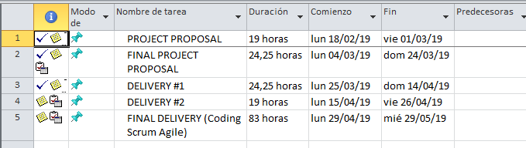

Timeline Diagram
This is the GANTT classic methodology to represent the tasks to be performed along the project’s time period.

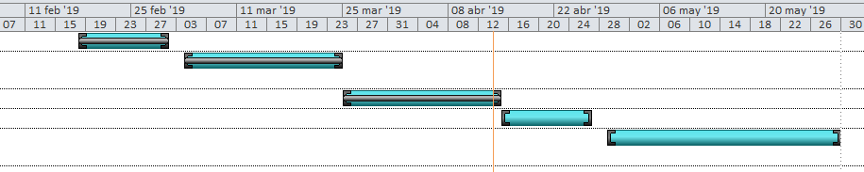

The last task (coding stage) have been planned with an agile methodology. See below in this document.

Higher Level Tasks

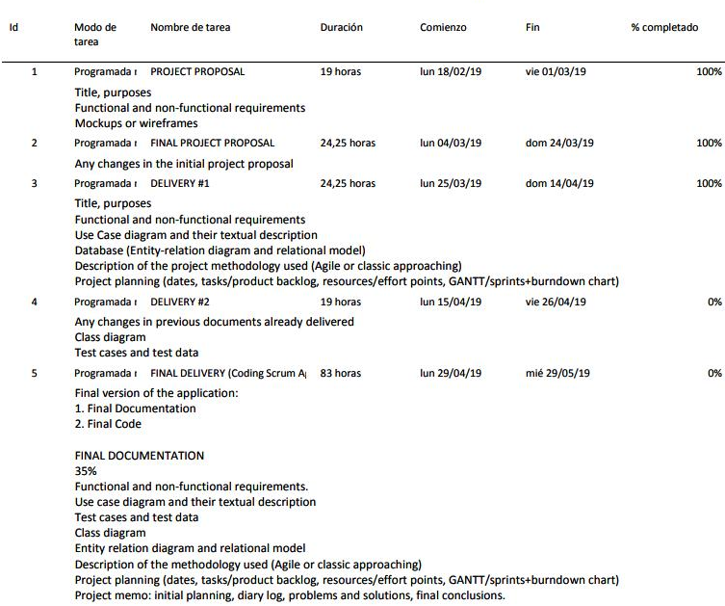
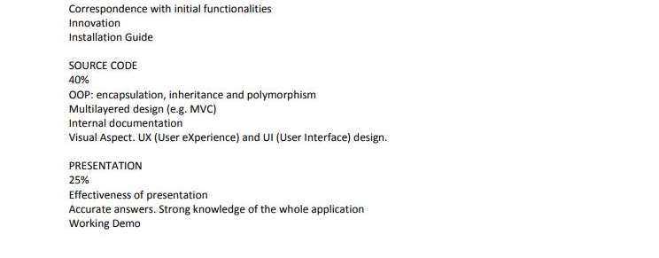

Calendar

The working time values ​​of the Proven1 calendar have been used for stages 1,2,3 and 4 (without specific time for project in teaching hours) and specifications of the Proven 2 calendar for stage 5 with time in class for project.

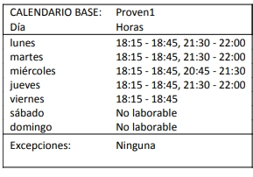
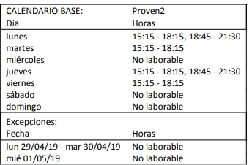

Product Backlog
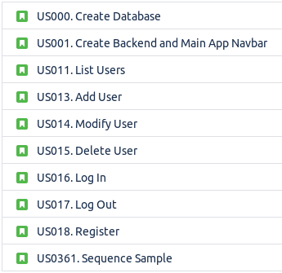
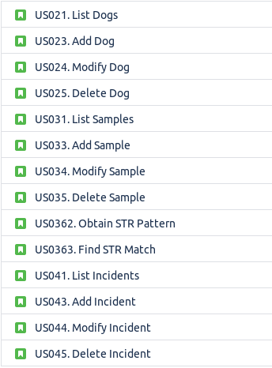
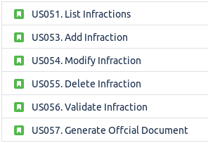

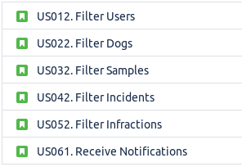

Sprints Planning
We are going to do 4 sprints, and each sprint is going to take 1 week.
First, the Product Backlog (this is, the User Stories) is created at Atlassian® Jira.

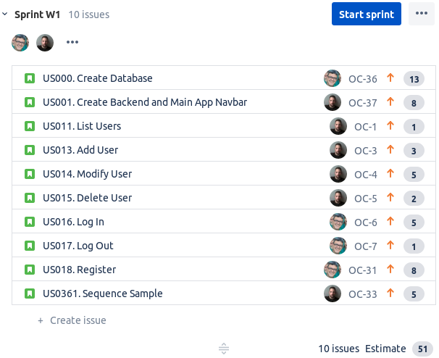
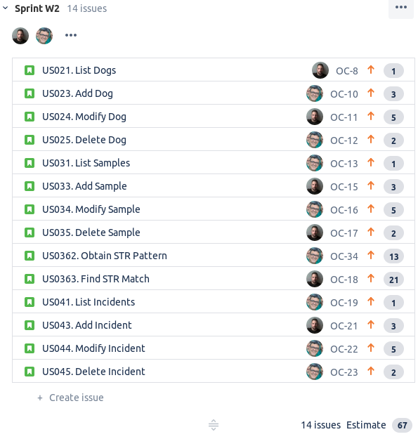
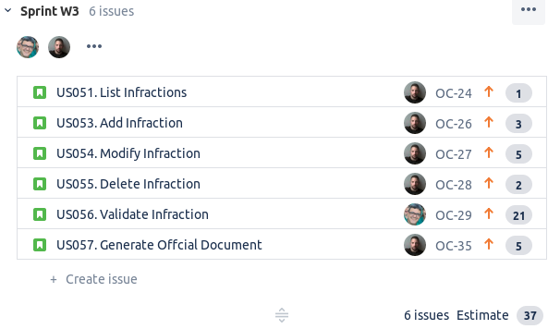

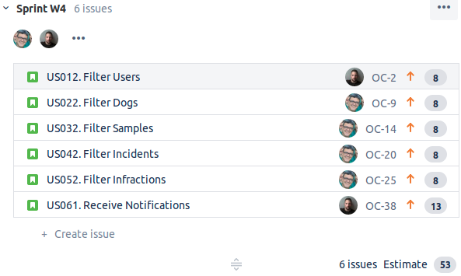

Effort Points

The developers, we have sit and assign the effort points to each user story using the agile methodology named Scrum Poker.

This can be played with real poker cards or, alternatively, using an app for smartphone. There are several Scrum Poker apps in both (Android) Google Play and (iOS) App Store.

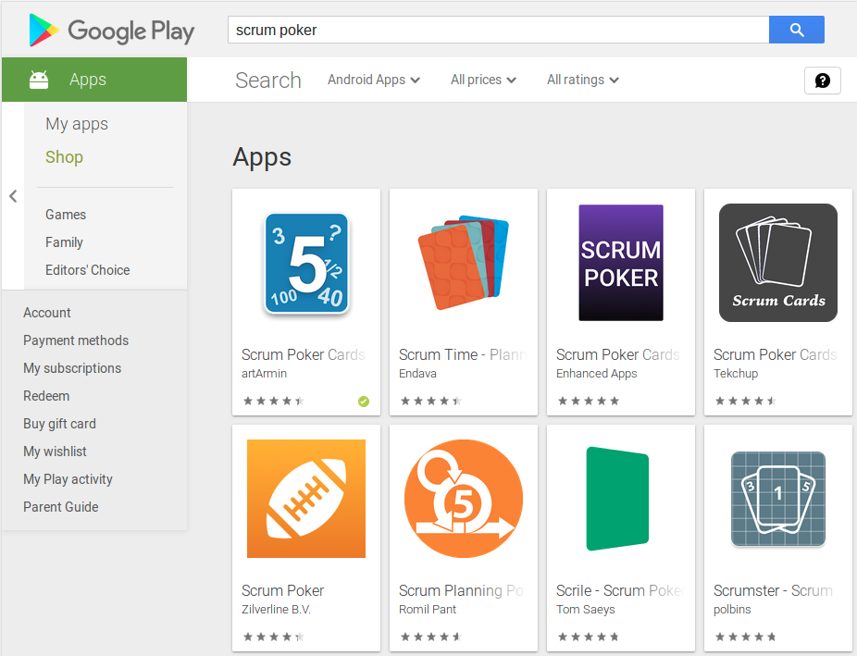
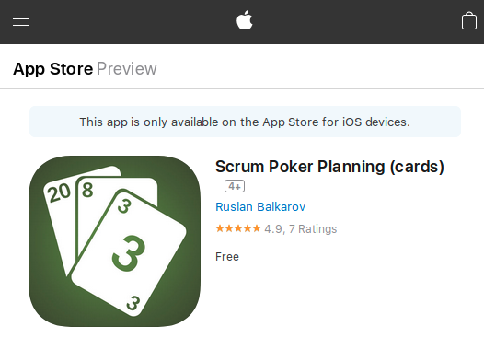

Concretely, we have used the Fibonacci progression to vote the effort points that each one thinks for each user story.

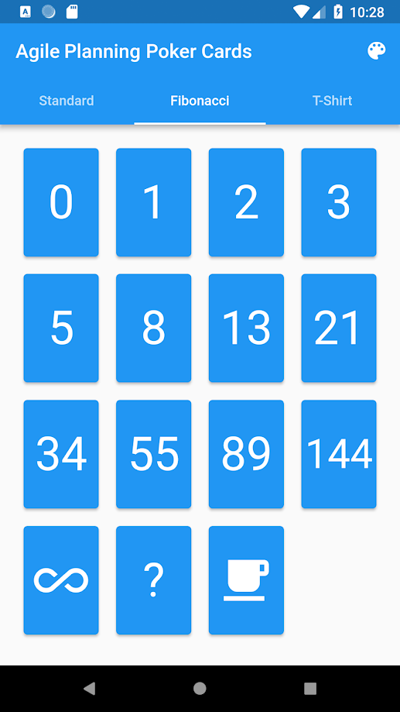

After the voting, if the two of us chose the same score, it is assigned directly to that user story; otherwise, each of us must explain why that score has been chosen. Then, we can re-vote or assign the mean of the two scores.

For each sprint, we have assigned approximately the same amount of user stories per each developer, regarding the effort points assigned by Scrum Poker previously.

Counting down all the user stories, we have a total of:

51 + 67 + 37 + 53 = 208 effort points

We have 1 month to develop de app, so if we divide the total effort points by 4 weeks, the resulting planning should have 4 sprints of approximately:

208 / 4 = 52 effort points per sprint

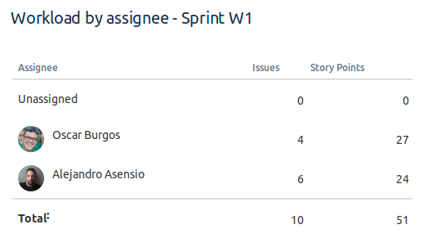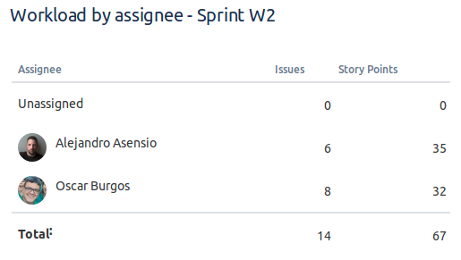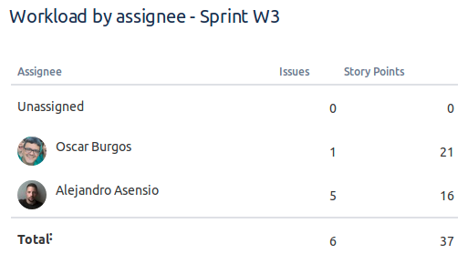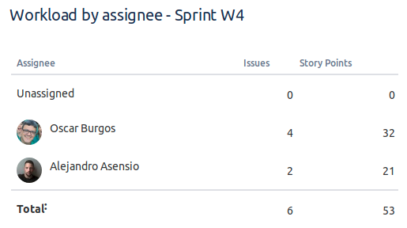

Burndown Chart

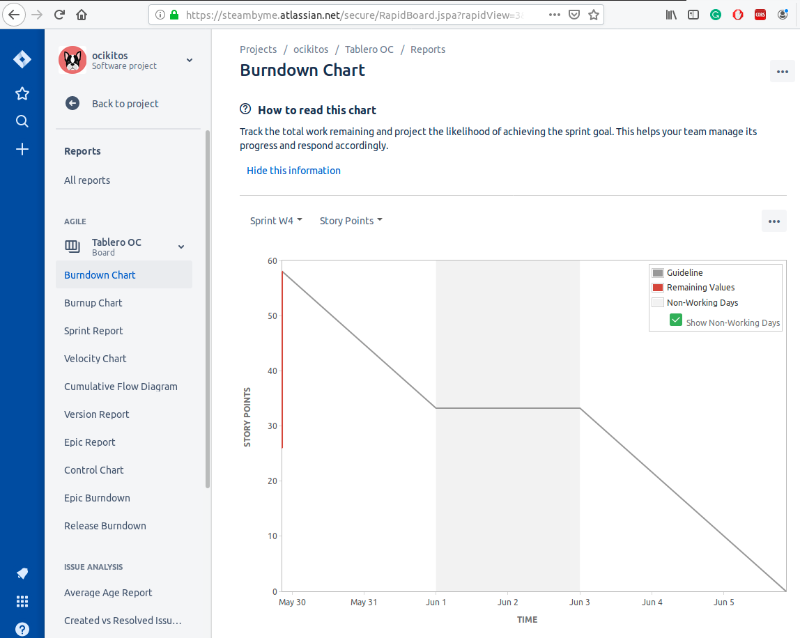

Entity-Relationship Diagram

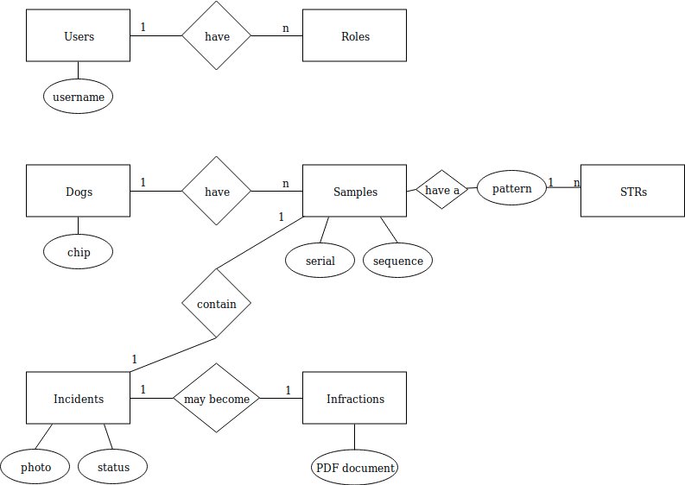

Class Diagram
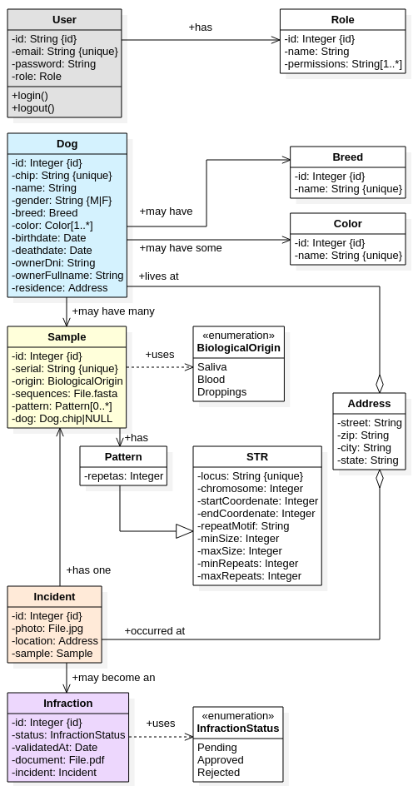

Use Case Specification

To understand better the following Use Case Specifications, first check the Use Case Diagram that illustrates them.

These Use Cases are specified by the initials US, which refers to User Stories. Those User Stories will be used later to make the project planning with an agile methodology (Scrum).

There are some use cases grouped by the same type of action.

Id | US011, US021, US031, US041, US051
Name | List users|dogs|samples|incidents|infractions
Description | List all elements of the corresponding class in table format.
Normal Flux
Actors | User with the required role for each object data management.
Pre-conditions | To be logged in the app.
Activation | Click on list button.
Description | A list of users|dogs|samples|incidents|infractions appears in table format.
Post-conditions | User can click on a row to check the detailed info about that object.
Alternative Flux 1
Description | There is no elements in database to list.
Post-conditions | A descriptive info message is shown to the user.
Alternative Flux 2
Description | There is some database error while retrieving data.
Post-conditions | A descriptive warning message is shown to the user.

Id | US012, US022, US032, US042, US052
Name | Filter users|dogs|samples|incidents|infractions
Description | Filter all elements of the corresponding class in table format.
Normal Flux
Actors | User with the required role for each object data management.
Pre-conditions | To be logged in the app.
Activation | Click on filter button.
Description | User types in or selects the filter criteria to get a list of filtered users|dogs|samples|incidents|infractions in table format.
Post-conditions | User can click on a row to check the detailed info about that object or change the filtering criteria.
Alternative Flux 1
Description | There is no elements in database that match the filtering criteria.
Post-conditions | A descriptive info message is shown to the user.
Alternative Flux 2
Description | There is some database error while retrieving data.
Post-conditions | A descriptive warning message is shown to the user.

Id | US013, US023, US033, US043, US053
Name | Add user|dog|sample|incident|infraction
Description | Add a new object of a given class to its corresponding table in database.
Normal Flux
Actors | User with the required role for each object data management.
Pre-conditions | To be logged in the app.
Activation | Click on add button.
Description | User completes the according form to add a new user|dog|sample|incident|infraction.
Post-conditions | A success message is shown to the user.
Alternative Flux 1
Description | There is some form field with validation errors.
Post-conditions | As many info messages as validation errors are shown to the user.
Alternative Flux 2
Description | There is some error while sending data to database.
Post-conditions | A descriptive warning message is shown to the user.

Id | US014, US024, US034, US044, US054
Name | Modify users|dogs|samples|incidents|infractions
Description | Modify an object of the corresponding class.
Normal Flux
Actors | User with the required role for each object data management.
Pre-conditions | To be logged in the app.
Activation | Click on modify button.
Description | User completes the according form to modify an existing user|dog|sample|incident|infraction.
Post-conditions | A success message is shown to the user.
Alternative Flux 1
Description | There is some form field with validation errors.
Post-conditions | As many info messages as validation errors are shown to the user.
Alternative Flux 2
Description | There is some error while sending data to database.
Post-conditions | A descriptive warning message is shown to the user.

Id | US015, US025, US035, US045, US055
Name | Delete user|dog|sample|incident|infraction
Description | Delete an existing object of a given class from its corresponding table in database.
Normal Flux
Actors | User with the required role for each object data management.
Pre-conditions | To be logged in the app.
Activation | Click on delete button.
Description | User confirms that is sure to delete the selected user|dog|sample|incident|infraction.
Post-conditions | A success message is shown to the user.
Alternative Flux 1
Description | The selected object cannot be deleted due to dependency reasons.
Post-conditions | A descriptive warning message is shown to the user.
Alternative Flux 2
Description | There is some error while sending the deletion action to database.
Post-conditions | A descriptive warning message is shown to the user.

Id | US016
Name | Login
Description | Log in the app with username and password.
Normal Flux
Actors | Any existing user.
Pre-conditions | To be registered in the app.
Activation | Click on login button.
Description | User types in the username and password and submits the form.
Post-conditions | The user is redirected to the dashboard according with its role.
Alternative Flux 1
Description | The username doesn’t exist.
Post-conditions | A descriptive info message is shown to the user.
Alternative Flux 2
Description | The password is not valid for the given username.
Post-conditions | A descriptive info message is shown to the user.

Id | US017
Name | Logout
Description | Log out from the app.
Normal Flux
Actors | Any existing user.
Pre-conditions | To be logged in the app.
Activation | Click on logout button.
Description | User clicks in the logout button to end its active session in the app.
Post-conditions | The user is redirected to the home page.
Alternative Flux 1
Description | There is some error while sending the logout action to the backend.
Post-conditions | A descriptive warning message is shown to the user.

Id | US018
Name | Register
Description | Register a new user in the app.
Normal Flux
Actors | Any future worker in our app.
Pre-conditions | Not to be registered yet in the app.
Activation | Click on register button.
Description | User completes the required fields and submits the form.
Post-conditions | The user is automatically logged in and redirected to the welcome page.
Alternative Flux 1
Description | The typed username already exists.
Post-conditions | A descriptive info message is shown to the user.
Alternative Flux 2
Description | The fields password and password repeat don’t match.
Post-conditions | A descriptive info message is shown to the user.

Id | US036 (includes US0361, US0362, US0363)
Name | Analyze Sample (includes Sequence Sample, Obtain STR pattern, Find STR match)
Description | Analyze a new or an existing sample.
Normal Flux
Actors | User with Bioinformatics Technician (“bio”) role.
Pre-conditions | To be logged in the app as a bio user.
Activation | Click on analyze sample button.
Description | Firstly, the sequence machine gives us the FASTA file with the raw DNA. Secondly, the STR pattern is obtained (number of repeats of each target locus). Thirdly, the previous STR pattern is tested against all database to find a potential matching.
Post-conditions | If matching occurs, a success message is shown to the user and the existing dog details are shown. If matching doesn’t occur and the sample comes from the veterinarian clinic, the current sample is stored as the first sample of the new dog, as well as its STR pattern; otherwise (the sample comes from the street agent), the sample is stored as an anonymous sample.
Alternative Flux 1
Description | There is some errors while obtaining STR pattern.
Post-conditions | A descriptive info message is shown to the user.
Alternative Flux 2
Description | There is some errors while looking for STR matching.
Post-conditions | A descriptive info message is shown to the user.

Id | US056
Name | Validate Infraction
Description | Validate (approve or reject) an infraction proposal.
Normal Flux
Actors | User with Police Officer (“oficer”) role.
Pre-conditions | An existing DNA sample has been match with another one, that means, a dog has been identified.
Activation | Click on validate infraction button.
Description | User checks all the evidences of the infraction and submits the form with the “approve” button.
Post-conditions | An automated official document of approval is generated and a descriptive success message is shown to the user.
Alternative Flux 1
Description | User checks all the evidences of the infraction and submits the form with the “reject” button.
Post-conditions | An automated official document of rejection is generated and a descriptive success message is shown to the user.
Alternative Flux 2
Description | There is some error while sending the validation action to the backend.
Post-conditions | A descriptive info message is shown to the user.

Id | US057
Name | Generate Official Document
Description | Generate a PDF document to leave proof of the Police Officer approval or rejection of an infraction.
Normal Flux
Actors | This is an automatic process after each time an officer validates an infraction.
Pre-conditions | An existing infraction proposal has to be with “pending” status.
Activation | An officer clicks on “approve” or “reject” button of the validate infraction form.
Description | User checks all the evidences of the infraction and submits the form with the “approve” button.
Post-conditions | An automated official document of approval is generated and a descriptive success message is shown to the user.
Alternative Flux 1
Description | There is some error while sending the validation action to the backend.
Post-conditions | A descriptive info message is shown to the user.

Test Data

This document is the Test Data content. Note that the coloured tables are the main models of the app, while the grayed-out ones exist to give support.

ROLES
id (PK) | name (UNIQUE) | permissions
0 | admin | all
1 | vet | dogs
2 | bio | samples
3 | agent | incidents
4 | officer | infractions
USERS
username (PK) | password | fullname | email (UNIQUE) | role_id (FK)
aasensio | aasensio1. | Alejandro Asensio | aasensio@ocikitos.com | 0
obp | obp1. | Óscar Burgos | obp@ocikitos.com | 1
eaguayo | eaguayo1. | Elisabet Aguayo | eaguayo@happydogs.com | 1
abarcelo | abarcelo1. | Ainhoa Barceló | abarcelo@bsc.com | 2
paco | paco1. | Francisco Regaña | paco@ciutatneta.bcn | 3
mgonz | mgonz1. | Marisa González | mgonz@urbana.lh | 4
BREEDS
id (PK) | name
1 | Border Collie
2 | Husky
3 | German Shepherd
4 | St. Bernard
5 | Basset Hound
COLORS
id (PK) | name
1 | white
2 | black
3 | brown
4 | lightbrown
5 | grey
6 | lightgrey
DOGS
chip (PK) | name | gender | breed_id (FK) | color_id (FK) | birthdate | deathdate | owner_dni | owner_fullname
1001 | Lassie | female | 1 | 3 | 1951-05-06 | 1963-07-05 | 69456058Z | Michael Jordan
1002 | Laika | female | 2 | 1, 2 | 1942-07-30 | 1957-11-03 | 47231677G | Elvis Presley
1003 | Rin-tin-tin | male | 3 | 1, 4 | 1949-11-18 | 1959-06-19 | 29808652P | Juana de Arco
1004 | Beethoven | male | 4 | 1, 3 | 1991-05-11 | 2007-03-10 | 58325882K | Albert Einstein
1005 | Poochy | male | 5 | 2, 3 | 2001-09-27 | 2001-10-12 | 94542968L | Homer Simpson
STRS
locus (PK) | chromosome | start_coordenate | end_coordenate | repeat_motif | min_size | max_size | min_repeats | max_repeats | annealing_temp
FH2001 | 23 | 50961325 | 50961475 | GATA | 119 | 160 | 30 | 40 | 51
FH2004 | 11 | 32161381 | 32161621 | AAAG | 233 | 325 | 58 | 81 | 64
FH2010 | 24 | 5196383 | 5196605 | ATGA | 222 | 243 | 56 | 61 | 57
FH2054 | 12 | 37914504 | 37914739 | GATA | 139 | 177 | 35 | 44 | 57
FH2088 | 15 | 53905651 | 53905779 | TTTA/TTCA | 95 | 138 | 12 | 17 | 56
FH2107 | 3 | 83830247 | 83830574 | GAAA | 292 | 426 | 73 | 107 | 54
FH2309 | 1 | 85772974 | 85773377 | GAAA | 340 | 428 | 85 | 107 | 52
FH2328 | 33 | 19158127 | 19158477 | GAAA | 171 | 213 | 43 | 53 | 58
FH3377 | 3 | 78748898 | 78749090 | GAAAA | 184 | 305 | 37 | 61 | 54
PEZ02 | 17 | 13276076 | 13276209 | GGAA | 104 | 144 | 26 | 36 | 60
PEZ05 | 12 | 60326434 | 60326541 | TTTA | 92 | 116 | 23 | 29 | 57
PEZ16 | 27 | 10305692 | 10305995 | GAAA | 281 | 332 | 70 | 83 | 57
PEZ17 | 4 | 71904833 | 71905038 | GAAA | 191 | 225 | 48 | 56 | 59
PEZ21 | 2 | 36438658 | 36438751 | AAAT | 83 | 103 | 21 | 26 | 52
VWF.X | 27 | 41977918 | 41978074 | AGGAAT | 151 | 187 | 25 | 31 | 57
SAMPLES
serial (PK) | origin | sequence | pattern | dog_id (FK)
2001 | saliva | 2001.fasta | 2001.pattern.txt | 1001
2002 | blood | 2002.fasta | 2002.pattern.txt | 1002
2003 | droppings | 2003.fasta | 2003.pattern.txt | 1003
2004 | saliva | 2004.fasta | 2004.pattern.txt | 1004
2005 | droppings | 2005.fasta | 2005.pattern.txt | NULL
INCIDENTS
id (PK) | location | photo | sample_serial
3001 | Carrer Rovires 69 num. 25 | 20190425012059.jpg | 2001
3002 | Carrer Rovires 69 num. 26 | 20190425012147.jpg | 2002
3003 | Carrer Rovires 69 num. 27 | 20190425020323.jpg | 2003
3004 | Carrer Rovires 69 num. 28 | 20190426165241.jpg | 2004
3005 | Carrer Rovires 69 num. 29 | 20190427132321.jpg | 2005
INFRACTIONS
id (PK) | status | validated_at | document | incident_id (FK)
4001 | pending | NULL | 4001.pdf | 3001
4002 | approved | 2019-03-26 | 4002.pdf | 3002
4003 | rejected | 2019-03-26 | 4003.pdf | 3003
4004 | approved | 2019-03-26 | 4004.pdf | 3004
4005 | pending | NULL | 4005.pdf | 3005

Conclusions
In the future, we may consider using the graphic user interface Voyager admin tool for Laravel [https://laravelvoyager.com/] to manage changes on the backend more quickly and consistently.

Personal Conclusions by Alejandro

This Project began with a lot of passion regarding the topic that my colleague Oscar and me have chosen: do a social improvement in our town and cities.

At mid-term tempo, we began to see that the time was going to be the limitation for our excitement. Working under pressure is tough but when the things start to be done, we could see the end of the tunnel.

In web developing terms, the previous words translate to facing OAuth2 issues because we wanted to use the official package Laravel Passport. And we finally made it. Then, Angular client had to consume the API with that particular authentication protection, handling the access token back and forth.

This little section meant to be an assertive and constructive feedback. That being said, I think that this project is a challenging opportunity to put in order all the knowledge accomplished in these two years, but I sincerely think that it would be nicer without other subjects (and their respective exams) to attend. I hope that lines will help the next generations of students, and I wish them all luck in this adventure of coding.

Personal Conclusions by Oscar

Once again I do not want to be reiterative in the demand for the extension of the time allotted for the realization of it, since it is a very important summary of the knowledge acquired during these last two years.

This project has allowed me to acquire new knowledge and skills in overcoming challenges that we have encountered at each step of the evolution of its development, reflecting a future work environment.

The beginning of this cycle, "Development of web programming with a specialty in bioinformatics", I raised it as a personal challenge; because of age and the acquisition of knowledge in biology, programming had been with me for many years but this time it would allow me to update my training. And at the beginning of this project I considered tackling my two biggest handicaps of this cycle; On the one hand, use the frontend technology with the Angular 7 framework and on the other hand the use of the English language. Not only have I managed to improve the learning outcomes stipulated in the M06 module, but I have also increased them by using new content that has not been possible to learn in the module.

It has also allowed me to work, in coordination and collaboration, with a partner to achieve a common goal; taking the opportunity to thank him for the involvement and patience with me at all times in the face of difficulties.

Thanks to my parents, classmates, project partner, teachers and especially to Conxi, Laia and Tania… Blessed patience.

Bibliography
Works Cited
https://www.mybib.com/b/noD5oN

“Angular Materials.” Angular Materials, material.angular.io/.
asciimoo. “Asciimoo/Exrex.” GitHub, 14 Jan. 2019, github.com/asciimoo/exrex. Accessed 6 May 2019.
barryvdh. “Barryvdh/Laravel-Cors.” GitHub, 26 Feb. 2019, github.com/barryvdh/laravel-cors. Accessed 22 May 2019.
“Canis Lupus Familiaris (ID 85) - Genome - NCBI.” Nih.Gov, 2016, www.ncbi.nlm.nih.gov/genome/85. Accessed 7 May 2019.
“Dog STRs.” Nist.Gov, National Institute of Standards and Technology, 2018, strbase.nist.gov/dogSTRs.htm. Accessed 24 Apr. 2019.
U.S. Department of Commerce
Font. “Font Awesome 5 Icons.” Fontawesome.Com, Font Awesome 5 Icons, 2017, fontawesome.com/icons. Accessed 28 May 2019.
“Genetic Data from 15 STR Loci for Forensic Individual Identification and Parentage Analyses in UK Domestic Dogs (Canis Lupus Familiaris).” Https://Www.Research.Ed.Ac.Uk/Portal/Files/21730846/15_STR_loci.Pdf, 26 Apr. 2019, www.research.ed.ac.uk/portal/files/21730846/15_STR_loci.pdf.
Google, INC. “Angular.” Angular.Io, 2019, angular.io/. Accessed 28 May 2019.
“Home | MyDogDNA.” Mydogdna.Com, 2015, mydogdna.com/. Accessed 29 Apr. 2019.
“Identificación Animal.” Perros.Com, 2010, www.perros.com/foros/general/veterinaria/identificacion-animal.html. Accessed 19 May 2019.
“Laravel Voyager.” Laravelvoyager.Com, 2019, laravelvoyager.com/. Accessed 12 May 2019.
Lucidchart. “UML Use Case Diagram Tutorial.” YouTube, 7 Feb. 2018, www.youtube.com/watch?v=zid-MVo7M-E. Accessed 14 Apr. 2019.
Media, Traversy. “Full Stack Vue.Js & Laravel.” YouTube, 19 Feb. 2018, www.youtube.com/watch?v=DJ6PD_jBtU0. Accessed 16 Apr. 2019.
---. “Laravel 5.5 API from Scratch Using Resources.” YouTube, 29 Dec. 2017, www.youtube.com/watch?v=4pc6cgisbKE. Accessed 16 Apr. 2019.
---. “Laravel from Scratch.” YouTube, 2019, www.youtube.com/playlist?list=PLillGF-RfqbYhQsN5WMXy6VsDMKGadrJ-. Accessed 15 Apr. 2019.
“Microchip Dog Id.” Http://Www.Realtrace.Com/Page-Sp/Regulacion, 27 Apr. 2019, www.realtrace.com/page-sp/regulacion.
“NGX Barcode.” NGX Barcode, www.npmjs.com/package/ngx-barcode.
Otto, Mark. “Bootstrap.” Getbootstrap.Com, 2000, getbootstrap.com/.
Otwel, Taylor. “Laracasts.” Laracasts, 2016, laracasts.com/series/whats-new-in-laravel-5-3/episodes/13. Accessed 24 May 2019.
Otwell, Taylor. “Laravel - The PHP Framework For Web Artisans.” Laravel.Com, 2015, laravel.com/. Accessed 25 May 2019.
---. “Laravel Passport.” Laravel.Com, 2019, laravel.com/docs/5.8/passport. Accessed 27 May 2019.
Parker, Heidi G. “Genomic Analyses of Modern Dog Breeds.” Mammalian Genome, vol. 23, no. 1–2, 10 Jan. 2012, pp. 19–27, www.ncbi.nlm.nih.gov/pmc/articles/PMC3559126/, 10.1007/s00335-011-9387-6. Accessed 29 Apr. 2019.
Savani, Hardik. “Build RESTful API In Laravel 5.8 Example.” Itsolutionstuff.Com, 2019, itsolutionstuff.com/post/build-restful-api-in-laravel-58-exampleexample.html.
The Apache Software Foundation. “VirtualHost Examples - Apache HTTP Server Version 2.4.” Apache.Org, 2019, httpd.apache.org/docs/2.4/vhosts/examples.html. Accessed 18 Apr. 2019.
Wictum, Elizabeth. “Developmental Validation of DogFiler, a Novel Multiplex for Canine DNA Profiling in Forensic Casework.” Https://Www.Fsigenetics.Com/Article/S1872-4973(12)00174-3/Pdf, 2013, www.fsigenetics.com/article/S1872-4973(12)00174-3/pdf.
Http://Www.Fci.Be/Es/, www.fci.be/es/.
Fédération Cynologique Internationale es la Organización Canina Mundial. *347 razas reconocidas *10 grupos de razas
26 Apr. 2019, www.research.ed.ac.uk/portal/files/21730846/15_STR_loci.pdf.
‌

Annexes

Annex 1 – API Documentation

The backend of out project is made with Laravel, a widely known PHP framework. The version used in this project has been the version 5.8.

With Laravel, we have build a RESTful API with OAuth2 authentication, using the official package Laravel Passport.

We decide to separate the backend from the frontend in order to, in the future, possibly build more client applications that consume the same database, with the same backend logic. This can be achieved developing a RESTful API that serves URL, some protected under OAuth2 authentication; this is, the user must be logged in the app to perform some actions.

Considering the client consumption side, there are two HTTP Headers that must be present in every HTTP Request to the API:

Accept:application/json
Authorization:'Bearer '.$accessToken

Users management:

POST http://apps.proven.cat/~dawbi1901/api/api/register
POST http://apps.proven.cat/~dawbi1901/api/api/login

Dogs, Samples, Incidents and Infractions management:

Create Dog
POST http://apps.proven.cat/~dawbi1901/api/api/dogs

HTTP Body:

chip:123456789012345
name:Dug
gender:male
breed_id:1
color_id:2
birthdate:2000-01-01
deathdate:
owner_dni:46477213D
owner_fullname:Alejandro Asensio
residence:Calle Falsa, 123

Read All Dogs

GET http://apps.proven.cat/~dawbi1901/api/api/dogs

Read One Dog (by its primary key 'id' or the whole Dog object)

GET http://apps.proven.cat/~dawbi1901/api/api/dogs/51

Update A Dog

PUT/PATCH http://apps.proven.cat/~dawbi1901/api/api/dogs/51?chip=123456789012346&name=Dig&gender=female&breed_id=1&color_id=2&birthdate=2000-01-02&deathdate=2010-12-30&owner_dni=X6477213D&owner_fullname=Alejandro Asensio&residence=Calle de la Piruleta S/N

HTTP Params to send for update:

chip:123456789012346
name:Dig
gender:female
breed_id:1
color_id:2
birthdate:2000-01-02
deathdate:2010-12-30
owner_dni:X6477213D
owner_fullname:Alejandro Asensio
residence:Calle de la Piruleta S/N

Delete A Dog

DELETE http://apps.proven.cat/~dawbi1901/api/api/dogs/51

API Routes

To be more accurate, here below are listed all the accepted routes by the API:
