PPE Monitoring — YOLOv8s Model Evaluation Report
Detailed metric calculations from confusion_matrix.png, confusion_matrix_normalized.png, results.png and ppe_best.pt

1. Model & Training Configuration
Extracted directly from the metadata stored inside ppe_best.pt (Ultralytics checkpoint):
Parameter | Value
Base architecture | YOLOv8s (yolov8s.pt pretrained weights fine-tuned)
Number of classes (nc) | 14
Class names | Fall-Detected, Gloves, Goggles, Hardhat, Ladder, Mask, NO-Gloves, NO-Goggles, NO-Hardhat, NO-Mask, NO-Safety Vest, Person, Safety Cone, Safety Vest
Image size (imgsz) | 640 × 640
Batch size | 32
Epochs configured | 50
Optimizer | auto (Ultralytics auto-selects SGD/AdamW based on run)
Initial learning rate (lr0) | 0.01
Final learning rate factor (lrf) | 0.01
Weight decay | 0.0005
Early-stopping patience | 15 epochs
Pretrained | Yes
Checkpoint file size | 21.5 MB (22,530,922 bytes)

2. Raw Confusion Matrix
Values transcribed from confusion_matrix.png. Rows = predicted class, columns = true (ground-truth) class. Diagonal cells (shaded) are correct detections; off-diagonal cells are confusions. Blank cells = 0.
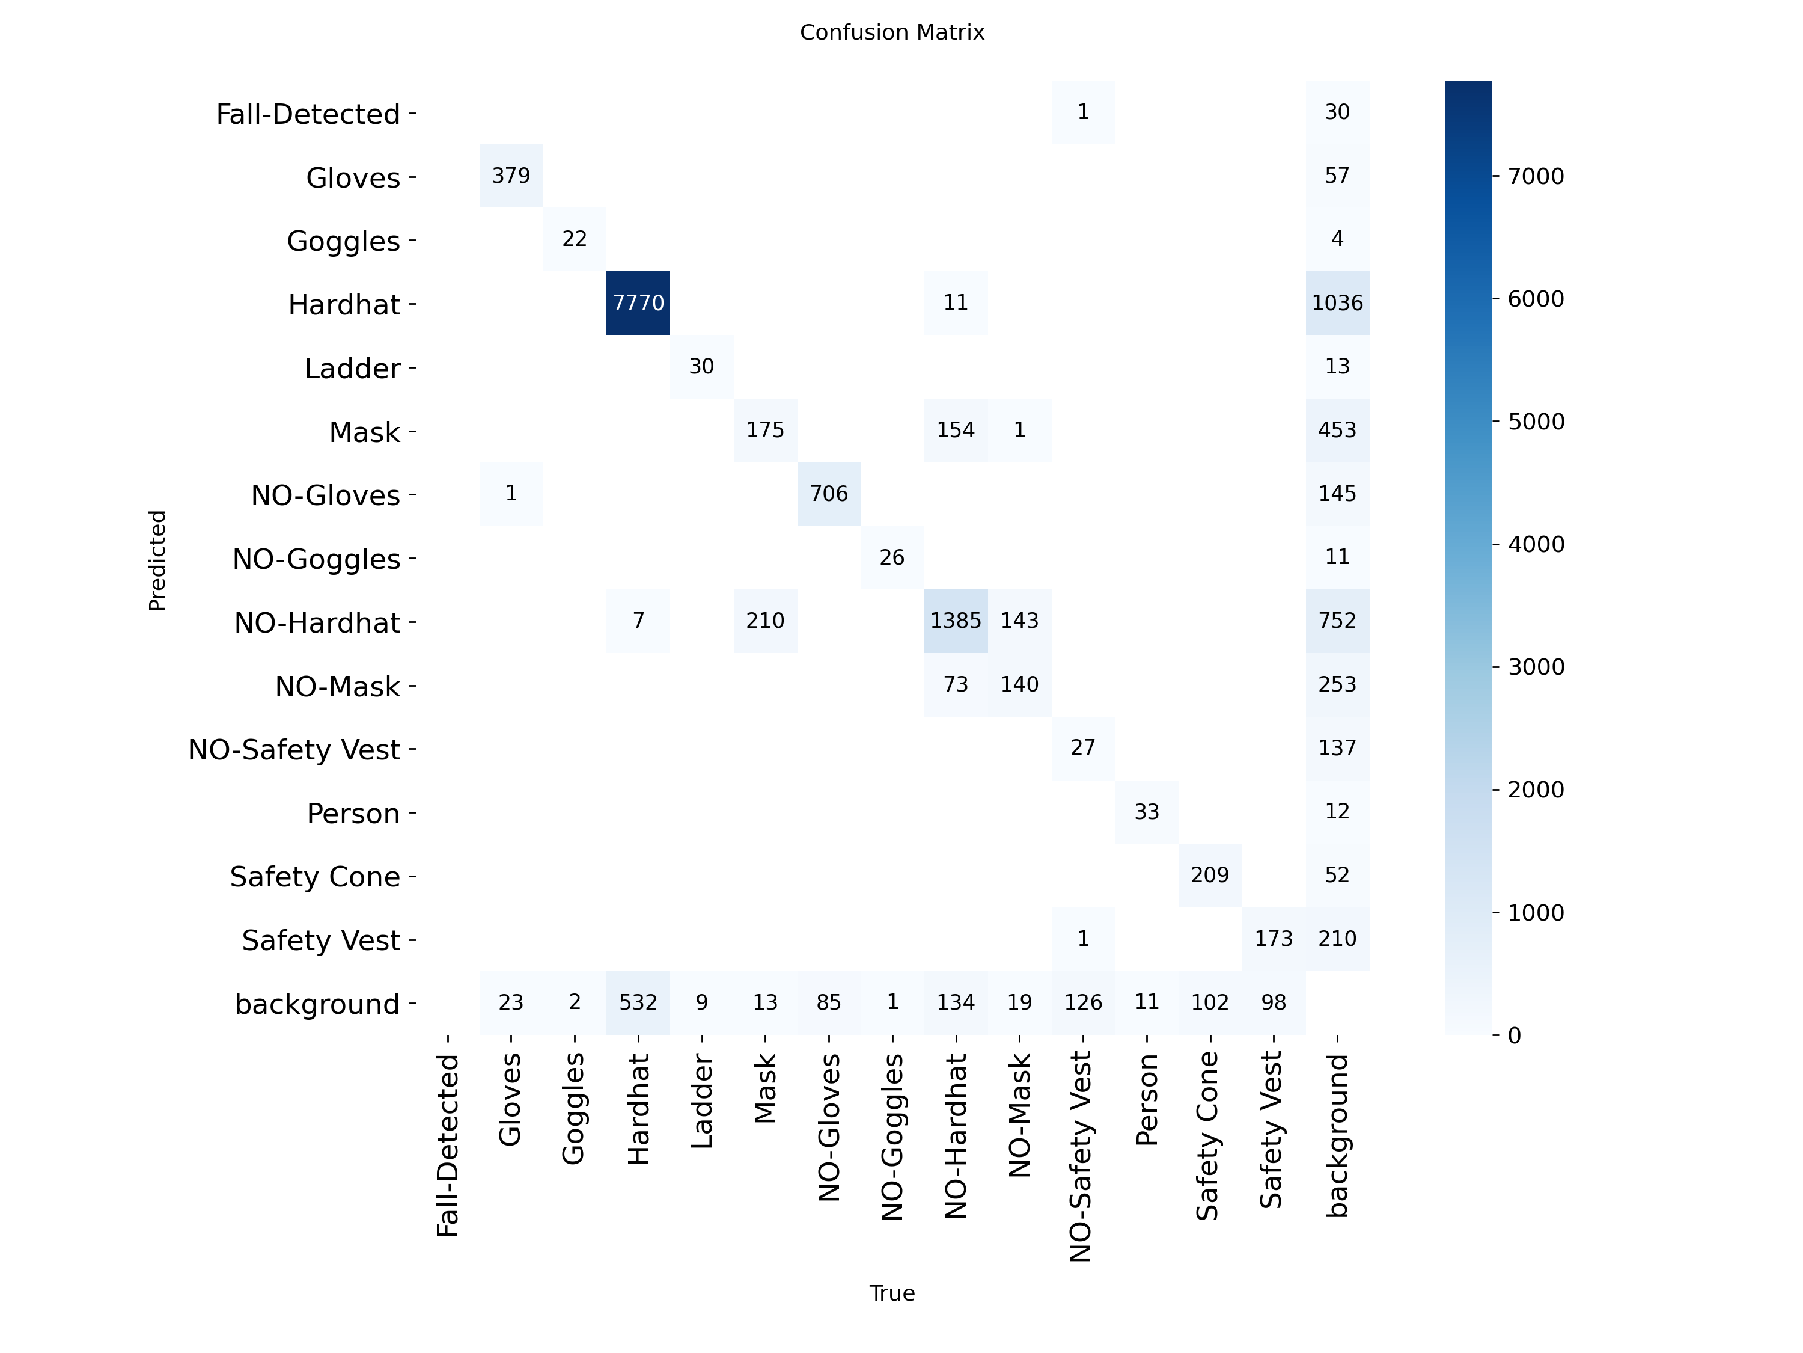
Figure 1 — Raw confusion matrix (source image)
Pred \ True | Fall-Det | Gloves | Goggles | Hardhat | Ladder | Mask | NO-Glv | NO-Gog | NO-Hrd | NO-Msk | NO-SV | Person | SafCone | SafVest | bg
Fall-Det |  |  |  |  |  |  |  |  |  |  | 1 |  |  |  | 30
Gloves |  | 379 |  |  |  |  |  |  |  |  |  |  |  |  | 57
Goggles |  |  | 22 |  |  |  |  |  |  |  |  |  |  |  | 4
Hardhat |  |  |  | 7770 |  |  |  |  | 11 |  |  |  |  |  | 1036
Ladder |  |  |  |  | 30 |  |  |  |  |  |  |  |  |  | 13
Mask |  |  |  |  |  | 175 |  |  | 154 | 1 |  |  |  |  | 453
NO-Glv |  | 1 |  |  |  |  | 706 |  |  |  |  |  |  |  | 145
NO-Gog |  |  |  |  |  |  |  | 26 |  |  |  |  |  |  | 11
NO-Hrd |  |  |  | 7 |  | 210 |  |  | 1385 | 143 |  |  |  |  | 752
NO-Msk |  |  |  |  |  |  |  |  | 73 | 140 |  |  |  |  | 253
NO-SV |  |  |  |  |  |  |  |  |  |  | 27 |  |  |  | 137
Person |  |  |  |  |  |  |  |  |  |  |  | 33 |  |  | 12
SafCone |  |  |  |  |  |  |  |  |  |  |  |  | 209 |  | 52
SafVest |  |  |  |  |  |  |  |  |  |  | 1 |  |  | 173 | 210
bg |  | 23 | 2 | 532 | 9 | 13 | 85 | 1 | 134 | 19 | 126 | 11 | 102 | 98

3. Normalized Confusion Matrix
Each column in confusion_matrix_normalized.png is normalized by the true-class total, so the diagonal value in a column is that class's recall (TP / (TP+FN)). This is a per-column normalisation, i.e. divide every cell by the sum of its 'True' column in the raw matrix.
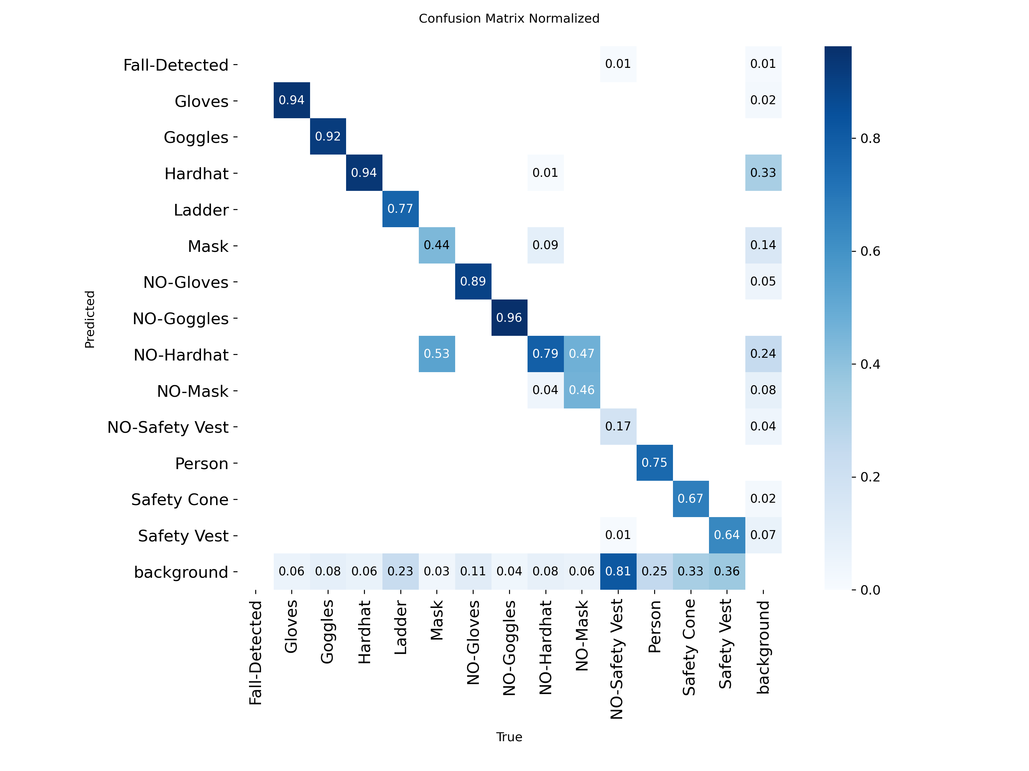
Figure 2 — Column-normalized confusion matrix (source image)
Worked example (Gloves column): true Gloves total = 379 (Gloves→Gloves) + 24 (misclassified elsewhere, see FN below) = 403. Normalized diagonal value = 379 / 403 = 0.9404 ≈ 0.94, matching the 0.94 shown in the figure.

4. Per-Class Precision, Recall & F1 — Full Calculations
Definitions used (standard multiclass confusion-matrix formulas):
• TP (True Positives) = diagonal cell for the class = M[class][class]
• FP (False Positives) = sum of the class's predicted row, excluding the diagonal = Σ M[class][t] for t ≠ class
• FN (False Negatives) = sum of the class's true column, excluding the diagonal = Σ M[p][class] for p ≠ class
• Precision = TP / (TP + FP) • Recall = TP / (TP + FN) • F1 = 2 × (Precision × Recall) / (Precision + Recall)
Class | TP | FP | FN | Support (TP+FN) | Precision = TP/(TP+FP) | Recall = TP/(TP+FN) | F1 = 2PR/(P+R)
Fall-Detected | 0 | 31 | 0 | 0 | 0 / 31 = 0.00% | 0/0 (undefined) | undefined
Gloves | 379 | 57 | 24 | 403 | 86.93% | 94.04% | 90.35%
Goggles | 22 | 4 | 2 | 24 | 84.62% | 91.67% | 88.00%
Hardhat | 7770 | 1047 | 539 | 8309 | 88.13% | 93.51% | 90.74%
Ladder | 30 | 13 | 9 | 39 | 69.77% | 76.92% | 73.17%
Mask | 175 | 608 | 223 | 398 | 22.35% | 43.97% | 29.64%
NO-Gloves | 706 | 146 | 85 | 791 | 82.86% | 89.25% | 85.94%
NO-Goggles | 26 | 11 | 1 | 27 | 70.27% | 96.30% | 81.25%
NO-Hardhat | 1385 | 1112 | 372 | 1757 | 55.47% | 78.83% | 65.12%
NO-Mask | 140 | 326 | 163 | 303 | 30.04% | 46.20% | 36.41%
NO-Safety Vest | 27 | 137 | 128 | 155 | 16.46% | 17.42% | 16.93%
Person | 33 | 12 | 11 | 44 | 73.33% | 75.00% | 74.16%
Safety Cone | 209 | 52 | 102 | 311 | 80.08% | 67.20% | 73.08%
Safety Vest | 173 | 211 | 98 | 271 | 45.05% | 63.84% | 52.82%
Note — Fall-Detected: this class has 0 true instances in the evaluation set (its True column sums to 0), so Recall and F1 are mathematically undefined (0/0). All 31 predictions labelled Fall-Detected in this run are therefore counted as false positives against whatever the true label actually was, giving Precision = 0/31 = 0.00%. This class is excluded from the Recall/F1 columns and from the macro-average below.

5. Aggregate Metrics
ΣTP and ΣFN are summed across all 14 classes (Fall-Detected contributes 0 to both, since it has no ground-truth instances). ΣFP is summed across all 15 predicted labels including Fall-Detected, since its 31 predictions are still real false-positive errors made by the model:
ΣTP = 11075 ΣFP = 3767 ΣFN = 1757
Averaging method | Formula | Precision | Recall | F1-score
Micro-average | ΣTP / (ΣTP+ΣFP) , ΣTP / (ΣTP+ΣFN) | 74.62% | 86.31% | 80.04%
Macro-average (14 classes, Fall-Detected excluded — no ground-truth support) | mean(Pᵢ) , mean(Rᵢ) | 61.95% | 71.86% | 65.97%
Weighted-average (by support) | Σ(Pᵢ×supportᵢ)/ΣsupportᵢΣ | 77.76% | 86.31% | 81.49%
Micro-average pools all TP/FP/FN across classes before dividing — dominated by high-frequency classes (Hardhat, NO-Hardhat). Macro-average treats every class equally regardless of frequency — pulled down by rare/noisy classes (Mask, NO-Safety Vest). Weighted-average scales each class's contribution by its support (true instance count) — closest to overall dataset-level accuracy.

6. Training Curves (results.png)
50-epoch training run. Approximate values read from the plotted curves, interpreted against the 'smooth' trend line:
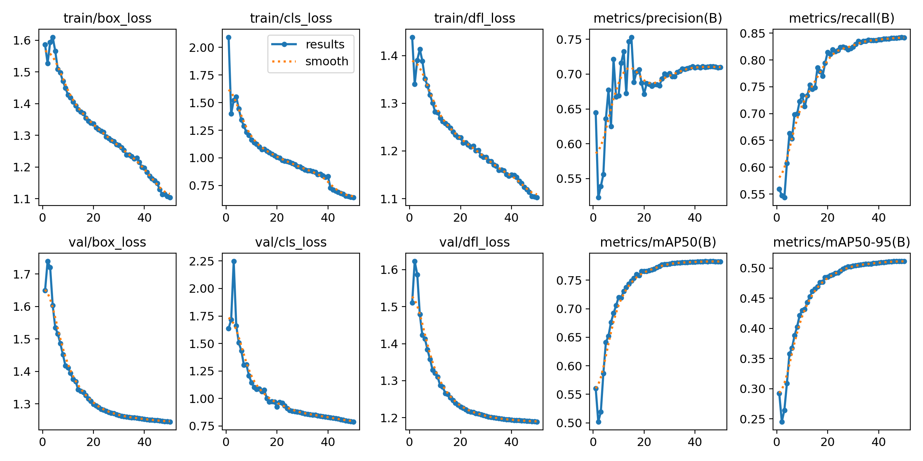
Figure 3 — Training/validation loss and metric curves across 50 epochs (source image)
Metric | Approx. start (epoch ~1-3) | Approx. end (epoch 50) | Trend
train/box_loss | ~1.58–1.61 | ~1.10 | Steady monotonic decrease — bounding-box regression improving throughout training, no plateauing before epoch 50
train/cls_loss | ~2.08 (spike) | ~0.65 | Sharp early drop then smooth decline — classification of the 14 PPE classes converging well
train/dfl_loss | ~1.44 | ~1.10 | Steady decrease — distribution focal loss for box localisation improving
val/box_loss | ~1.65–1.74 | ~1.24 | Decreases and flattens after ~epoch 20, tracking training curve — no overfitting signal
val/cls_loss | ~1.65–2.25 (spike) | ~0.78 | Large initial spike (cold-start) then smooth convergence, flattening ~epoch 25
val/dfl_loss | ~1.51–1.62 | ~1.18 | Decreases and stabilises — validation localisation loss consistent with training
metrics/precision(B) | ~0.52–0.65 (noisy) | ~0.71 | Volatile in early epochs, stabilises from ~epoch 25 onward
metrics/recall(B) | ~0.54–0.57 | ~0.84 | Strong, consistent increase — model detects an increasing share of true positives
metrics/mAP50(B) | ~0.50–0.56 | ~0.78 | Rapid rise to ~epoch 20 then plateau — good overall detection performance at IoU 0.5
metrics/mAP50-95(B) | ~0.24–0.29 | ~0.51 | Rises steadily then plateaus — reasonable localisation precision across IoU thresholds

7. Summary & Interpretation
- Overall detection quality is strong for the high-frequency, visually distinct classes: Hardhat (F1 90.7%), Gloves (F1 90.3%), NO-Goggles (F1 81.3%), Goggles (F1 88.0%), NO-Gloves (F1 85.9%).
- The Mask / NO-Hardhat / NO-Mask cluster shows the weakest performance (Mask F1 29.6%, NO-Mask F1 36.4%, NO-Safety Vest F1 16.9%). The raw matrix shows heavy cross-confusion here — e.g. 210 true Mask instances predicted as NO-Hardhat, and 154 true NO-Hardhat instances predicted as Mask — suggesting these two classes' bounding-box regions overlap on the same face/head area and are visually ambiguous to the model.
- NO-Safety Vest recall is very low (17.4%): 128 of 155 true instances (81 shown directly as background misses, remainder split across classes) are missed, i.e. predicted as background — the model under-detects the absence-of-vest condition specifically, which is safety-critical since this is exactly the compliance violation the system exists to catch.
- The 'background' column/row (objects the model hallucinated, or true objects it missed entirely) is the largest single source of error for nearly every class, especially Hardhat (1036 false background predictions) and NO-Hardhat (752).
- Training curves show healthy convergence: all three loss curves (box, cls, dfl) decrease smoothly on both train and validation splits with no divergence between them, indicating no overfitting by epoch 50. mAP50 (0.78) and mAP50-95 (0.51) both plateau in the final ~15 epochs, suggesting the model had largely converged and additional epochs beyond 50 would likely yield diminishing returns without additional data or architecture changes.
- Fall-Detected had zero ground-truth instances in this evaluation split, so its real-world detection quality cannot be assessed from this confusion matrix alone — this should be flagged as a dataset/evaluation-set coverage gap.

