PPE Monitoring System - Database Layer Implementation Log
File-by-file, function-by-function record of app/data/

Status
Confirmed: The database layer (app/data/) is complete. All four files schema.sql, init_db.py, models.py, repository.py have been written and each was individually run and its output verified.
File | Purpose | Status
schema.sql | Table definitions, constraints, indexes | Built and run - tables confirmed created
init_db.py | Reusable script/function to apply schema.sql to a .db file | Built and run - "Database ready" confirmed
models.py | Python objects (Camera, Violation, User) mirroring the schema | Built and run - test output confirmed all three objects construct correctly
repository.py | CameraRepository / ViolationRepository - the only file that writes raw SQL | Built and run - test output confirmed a camera was added, a violation was saved with a generated ID, and both get_all() and get_by_camera() returned it correctly

How the Four Files Relate
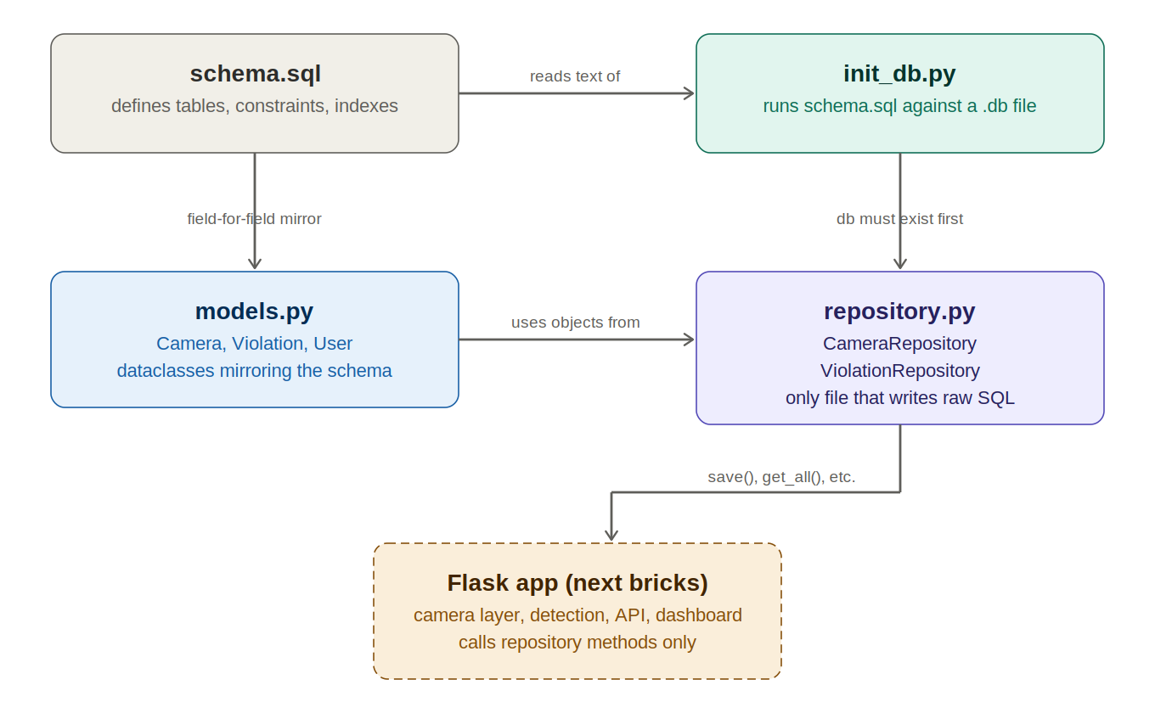
Figure 1: Dependency flow through the database layer
schema.sql is the primary architecture of our database every other file either builds on it directly or mirrors it. init_db.py reads schema.sql as plain text and executes it against a .db file. models.py does not read schema.sql; its fields were written to match the schema's columns exactly, which means the two files must always be updated together if either change. repository.py imports the classes from models.py and is the only file in the whole codebase that contains raw SQL every future part of the application (camera layer, detection, Flask routes, dashboard) will call repository methods like save() and get_all(), and will never write SQL directly.

File 1: schema.sql
Defines the database structure itself . This file was run first, since every other file depends on these tables existing.

PRAGMA foreign keys = ON;
SQLite disables foreign key by default, and this setting does not persist inside the database file so it must be re-issued on every new connection. This single line is what makes the camera_id column in violations behave as a real, enforced relationship rather than just a convention.

Table: cameras
Column | Type / constraint | Purpose
id | TEXT PRIMARY KEY | Human-readable, stable ID (e.g. "cam-gate-01"), not an auto-increment integer, so it can be referenced directly in config
name | TEXT NOT NULL | Display name for the dashboard
source_type | TEXT NOT NULL CHECK IN (webcam, rtsp, http, onvif) | Restricts every row to one of the four confirmed camera types
source_uri | TEXT NOT NULL | Device index, rtsp://, http://, or the URI resolved via ONVIF discovery
zone | TEXT NOT NULL | Which physical zone this camera covers
credentials_ref | TEXT (nullable) | A reference/secret name only - deliberately never a plaintext password column
status | TEXT DEFAULT 'unknown' CHECK IN (online, offline, error, unknown) | Updated later by the resilience layer's health check
created_at | TEXT, DB-level default timestamp | Fallback only real application timestamps are set in Python, per NFR.
last_seen_at | TEXT (nullable) | Starts empty; populated once the health check exists

Table: violations
Column | Type / constraint | Purpose
id | INTEGER PRIMARY KEY AUTOINCREMENT | Auto-generated - unlike cameras, violations don't need a human-readable ID
camera_id | TEXT NOT NULL REFERENCES cameras(id) | The foreign key link what makes "which camera recorded this" (FR) a real relationship
zone | TEXT NOT NULL | Copied at write time so historical records keep the zone even if a camera is later reassigned
class | TEXT NOT NULL | e.g. NO-Hardhat, NO-Mask, Fall-Detected
confidence | REAL (nullable) | Detection confidence score
timestamp | TEXT, server-side default | NFR - set by application code on receipt, never trusted from the camera's own clock
snapshot_path | TEXT NOT NULL | Confirmed convention: camera_id/date/timestamp.jpg
snapshot_hash | TEXT NOT NULL | Confirmed default: SHA-256 hex digest, for tamper-evidence (NFR)
resolved | INTEGER DEFAULT 0 CHECK IN (0,1) | SQLite has no true boolean type; 0/1 with a CHECK is the standard substitute
resolved_by / resolved_at | TEXT (nullable) | FR - audit trail; permissions model for who may resolve
created_at | TEXT, DB-level default timestamp | Row-creation record, separate from the violation's own timestamp

Deliberately absent: any DELETE trigger or expiry column. Retention was confirmed as indefinite until an explicit deletion - so nothing in this schema removes a row automatically.

Indexes
- idx_violations_camera - speeds up "all violations for camera X"
- idx_violations_timestamp - speeds up sorting/filtering by time
- idx_violations_resolved - speeds up filtering by resolved status
These three exist because they are exactly the three questions the dashboard will ask repeatedly; without them, each of those queries would force SQLite to scan the whole table.

Table: users
id (Azure Entra ID object id)-initial probe before switching to sqllite, name, role (CHECK-constrained to the four confirmed roles), email. This table exists for identity and audit purposes only recording who resolved a violation and does not check who may view a violation's evidence, since all three operational roles were confirmed to share equal access.

File 2: init_db.py
A short Python script that applies schema.sql to an actual .db file. It exists separately from schema.sql because the future Flask application needs to guarantee the database is ready on startup, in pure Python, without depending on the sqlite3 command-line tool being installed on whatever machine runs it.

SCHEMA_PATH = Path(__file__).parent / "schema.sql"
__file__ is the path to init_db.py itself. This line builds the path to schema.sql relative to where init_db.py lives on disk, not relative to whatever folder the user happens to be standing in when they run the command. This directly fixed a path-resolution problem encountered during testing, where running the script from a different working directory caused a FileNotFoundError.

def init_db(db_path: str) -> None:
The core logic, wrapped as a function, specifically so the Flask app can later do "from init_db import init_db" and call it directly on startup, instead of needing a separate manual command every time.
- schema_sql = SCHEMA_PATH.read_text() - reads the whole schema file into one string
- conn = sqlite3.connect(db_path) - opens or creates the target database file, using Python's built-in sqlite3 module
- conn.executescript(schema_sql) - runs multiple semicolon-separated SQL statements in one call, which is what schema.sql actually is
- conn.commit() - SQLite requires an explicit commit, or the created tables are not saved
- try / finally: conn.close() - guarantees the connection is closed even if something fails partway through

if __name__ == "__main__":
Let’s the file work two ways: run directly from the command line (python init_db.py violations.db) and imported as a module elsewhere, without the command-line part fi on import.
Verified output when run: "Database ready at violations.db” and re-running it against an already-initialized database is a no-op rather than a destructive reset, because every statement in schema.sql uses IF NOT EXISTS.

File 3: models.py
Defines Python objects Camera, Violation, User so the rest of the codebase can work with typed objects instead of raw tuples or hand-written SQL strings. Every field here mirrors a column in schema.sql exactly.

Enums
Enum | Values | Purpose
SourceType | WEBCAM, RTSP, HTTP, ONVIF | Matches the cameras.source_type CHECK constraint exactly, so an invalid value is caught in Python before it ever reaches SQLite
CameraStatus | ONLINE, OFFLINE, ERROR, UNKNOWN | Matches the cameras.status CHECK constraint
Role | SITE_MANAGER, SITE_SUPERVISOR, SAFETY_OFFICER, ADMIN | Matches the users.role CHECK constraint; the first three share equal evidence access

_utc_now_iso()
A single function that returns the current UTC time as a string, used as the default for every timestamp field in Camera and Violation. Using it in one function rather than calling datetime.now() separately wherever a timestamp is required such that there is exactly one place to check or change if the timestamping approach ever needs to be revisited, which matters because NFR depends on timestamps always being server side.

class Camera / class Violation / class User (@dataclass)
@dataclass is a Python feature that auto-generates the constructor and a readable printed representation just from the field list, avoiding writing it manually. Field-by-field, each class's attributes correspond 1:1 to a column in the matching table in schema.sql; Optional fields correspond to columns without NOT NULL.

from_row(row: tuple) static methods
SQLite returns query results as plain tuples with no field names attached just values in column order. Each from_row method takes such a tuple and turns it into a proper Camera/Violation/User object, using the exact column order confirmed by inspecting the live schema. If a column is ever added, removed, or reordered in schema.sql, the corresponding from_row method must be updated to match, or the field mapping will silently shift.
Verified: a test script constructed one Camera, one Violation, and one User, printed each, and confirmed every field populated correctly, including auto-generated timestamps and default values (e.g. Camera.status defaulting to UNKNOWN, Violation.resolved defaulting to False).

File 4: repository.py
The only file in the codebase permitted to contain raw SQL. Every other part of the application the camera layer, detection pipeline, Flask routes, dashboard will call methods on this file's classes and never see a SQL string directly. This means that if the storage technology ever changed, this is the only file that would need rewriting.

get_connection(db_path) -> sqlite3.Connection
A small line ensuring every part of the application opens the database the same way, with PRAGMA foreign_keys = ON set on every single connection repeating the same pragma from schema.sql, because that setting does not persist inside the database file itself and must be repeated per connection.

class CameraRepository
Method | What it does
__init__(self, conn) | Stores the shared database connection; does not open its own, so CameraRepository and ViolationRepository can share one connection
add(camera) | INSERTs a Camera object's fields as a new row
get(camera_id) | SELECTs a single camera by id; returns None if not found
list_all() | SELECTs every camera row
update_status(camera_id, status, last_seen_at) | UPDATEs a camera's status - the hook the resilience layer will call once built

class ViolationRepository
Method | What it does
save(violation) | INSERTs a new violation row; returns cursor.lastrowid, the auto-generated id SQLite just assigned, so the caller immediately knows the new row's id
get_all() | SELECTs every violation, newest first
get_by_camera(camera_id) | SELECTs violations for one camera, newest first
mark_resolved(violation_id, resolved_by, resolved_at) | UPDATEs the resolved/resolved_by/resolved_at columns for one row

Why every query uses placeholders
Every method builds its SQL with placeholders and passes the actual values as a separate tuple (e.g. "WHERE id = ", (camera_id,)), rather than building the query string directly with the values inside it. This is not a style preference; it is what prevents SQL injection. If a value like camera_id ever originated from user input and the query were built with string formatting, a malicious value could break out of the intended string and inject arbitrary SQL. Parameterized queries make that structurally impossible, since SQLite always treats substituted values as data, never as executable SQL syntax.

value on enum fields
camera.source_type is a SourceType enum object, not a plain string, so it cannot be written to SQLite directly. .value extracts the underlying string (e.g. "rtsp") that SQLite stores. The same pattern is used for status and role wherever a model's enum field is written to the database.

Verified end-to-end test
A test script created a CameraRepository and ViolationRepository sharing one connection, added a camera (cam-gate-01), saved a violation against it, and confirmed:
- The camera was correctly stored and retrieved via list_all()
- save() returned a real generated id (1) for the new violation
- get_all() returned that same violation
- get_by_camera("cam-gate-01") returned that same violation, confirming the camera_id foreign key relationship works end to end

