AI-Powered Workplace Safety and PPE Compliance Monitoring System
Requirements, Planning and System Design
MSc Computer Science - Capstone Project

Literature Review and Related Work

0.1 Overview of CV-Based PPE Compliance
Vukicevic et al. [1] conducted a PRISMA-based systematic review of 32 studies on computer vision-based PPE compliance, identifying two dominant technical approaches: direct object detection (e.g. YOLO, SSD, Faster R-CNN) and multi-step pipelines that combine pose estimation with region-of-interest (ROI) classification. The review found that object detection approaches are more common in the literature and offer a better speed/accuracy trade-off for real-time deployment, which supports the choice of a single-stage YOLO-based detector for this project rather than a more computationally demanding pose-plus-classification pipeline.
The same review introduces the concept of "PPE Compliance 4.0", framing compliance as a function of three interacting factors: PPE-related (style, fit, availability), human-related (awareness, training, risk perception), and company-related (policy, culture, enforcement). It also highlights recurring barriers to real-world adoption that go beyond model accuracy: computational cost trade-offs between cloud, on-premises, and edge deployment; the difficulty of employee identification without violating privacy; and the need to align systems with the GDPR and the EU Artificial Intelligence Act [1]. These barriers directly inform the non-functional requirements and security considerations in this report, particularly around data retention and identity anonymization.

0.2 Applied Systems and Benchmarks
Several applied studies provide useful benchmarks and design precedents for this project. Balakreshnan et al. [2] built a hybrid cloud/edge PPE detection system using Azure Custom Vision and low-power IoT cameras, and found that a model trained only on generic web-scraped images performed poorly (13.0% mAP), while retraining on images captured from the deployment environment itself improved mAP by 233% to 43.3% [2]. This finding is directly relevant to this project's decision to train on a large, purpose-built 35,000-image dataset rather than relying on generic public images alone.
Sanjeewani et al. [3] proposed a real-time PPE non-compliance system using SSD MobileNetV2 deployed on AI-enabled edge cameras, chosen over YOLOv5 after benchmarking showed it ran roughly 14 times faster per frame (0.20s versus 2.75s) with an acceptable trade-off in accuracy [3]. Their system also demonstrates a four-class compliance schema (hard hat only, vest only, both, neither) and a COCO-style evaluation methodology (AP/AR across IoU thresholds) that mirrors good practice for this project's own testing and evaluation section.
Guney et al. [4] compared YOLO-NAS, YOLOv8, and YOLOv9 on a 2,581-image PPE dataset of coloured hard hats and vests, training all three for 200 epochs for a fair comparison. YOLO-NAS achieved the highest F1 and recall (91.6% F1, 95.9% recall, 89.5% mAP), YOLOv9 achieved the highest precision (99.5%), and YOLOv8 trained fastest but scored slightly lower across metrics (86.2% mAP) [4]. These figures provide a like-for-like benchmark against this project's own YOLOv8s model, discussed further in Section 0.3 below.

0.3 Benchmarking This Project Against the Literature
The table below places this project's trained model (YOLOv8s, 78.3% mAP50, 35,000-image dataset) alongside the figures reported in the reviewed studies. The comparison is illustrative rather than exact, since datasets, class counts, and hardware differ across studies.
Study | Model | Dataset size | mAP50 (%) | Train time (h)
This project | YOLOv8s | n/a | n/a | n/a
Guney et al. [4] | YOLO-NAS | 2,581 | 89.5 | 13.8
Guney et al. [4] | YOLOv9 | 2,581 | 88.3 | 7.4
Guney et al. [4] | YOLOv8 | 2,581 | 86.2 | 4.2
Sanjeewani et al. [3] | SSD MobileNetV2 | 2,653 | 22.0 (mAP@.50:.95 base) | n/a
Balakreshnan et al. [2] | Azure Custom Vision | ~700 (local) | 43.3 | n/a

This project's mAP50 sits below the figures reported by Guney et al. [4], but the comparison is not directly like-for-like: their dataset covers 2,581 images across 9 colour-coded classes of just two PPE types (helmets and vests), whereas this project's dataset spans 14 PPE classes across a substantially larger and more varied 35,000-image set, which is a harder detection problem. The result is broadly consistent with the pattern Balakreshnan et al. [2] observed, where accuracy is highly sensitive to dataset scope and class complexity rather than model choice alone. This trade-off, and the option of narrowing the class set or extending training time to close the gap, is worth discussing explicitly in the report's evaluation and limitations section rather than leaving the lower figure unexplained.

Stage 1: Requirements and Planning

1.1 Project Scope
An AI-powered system that monitors live camera feeds on a construction site, detects PPE violations and fall incidents in real time, logs them, and alerts relevant personnel, with a dashboard for review and reporting.

1.2 Stakeholders
Stakeholder | Interest
Construction/Site Manager | Overall compliance, liability reduction, incident response
Site Supervisor | Immediate alerts, daily enforcement
Safety Officer | Historical trends, audit trail, compliance reporting
Workers | Subject of monitoring - privacy considerations
IT/Admin | System uptime, integration, data security

1.3 Functional Requirements
The following requirements were drafted using reasonable working assumptions based on standard construction-site PPE compliance needs. Items marked "To validate" are pending confirmation from stakeholder consultation with a construction manager.
ID | Requirement | Status
FR1 | Detect missing hardhat, missing mask, and fall events from live video | Confirmed
FR2 | Log each violation with timestamp, camera/zone ID, and snapshot | Assumed
FR3 | Send real-time email alert to designated personnel on violation | Confirmed
FR4 | Provide a live dashboard showing current violations and resolve workflow | Confirmed
FR5 | Provide historical/trend reporting via Power BI | Confirmed
FR6 | Allow marking violations as resolved with an audit trail | Assumed - to validate permissions
FR7 | Support multiple camera feeds/zones | To validate
FR8 | Escalate repeat violations differently | To validate

1.4 Non-Functional Requirements
ID | Requirement | Status
NFR1 | Detection latency low enough for real-time response | To validate - threshold TBC
NFR2 | Model accuracy of at least 78.3% mAP50 | Confirmed
NFR3 | Data privacy/retention policy for video and snapshots | To validate
NFR4 | System runs on free/low-cost infrastructure | Confirmed
NFR5 | Secure authentication via Azure Entra ID | Confirmed
NFR6 | Acceptable false-positive rate | To validate

NFR3 (data privacy/retention) is informed directly by the literature: Vukicevic et al. [1] argue that identity data used for PPE compliance should be confidential, retained only for as long as needed, and anonymised where possible, in line with GDPR and the EU Artificial Intelligence Act. This project's final design should state explicitly how long violation snapshots are retained and who can access them, to close out this requirement.

1.5 Constraints
- Free-tier tooling only
- University tenant restrictions (no SharePoint/Azure app registration) resolved via sql lite and gmail account workaround
- Covers four MSc modules- Computer Vision(in depth with use of YOLO), Intelligent Interactive Systems, Intelligent Software Engineering, and Design and Manage Secure Systems

1.6 Assumptions and Risks
Since some requirements are pending stakeholder validation or might fail to obtain exact information, these are documented explicitly as assumptions made in the absence of stakeholder input, to be validated in a future iteration. This follows good practice for requirements traceability in an Intelligent Software Engineering context.

Stage 2: System Design

2.1 System Architecture
The diagram below shows the core architecture. A live webcam feed enters the Flask backend, where YOLOv8s runs detection and writes violation records to SQLite. From there, two things happen in parallel: the alert engine emails supervisors, and the dashboard displays live status. Power BI pulls from the same data via REST API for trend reporting. Azure Entra ID authenticates dashboard and API access alongside this flow.
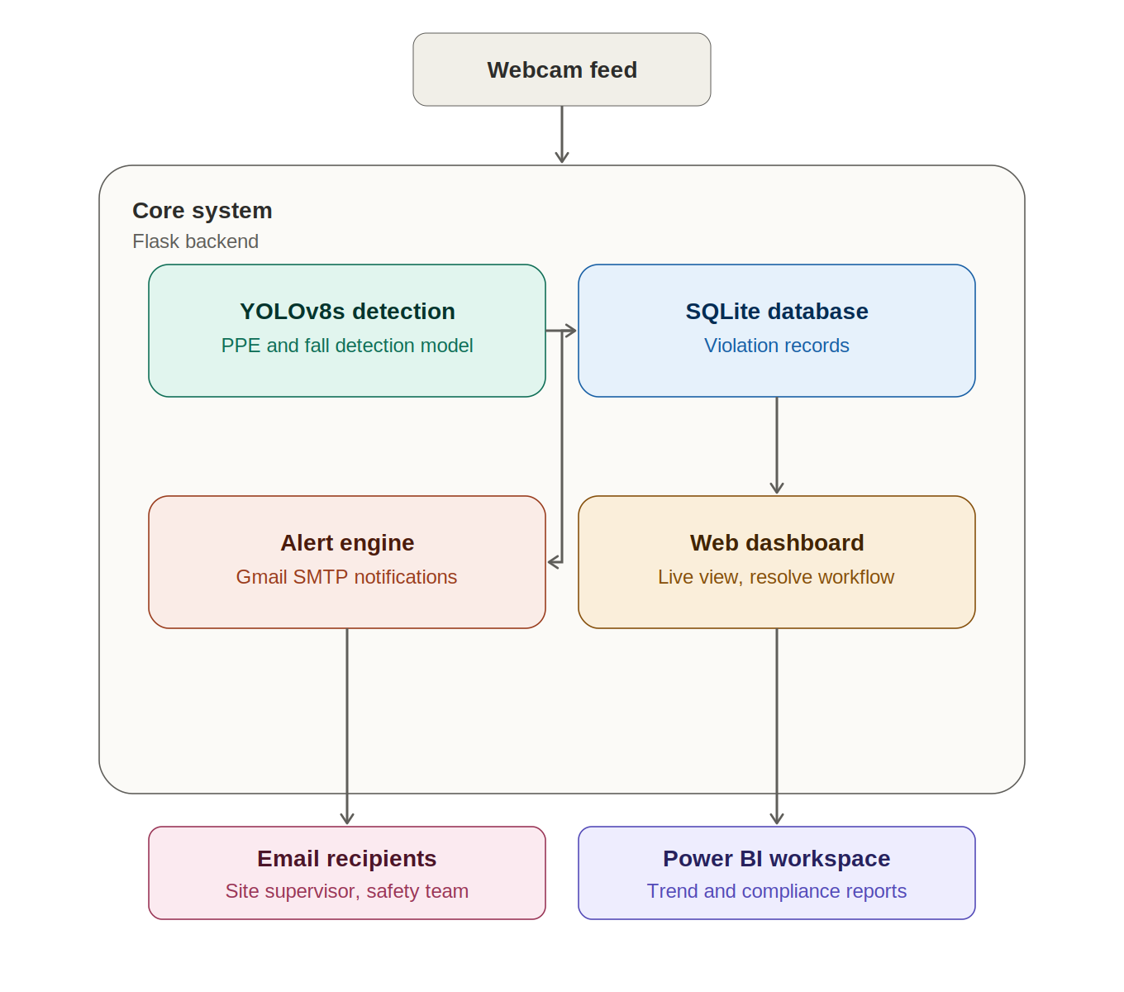
Figure 1: Basic System architecture

2.2 Data Flow
The sequence below traces a single frame from capture through to reporting.
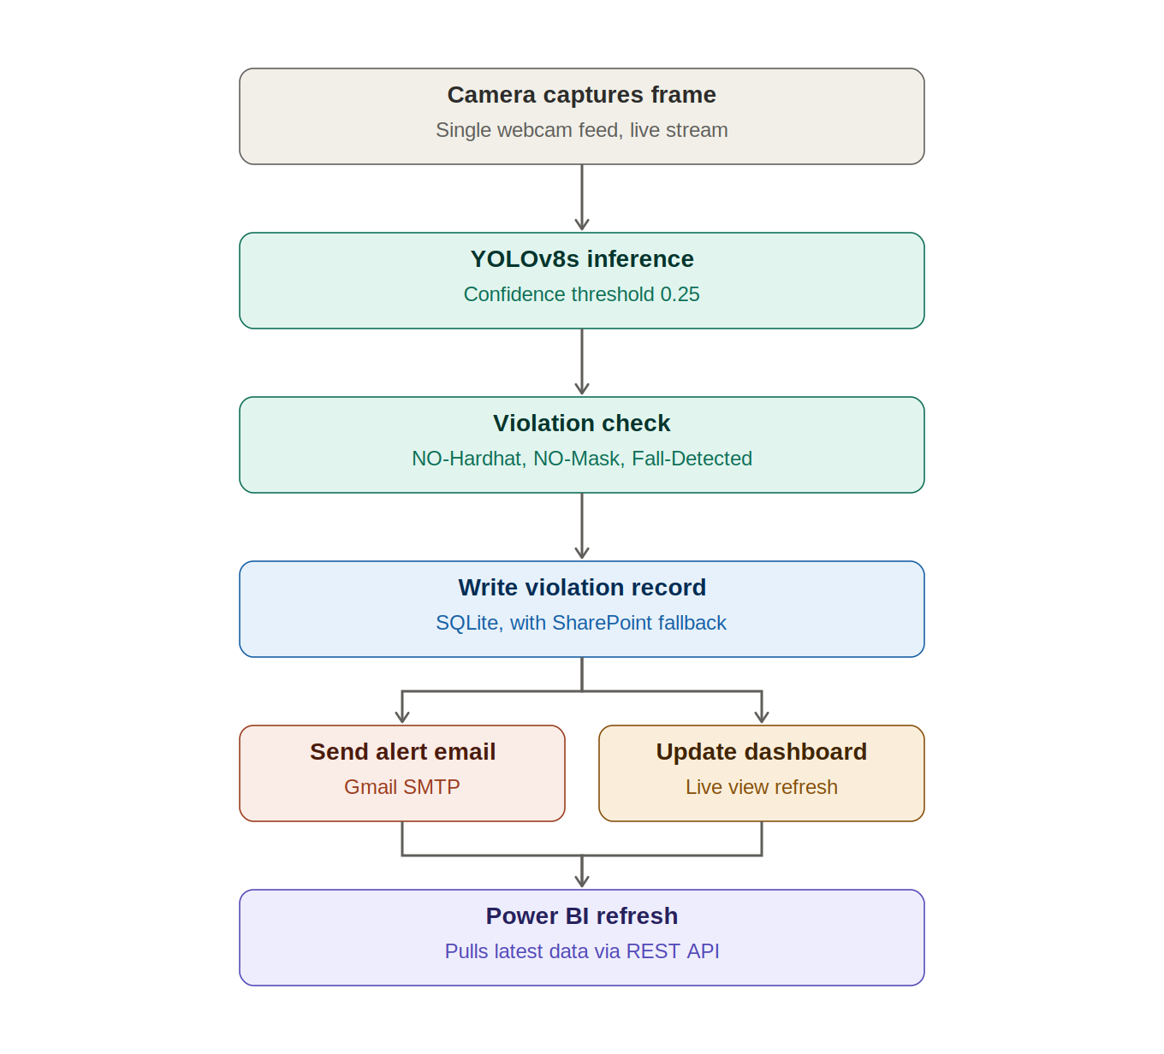
Figure 2: Data flow from camera capture to reporting

2.3 Component Breakdown
Component | Technology | Responsibility
Detection engine | YOLOv8 | Real-time inference on video frames
API layer | Flask REST API | Orchestration, MJPEG streaming, endpoints for dashboard/Power BI
Data layer | SQLite, with SharePoint fallback | Persist violation records
Alerting | Gmail SMTP | Notify designated personnel
Presentation | Web dashboard | Live monitoring, resolve workflow
Reporting | Power BI (via REST) | Historical trends, compliance reports
Testing and evaluation | Improved performance & security | Try to improve as much as possible

2.4 Design Decisions and Justifications
- YOLOv8s over YOLOv8n: better accuracy trade-off given free-tier GPU along with already available datasets on Kaggle. This follows the pattern in the literature where single-stage object detectors are preferred over multi-step pose-plus-classification pipelines for real-time deployment.
- SQLite over a cloud database: University tenant restrictions on Azure and Microsoft 365 pushed towards local, dependency-light store. This reflects the on-premise/cloud/edge cost trade-off discussed by Vukicevic et al. [1].
- Gmail SMTP over Outlook: pragmatic pivot after Outlook SMTP was blocked by Microsoft policy changes.
- MJPEG streaming over WebRTC: simple to implement within the timeframe, sufficient for single-feed demo purposes, flagged as a scalability limitation for future work.
- Training on a large, purpose-built 35,000-image dataset rather than a small generic one: consistent with Balakreshnan et al.'s finding that models trained on images resembling the deployment environment substantially outperform those trained only on generic web-sourced images.

2.5 Open Design Questions
The following effect how far the design should scale and remain pending the construction manager's input:
- Single feed vs multi-camera zone architecture (FR7) - affects whether the dashboard needs a zone-selector component.
- Escalation logic for repeat violations (FR8) - affects whether a rules engine layer is needed beyond the existing database queries.
- Required response time (NFR1) - affects whether MJPEG polling is sufficient or a push/websocket model is needed.

References
[1] A. M. Vukicevic, M. Petrovic, P. Milosevic, A. Peulic, K. Jovanovic, and A. Novakovic, "A systematic review of computer vision-based personal protective equipment compliance in industry practice: advancements, challenges and future directions," Artificial Intelligence Review, vol. 57, art. 319, 2024. https://doi.org/10.1007/s10462-024-10978-x
[2] B. Balakreshnan, G. Richards, G. Nanda, H. Mao, R. Athinarayanan, and J. Zaccaria, "PPE Compliance Detection using Artificial Intelligence in Learning Factories," Procedia Manufacturing, vol. 45, pp. 277-282, 2020. https://doi.org/10.1016/j.promfg.2020.04.017
[3] P. Sanjeewani, G. Neuber, J. Fitzgerald, N. Chandrasena, S. Potums, A. Alavi, and C. Lane, "Real-Time Personal Protective Equipment Non-Compliance Recognition on AI Edge Cameras," Electronics, vol. 13, no. 15, art. 2990, 2024. https://doi.org/10.3390/electronics13152990
[4] E. Guney, H. Altin, A. E. Asci, O. U. Bayilmis, and C. Bayilmis, "YOLO-Based Personal Protective Equipment Monitoring System for Workplace Safety," Jurnal Ilmiah Teknologi Sistem Informasi, vol. 5, no. 2, pp. 77-85, 2024. https://doi.org/10.62527/jitsi.5.2.238

