Angela Asgekar

May 25, 2020

Foundations of Programming: Python

Assignment 06

[GitHub Link](https://github.com/aasgekar/IntroToProg-Python-Mod06-)

Utilizing Functions

Introduction

In this document, I will be reviewing how I took someone else’s pseudocode and defined functions to perform actions just like the actions that were performed in last week’s assignment. This assignment focuses on functions and reinforces and understanding of global vs. local variables.

Writing the Script

I began by downloading the started file for assignment six. I then read through the started code, looking at the global variables and where there was a note that I needed to fill in the script.

The first function that needed to be defined was to perform the action of adding data to a list. Since I had already read through the script, I knew that the user inputs would be collected using a different function, so I wrote this function only to add data to a list and store each row as a dictionary (Figure 1).

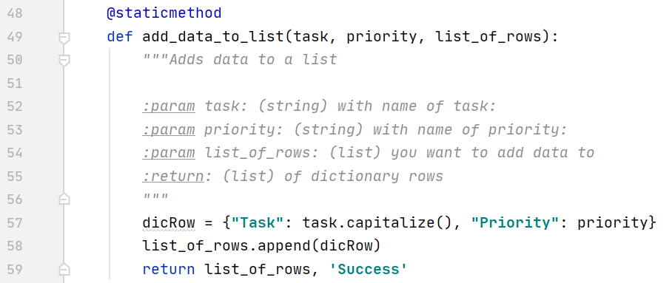

Figure 1: Function to add data to the list

The second function was to remove data from the list. Again, since I had already read through the code I knew the user inputs would be collected in a separate function so I copied part of my script from last week’s assignment and modified the variables to match assignment six (Figure 2).

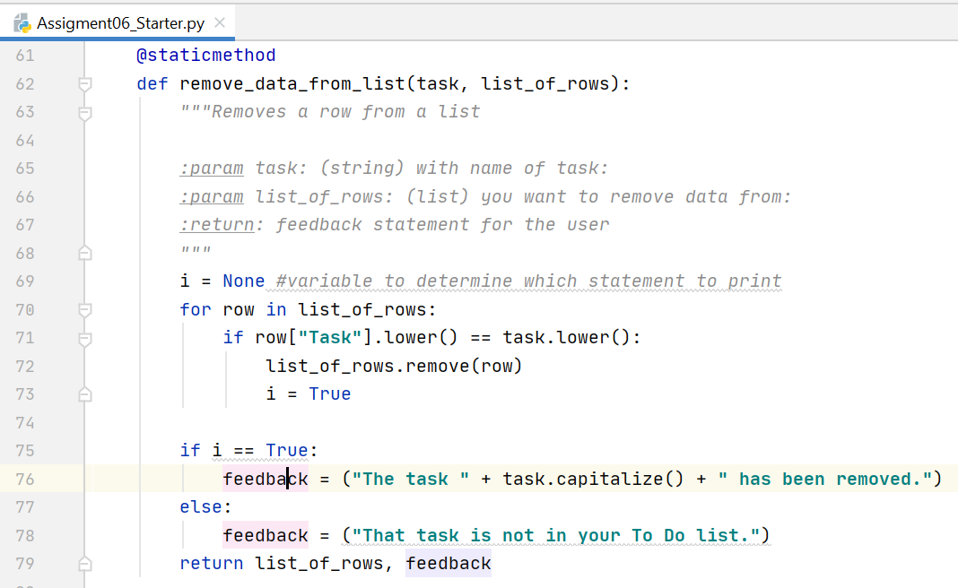

Figure 2: Function to remove data from the list

The last function in the Processions module of the code was to save the current list to a text file. Again, I copied my code from last week’s assignment and modified the variable names to fit this week’s assignment (Figure 3).

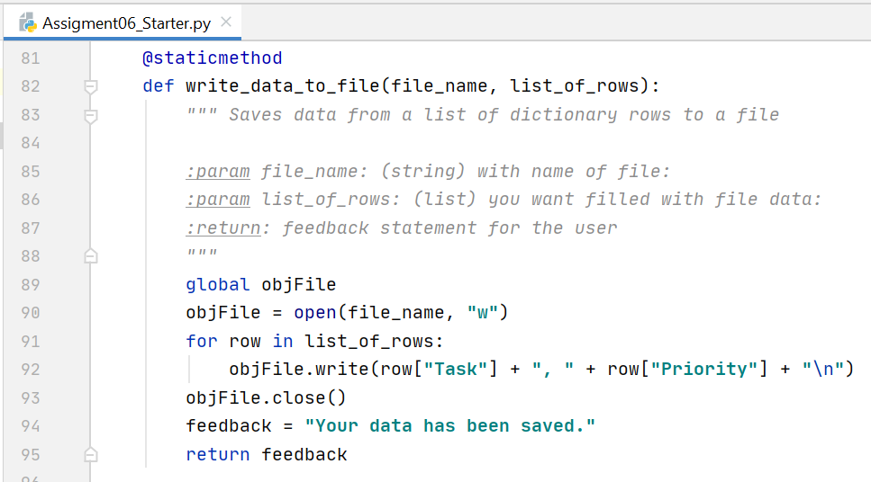

Figure 3: Function to save current list to text file

Moving on to the input/output functions, I used the same logic—copied my code from last week and modified the variables for this week’s assignment (Figure 4).

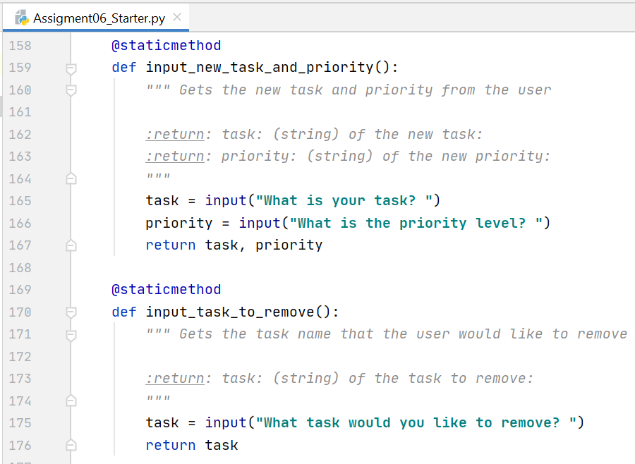

Figure 4: Two functions for gathering user inputs

The portion of the code where I call the various functions that had been defined, was definitely what I found to be the most challenging. I realized that I had to return two variables in most functions—strStatus and list_of_rows. In order to properly use those variables, I had to set them equal to global variables so they could then be used as inputs for other functions (Figure 5).

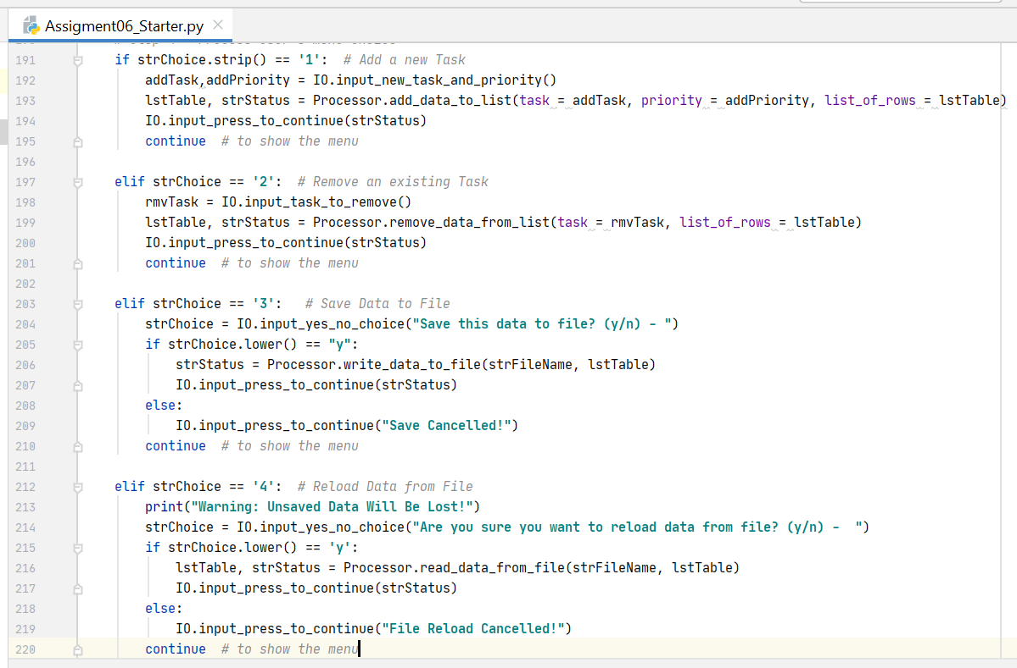

Figure 5: Calling the defined functions

Testing the Script

I tested a couple of the functions separately in a demo file, but at the end of writing the script I tested each of the menu items in PyCharm. An example of menu item 1 can be seen in Figure 6.

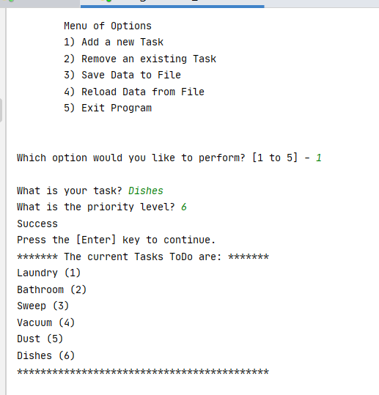

Figure 6: Testing in PyCharm

After testing in PyCharm, I then tested all five menu options in the console. An example of menu item 2 can be seen in Figure 7.

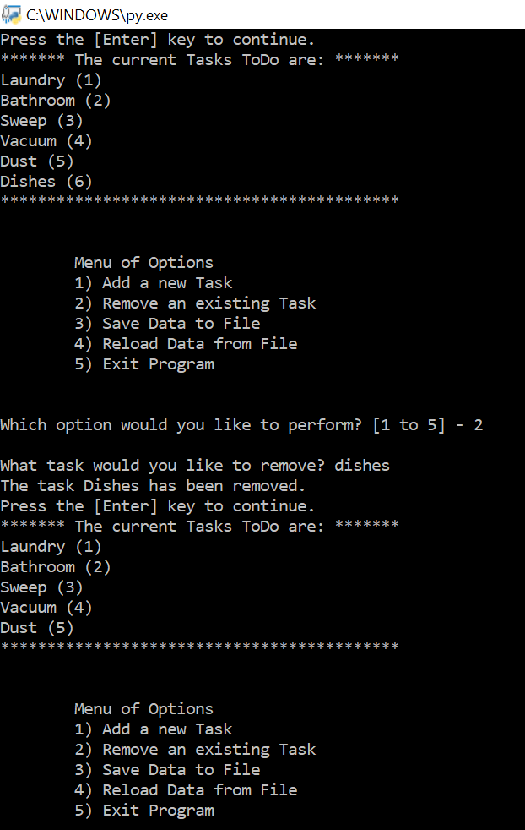

Figure 7: Testing in the console

Summary

Throughout this assignment, I learned about utilizing functions and the importance of knowing when to use a global variable vs. a local variable.