Angela Asgekar

May 18, 2020

Foundations of Programming: Python

Assignment 05

Creating a To Do List with Dictionaries

Introduction

In this document, I will be reviewing how I created a python script that allows a user to create, modify and save a to do list to a text file. This assignment encompassed all the material learned to date with an emphasis on utilizing dictionaries in a nested list to store information and taking someone else’s code that has been partially written and completing it to perform the intended purpose.

Writing the Script

I began by saving the starter file for the assignment and pulling it up in PyCharm. In the interest of moving in a logical manner, I decided to work through the code step by step. Starting with step one, I create a text file titled “ToDoList.txt” and input two items into the text file. I then wrote code to take the data that was in the text file and save it into a nested list with each item in the list being a dictionary (Figure 1).

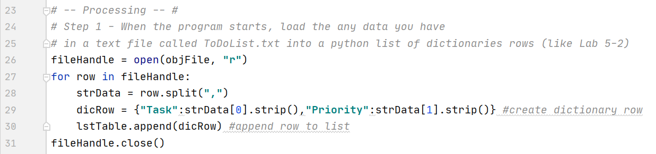

Figure 1: Assigning variables to the data from the text file

Step two was already written in the starter file so I moved on to step three. I displayed some header information for the user and then utilized a for loop to print each dictionary item in the list.

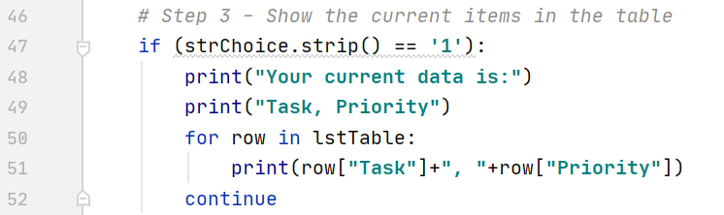

Figure 2: Step 3 – for loop

For step four, I utilized two variables to capture the user input and saved those to a dictionary variable then appended that to the list (Figure 3).

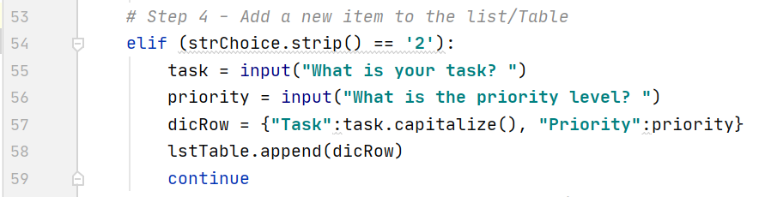

Figure 3: Step 4 appending a new item

I found step five to be the most challenging since you cannot search for a value in a dictionary, but rather have to search using the key. This made writing an if statement to print information to the user challenging inside of the for loop itself so I decided to create a variable “i” that would be used in a separate if statement, after the for loop completed to let the user know if the task was removed or if it was never on the list (Figure 4).

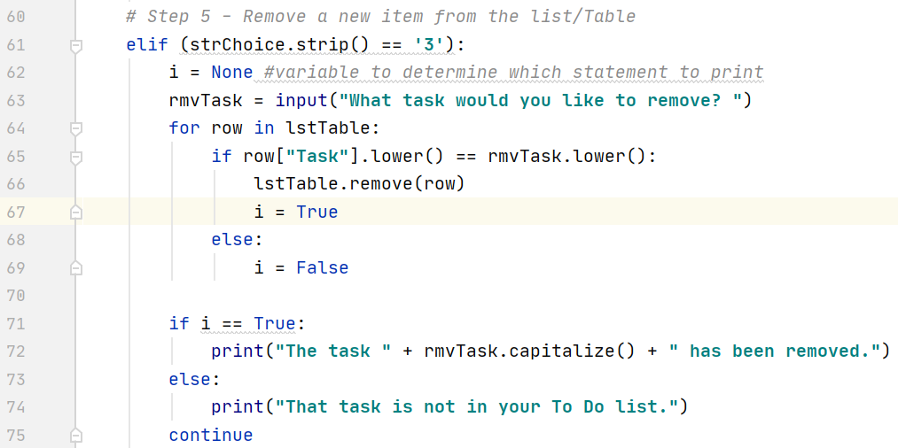

Figure 4: Step 5

Step six was easy since it is a task that was required in last weeks assignment as well. I copied the code from last week’s assignment and modified it to work for a dictionary in a nested list (Figure 5).

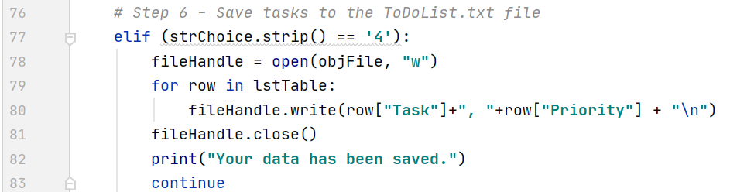

Figure 5: Step 6

Lastly, for step seven, I thanked the user for utilizing the program and kept the window open until they pressed the enter key to exit (Figure 6).

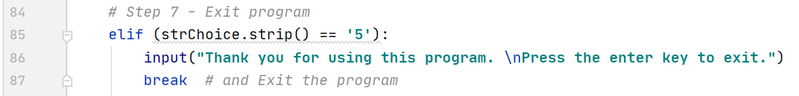

Figure 6: Exiting the program

Testing the Script

I tested each element of the script in PyCharm to make sure that every element worked properly. A demonstration of steps one and five can be seen in Figure 7.

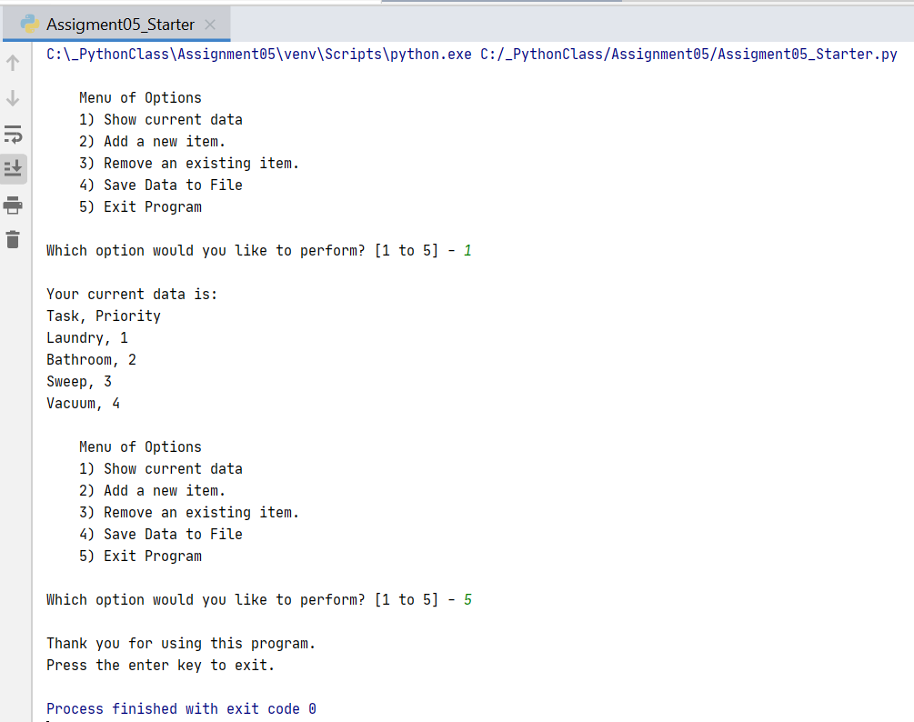

Figure 7: Testing the script in the PyCharm

I then tested the program in the console. A demonstration of steps two and five can be seen in Figure 8.

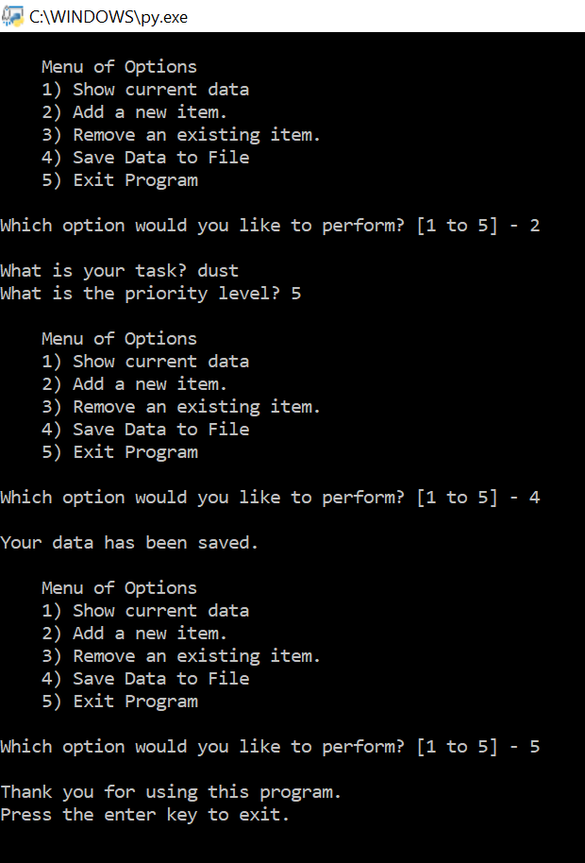

Figure 8: Console Test

To finish, I checked the text file to see if the data was saved properly (Figure 9).

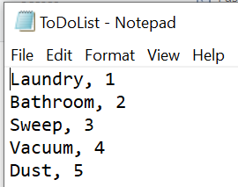

Figure 10: Text file after running Console test

Summary

Throughout this assignment, I learned about utilizing dictionaries to store information and how they can be nested into a list to mimic a table. I was also able to take someone else’s pseudocode as well as partially written script and understand the intended purpose and complete the assignment.