Answer the following:

1. Define the following terms:
   1. Term frequency
   2. Document frequency
   3. Inverse document frequency
   4. TFIDF
2. With an example explain the importance of TFIDF. Which component of TFIDF helps in measuring the relevancy score of a term in the corpus
3. Consider the below diagram and answer the questions

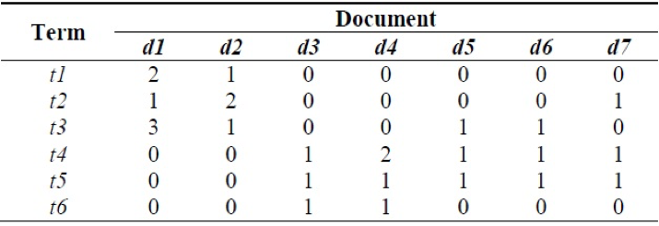

* 1. What is the above diagram called in text analytics?
  2. Which are the most common and the rarest term of the corpus?
  3. What is the term frequency of a term which is used a most number of times in that document? Mention the term as well as the term frequency
  4. Identify the document frequency and its IDF of a term which occurs :
     1. In least no. of documents
     2. Most of the documents
  5. Which document is most relevant for the term t3 and t4