|  |
| --- |
| **CAB301: Applied Project** |
| Tool Library System: Report |
| Semester 1, 2021 |

**Adrian Ash: N1064937**

**Table of Contents**

**Introduction** 2

**Design and Analysis of Algorithms** 2

**Algorithm Document** 2

**Algorithm Design** 2

**Algorithm Analysis** 5

**Software Test Plans and Test Results** 6

**Staff Functionality** 6

**Member Functionality** 6

# **Introduction**

The project was the creation of a Tool Library System through the implementation of defined interfaces. The system will serve staff and members with a variety of different functions. Members will be able to view library tools, borrow tools, return tools, list all borrowed tools and display top three most frequently borrowed tools. Staff will be able to add new tools to the library, update existing tools stock, remove stock or delete tools from the library, register members, remove members and (list all borrowed tools of a select member/return phone number of select member).

The purpose of this report is to deconstruct the algorithm used for finding the ‘top three borrowed tools’ into pseudo-code and evaluate its big O efficiency. This is under the ‘Design and Analysis of Algorithms’ section. It will also show that thorough testing of the system was conducted under the ‘Software Test Plans and Test Results’ section.

# **Design and Analysis of Algorithms**

## **Algorithm Document**

For the algorithm analysis I created a latex document for a more mathematical approach.



## **Algorithm Design**

The ‘Display Top Three’ method consists of 4 different algorithms

Pseudo-code is also located in separate pdf document.

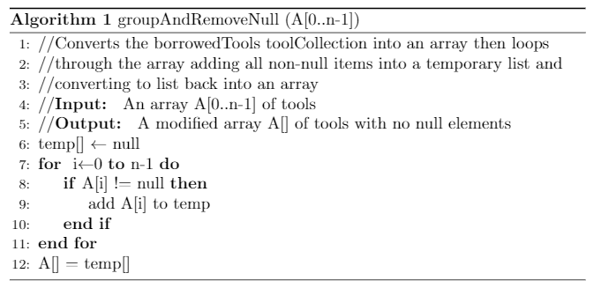

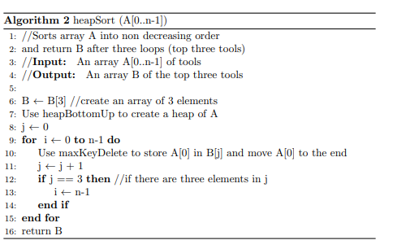 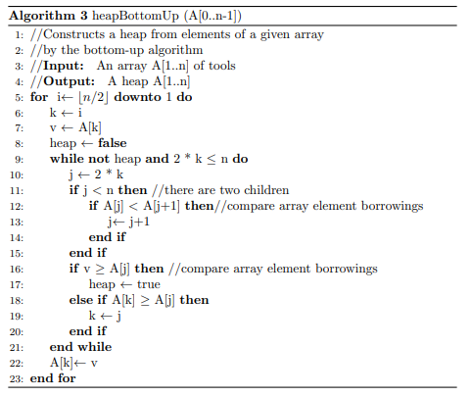

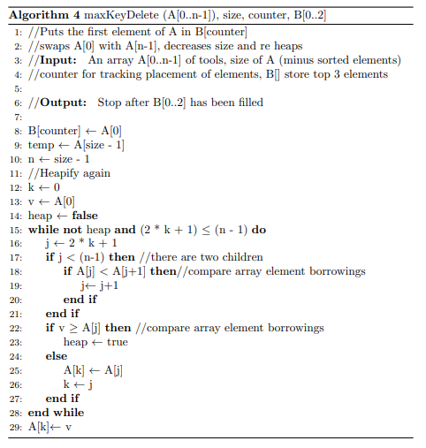

Algorithms 2,3 and 4 are modified algorithms from lecture 6.

## **Algorithm Analysis**

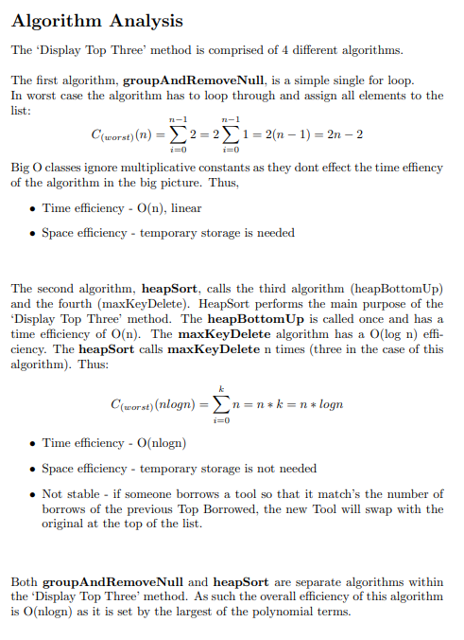

# **Software Test Plans and Test Results**

## **Staff Functionality**

|  |  |
| --- | --- |
| Login | Errors: |
| Add Tool | Errors: |
| Add Stock | Errors: |
| Remove/Delete from library | Errors |
| New Member | Errors: |
| Remove Member | Errors: |
|  |  |

## **Member Functionality**

|  |  |
| --- | --- |
| Login | Errors: |
| Display Tools | Errors: |
| Borrow Tool | Errors: |
| Return Tool | Errors |
| List tools on loan | Errors: |
| Top Three | Borrow Green Machine    Borrow 2 Straight Cutter 54’s    Errors: |