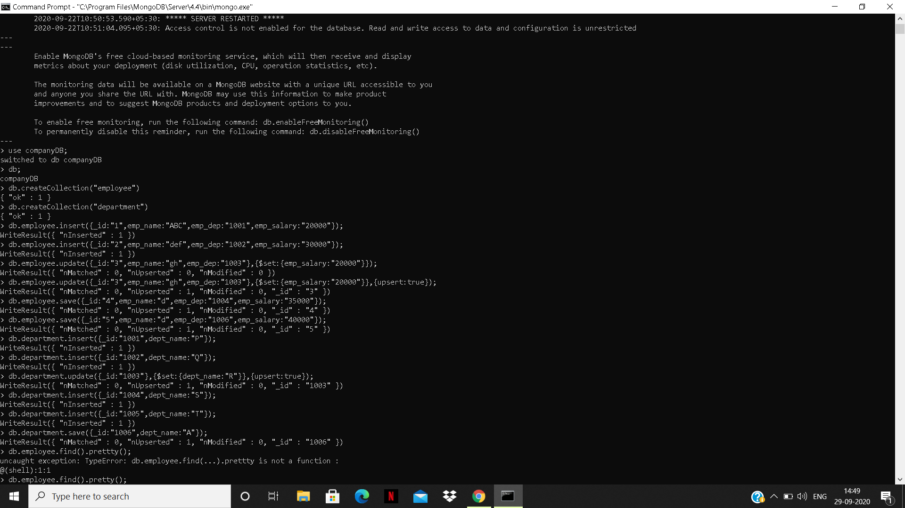

OUTPUT OF SELECT ALL DOCUMENTS

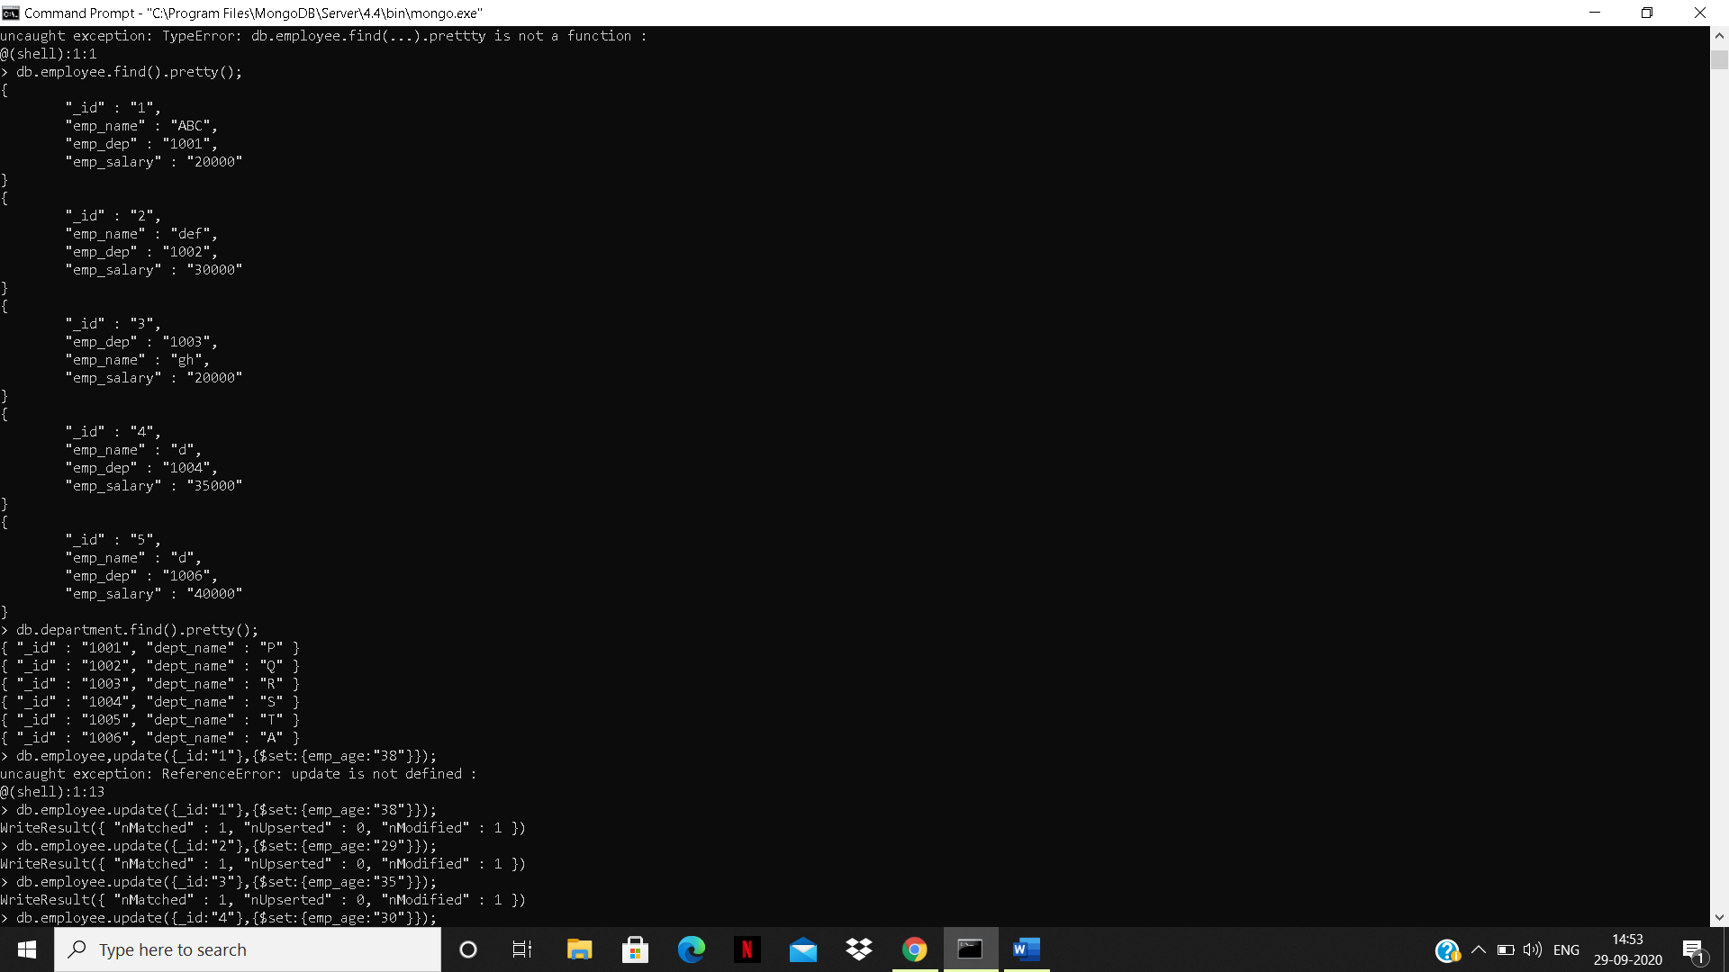

OUTPUT OF UPDATE

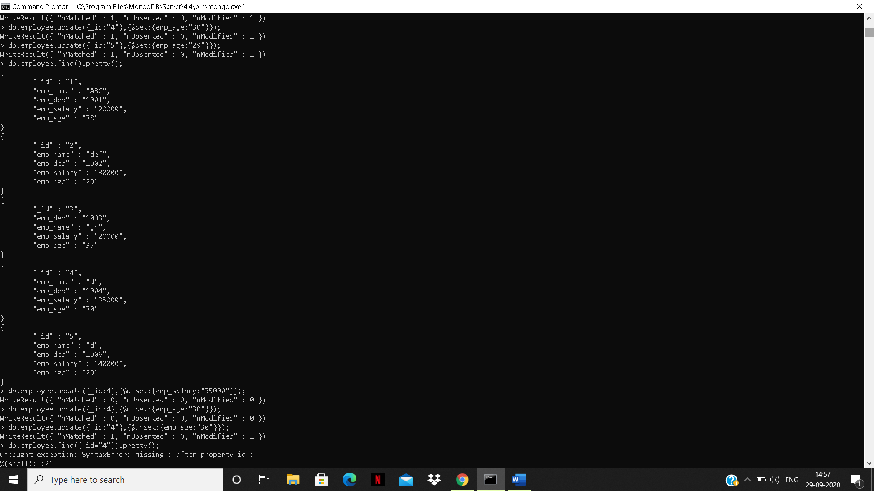

OUTPUT OF REMOVING A FIELD

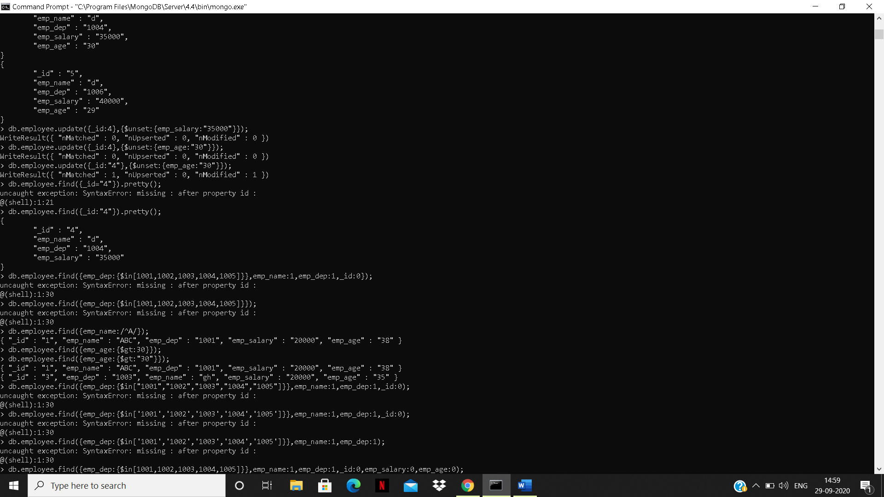

OUTPUT OF FINDING EMPLOYEE NAME STARTING WITH A

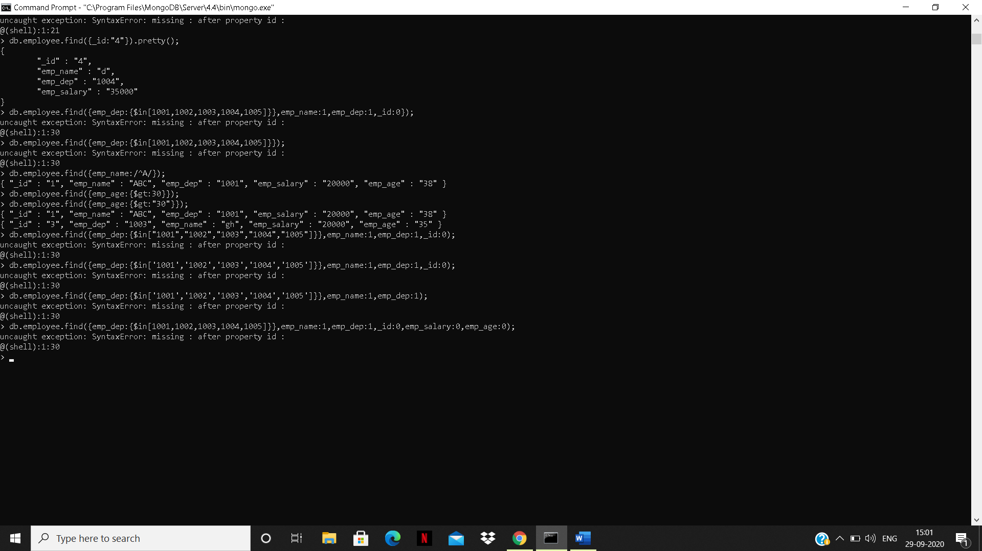

OUTPUT OF EMPLOYEE who have age greater than 30



OUTPUT OF EMPLOYEES WHOSE DEP NUMBER FALL IN THE RANGE 1001-1005

