**Programming Assignment 2 :** **PROGOL**

**CS 6364**

Submitted by:

Aashaar Panchalan – adp170630

Manish Biyani – mxb172930

**Ex. 1:**

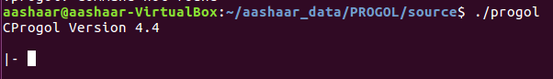

**Ex. 2:**

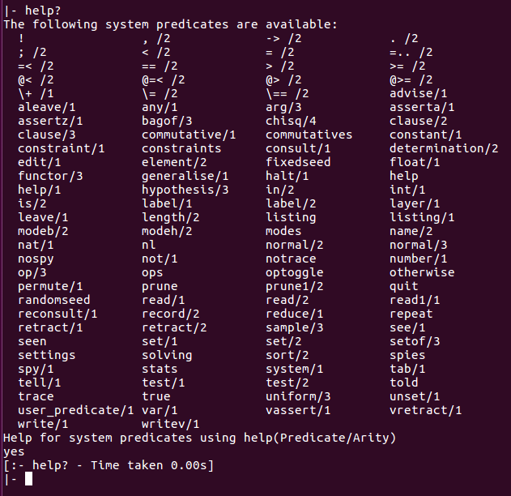

**Ex. 3:**

Please refer the file ‘adder.pl’ in the codes folder, for the code.

Here’s the screenshot for input state : a, not_b, not_c_in:

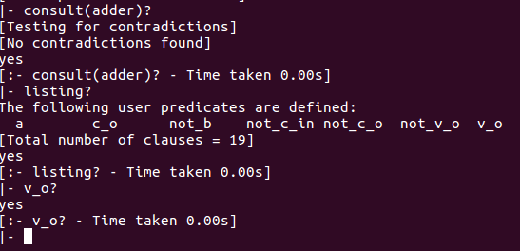

**Ex. 4:**

**a)**

|  |  |  |  |  |  |
| --- | --- | --- | --- | --- | --- |
| **A** | **B** | **Cin** | **Vo** | **Co** | **Progol Screenshot** |
| 0 | 0 | 0 | 0 | 0 |  |
| 0 | 0 | 1 | 1 | 0 |  |
| 0 | 1 | 0 | 1 | 0 |  |
| 0 | 1 | 1 | 0 | 1 |  |
| 1 | 0 | 0 | 1 | 0 |  |
| 1 | 0 | 1 | 0 | 1 |  |
| 1 | 1 | 0 | 0 | 1 |  |
| 1 | 1 | 1 | 1 | 1 |  |

From the truth-table, we have verified that Progol gives correct answers for all the output propositions.

**b)**

Yes, the adder circuit can be represented by fewer clauses by eliminating the negation of the two outputs. If we have the propositions for v_o and c_o we don’t need to maintain not_v_o and not_c_o. if required, they can simply be obtained by negating the v_o & c_o respt. Thus we can eliminate 8 clauses and the same adder circuit can be formed using only 8 clauses – 4 each for v_o and c_o.

**Ex. 5:**

Please refer the file ‘adder2.pl’ in the codes folder, for the code.

Below is the screenshot for input state : a, c (since we require not(b) to be true, we haven’t specified ‘b’ in the file so that by closed world assumption it becomes true.):

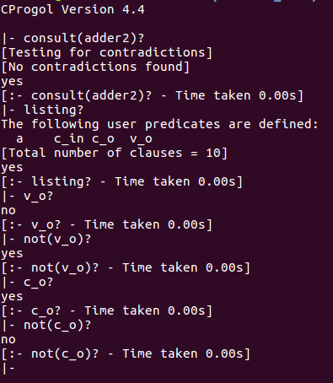

From the output in the above screenshot, we can see that not_v_o and not_c_o can be derived from the the v_o and c_o respt., simply by negating them due to the closed world assumption.

**b)**

|  |  |  |  |  |  |
| --- | --- | --- | --- | --- | --- |
| **A** | **B** | **Cin** | **Vo** | **Co** | **Progol Screenshot** |
| 0 | 0 | 0 | 0 | 0 |  |
| 0 | 0 | 1 | 1 | 0 |  |
| 0 | 1 | 0 | 1 | 0 |  |
| 0 | 1 | 1 | 0 | 1 |  |
| 1 | 0 | 0 | 1 | 0 |  |
| 1 | 0 | 1 | 0 | 1 |  |
| 1 | 1 | 0 | 0 | 1 |  |
| 1 | 1 | 1 | 1 | 1 |  |

From the truth-table, we have verified that Progol gives correct answers for all the output propositions.

**Ex. 6:**

1. in_and(X,S1,S2):-  
    elem(X,S1), elem(X,S2).
2. in_mult(X,Y,S1,S2):-  
    elem(X,S1), elem(Y,S2).
3. in_div(X,S1,S2):-  
    elem(X,S1), not(elem(X,S2)).

**Ex. 7:**

1. less_than_5(0,1).

less_than_5(0,2).

less_than_5(0,3).

less_than_5(0,4).

less_than_5(1,2).

less_than_5(1,3).

less_than_5(1,4).

less_than_5(2,3).

less_than_5(2,4).

less_than_5(3,4).

1. in_mult(X,Y,A,B):-  
    elem(X,A),elem(X,B),less_than_5(X,Y).

**Ex. 8 :**

1. bachelor(X) returns NO.
2. bachelor(bill) returns YES and bachelor(john) returns NO.  
   Please refer below screenshot for the above two answers.

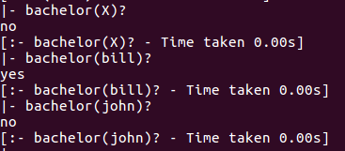

1. bachelor(X) gives   
    X=Bill  
    Yes.

bachelor(bill) returns YES and bachelor(john) returns NO.  
Please refer below screenshot for the above two answers.

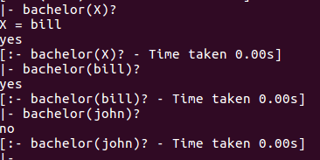

**Ex. 9:**

We added all the predicates to a file named tc.pl (available in codes folder) and changed the definition for each question.

1. **Definition 1:**

tc(3,6)- No

tc(3,7) – Yes

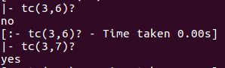

**Definition 2:**

tc(3,6)- No

tc(3,7) – Yes

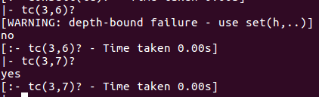

**Definition 3:**

tc(3,6)- No

tc(3,7) – Yes

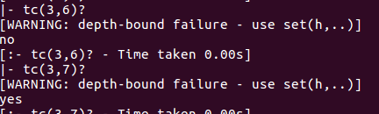

1. **Definition 1:**

tc(X,5)

X = 2 ;

X = 1 ;

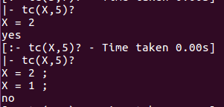

tc(5,X)

X = 6 ;

X = 7 ;

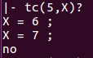

tc(X,Y)

X = 1

Y = 2 ;

X = 1

Y = 3 ;

X = 2

Y = 4 ;

X = 2

Y = 5 ;

X = 3

Y = 4 ;

X = 4

Y = 7 ;

X = 5

Y = 6 ;

X = 6

Y = 7 ;

X = 1

Y = 4 ;

X = 1

Y = 5 ;

X = 1

Y = 7 ;

X = 1

Y = 6 ;

X = 1

Y = 7 ;

X = 1

Y = 4 ;

X = 1

Y = 7 ;

X = 2

Y = 7 ;

X = 2

Y = 6 ;

X = 2

Y = 7 ;

X = 3

Y = 7 ;

X = 5

Y = 7 ;

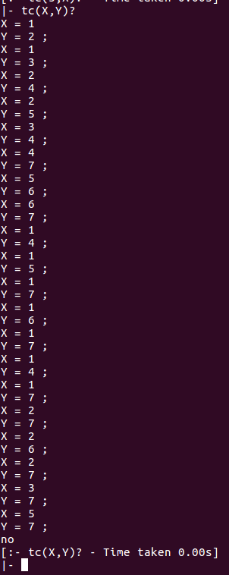

**(Ex.9b conted …)**

**Definition 2:**

tc(X,5)

X = 2;

X = 1;

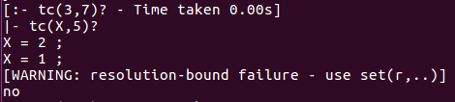

tc(5,X)

X = 6;

X =7;

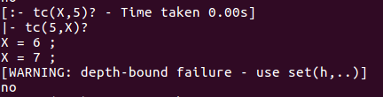

tc(X,Y)

X = 1

Y = 2 ;

X = 1

Y = 3 ;

X = 2

Y = 4 ;

X = 2

Y = 5 ;

X = 3

Y = 4 ;

X = 4

Y = 7 ;

X = 5

Y = 6 ;

X = 6

Y = 7 ;

X = 1

Y = 4 ;

X = 1

Y = 5 ;

X = 1

Y = 4 ;

X = 2

Y = 7 ;

X = 2

Y = 6 ;

X = 3

Y = 7 ;

X = 5

Y = 7 ;

X = 1

Y = 7 ;

X = 1

Y = 6 ;

X = 1

Y = 7 ;

X = 2

Y = 7 ;

X = 1

Y = 7 ;

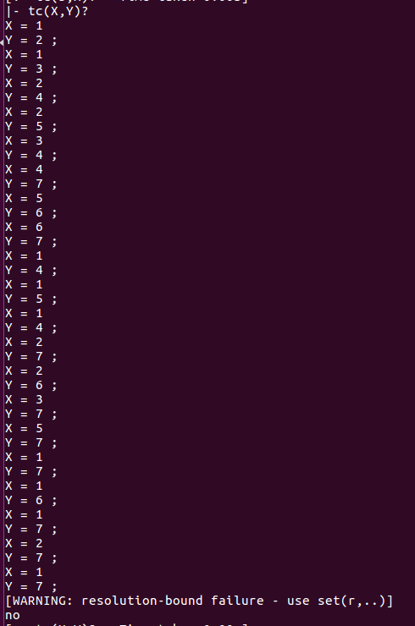

**(Ex.9b conted …)**

**Definition 3:**

tc(X,5) – None

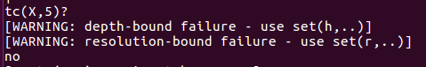

tc(5,X)

X = 6;

X =7;

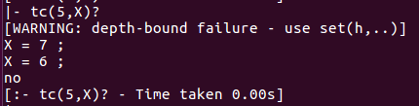

tc(X,Y) – None

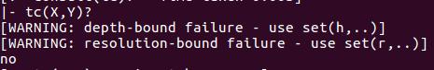

**c)**

X = 2 ;

X = 3 ;

X = 3 ;

X = 4 ;

X = 1 ;

X = 2 ;

X = 3 ;

X = 3 ;

X = 4 ;

X = 1 ;

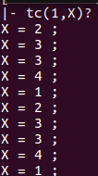

**Ex. 10:**

**a)** X= 2+3? - Yes

**b)** X is 2+3?

X = 5?

Yes

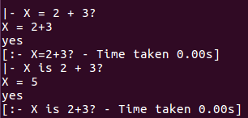

**Ex. 11:**

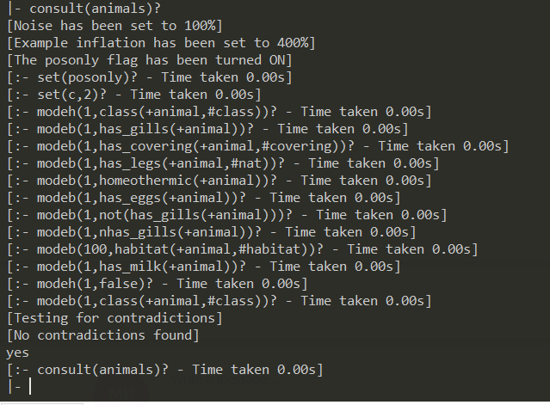

**Ex. 12:**

has_gills/1 args: animal  
has_covering/2 args: animal, covering  
has_legs/2 args: animal, count  
homeothermic/1 args: animal  
has_eggs/1 args: animal  
nhas_gills/1 args: animal  
habitat/2 args: animal, habitat  
has_milk/1 args: animal  
class/2 args: animal, class

**Ex. 13:**

Yes, it is legal.  
X takes the value given when we query the data. The definition will check if the given X is a member of the list [mammal, fish, reptile, bird]. If the value returns True, Class(X) is also true else it is false.

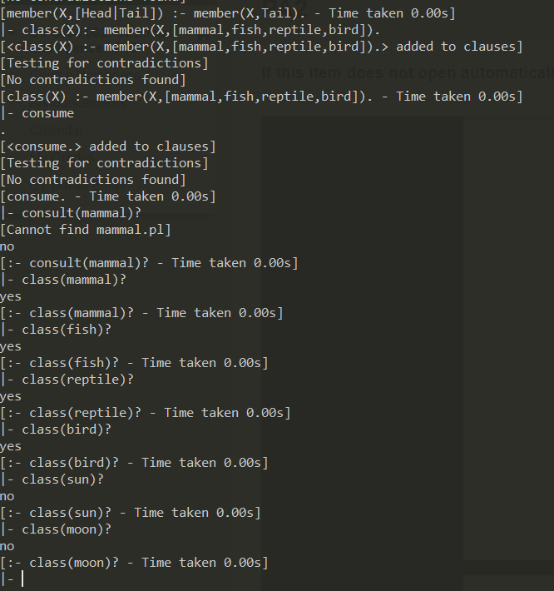

**Ex: 14**

**(a)** class(A,B):- has_milk(B).  
Not allowed. The first argument in class/2 should have the same argument in has_milk/1   
**(b)** class(A,B):- has_milk(A).  
Not allowed. 2nd argument in class/2 should be a constant.  
**(c)** class(A, mammal):-has_milk(platypus).  
Not allowed. The argument in has_milk/1 should not be a constant in the definition. The argument in has_milk/1 should be the same as the first argument in class/2.   
**(d)** class(platypus, mammal):- has_milk(platypus).  
Not allowed. The argument in has_milk/1 and first argument in class/2 should not be a  
constant.  
**(e)** class(A, mammal):- has_milk(A).  
Allowed. The above example satisfies the language constraints..

**Ex: 15**

For Eg: habitat(crocodile, land)succeeds. Similarly habitat(crocodile, water) also succeeds.

Habitat is a predicate which can return finite number of output values and so we write habitat/2 \***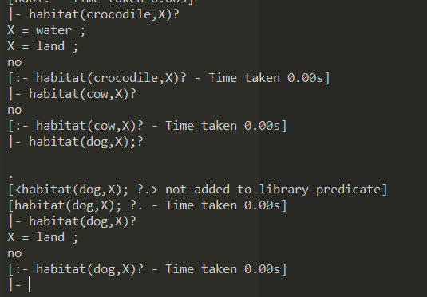**

**Ex: 16**

**a)**

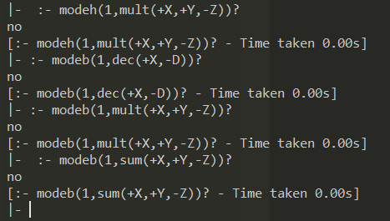

**b)**



