Module 1: Hardware and Components Basics Understanding of Hardware and its components

DAY 1:-
Motherboard
CPU
Task 1:
RAM

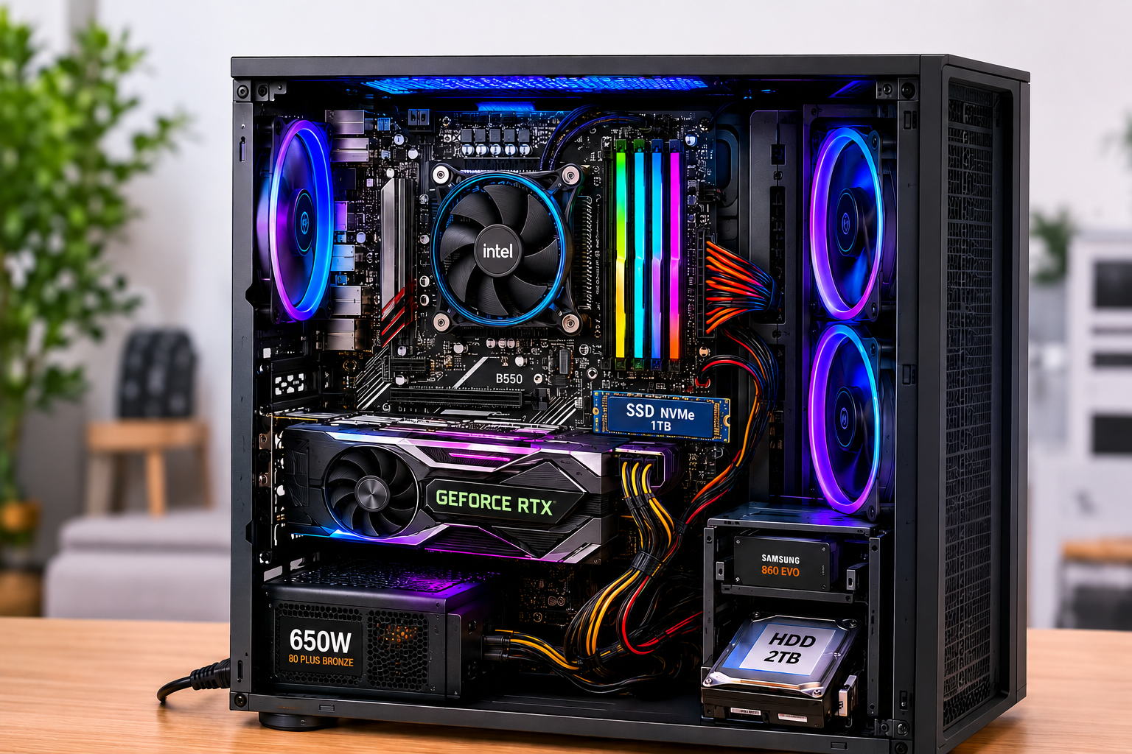
SSD
HDD
GPU

Task 2:

HDD | SSD
Slower: typically 80-160 MB/s, longer boot and load. | Much faster: 200 MB/s to 5,000+ MB/s, seconds to boot.
Less shock-resistant: has spinning platters and moving head, prone to damage from drops. | More shock-resistant: no moving parts, safer if laptop is dropped.
Data backups, archives, bulk storage of photos/videos etc. | Gaming PCs, laptops, OS drives, data analytics etc.

Task 3:

CPU - The CPU handles the game's core logic, including player movements, physics calculations, map rendering decisions, and network interactions. It acts as the "brain" that coordinates all non-graphics tasks and ensures the game runs smoothly without lag.

RAM - RAM temporarily stores game data that the CPU needs quickly, such as level maps, character models, and active texture data. Without sufficient RAM, the game must constantly fetch data from storage, causing slowdowns and stuttering during gameplay.

GPU - The GPU renders all visual elements—textures, lighting, shadows, and effects into the images you see on screen. A strong GPU ensures high frame rates and crisp visuals.

Task 4:

I would upgrade the following hardware components:
- SSD - Replacing an HDD with a SSD drastically reduces load times and makes the game more responsive.
- GPU - GPU is needed for high resolution, realistic lighting and smooth frame rates.
- CPU - A faster CPU improves overall game logic.
- RAM - Upgrading RAM ensures smooth multitasking and prevent stuttering.

