Bluestock Fund Analytics Capstone Project

Prepared by:
Savni Nukala
Data Analyst Intern
Fintech Division – Analytical and Insights Team

project: Mutual Fund Analytics and Investor Insights Platform

Tools Used: Python,Pandas,Numpy, SQL, Jupyter Notebook, Tableau,Github

Submitted to: Bluestock fintech Pvt. ltd
Capstone Project – Mutual Fund Analytics

DATE: June 2026

Executive Summary

This project set out to understand mutual fund performance and investor behavior through a data-driven lens. The goal was to design a complete analytics solution that could clean raw data, uncover meaningful patterns, evaluate risk, and present insights in a way that supports smarter investment decisions.
We worked with mutual fund NAV data, performance indicators, and transaction-level investor records. Using Python and SQL, the data was transformed into analysis-ready formats. Exploratory Data Analysis (EDA) helped highlight key trends, anomalies, and investor activity across different schemes.
To measure performance and risk, we applied advanced techniques such as CAGR, Sharpe and Sortino Ratios, Alpha, Beta, Maximum Drawdown, Value at Risk (VaR), Conditional VaR, and rolling performance metrics. These measures provided a balanced view of returns and risks, helping to identify both opportunities and vulnerabilities.
Finally, we built an interactive Tableau dashboard that brings these insights to life. Business users can now explore fund performance, track investor behaviour, and monitor industry trends in real time. The outcome is a comprehensive analytics platform that empowers data-driven investment analysis and decision-making.

Problem Statement

The mutual fund industry produces vast amounts of data — from daily NAV values to investor transactions and performance metrics. Yet, investors and analysts often find it difficult to bring all this information together into clear, actionable insights. Traditional reporting methods fall short: they don’t provide a unified view for comparing schemes, tracking SIP activity, or evaluating risk-adjusted returns. This gap creates a need for a comprehensive analytics solution that can simplify complexity and support better decision-making.

Project Objectives

- This project was designed to bridge that gap by:
- Building an end-to-end data pipeline for mutual fund analytics.
- Cleaning and standardizing NAV, transaction, and performance datasets.
- Conducting exploratory data analysis (EDA) to uncover industry and investor trends.
- Calculating advanced performance metrics including CAGR, Sharpe Ratio, Sortino Ratio, Alpha, Beta, VaR, and CVaR.
- Analyzing investor behavior through cohort analysis and SIP continuity tracking.
- Developing an interactive Tableau dashboard for business reporting and decision support.
- Documenting the full workflow and insights in a professional analytics report.

Data Sources

The project relied on three key datasets:
- NAV Dataset (clean_nav.csv)
- Daily Net Asset Value (NAV) records for mutual fund schemes (2022–2026).
- Fields: amfi_code, date, nav
- Purpose: Trend analysis, return calculation, risk analytics
- Transaction Dataset (clean_transactions.csv)
- Investor-level mutual fund transactions including SIP, Lumpsum, and Redemption records.
- Fields: investor_id, transaction_date, amount_inr, transaction_type, state, age_group, city_tier
- Purpose: Investor behavior analysis, cohort analysis, SIP continuity tracking
- Performance Dataset (clean_performance.csv)
- Scheme-level performance and risk metrics.
- Fields: return_1yr_pct, return_3yr_pct, return_5yr_pct, sharpe_ratio, sortino_ratio, alpha, beta, max_drawdown_pct, aum_crore, expense_ratio_pct, risk_grade
- Purpose: Performance comparison, ranking, and recommendation analysis

ETL Design
The ETL pipeline was built to transform raw mutual fund data into analytics-ready tables.
- Extract
- Loaded raw CSV files into Python using Pandas.
- Imported datasets into Jupyter Notebook and Tableau for analysis and visualization.
- Transform
    - Standardized column names and data types.
    - Converted date columns to datetime format.
    - Removed duplicates and handled missing values.
    - Created derived metrics (daily returns, rolling Sharpe ratios, cohort years).
    - Built aggregated tables for fund performance and investor analytics.
- Load
- Exported cleaned datasets to the data/processed/ directory.
- Saved analytical outputs and reports in the reports/ directory.
- Connected processed datasets to Tableau for dashboard creation.

Exploratory Data Analysis (EDA)
The purpose of EDA was to get a clear picture of the mutual fund datasets — their structure, quality, and distribution — before moving into advanced analytics.
Data Quality Assessment
- Checked that datasets were complete and consistent.
- Converted date fields into proper datetime format.
- Standardized column names and removed duplicate records.
- Identified and handled missing values to ensure reliability.

NAV Analysis
- Tracked daily NAV trends across all schemes.
- Highlighted long-term growth patterns and periods of market volatility.
- Compared NAV movements across different fund categories to spot relative performance.

Transaction Analysis
- Studied SIP, Lumpsum, and Redemption activity.
- Examined investor participation by state, age group, and city tier.
- Analyzed transaction volumes over time to identify behavioral shifts.

Performance Dataset Analysis
- Compared returns across Large Cap, Mid Cap, Small Cap, and Debt funds.
- Reviewed risk measures such as standard deviation and drawdown.
- Explored how returns, risk, and fund ratings interact to shape overall performance.

Key EDA Findings
- Return vs. Risk Trade-off Small Cap funds delivered the strongest long-term returns, but this came with much higher volatility compared to Large Cap funds. Investors chasing growth faced sharper ups and downs.

- Investor Activity Patterns SIP transactions dominated recurring activity, highlighting the growing role of retail investors who prefer disciplined, long-term investing.

- Cost Efficiency of Direct Plans Direct plans consistently showed lower expense ratios than regular plans. Over time, this cost advantage translated into better net returns for investors.

- Market Concentration Assets under management (AUM) were heavily concentrated among a few large fund houses. Despite this, the broader market remained fairly diversified, offering investors multiple choices.

- Rising Participation Mutual fund adoption grew steadily throughout the analysis period, reflecting increasing investor awareness and confidence in the industry.

Performance Analysis
To evaluate mutual fund schemes, several performance metrics were applied, each offering a different lens on returns and risk.
CAGR (Compound Annual Growth Rate)
Measured annualized returns over 1-year, 3-year, and 5-year horizons, providing a straightforward view of long-term growth.
Sharpe Ratio
Assessed risk-adjusted performance by comparing excess returns against overall volatility.
Sortino Ratio
Focused specifically on downside risk, giving a more investor-centric measure of performance.

Alpha and Beta
- Alpha captured excess returns relative to the benchmark.
- Beta measured sensitivity to market movements, showing how funds reacted to broader market swings.
Maximum Drawdown
Quantified the largest decline from a peak NAV, highlighting exposure to severe downside risk.
Key Observations
- Funds with strong Sharpe and Sortino ratios consistently delivered superior risk-adjusted returns.
- Higher-return funds often came with greater volatility and deeper drawdowns, underscoring the return-risk trade-off.
- Several schemes generated positive alpha, showing consistent outperformance against their benchmarks.

Risk Analytics
To evaluate downside exposure, advanced risk analytics were applied across mutual fund schemes.

Historical VaR (95%)
Estimated the potential loss under normal market conditions at a 95% confidence level, giving a baseline view of risk.

Conditional VaR (CVaR)
Measured the average loss during the worst-performing periods beyond the VaR threshold, capturing tail-risk exposure.

Rolling Sharpe Ratio
Calculated 90-day rolling Sharpe Ratios to track how risk-adjusted performance evolved over time, highlighting shifts in fund stability.
The rolling Sharpe ratio measures risk-adjusted performance over a moving 90-day window. Higher values indicate better returns relative to risk. The chart highlights periods of strong and weak fund performance across selected schemes.
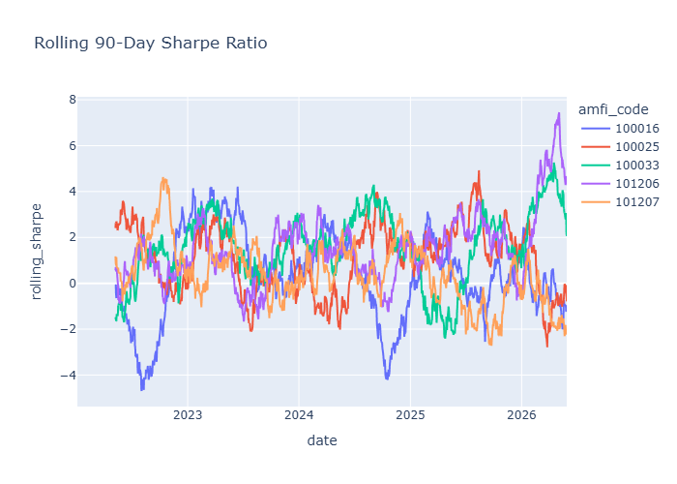
Figure 1: Rolling 90-Day Sharpe Ratio of Selected Mutual Fund Schemes

Key Findings
- Funds with higher returns often carried larger downside risks.
- CVaR values were consistently more negative than VaR, underscoring exposure to extreme market events.
- Rolling Sharpe trends revealed alternating periods of strong and weak risk-adjusted performance, reflecting market cycles.

Dashboard Visualizations
Interactive dashboards were developed in Tableau to present key insights from the mutual fund datasets.
KPI Dashboard
Displays high-level metrics such as total schemes, total fund houses, total AUM, and other summary indicators.
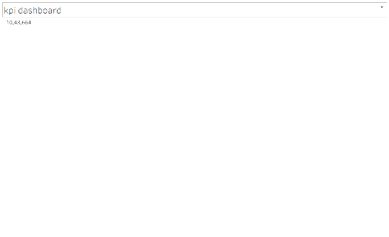
SIP Inflows Dashboard
Visualizes investment patterns over time and highlights SIP contribution trends.

Total Schemes Dashboard
Shows the distribution of mutual fund schemes across different categories and fund houses.


Fund Houses Dashboard
Provides a comparison of fund houses based on scheme count and assets under management.

Investment Trend Dashboard
Tracks changes in NAV and investment growth over time, helping identify market trends and fund performance patterns.
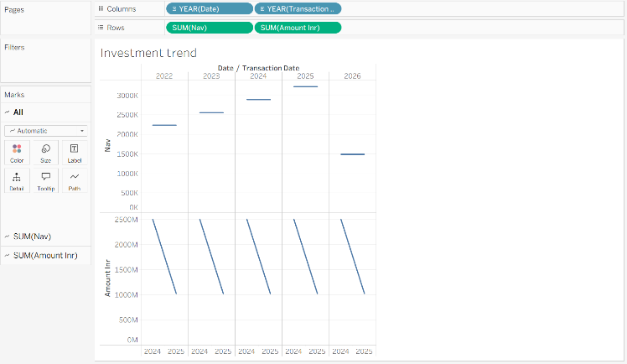
These dashboards enable quick decision-making through interactive and visual exploration of the data.

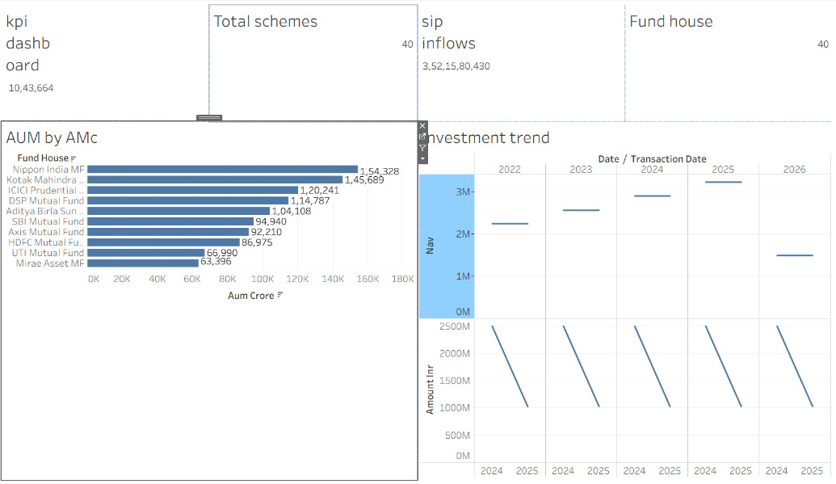

Limitations
- The analysis is dependent on the quality and completeness of the provided datasets.
- Historical data may not fully capture future market conditions.
- Some advanced financial metrics were calculated using available data and may differ from industry-standard implementations.
- Investor behavior analysis is limited to the transactions available in the dataset.
- External economic factors, market sentiment, and macroeconomic events were not incorporated into the analysis.

Recommendations
- Investors should consider both return and risk metrics before selecting funds.
- Funds with consistently higher Sharpe ratios may provide better risk-adjusted returns.
- SIP investors should maintain continuity to maximize long-term wealth creation.
- Diversification across fund categories can help reduce portfolio concentration risk.
- Future versions of the project can incorporate real-time market data and predictive analytics models for enhanced decision support.
- Additional investor segmentation techniques can be used to create more personalized investment recommendations.

Conclusion
This project successfully developed an end-to-end Mutual Fund Analytics platform covering data cleaning, exploratory analysis, performance evaluation, risk analytics, investor behavior analysis, and interactive dashboards. The solution demonstrates how data analytics and business intelligence techniques can be applied to generate meaningful insights for investors and financial institutions. The project achieved all planned objectives and delivered a comprehensive analytics framework for mutual fund analysis.

