COMPREHENSIVE RETAIL STORE DATA ANALYSIS REPORT
Data Cleaning, Exploratory Visualization, Statistical Analysis and Predictive Modeling Using R
Week 4 – Comprehensive Data Analysis Reporting and Presentation
Prepared by:
Aashin N
Role:
Virtual R Data Analyst Intern
Contents
COMPREHENSIVE RETAIL STORE DATA ANALYSIS REPORT 1
1. INTRODUCTION 5
1.1 Project Background 5
1.2 Project Objectives 6
2. DATASET OVERVIEW 7
3. METHODOLOGY 8
Stage 1 – Data Preparation 8
Stage 2 – Exploratory Data Visualization 8
Stage 3 – Statistical Analysis and Predictive Modeling 8
Stage 4 – Integrated Interpretation 8
4. DATA PREPARATION AND CLEANING 8
4.1 Initial Data Inspection 8
4.2 Missing and Uncertain Values 9
4.3 Data Type Conversion 10
5. OUTLIER DETECTION AND TREATMENT 10
6. DATA TRANSFORMATION AND FEATURE ENGINEERING 11
6.1 Normalization 11
6.2 Encoding Categorical Variables 11
6.3 Temporal Feature Creation 12
7. EXPLORATORY DATA VISUALIZATION 12
7.1 Quantity Sold by Product Category 12
Business Implication 14
7.2 Revenue by Purchase Location 14
7.3 Distribution of Total Spent 15
7.4 Quantity vs Total Spent 16
7.5 Monthly Sales Trend 17
Business Implication 18
7.6 Total Spent by Product Category 18
7.7 Payment Method by Purchase Location 19
Business Implication 20
8. STATISTICAL ANALYSIS 20
8.1 Quantity and Total Spent 21
Hypotheses 21
8.2 Price Per Unit and Total Spent 21
Hypotheses 21
8.3 Normality Analysis 22
8.4 Online vs In-store Transaction Values 23
Hypotheses 23
Integrated Interpretation 23
9. PREDICTIVE MODELING 24
9.1 Modeling Objective 24
9.2 Train-Test Split 24
9.3 Model 1 – Additive Multiple Linear Regression 25
10. MODEL PERFORMANCE 26
11. TEN-FOLD CROSS-VALIDATION 27
12. MODEL DIAGNOSTICS 28
12.1 Residuals vs Fitted 29
12.2 Normal Q-Q Plot 29
12.3 Scale-Location Plot 30
12.4 Residuals vs Leverage 30
13. COOK'S DISTANCE ANALYSIS 30
14. MODEL OPTIMIZATION 31
15. MODEL 2 – INTERACTION MODEL 32
16. MODEL COMPARISON 32
17. ACTUAL VS PREDICTED PERFORMANCE 33
18. INTEGRATED RESULTS AND DISCUSSION 34
18.1 Transaction Size Is Primarily Driven by Price and Quantity 34
18.2 Online Revenue Was Higher, but Average Spending Was Similar 34
18.3 Product Demand Was Relatively Distributed 35
18.4 Payment Behavior Was Balanced 35
18.5 Statistical Outliers Were Not Necessarily Invalid Transactions 35
18.6 High Predictive Accuracy Requires Context 36
19. BUSINESS IMPLICATIONS 36
Inventory Planning 36
Digital Channel Strategy 36
Payment Flexibility 36
Transaction Value Drivers 37
Analytical Decision-Making 37
20. CHALLENGES ENCOUNTERED AND SOLUTIONS 37
20.1 Data Quality and Dataset Verification 37
Lesson 37
20.2 R Package Setup 38
Lesson 38
20.3 Outlier Interpretation 38
Lesson 38
20.4 Incomplete Temporal Periods 38
Lesson 38
20.5 Regression Assumption Violations 39
Solution 39
20.6 Essentially Perfect Model Fit 39
Lesson 39
21. LESSONS LEARNED 39
22. RECOMMENDATIONS 40
1. Maintain Support for Both Sales Channels 40
2. Maintain Multiple Payment Options 40
3. Use Category Demand for Inventory Planning 40
4. Interpret Outliers Before Removing Them 40
5. Combine Descriptive and Inferential Analysis 40
6. Validate Predictive Targets Carefully 40
23. FUTURE DIRECTIONS 41
23.1 Alternative Predictive Targets 41
23.2 Additional Customer Variables 41
23.3 Promotional Analysis 41
23.4 Advanced Predictive Models 41
23.5 More Detailed Temporal Analysis 42
24. CONCLUSION 42
25. APPENDIX – SELECTED R CODE 43
A. Data Inspection 43
B. Correlation Analysis 43
C. Normality Test 43
D. Welch Two-Sample T-Test 44
E. Model 1 44
F. Model Diagnostics 44
G. Model 2 44

EXECUTIVE SUMMARY
This report presents a comprehensive analysis of a Retail Store Sales dataset using R. It integrates the data preparation, exploratory visualization, statistical analysis and predictive modeling activities completed throughout the project into a single analytical workflow.
The purpose of the project was to transform raw retail transaction data into reliable analytical information, identify meaningful sales and purchasing patterns, statistically evaluate relationships within the dataset, and assess the ability of selected transaction characteristics to explain and predict Total Spent.
The project began with data cleaning and preprocessing. Missing and uncertain values were investigated, variable types were verified, numerical variables were normalized, categorical variables were encoded, and a Year-Month variable was created to support temporal analysis. Potential outliers were also examined using the interquartile range (IQR) method. Rather than automatically deleting statistically flagged observations, their business plausibility was considered before making cleaning decisions.
Following preprocessing, exploratory visualizations were created to investigate product demand, revenue by purchase location, transaction-value distributions, relationships between quantity and spending, monthly sales patterns, category-level variation and payment behavior.
Furniture recorded the highest total quantity sold, with 8,462 units, while Patisserie recorded the lowest total quantity among the analyzed categories, with 7,943 units. Online transactions generated total revenue of 791,401 compared with 760,670 for In-store transactions. However, later statistical analysis showed that the average transaction values for Online and In-store purchases were not significantly different.
Inferential statistical analysis identified significant positive relationships between key numerical variables. Quantity and Total Spent had a Pearson correlation of approximately 0.7121, while Price Per Unit and Total Spent had a correlation of approximately 0.6306. Both relationships were statistically significant. A Shapiro-Wilk test indicated that sampled Total Spent values did not follow a normal distribution, while a Welch two-sample t-test found no statistically significant difference in average Total Spent between Online and In-store transactions.
Predictive modeling was subsequently performed using multiple linear regression. The dataset was divided into 9,576 training observations and 2,395 test observations. The primary additive regression model achieved a test R² of approximately 0.8935, an RMSE of approximately 30.97 and an MAE of approximately 23.13. Ten-fold cross-validation produced an average R² of approximately 0.8956, demonstrating relatively stable predictive performance.
Regression diagnostics nevertheless revealed systematic residual patterns, indicating limitations in the additive model specification. A second model incorporating an interaction between Price Per Unit and Quantity achieved an essentially perfect fit because Total Spent is structurally determined by the product of these variables. The result was therefore interpreted as evidence of a deterministic target relationship rather than exceptional generalizable predictive performance.
Overall, the project demonstrates the importance of combining data preparation, visualization, statistical inference, predictive modeling and business interpretation. The analysis also illustrates why statistical results and model-performance metrics should be evaluated alongside an understanding of dataset construction, assumptions and business context.

1. INTRODUCTION

1.1 Project Background
Modern retail organizations generate substantial amounts of transactional data through customer purchases. These datasets can contain information relating to products, prices, quantities, payment methods, transaction locations, discounts and purchase dates.
When appropriately prepared and analyzed, retail transaction data can provide valuable insights into purchasing patterns, product demand, sales performance and customer behavior. However, raw data cannot always be analyzed immediately. Data quality issues, missing values, inconsistent formats, categorical variables, unusual observations and other analytical challenges may need to be addressed before reliable conclusions can be produced.
This project applied a structured data-analysis workflow using R to a Retail Store Sales dataset.
The project progressed through four connected stages:
- Data cleaning and preprocessing.
- Exploratory data visualization.
- Statistical analysis and predictive modeling.
- Integration and communication of the complete analytical findings.
Maintaining the same dataset throughout these stages allowed the project to demonstrate how an analysis can evolve from raw data preparation into increasingly advanced analytical techniques.

1.2 Project Objectives
The overall objectives of the project were to:
- prepare a retail transaction dataset for reliable analysis;
- identify and appropriately handle data-quality issues;
- transform and encode variables where necessary;
- investigate transaction and sales patterns through visualizations;
- examine statistical relationships among important variables;
- formulate and evaluate statistical hypotheses;
- develop and validate a predictive regression model;
- evaluate model assumptions and limitations;
- translate analytical results into understandable business insights; and
- identify potential directions for future analysis.
The final objective was not simply to generate statistical outputs, but to demonstrate how different stages of data analysis can contribute to evidence-based decision-making.

2. DATASET OVERVIEW
The project used a publicly available Retail Store Sales dataset containing transaction-level retail information.
Following the cleaning and preprocessing process, the analytical dataset contained:
11,971 observations and 18 variables.
Important variables included:
- Category
- Price Per Unit
- Transaction ID
- Customer ID
- Item
- Quantity
- Total Spent
- Payment Method
- Location
- Transaction Date
- Discount Applied
Additional transformed variables were generated during preprocessing, including:
- Price_Normalized
- Total_Spent_Normalized
- Location_Encoded
- Payment_Cash
- Payment_Credit_Card
- Payment_Digital_Wallet
- Year_Month
The dataset included both numerical and categorical variables, making it suitable for data cleaning, exploratory visualization, inferential statistics and regression modeling.
Three numerical variables were particularly important throughout the project:
Price Per Unit represents the unit price of a purchased product.
Quantity represents the number of units involved in a transaction.
Total Spent represents the total monetary value of the transaction.

3. METHODOLOGY
A structured analytical workflow was used throughout the project.
The methodology consisted of four main stages:

Stage 1 – Data Preparation
The raw dataset was inspected and cleaned to improve its quality and consistency. This included examining missing values, checking variable types, evaluating potential outliers, normalizing numerical variables and encoding categorical variables.

Stage 2 – Exploratory Data Visualization
Graphs and charts were developed to investigate sales patterns, product demand, transaction-value distributions, purchase locations, payment methods and temporal trends.

Stage 3 – Statistical Analysis and Predictive Modeling
Inferential statistical methods were used to evaluate relationships identified during exploratory analysis. Multiple linear regression was then used to model Total Spent, followed by train-test evaluation, 10-fold cross-validation and regression diagnostics.

Stage 4 – Integrated Interpretation
Results from the previous analytical stages were combined to identify key findings, business implications, limitations, lessons learned and recommendations for future analysis.
R was used throughout the project for data manipulation, statistical analysis, visualization and predictive modeling.

4. DATA PREPARATION AND CLEANING

4.1 Initial Data Inspection
The first stage of the project involved examining the structure and quality of the dataset.
Functions such as the following were used to understand the dataset:
dim(data)
str(data)
summary(data)
These functions provided information about the number of observations and variables, variable data types, numerical distributions and potential data-quality issues.
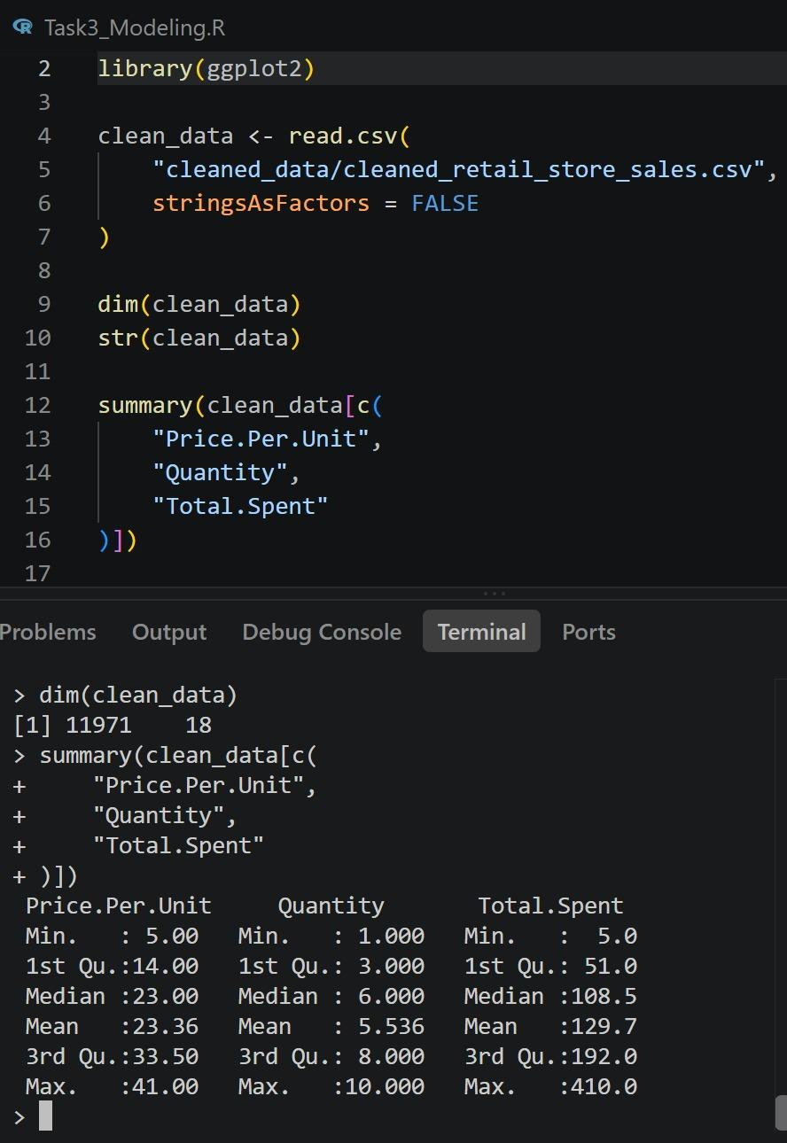
Figure 1. Initial inspection of the Retail Store Sales dataset in R.

4.2 Missing and Uncertain Values
Missing and uncertain values were examined before further analysis.
Rather than automatically removing observations containing incomplete information, the relevance of each variable to subsequent analysis was considered.
The Discount Applied variable included an Unknown category. Maintaining this information as a distinct categorical level prevented uncertain discount information from being incorrectly classified as either Yes or No.
This approach helped preserve observations while maintaining transparency regarding uncertain values.

4.3 Data Type Conversion
Correct variable types are important because R handles numerical, categorical and date variables differently.
Categorical variables such as Category, Payment Method, Location and Discount Applied were appropriately treated as categorical information during analysis and modeling.
Transaction Date was converted into a date format where required to enable chronological analysis.
Appropriate data types reduced the possibility of incorrect calculations and supported later statistical and visualization procedures.

5. OUTLIER DETECTION AND TREATMENT
Potential outliers in Total Spent were investigated using the Interquartile Range method.
The general IQR approach is:
IQR = Q3 - Q1

Lower Bound = Q1 - 1.5 × IQR

Upper Bound = Q3 + 1.5 × IQR
Approximately 60 observations were identified as potential statistical outliers according to the IQR criterion.
However, these observations were not automatically deleted.
For example, Total Spent could reach 410 when an item priced at 41 was purchased in a quantity of 10:
41 × 10 = 410
Although such a transaction could exceed an IQR-based upper threshold, it remains a logically valid transaction within the observed price and quantity ranges.
This demonstrated an important distinction between a statistical outlier and an invalid observation.
The observations were therefore retained where they remained plausible according to the underlying transaction variables.
This decision prevented legitimate high-value transactions from being removed solely because of a statistical threshold.

6. DATA TRANSFORMATION AND FEATURE ENGINEERING

6.1 Normalization
Selected numerical variables were normalized to create scaled versions of the original measures.
These included:
- Price_Normalized
- Total_Spent_Normalized
Normalization placed values on a comparable scale while preserving the original variables for interpretation.

6.2 Encoding Categorical Variables
Categorical variables were transformed where numerical representations were useful.
Location was represented using:
- In-store = 0
- Online = 1
Payment Method was represented through separate binary variables:
- Payment_Cash
- Payment_Credit_Card
- Payment_Digital_Wallet
Using separate binary indicators avoided incorrectly treating payment methods as if they had a meaningful numerical ranking.
For example, assigning:
Cash = 1
Credit Card = 2
Digital Wallet = 3
could falsely imply that Digital Wallet is numerically “greater” than Credit Card or Cash.
One-hot encoding therefore provided a more appropriate representation.

6.3 Temporal Feature Creation
A Year_Month variable was created from Transaction Date.
This supported monthly aggregation and enabled the temporal sales visualization performed later in the project.
The transformation demonstrated how raw variables can be converted into features designed specifically for analytical objectives.

7. EXPLORATORY DATA VISUALIZATION
After cleaning and preprocessing, exploratory data visualization was used to identify patterns, relationships and anomalies within the dataset.
Seven major visualizations were developed using R.

7.1 Quantity Sold by Product Category
Total Quantity was aggregated for each product category.
The results showed:
Category | Total Quantity
Furniture | 8,462
Food | 8,387
Beverages | 8,358
Milk Products | 8,339
Electric household essentials | 8,309
Computers and electric accessories | 8,272
Butchers | 8,206
Patisserie | 7,943
Furniture recorded the highest total quantity sold, while Patisserie recorded the lowest among the eight categories.
However, the differences between categories were relatively moderate rather than extreme. This suggests that demand was distributed across several product categories rather than being concentrated entirely within one category.
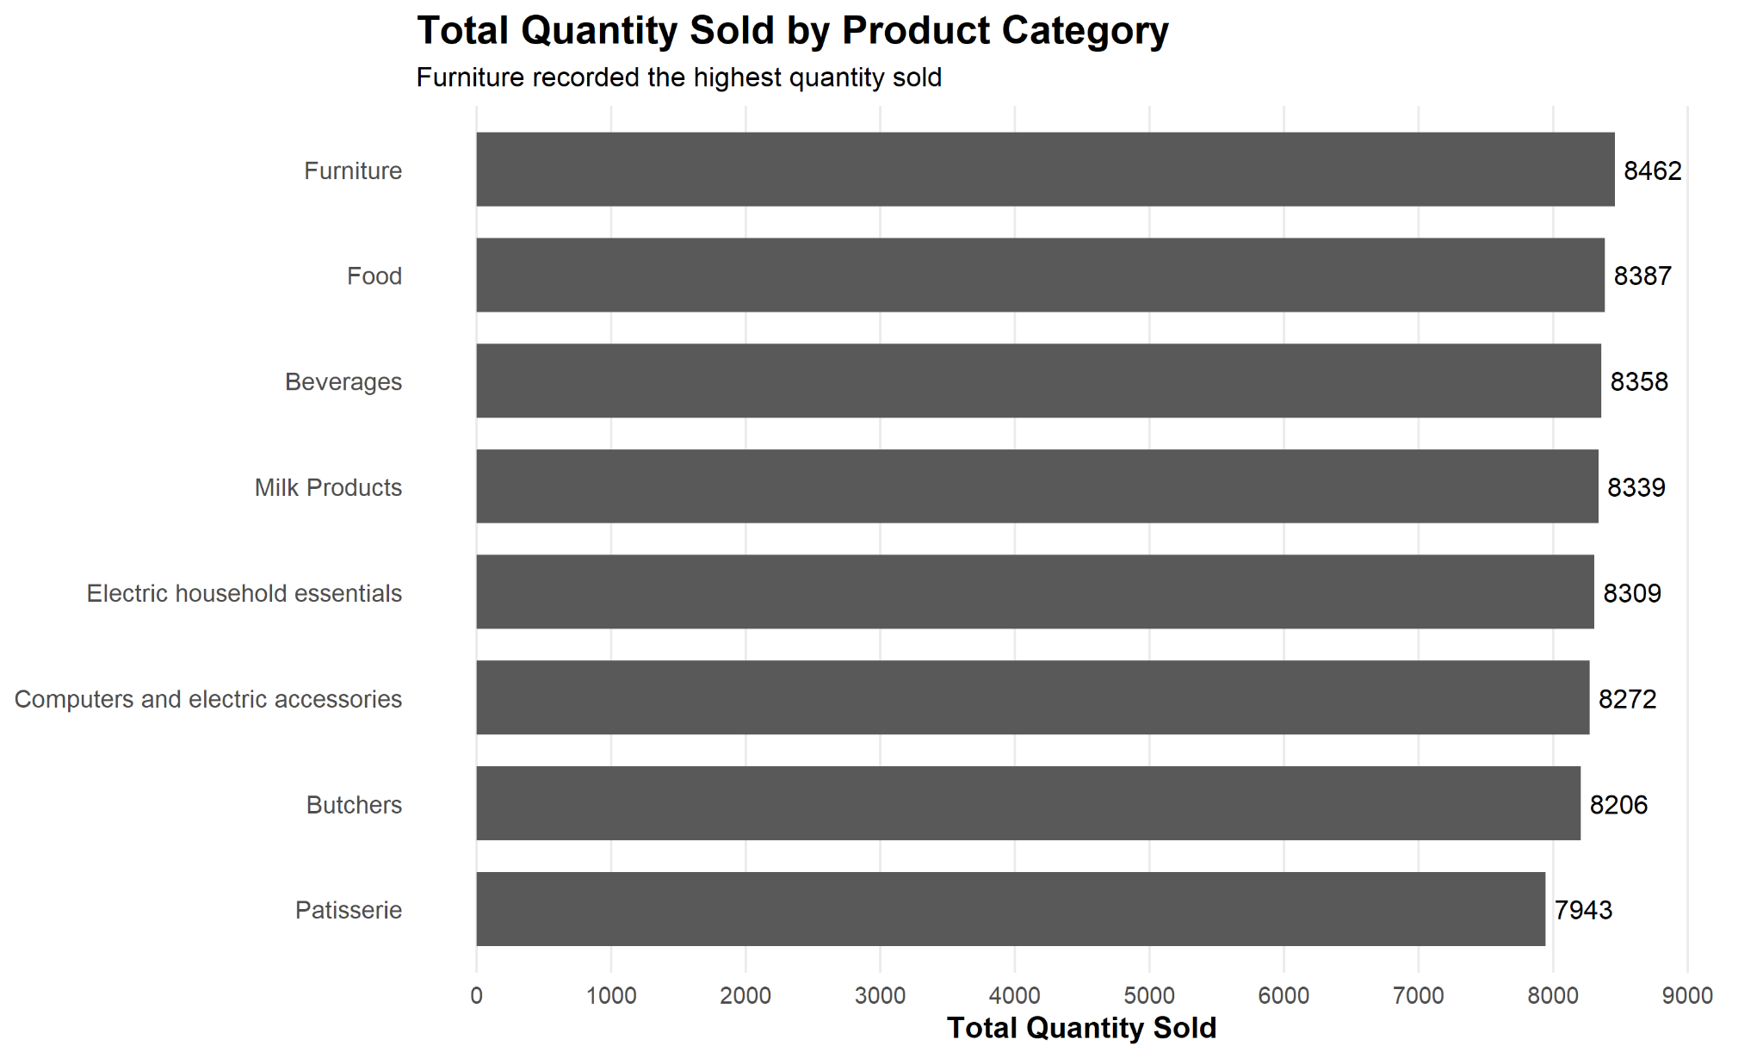
Figure 2. Total Quantity Sold by Product Category.

Business Implication
Product categories with consistently high sales quantities may require greater attention to inventory availability and replenishment planning.
At the same time, the relatively balanced quantities indicate that inventory decisions should not focus exclusively on one category.

7.2 Revenue by Purchase Location
Total revenue was compared between Online and In-store transactions.
The results were:
Location | Total Revenue
Online | 791,401
In-store | 760,670
Online transactions generated approximately 30,731 more total revenue than In-store transactions.
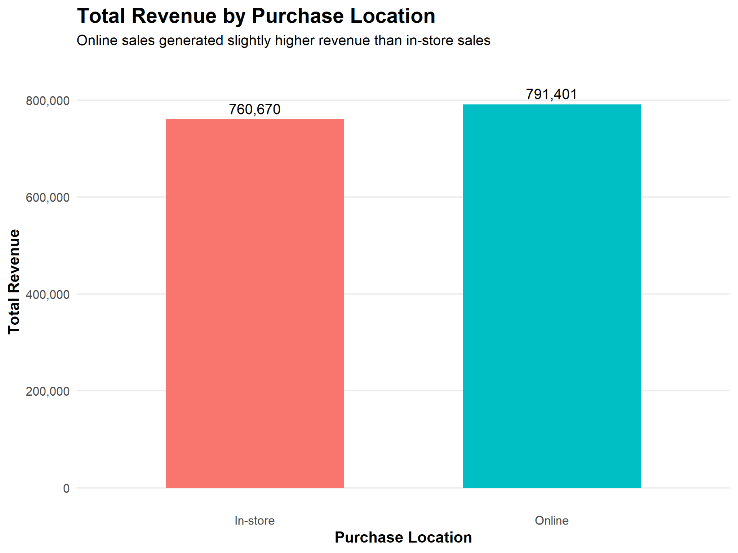
Figure 3. Total Revenue by Purchase Location.
At the exploratory stage, this suggested stronger aggregate revenue performance from the online channel.
However, later hypothesis testing showed that average transaction values were not significantly different between the two locations.
This demonstrates why visual descriptive results should be supplemented by statistical testing before broader conclusions are made.

7.3 Distribution of Total Spent
A histogram was created to examine the distribution of transaction values.
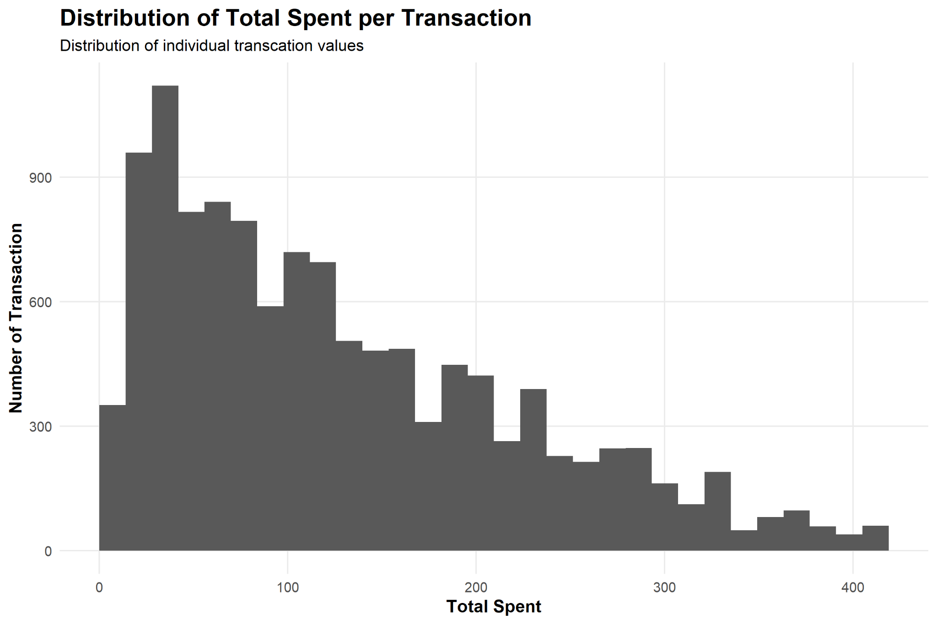
Figure 4. Distribution of Total Spent.
The distribution showed a greater concentration of transactions at lower and middle spending levels, with fewer transactions toward the highest values.
The mean Total Spent was approximately 129.7, while the median was approximately 108.5.
The higher mean relative to the median was consistent with a right-skewed distribution.
This visual observation was later supported by formal normality testing.

7.4 Quantity vs Total Spent
A scatter plot was created to examine the relationship between Quantity and Total Spent.
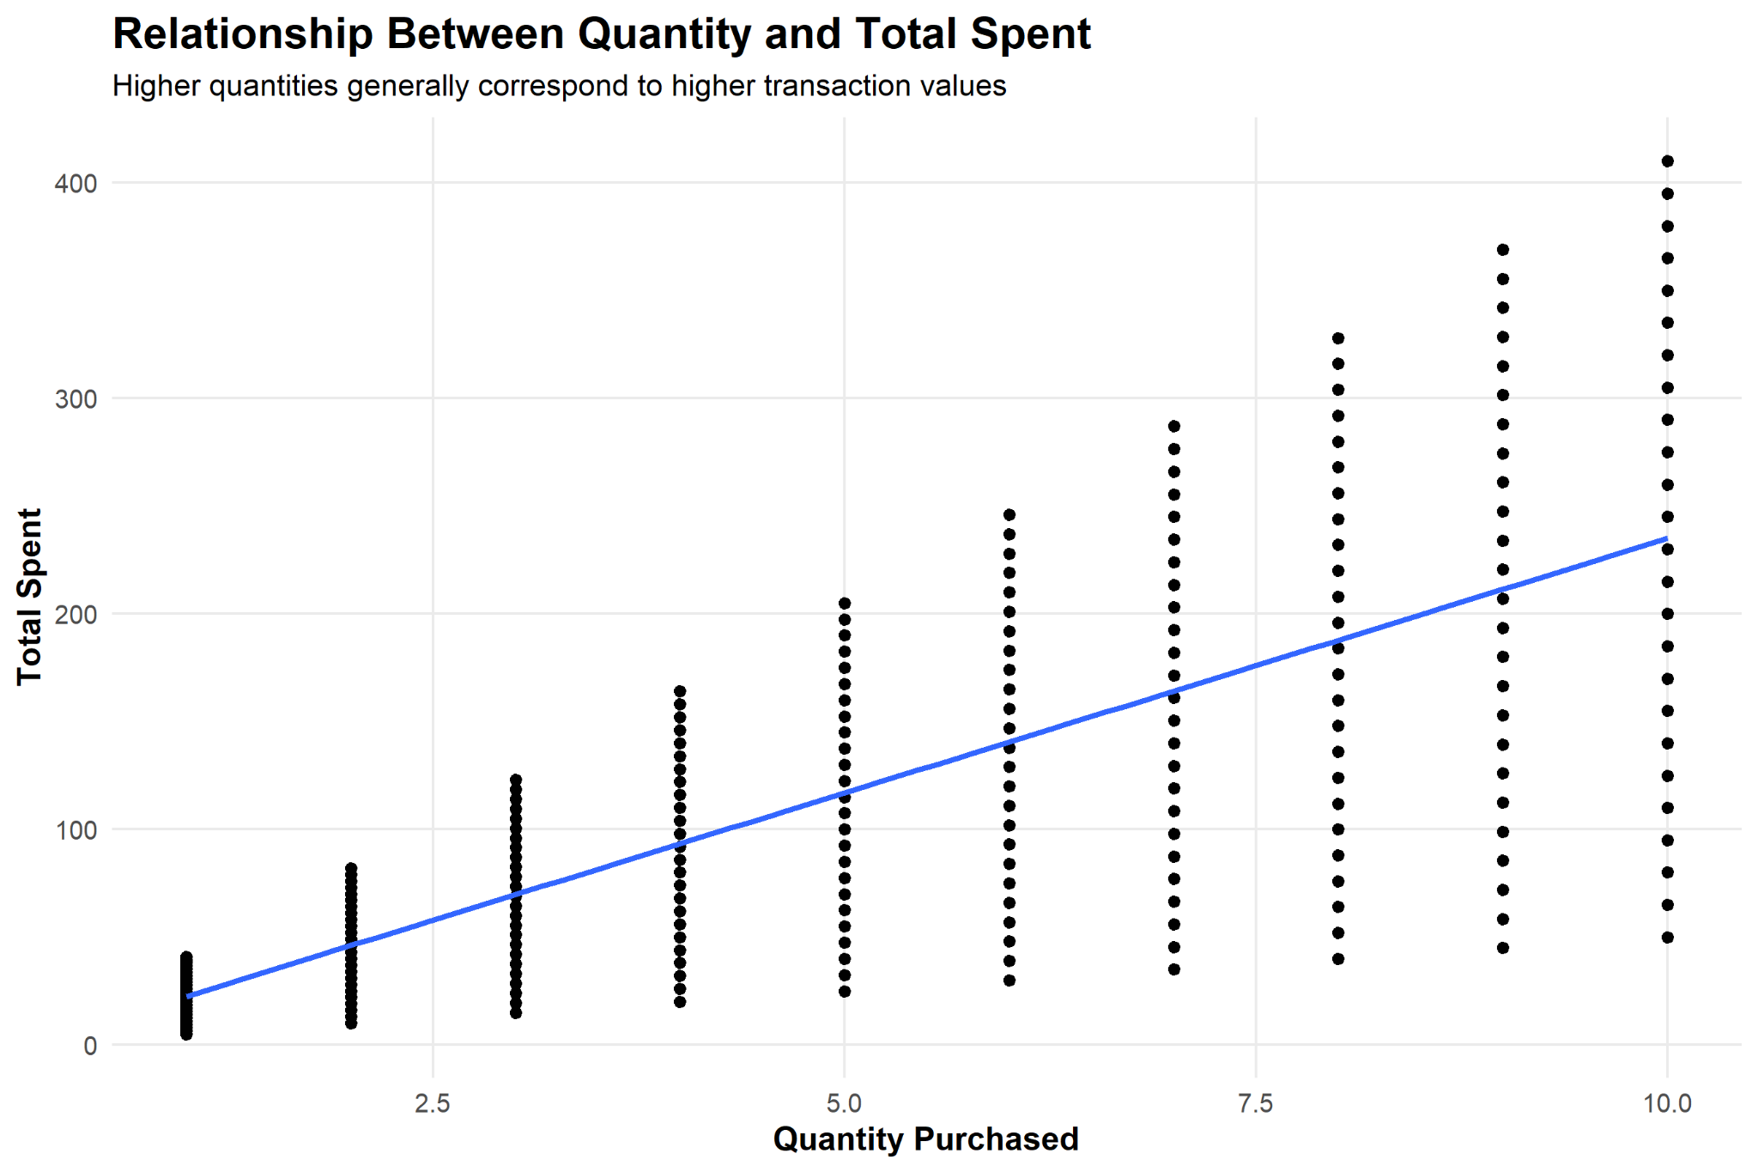
Figure 5. Relationship Between Quantity and Total Spent.
The graph demonstrated a clear positive relationship. Transactions involving larger quantities generally produced higher Total Spent values.
This exploratory observation was subsequently confirmed statistically using Pearson correlation analysis, which produced:
r = 0.7121
p < 2.2e-16
Therefore, Quantity had a strong and statistically significant positive relationship with Total Spent.

7.5 Monthly Sales Trend
Monthly revenue was aggregated using the Year_Month feature created during preprocessing.
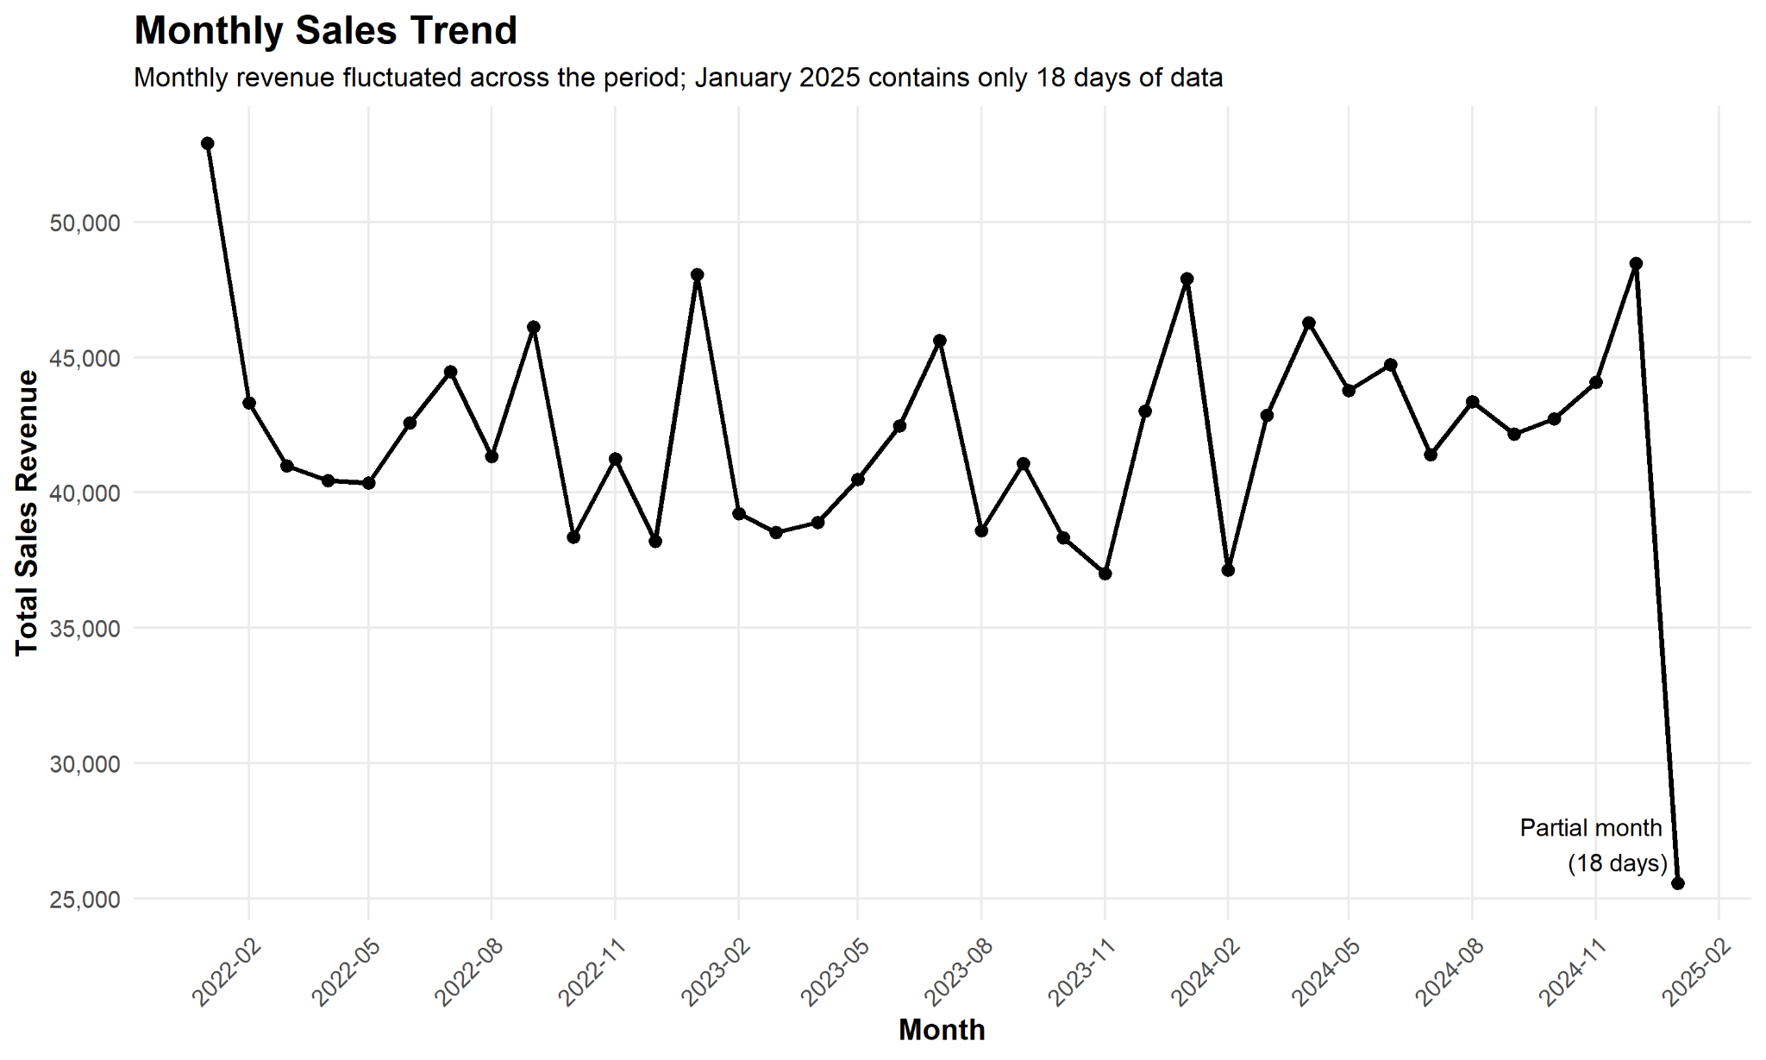
Figure 6. Monthly Sales Trend.
The visualization allowed changes in revenue over time to be examined and made it easier to identify periods of comparatively high and low sales.
The final month in the dataset required cautious interpretation because it represented only a partial month with approximately 18 days of sales records. Comparing this directly with complete months could therefore produce misleading conclusions.

Business Implication
Temporal sales analysis can support inventory planning, staffing decisions and promotional scheduling. However, incomplete periods should be clearly identified before comparing monthly totals.

7.6 Total Spent by Product Category
A boxplot was used to compare transaction spending distributions across product categories.
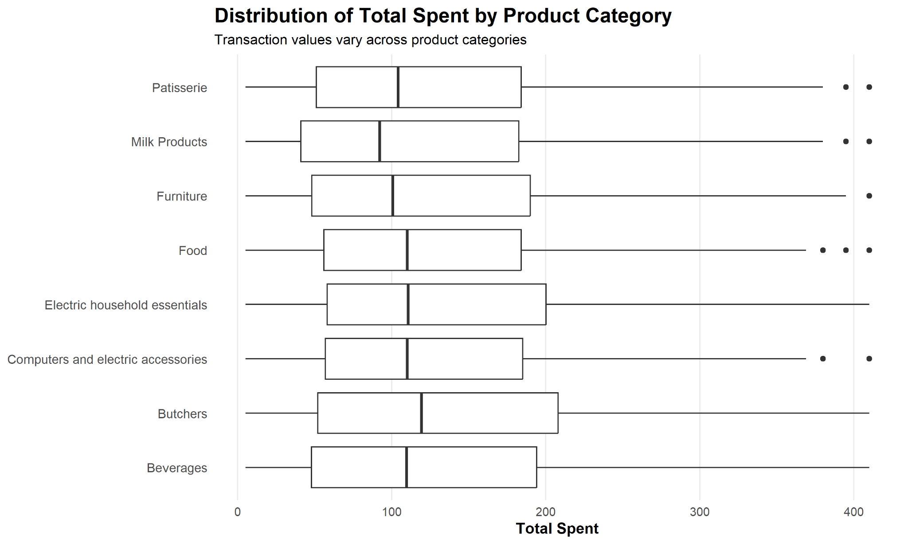
Figure 7. Distribution of Total Spent Across Product Categories.
The visualization demonstrated variation within and across categories and made it possible to identify differences in medians, ranges and higher-value transactions.
Boxplots were particularly appropriate because they display the distribution of numerical values while also making unusual observations visible.

7.7 Payment Method by Purchase Location
Payment-method usage was compared across Online and In-store transactions.
The observed transaction counts were:
Location | Payment Method | Count
In-store | Cash | 2,032
Online | Cash | 2,071
In-store | Credit Card | 1,918
Online | Credit Card | 2,009
In-store | Digital Wallet | 1,953
Online | Digital Wallet | 1,988
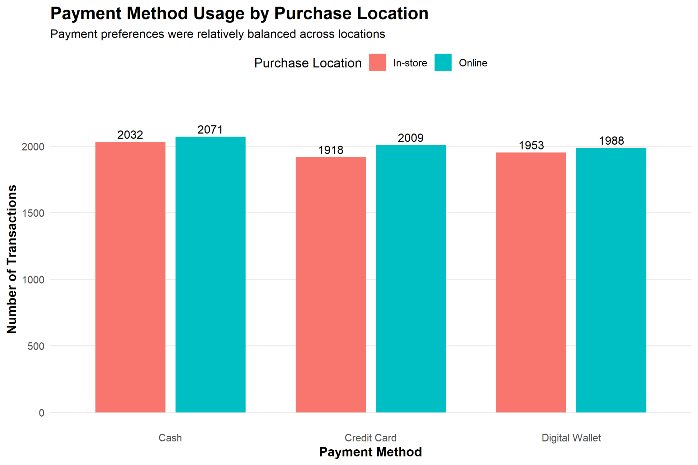
Figure 8. Payment Method Usage by Purchase Location.
The counts were relatively balanced across the three payment methods and the two purchase locations.
No single payment method completely dominated transaction activity.

Business Implication
Supporting multiple payment options remains important because customers use Cash, Credit Card and Digital Wallet methods in substantial numbers.

8. STATISTICAL ANALYSIS
Following exploratory visualization, inferential statistical analysis was conducted to determine whether selected observed relationships were statistically significant.

8.1 Quantity and Total Spent
A Pearson correlation test examined the relationship between Quantity and Total Spent.

Hypotheses
H₀: There is no significant linear correlation between Quantity and Total Spent.
H₁: There is a significant linear correlation between Quantity and Total Spent.
R code:
cor.test(
clean_data$Quantity,
clean_data$Total.Spent,
method = "pearson"
)
The test produced:
r = 0.7120691
t = 110.95
df = 11969
p-value < 2.2e-16

95% CI:
0.7031242 to 0.7207887
The null hypothesis was rejected.
There was strong evidence of a statistically significant positive linear relationship between Quantity and Total Spent.

8.2 Price Per Unit and Total Spent
A second Pearson correlation test examined Price Per Unit and Total Spent.

Hypotheses
H₀: There is no significant linear correlation between Price Per Unit and Total Spent.
H₁: There is a significant linear correlation between Price Per Unit and Total Spent.
The test produced:
r = 0.6306162
t = 88.895
df = 11969
p-value < 2.2e-16

95% CI:
0.6197029 to 0.6412856
The null hypothesis was rejected.
Price Per Unit therefore demonstrated a statistically significant positive relationship with Total Spent.
Quantity nevertheless had the stronger individual linear correlation:
Quantity ↔ Total Spent = 0.7121

Price Per Unit ↔ Total Spent = 0.6306

8.3 Normality Analysis
The Shapiro-Wilk test was used to assess the distribution of Total Spent.
Because R's shapiro.test() accepts a maximum of 5,000 observations, a reproducible random sample was selected.
set.seed(123)

total_spent_sample <- sample(
clean_data$Total.Spent,
5000
)

shapiro.test(total_spent_sample)
The result was:
W = 0.92517
p-value < 2.2e-16
The null hypothesis of normality was rejected.
The result provided statistical evidence that the sampled Total Spent values did not follow a normal distribution and was consistent with the right-skewed pattern observed in the histogram.

8.4 Online vs In-store Transaction Values
Although Online transactions generated greater aggregate revenue, it was necessary to determine whether average transaction spending actually differed significantly between the two locations.
The average values were:
In-store = 128.8616
Online = 130.4221
A Welch two-sample t-test was conducted.

Hypotheses
H₀: Mean Total Spent is equal between Online and In-store transactions.
H₁: Mean Total Spent differs between Online and In-store transactions.
The result was:
t = -0.90082
df = 11958
p-value = 0.3677

95% CI:
-4.955949 to 1.835040
Since p = 0.3677 was greater than 0.05, the null hypothesis was not rejected.
There was insufficient statistical evidence that average transaction spending differed between Online and In-store purchases.

Integrated Interpretation
This is an important distinction.
Exploratory analysis showed:
Online total revenue = 791,401
In-store total revenue = 760,670
But inferential analysis showed:
Online average transaction = 130.42
In-store average transaction = 128.86

p = 0.3677
Therefore, the higher total Online revenue should not be interpreted as evidence that individual Online transactions are significantly larger.

9. PREDICTIVE MODELING

9.1 Modeling Objective
The predictive stage investigated whether transaction characteristics could explain and predict Total Spent.
The primary predictors included:
- Quantity
- Price Per Unit
- Location
- Payment Method
- Discount Applied
- Category
Multiple linear regression was selected because Total Spent is a continuous numerical target.

9.2 Train-Test Split
The dataset was divided into training and test subsets.
set.seed(123)

train_index <- sample(
seq_len(nrow(clean_data)),
size = 0.80 * nrow(clean_data)
)

train_data <- clean_data[train_index, ]
test_data <- clean_data[-train_index, ]
The resulting split contained:
Training observations = 9,576
Testing observations = 2,395
The training dataset was used to fit the model, while the test dataset remained unseen during model development and was used for final evaluation.

9.3 Model 1 – Additive Multiple Linear Regression
The initial model was:
model_1 <- lm(
Total.Spent ~
Quantity +
Price.Per.Unit +
Location +
Payment.Method +
Discount.Applied +
Category,
data = train_data
)

summary(model_1)
Important training results were:
Residual standard error = 30.55

Multiple R² = 0.8961
Adjusted R² = 0.8959

F-statistic = 5889
p-value < 2.2e-16
The model explained approximately 89.61% of the variation in Total Spent within the training dataset.
Quantity and Price Per Unit were highly statistically significant predictors.
Quantity:
Estimate = 23.4335
p < 2e-16

Price Per Unit:
Estimate = 5.4972
p < 2e-16
Other variables such as Location, Payment Method and Discount Applied were not statistically significant at the conventional 0.05 level within this model.
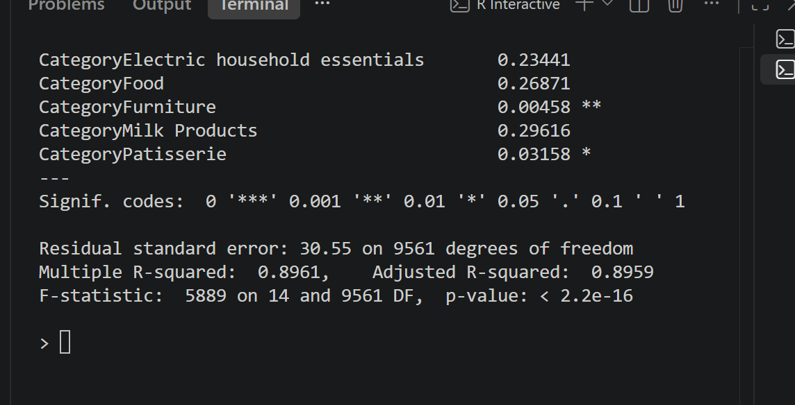
Figure 9. Multiple Linear Regression Model 1 Summary Output.

10. MODEL PERFORMANCE
The additive model was evaluated using the unseen test dataset.
Three performance metrics were calculated:
- Root Mean Squared Error
- Mean Absolute Error
- R-squared
The results were:
Metric | Model 1
RMSE | 30.9746
MAE | 23.1266
R² | 0.8935
The test R² indicated that the model explained approximately 89.35% of the variation in Total Spent in unseen test observations.
The MAE indicated an average absolute prediction error of approximately 23.13 monetary units.
The similarity between training and testing R² suggested that predictive performance remained relatively stable when the model was applied to unseen data.

11. TEN-FOLD CROSS-VALIDATION
To evaluate model stability more thoroughly, 10-fold cross-validation was conducted on the training dataset.
The data was divided into ten approximately equal subsets. During each iteration, nine folds were used for training and one fold for validation.
This process was repeated until every fold had served as validation data.
The average results were:
Average RMSE = 30.5632
Average MAE = 22.9034
Average R² = 0.8956
A comparison with the final test set showed:
Metric | 10-Fold CV | Test Set
RMSE | 30.5632 | 30.9746
MAE | 22.9034 | 23.1266
R² | 0.8956 | 0.8935
The close agreement between cross-validation and test-set results provided evidence that Model 1's performance was relatively stable rather than being dependent on one favorable train-test split.

12. MODEL DIAGNOSTICS
Strong performance metrics alone are not sufficient to establish that a regression model is appropriately specified.
Standard regression diagnostic plots were therefore examined.
par(mfrow = c(2, 2))
plot(model_1)
par(mfrow = c(1, 1))
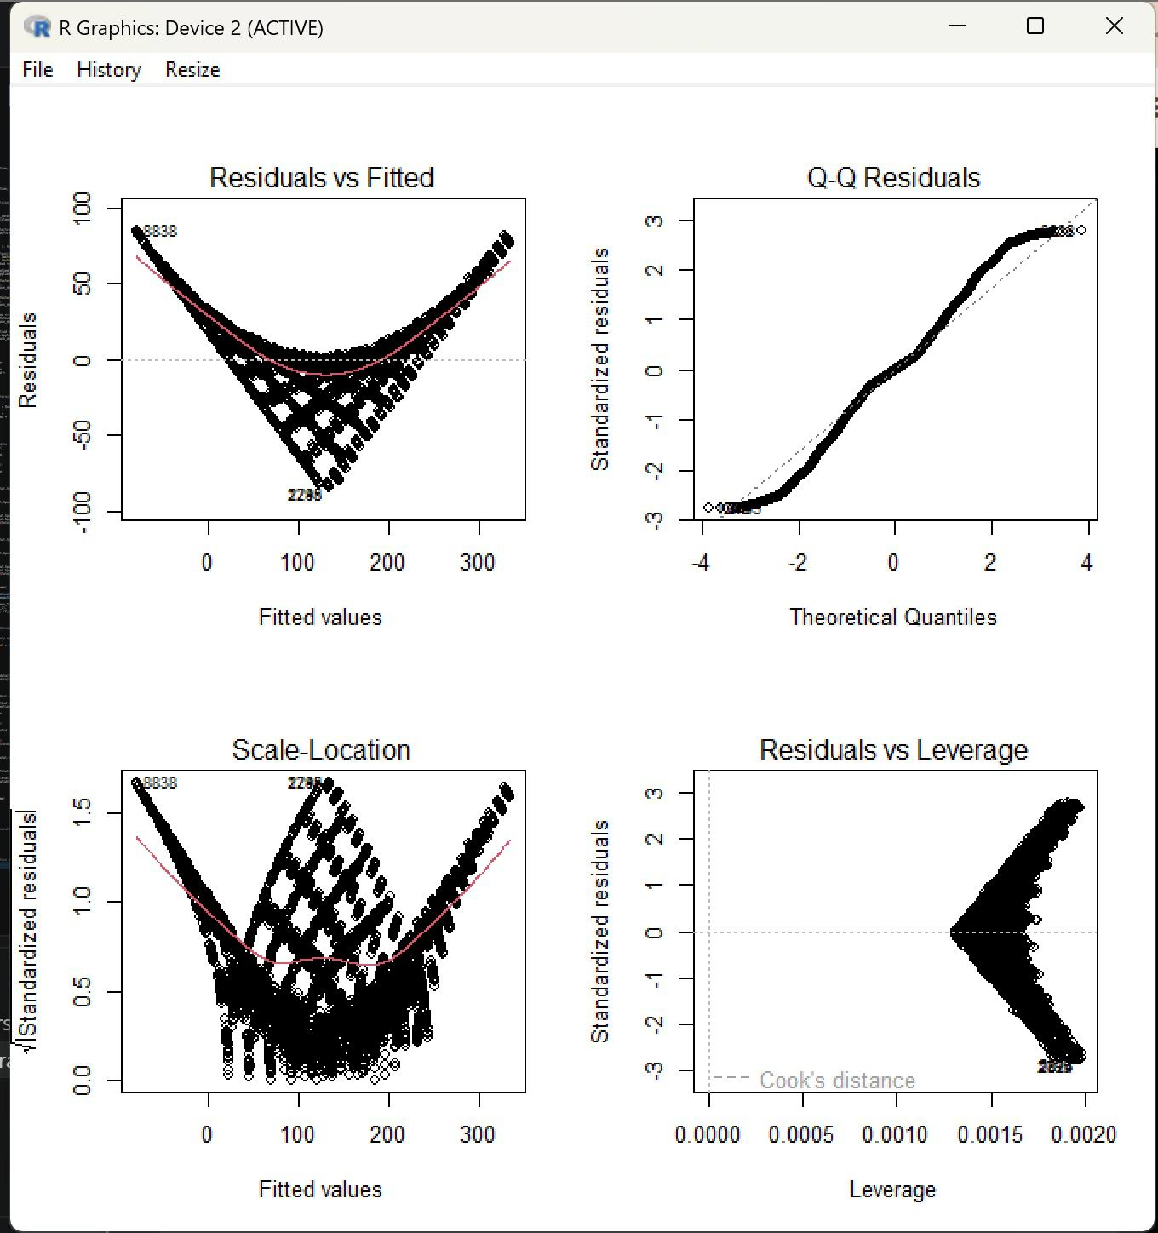
Figure 10. Regression Diagnostic Plots for Model 1.

12.1 Residuals vs Fitted
The Residuals vs Fitted plot showed a systematic curved pattern.
Ideally, residuals should appear as an approximately random horizontal cloud around zero.
The observed curvature indicated that the additive regression specification did not fully capture the underlying relationship between the predictors and Total Spent.

12.2 Normal Q-Q Plot
The Q-Q plot showed systematic departures from the theoretical diagonal line.
This suggested that Model 1's residuals were not normally distributed.

12.3 Scale-Location Plot
The Scale-Location plot also displayed a systematic pattern.
This provided evidence that residual variance was not completely constant across fitted values and therefore suggested heteroscedasticity.

12.4 Residuals vs Leverage
The Residuals vs Leverage plot was examined to identify potentially influential observations.
A formal Cook's distance analysis was subsequently used to investigate influence quantitatively.

13. COOK'S DISTANCE ANALYSIS
Cook's distance was calculated using:
cooks_d <- cooks.distance(model_1)

cook_threshold <- 4 / nrow(train_data)

cook_threshold
sum(cooks_d > cook_threshold)
max(cooks_d)
The results were:
4/n threshold = 0.0004177109

Observations above threshold = 809

Maximum Cook's distance = 0.00100706
Although 809 observations exceeded the conservative 4/n screening threshold, the maximum Cook's distance was only approximately 0.00101.
The very small maximum value did not indicate that a small number of observations exerted extreme individual influence on the fitted model.
No observations were therefore removed solely on the basis of Cook's distance.
The diagnostic evidence suggested that Model 1's primary limitation was its functional specification rather than a small set of extremely influential observations.

14. MODEL OPTIMIZATION
The diagnostic plots suggested that the additive model did not fully represent the underlying relationship.
A second model therefore introduced an interaction between Price Per Unit and Quantity.
model_2 <- lm(
Total.Spent ~
Price.Per.Unit * Quantity +
Location +
Payment.Method +
Discount.Applied +
Category,
data = train_data
)

summary(model_2)
In an R formula:
Price.Per.Unit * Quantity
includes:
Price.Per.Unit
Quantity
Price.Per.Unit:Quantity
The interaction allows the effect of one variable to depend on the value of the other.

15. MODEL 2 – INTERACTION MODEL
Model 2 produced:
Price.Per.Unit:Quantity coefficient = 1.000

Multiple R² = 1
Adjusted R² = 1

Residual standard error ≈ 1.267e-13
R also generated the warning:
essentially perfect fit:
summary may be unreliable
The apparent perfect performance required careful interpretation.
Total Spent is essentially determined by:
Total Spent =
Price Per Unit × Quantity
Once the interaction was included, the model effectively contained the mathematical relationship used to determine the target.
The interaction coefficient of approximately 1.000 confirmed this relationship.
Therefore, Model 2 was treated primarily as a demonstration of model specification and deterministic target construction rather than as evidence of generalizable predictive performance.

16. MODEL COMPARISON
The two models produced:
Model | RMSE | MAE | R²
Model 1 – Additive | 30.9746 | 23.1266 | 0.8935
Model 2 – Interaction | ≈ 0 | ≈ 0 | 1.0000
Model 2 generated essentially zero prediction error because the interaction reproduced the deterministic relationship underlying Total Spent.
Therefore, the comparison demonstrates an important analytical principle:
A model with extremely high predictive performance is not automatically the most informative model.
Analysts must investigate how the target variable was generated and whether predictor variables directly encode the answer being predicted.

17. ACTUAL VS PREDICTED PERFORMANCE
Model 1 predictions were visualized against actual test-set Total Spent values.
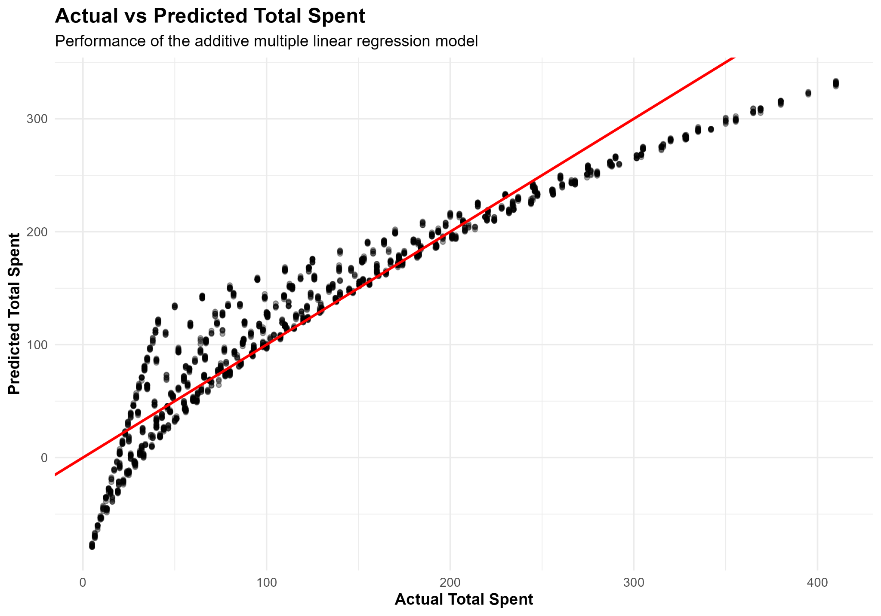
Figure 11. Actual vs Predicted Total Spent for Model 1.
The observations broadly followed the diagonal perfect-prediction line, consistent with the test R² of approximately 0.8935.
However, systematic deviations were visible, particularly at the extremes of transaction values.
Higher-value transactions showed evidence of underprediction.
This pattern was consistent with the regression diagnostic results and supported the conclusion that the additive model did not completely capture the multiplicative relationship between Price Per Unit and Quantity.

18. INTEGRATED RESULTS AND DISCUSSION
Combining the cleaning, visualization, statistical and modeling stages produced several important insights.

18.1 Transaction Size Is Primarily Driven by Price and Quantity
Quantity had the strongest individual linear relationship with Total Spent:
r = 0.7121
Price Per Unit also demonstrated a substantial relationship:
r = 0.6306
Both relationships were statistically significant.
The predictive modeling stage reinforced the importance of these variables.

18.2 Online Revenue Was Higher, but Average Spending Was Similar
Online transactions generated:
791,401
compared with:
760,670
for In-store transactions.
However:
Online mean = 130.42
In-store mean = 128.86
p = 0.3677
Therefore, the difference in aggregate channel revenue should not be interpreted as evidence of significantly greater individual Online transaction values.
This distinction demonstrates the importance of considering both aggregate metrics and per-transaction statistics.

18.3 Product Demand Was Relatively Distributed
Furniture recorded the highest total quantity at 8,462 units, while Patisserie recorded 7,943.
Although a ranking was present, the differences were not sufficiently extreme to suggest that overall demand was concentrated entirely within one category.
Retail planning should therefore consider the complete category portfolio.

18.4 Payment Behavior Was Balanced
Cash, Credit Card and Digital Wallet transactions appeared in substantial numbers across both Online and In-store purchases.
This suggests that maintaining diverse payment options is appropriate rather than optimizing exclusively for a single payment method.

18.5 Statistical Outliers Were Not Necessarily Invalid Transactions
The IQR procedure identified approximately 60 potential Total Spent outliers.
However, high transaction values could be mathematically valid given observed Price Per Unit and Quantity values.
This demonstrated why outlier treatment requires contextual interpretation.
Automatically deleting all statistically unusual observations could remove legitimate high-value transactions and distort the analysis.

18.6 High Predictive Accuracy Requires Context
Model 1 achieved strong and relatively stable predictive performance.
However, its residual diagnostics showed that strong R² alone did not guarantee that the model assumptions were satisfied.
Model 2 then produced an essentially perfect fit because the target was mathematically derived from the interacting predictors.
This highlighted the importance of understanding data-generating relationships, rather than relying only on model-performance scores.

19. BUSINESS IMPLICATIONS
The analysis supports several practical interpretations for retail decision-making.

Inventory Planning
Category-level quantity analysis can support stock planning and replenishment decisions. Furniture recorded the highest quantity sold, although demand remained relatively balanced across categories.

Digital Channel Strategy
Online transactions generated slightly greater aggregate revenue than In-store transactions. The online channel therefore represents an important component of overall sales activity.
However, because average transaction values were not significantly different, decisions should not assume that online customers necessarily spend more per transaction.

Payment Flexibility
The balanced use of Cash, Credit Card and Digital Wallet methods suggests that maintaining multiple payment options can support different customer preferences.

Transaction Value Drivers
Quantity and Price Per Unit were the strongest numerical factors associated with Total Spent.
Understanding these relationships can support pricing, product-bundling and transaction-value analysis.

Analytical Decision-Making
The project demonstrates why business decisions should not rely on a single metric.
For example, aggregate revenue suggested an Online advantage, while inferential statistics showed no significant difference in average transaction values.
Using multiple analytical perspectives therefore produces a more complete interpretation.

20. CHALLENGES ENCOUNTERED AND SOLUTIONS
Several challenges were encountered during the project.

20.1 Data Quality and Dataset Verification
During analysis, careful verification of variable contents was necessary to ensure that fields represented the intended information.
Checking unique values and inspecting sample observations helped detect inconsistencies before they affected subsequent visualizations or statistical results.

Lesson
Dataset validation should continue throughout an analytical project rather than being treated as a one-time activity.

20.2 R Package Setup
Visualization initially required installation and loading of the appropriate R packages.
For example:
install.packages("ggplot2")
library(ggplot2)
Ensuring that required packages were installed and loaded was necessary before visualization functions could be used.

Lesson
Reproducible R projects should clearly document package dependencies.

20.3 Outlier Interpretation
The IQR method flagged potential outliers that were nevertheless plausible transaction values.
Rather than automatically removing them, the relationship among Price Per Unit, Quantity and Total Spent was examined.

Lesson
Statistical rules should be combined with domain logic before observations are removed.

20.4 Incomplete Temporal Periods
The final month contained only approximately 18 days of sales data.
Treating this partial period as directly comparable with complete months could produce misleading conclusions.

Lesson
Time-series and trend analysis should account for differences in observation coverage.

20.5 Regression Assumption Violations
Model 1 produced a strong R² but diagnostic plots revealed systematic residual patterns, non-normal residual behavior and evidence of non-constant variance.

Solution
Regression diagnostics were used to identify the structural limitation, and an interaction term was subsequently investigated.

20.6 Essentially Perfect Model Fit
Model 2 produced an R² of 1, which initially appeared to represent ideal predictive performance.
Further examination showed that Total Spent was mathematically determined by Price Per Unit × Quantity.

Lesson
Perfect or near-perfect predictive performance should always be investigated for deterministic target construction, target leakage or other structural explanations.

21. LESSONS LEARNED
The project produced several broader analytical lessons.
First, data preparation directly affects the reliability of every later analytical stage. Errors that remain undetected during cleaning can influence visualizations, statistical tests and predictive models.
Second, statistical outliers are not automatically data errors. Business context and relationships among variables should be examined before unusual observations are removed.
Third, visualization and statistical testing complement each other. Visualizations are useful for discovering patterns, while inferential statistics help determine whether observed differences are supported statistically.
Fourth, aggregate and average metrics can tell different stories. Online revenue was higher in total, but average transaction values were not significantly different.
Fifth, high model performance does not eliminate the need for diagnostics. Model 1 achieved a strong R² while still displaying clear assumption violations.
Finally, understanding how variables are constructed is essential for predictive modeling. Model 2 demonstrated that perfect prediction can occur because a target is mathematically encoded by predictors rather than because a model has discovered a complex generalizable pattern.

22. RECOMMENDATIONS
Based on the analysis, the following recommendations are proposed.

1. Maintain Support for Both Sales Channels
Both Online and In-store channels generated substantial revenue. Neither should be evaluated solely using aggregate revenue without considering transaction counts and average transaction values.

2. Maintain Multiple Payment Options
Cash, Credit Card and Digital Wallet were all used frequently. Maintaining payment flexibility can accommodate different purchasing preferences.

3. Use Category Demand for Inventory Planning
Category-level quantity analysis should be incorporated into stock and replenishment decisions, while recognizing that demand was relatively balanced across several categories.

4. Interpret Outliers Before Removing Them
Automated outlier thresholds should be used as screening tools rather than automatic deletion rules.

5. Combine Descriptive and Inferential Analysis
Visual or aggregate differences should be statistically evaluated where appropriate before they are translated into business conclusions.

6. Validate Predictive Targets Carefully
Future predictive projects should verify that the target is not directly calculated from the predictors used to model it.

23. FUTURE DIRECTIONS
Several opportunities exist for extending this project.

23.1 Alternative Predictive Targets
Future analysis could focus on a target that is not directly determined by existing transaction variables.
Potential targets could include:
- repeat purchase behavior;
- customer retention;
- future category demand;
- probability of using a particular sales channel; or
- customer segmentation.
These would provide more genuinely uncertain predictive problems.

23.2 Additional Customer Variables
Additional information such as customer demographics, purchase history, loyalty activity and behavioral characteristics could support deeper customer-level analysis.

23.3 Promotional Analysis
More detailed promotional and discount information could be used to investigate whether promotions significantly affect transaction value, purchase frequency or product demand.

23.4 Advanced Predictive Models
For suitable future targets, alternative methods could be evaluated, including:
- Decision Trees
- Random Forests
- Gradient Boosting
- Classification models
These approaches could then be compared using appropriate cross-validation and holdout evaluation.

23.5 More Detailed Temporal Analysis
With longer and consistently complete time periods, future analysis could investigate seasonality, recurring monthly patterns and sales forecasting.

24. CONCLUSION
This project demonstrated a complete data-analysis workflow using R, beginning with raw retail transaction data and progressing through cleaning, transformation, visualization, statistical analysis, predictive modeling and business interpretation.
The data-preparation stage established a reliable analytical foundation by addressing data quality, variable types, categorical encoding, normalization, temporal feature engineering and potential outliers.
Exploratory visualization then identified patterns in product demand, purchase channels, transaction values, payment behavior and temporal sales activity.
Inferential statistical analysis provided a deeper understanding of these patterns. Quantity and Price Per Unit both demonstrated statistically significant positive relationships with Total Spent, while average transaction values did not differ significantly between Online and In-store transactions.
Predictive modeling demonstrated that an additive multiple linear regression model could explain approximately 89% of the variation in unseen Total Spent values. Ten-fold cross-validation produced comparable results, providing evidence of stable model performance.
However, diagnostic analysis revealed important limitations in the additive specification. Introducing an interaction between Price Per Unit and Quantity produced an essentially perfect fit because Total Spent was structurally determined by their product. This finding reinforced the importance of understanding how variables are constructed before interpreting predictive performance.
Overall, the project demonstrates that effective data analysis requires more than producing graphs, statistical tests or predictive models individually. Reliable conclusions depend on integrating data quality assessment, exploratory investigation, statistical reasoning, model validation, diagnostics and domain interpretation.
A data-driven approach can support better retail decision-making, but analytical results must always be interpreted within the context and limitations of the available data.

25. APPENDIX – SELECTED R CODE

A. Data Inspection
dim(clean_data)
str(clean_data)
summary(clean_data)

B. Correlation Analysis
cor.test(
clean_data$Quantity,
clean_data$Total.Spent,
method = "pearson"
)

cor.test(
clean_data$Price.Per.Unit,
clean_data$Total.Spent,
method = "pearson"
)

C. Normality Test
set.seed(123)

total_spent_sample <- sample(
clean_data$Total.Spent,
5000
)

shapiro.test(total_spent_sample)

D. Welch Two-Sample T-Test
t.test(
Total.Spent ~ Location,
data = clean_data
)

E. Model 1
model_1 <- lm(
Total.Spent ~
Quantity +
Price.Per.Unit +
Location +
Payment.Method +
Discount.Applied +
Category,
data = train_data
)

summary(model_1)

F. Model Diagnostics
par(mfrow = c(2, 2))
plot(model_1)
par(mfrow = c(1, 1))

G. Model 2
model_2 <- lm(
Total.Spent ~
Price.Per.Unit * Quantity +
Location +
Payment.Method +
Discount.Applied +
Category,
data = train_data
)

summary(model_2)

