Course Project Part 2: Basic Inferential Data Analysis

Aashay Binaykia

12 June 2017

require(datasets)  
require(ggplot2)

## Loading required package: ggplot2

data("ToothGrowth")

## Exploratory Analysis

Investigating the ToothGrwoth data frame :

str(ToothGrowth)

## 'data.frame': 60 obs. of 3 variables:  
## $ len : num 4.2 11.5 7.3 5.8 6.4 10 11.2 11.2 5.2 7 ...  
## $ supp: Factor w/ 2 levels "OJ","VC": 2 2 2 2 2 2 2 2 2 2 ...  
## $ dose: num 0.5 0.5 0.5 0.5 0.5 0.5 0.5 0.5 0.5 0.5 ...

We shall draw boxplots to visually understand the data:

## By Delivery Method:  
ggplot(ToothGrowth, aes(supp, len)) + geom_boxplot(aes(fill=supp)) +  
 labs(title = "Tooth lengths by delivery method",  
 x = "Delivery Method", y = "Tooth length in mm")

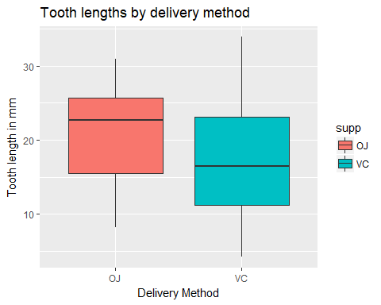

## By Dose:  
ToothGrowth$dose<-as.factor(ToothGrowth$dose)  
ggplot(ToothGrowth, aes(dose, len)) + geom_boxplot(aes(fill=dose)) +  
 labs(title = "Tooth lengths per dose",  
 x = "Dose in mg per day", y = "Tooth length in mm")

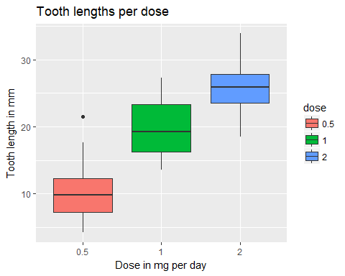

## Summary

Summarizing the Data:

summary(ToothGrowth)

## len supp dose   
## Min. : 4.20 OJ:30 0.5:20   
## 1st Qu.:13.07 VC:30 1 :20   
## Median :19.25 2 :20   
## Mean :18.81   
## 3rd Qu.:25.27   
## Max. :33.90

## Hypothesis Testing

### a) Hypothesis: Supplement does not have an affect on Tooth Growth:

Our null hypothesis is that the mean of the tooth growth corresponding to each supplement is the same.

#### Assumptions:

* A t distribution for tooth Growth, and
* The Variance of both the factions of ToothGrowth to be the same:

TOJ <- ToothGrowth[ToothGrowth$supp=="OJ",]$len  
TVC <- ToothGrowth[ToothGrowth$supp=="VC",]$len  
t.test(x = TOJ,y = TVC,var.equal = TRUE)$conf.int

## [1] -0.1670064 7.5670064  
## attr(,"conf.level")  
## [1] 0.95

We see that 0 lies in the 95% confidence Interval, therfore **we fail to reject the hypothesis that a Supplement does not have an affect on Tooth Growth**

### b) Hypothesis: Doses does not have an affect on Tooth Growth:

Our null hypothesis is that the mean of the ooth growth corresponding to each dose is the same. The assumptions of this part is the same as in part (a). Here we shall take the two extreme doses, that is 0.5, and 2:

Tp5 <- ToothGrowth[ToothGrowth$dose==0.5,]$len  
T2 <- ToothGrowth[ToothGrowth$dose==2,]$len  
t.test(x = Tp5,y = T2,var.equal = TRUE)$conf.int

## [1] -18.15352 -12.83648  
## attr(,"conf.level")  
## [1] 0.95

We see that 0 does not lie in the 95% confidence interval, thus **we reject the hypothesis that Doses does not have an affect on Tooth Growth**.

## Conclusion

* We fail to reject the hypothesis that a Supplement does not have an affect on Tooth Growth with 95% certainty.
* We reject the hypothesis that Doses does not have an affect on Tooth Growth with 95% certainty.