Let’s keep it simple.
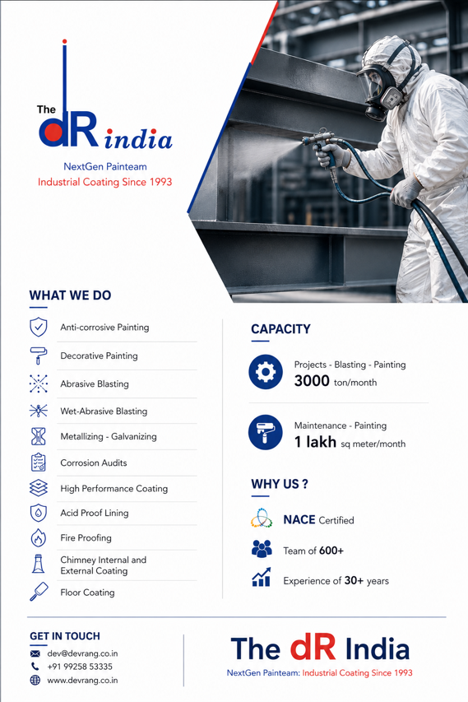
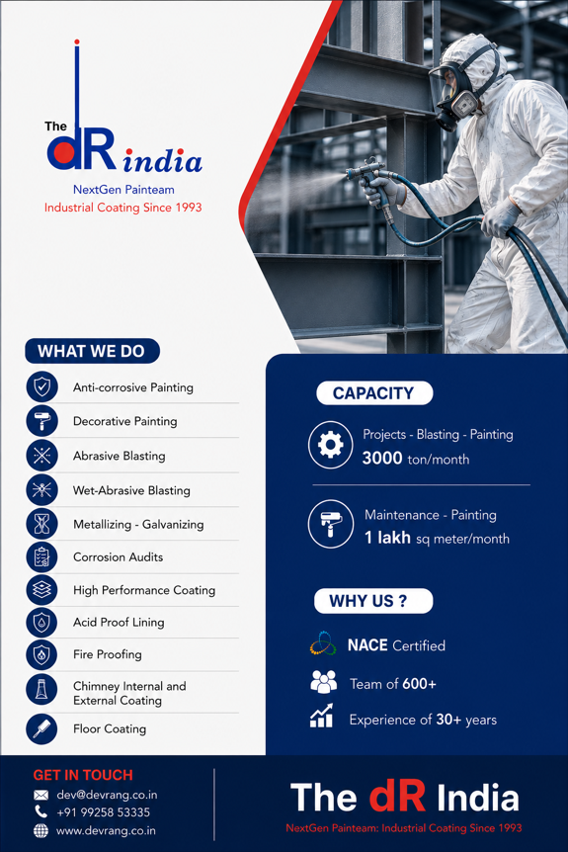
Color combinations like below:

In starting of the website during entering, highlight logo below image:

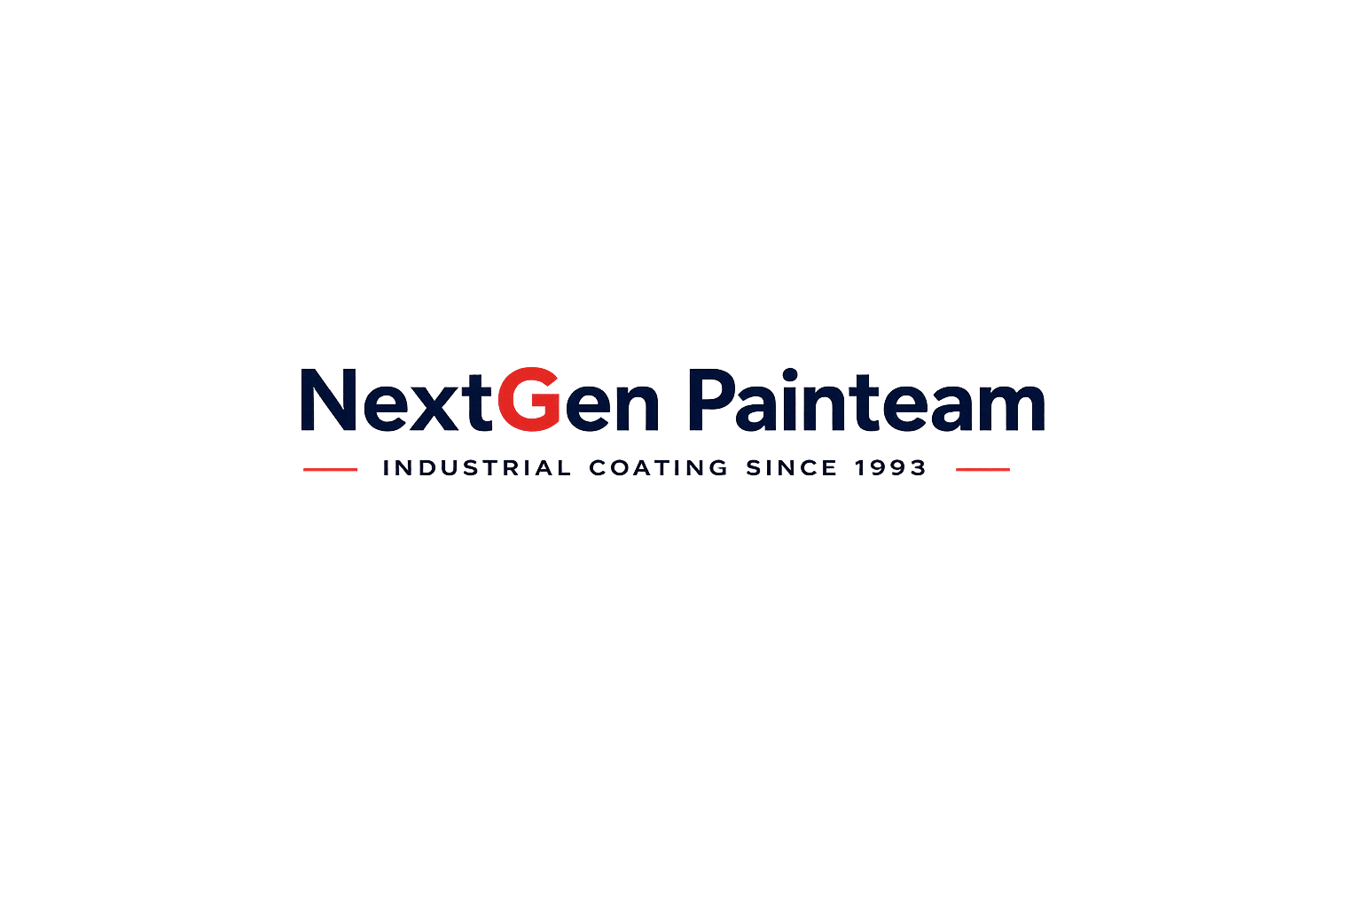
Below this:
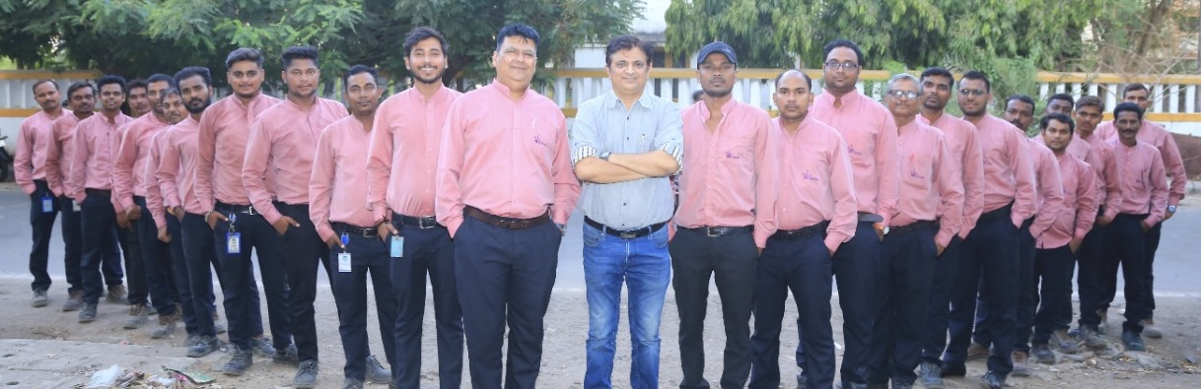

Capacity:

Projects – Blasting & Painting: 3000 MT / Month

Maintenance Painting: 1 Lakh Sq. Meter / Month
Manpower: 600 +

Experience: 30 years +
Present clients: 25+

WHAT WE DO
• Anti-corrosive Painting
• Decorative Painting
• Abrasive Blasting
• Wet-Abrasive Blasting
• Metallizing & Galvanizing
• Corrosion Audits
• High Performance Coating
• Acid Proof Lining
• Fire Proofing
• Chimney Internal & External Coating
• Floor Coating

ASSOCIATED WITH PAINT MANUFACTURERS LIKE:
ATUL LTD
AKZONOBEL INTERNATIONAL
ASIAN PAINTS
HTD NextGen
PPG-SIGMA
BERGER PAINTS
HEMPEL PAINTS
JOTUN
KIRLOSKAR CORROCOAT
CERTIFICATIONS:

NACE INTERNATIONAL – Coating Inspector

SSPC – Paint Coatings, Inspection & Quality Control

ISO 9001:2015 – Quality Management System

ISO 14001:2015 – Environmental Management System

ISO 45001:2018 – Occupational Health & Safety Management System

PRESENCE:

PING US / SAY HI:

