Introduction

Getting started with application creation

Requirements :
node – v14.4.0
create-react-app - v5.0.0

Terminal:
navigate to desired directory
npx create-react-app pdf-creator
cd pdf-creator
delete all src files present

tree structure diagram screenshot

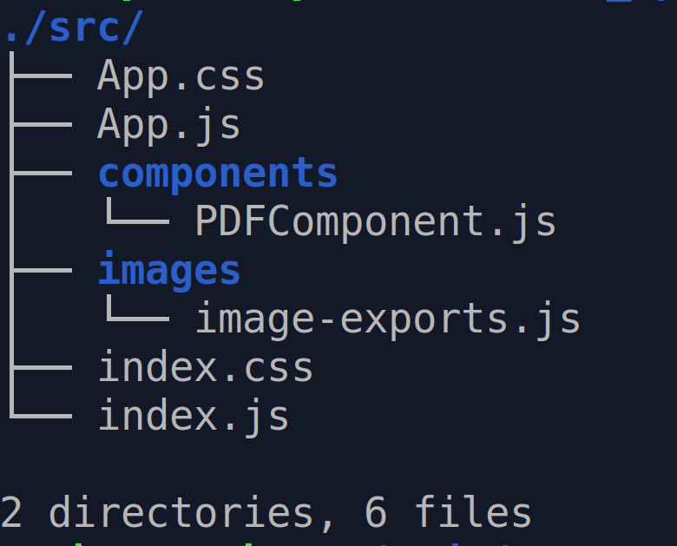
npm install jspdf jspdf-autotable
copy-paste code

Explaination steps
- convert image to base64 using the link : https://www.base64-image.de/
- exporting the base64-image data from another file
- adding text
- adding border

