- Create a signup & login mechanism (Different routes for signup and login)

- Create a similar table as shown below using reactJS.
Note: Any UI framework like Material UI, AntDesign is not allowed. Assignments using the frameworks for the table and checkbox handling will be rejected.
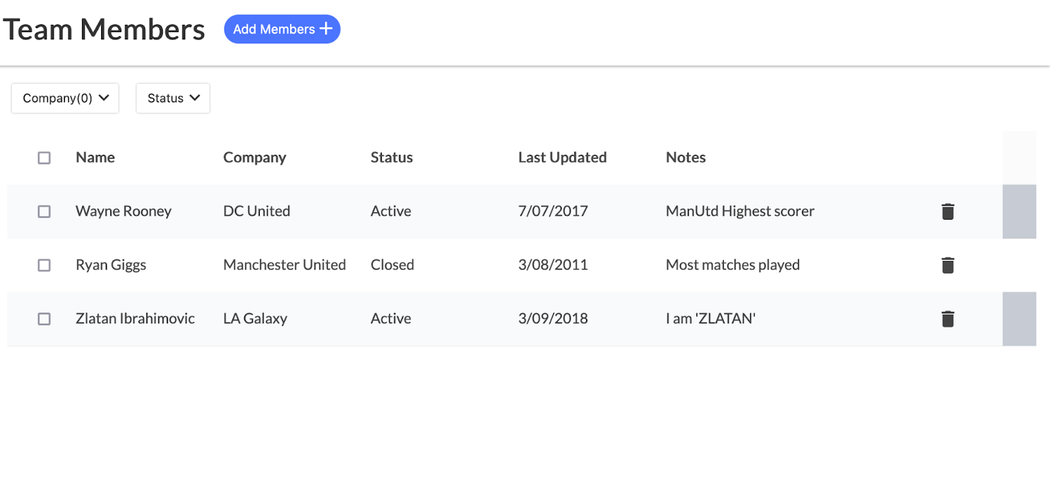
- Use redux for the data layer setup. It should have the following features

- User should be able to add and delete record
- Records should be sortable by status
- Create a filter dropdown that supports a multi-select checkbox. Please handle select all scenarios(if user click select all, all checkbox should be clicked and removing any one of checkbox should uncheck select all )

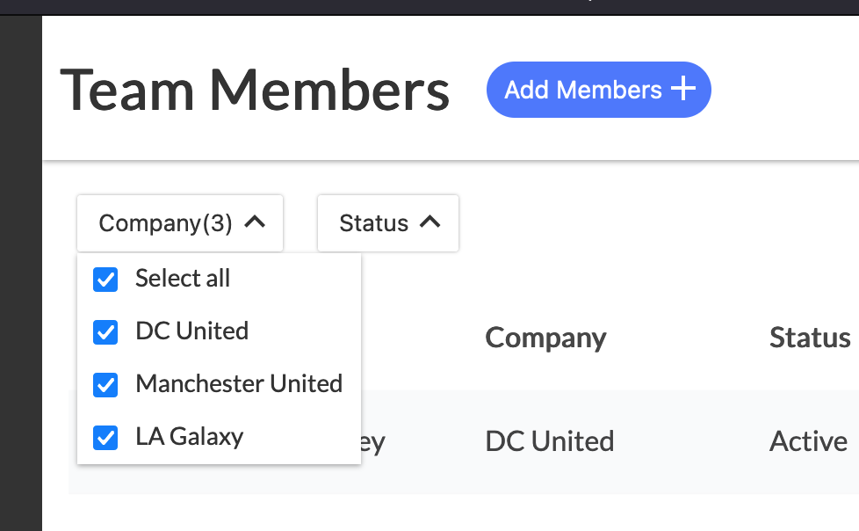

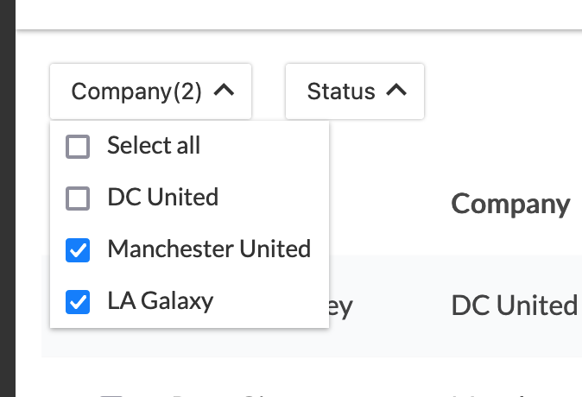

- Create a Modal to add members
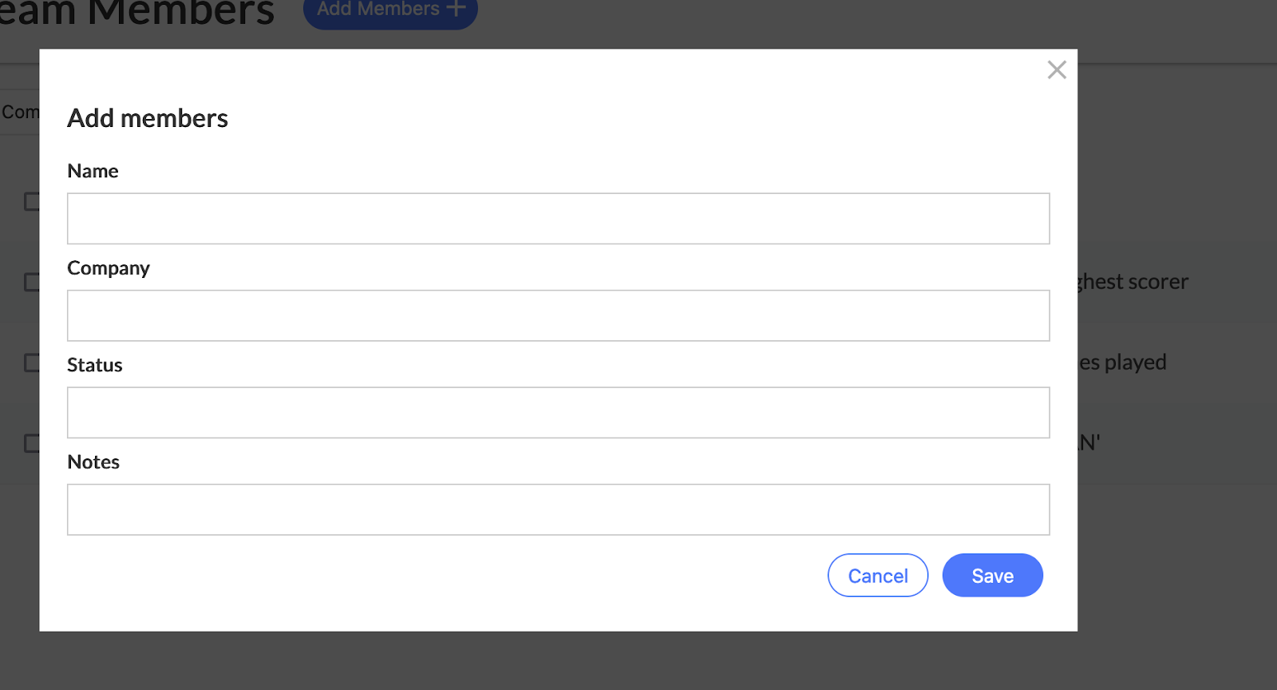

5. Bonus points

- On auto login after signup
- On using an online backend service to store the data

6. Create a public repository for this assignment to push the changes and mail it to us. You can mail the solution to gopi.malla@delta.exchange and cc suraj.kawale@delta.exchange.

ALL THE BEST :)

redux login implementation
https://medium.com/@jebasuthan/react-user-registration-and-login-using-redux-81ec739e93d1

