Chapter 1

Introduction

1.1 Background
Electricity has become the backbone of modern civilization, powering industries, homes, hospitals, transportation, and countless other aspects of daily life. As populations grow and technology becomes more integrated into our lifestyles, the global demand for electricity has seen a steep rise. With the increasing number of electrical appliances in every household—from essential devices like refrigerators and air conditioners to entertainment systems and smart home gadgets—managing and monitoring electricity consumption is more critical than ever. However, this growth has not been matched by a parallel increase in energy efficiency and awareness. Users often remain unaware of their consumption patterns, leading to energy wastage, higher electricity bills, and a greater environmental footprint.
Traditional electricity meters only provide a cumulative usage reading, which is insufficient for users to understand how their energy is being consumed at the appliance level. While smart meters have improved monitoring to some extent, they still fall short in delivering intelligent insights and recommendations that help users take action. This gap opens an opportunity for integrating Artificial Intelligence (AI) and Internet of Things (IoT) technologies into energy monitoring. AI can analyze complex datasets, detect trends, and provide predictive insights, while IoT enables real-time data collection from individual appliances.
This project focuses on creating an AI-based electricity monitoring system that leverages both technologies to offer intelligent, personalized energy management. By giving users visibility into how much energy each appliance consumes, predicting future usage, and providing recommendations for reducing consumption, the system encourages better energy habits and contributes to sustainable development. This project is not just a technological innovation—it addresses environmental and economic challenges faced by individuals and communities worldwide.

1.2 Problem Statement
Despite the availability of various energy-saving devices and technologies, users still face significant challenges in managing their electricity consumption effectively. The core issue lies in the lack of visibility and actionable insight into energy usage at the individual appliance level. Traditional electricity meters, even modern smart meters, provide only total consumption figures without any context or breakdown. As a result, users are unable to determine which specific appliances are responsible for high energy use or when peak consumption occurs.
Moreover, most systems currently in use are reactive rather than proactive. They tell users how much energy they have already consumed, but offer no prediction, alerts, or optimization suggestions. For example, if a user receives a high electricity bill, the only feedback is the total units consumed—no information about which devices consumed the most, whether the usage was abnormal, or how to reduce it in the future. This leads to frustration, confusion, and continued inefficiency.
Another significant issue is the inability of existing systems to adapt to changing user behavior. As energy consumption habits evolve—perhaps due to seasonal changes, new appliances, or work-from-home trends—static monitoring tools fail to keep up. Users also differ in how they use electricity, making one-size-fits-all energy recommendations ineffective. Furthermore, current solutions rarely leverage AI's potential to offer personalized, intelligent, and adaptive recommendations.
This project addresses these problems by developing an AI-based system capable of detailed, appliance-level monitoring, real-time analysis, usage forecasting, and behavior-driven suggestions. It aims to fill the existing gap between energy monitoring and actionable decision-making. Ultimately, the goal is to empower users to make informed choices that lead to energy savings, reduced costs, and a more sustainable lifestyle.

1.3 Objective
The primary purpose of this project is to design and implement a smart AI-based system capable of monitoring, analyzing, and predicting electricity consumption in residential settings. The system will utilize data from smart sensors attached to various electrical appliances, analyze it using machine learning algorithms, and present the findings to users in an intuitive and actionable format. The system's ultimate objective is to help users understand their energy consumption patterns, reduce unnecessary usage, and save on electricity costs.
Key objectives of this project include:
- Real-time monitoring: Track energy usage at the appliance level to provide immediate feedback.
- Data analysis and forecasting: Use AI to identify trends and predict future electricity consumption based on past behavior.
- Energy-saving recommendations: Offer personalized suggestions to help users reduce energy waste.
- User-friendly interface: Provide a dashboard that visualizes consumption data clearly and interactively.
- Environmental sustainability: Encourage reduced energy use to lower carbon emissions and support a greener future.
This project also serves an educational purpose by raising awareness about energy efficiency and the impact of daily habits on electricity usage. By empowering users with data-driven insights, it fosters accountability and encourages behavioral change. For instance, a user who learns that their air conditioner is consuming 40% of their total electricity might opt to use it more sparingly or invest in an energy-efficient model.
In essence, this project bridges the gap between raw consumption data and actionable intelligence. It combines technological innovation with environmental responsibility, creating a tool that not only benefits individual users but also contributes to broader energy conservation goals.

1.4 Solution Approach
The solution approach for this AI-based electricity monitoring system integrates both software and hardware components to ensure accurate data acquisition, intelligent processing, and actionable insights. At the core of this approach lies the use of Internet of Things (IoT) devices that capture real-time energy usage data from various appliances in a household. These IoT sensors are installed inline with electrical circuits or directly on appliances to monitor parameters such as voltage, current, and power factor. The collected data is transmitted securely to a central server or cloud-based platform for further processing.
The software layer, driven by artificial intelligence, performs multiple tasks. First, it cleans and normalizes the incoming data to remove anomalies or noise. Then, using machine learning models such as decision trees, linear regression, or neural networks, the system classifies appliances based on their consumption patterns and predicts their future usage. For instance, the AI can learn that a user's washing machine is typically used on weekends and can anticipate similar behavior in the coming weeks. Based on these patterns, the system provides recommendations like shifting heavy usage to off-peak hours or replacing old appliances with energy-efficient models.
The interface design plays a pivotal role in making the solution user-centric. The dashboard is built to display daily, weekly, and monthly consumption graphs, breakdowns by appliance, and a comparison of usage with past performance. Alerts and suggestions are generated in real-time to prompt users when usage crosses thresholds or when abnormalities are detected. Users can also set goals, track progress, and receive gamified feedback to stay motivated.
Overall, the solution approach is comprehensive, covering data collection, intelligent analysis, and user engagement. It ensures that the system is scalable, secure, and adaptable to various household configurations. Most importantly, it transforms passive energy monitoring into an active tool for awareness, savings, and sustainability.

1.5 Scope of the Project
The scope of this AI-based electricity monitoring system encompasses the full cycle of energy data acquisition, processing, analysis, and user engagement with the ultimate goal of reducing electricity consumption and promoting sustainability. It is primarily focused on residential environments, although the system’s architecture can be extended to support commercial or institutional use cases with some modifications.
At the hardware level, the scope includes the deployment of smart sensors or IoT-enabled meters capable of tracking the power usage of individual appliances. These devices are strategically placed to ensure accurate monitoring without requiring invasive installations. The system will handle data in real-time, capturing various electrical parameters, including voltage, current, power consumption, and frequency.
On the software side, the project involves developing AI algorithms for predictive analytics, pattern recognition, and anomaly detection. These algorithms will analyze past and present data to predict future usage patterns, identify potential wastage, and offer practical recommendations. The system will also be capable of generating reports and usage summaries that can be visualized through interactive dashboards.
User experience is another crucial component of the project scope. The system will feature a user-friendly interface accessible via web browsers or mobile apps. It will allow users to view energy statistics, receive personalized alerts, and implement suggested energy-saving practices. Additionally, users will be able to compare their usage trends over time, set consumption goals, and measure progress.
The project’s scope also includes addressing issues related to data security and privacy. All transmitted and stored data will be encrypted, and user access will be protected by secure authentication mechanisms.
While the primary deployment is intended for residential users, future extensions can adapt the system for schools, offices, or industrial facilities. Scalability, modularity, and cross-platform compatibility are integral to the design. In summary, the scope covers the end-to-end deployment of a smart energy monitoring ecosystem that combines advanced technology with environmental consciousness.

1.6 Existing Systems
There are several systems and technologies available today that help track electricity consumption and promote energy efficiency. These systems vary in complexity, functionality, and integration with other smart home devices. A few notable examples include:
- Traditional Electricity Meters: These are the most common form of electricity monitoring, providing consumers with monthly or yearly data on total consumption. However, they do not offer detailed insights at the appliance level or real-time analysis.
- Smart Meters: Smart meters are digital devices that provide more detailed usage data than traditional meters. They can track consumption on an hourly or daily basis and transmit data to utility companies in real-time. While this provides more granular insights into consumption, smart meters typically do not offer proactive feedback or suggestions on how to optimize usage.
- Energy Management Systems (EMS): EMS solutions are designed to provide centralized control of energy consumption within a home or business. They aggregate data from various devices, appliances, and smart meters to offer a comprehensive view of energy usage. EMS platforms can analyze consumption trends, but their reliance on manually set parameters makes them reactive rather than adaptive. They generally focus on identifying opportunities for energy reduction after a high consumption event has been detected.
- Smart Plugs and Energy Monitors: These devices can be plugged in between an appliance and the wall socket to monitor individual device energy usage. They are typically used for specific appliances, but they do not provide a holistic view of a household’s energy consumption.
- Home Automation Systems: Platforms like Google Home and Amazon Alexa integrate with IoT devices to allow users to control various appliances. While these systems can schedule usage, they do not provide comprehensive insights into energy usage and inefficiencies.
Despite the advancements in these existing systems, there are several limitations. Most importantly, they fail to provide predictive insights or proactive recommendations. Users often receive feedback only after consumption has occurred, making it difficult to optimize usage behavior in real-time. Furthermore, most of these systems do not offer appliance-level analysis, meaning that users cannot easily identify which devices are consuming the most energy and where improvements can be made.
This AI-based electricity monitoring system aims to overcome these limitations by providing real-time, appliance-specific data, predictive analysis, and personalized suggestions to reduce energy waste.

1.7 Limitations of Current Systems
While current energy monitoring systems, including traditional meters, smart meters, and energy management solutions, have provided some level of insight into electricity consumption, they come with a set of limitations that hinder their overall effectiveness. These limitations can prevent users from fully optimizing their energy consumption and achieving significant cost and energy savings. Key limitations include:
- Lack of Real-Time Feedback: Traditional and smart meters typically provide data on total consumption, but they do not offer real-time feedback or insights into how energy is being used across different appliances. Users may not know which appliances are consuming the most power until they receive a bill, making it harder to take immediate action to reduce consumption.
- Limited Granularity: Many existing systems fail to break down energy consumption at the appliance level. While smart meters may offer insights into overall household usage, they do not provide data on individual devices. Without this granular insight, users cannot identify specific appliances that are responsible for high energy consumption or inefficiency.
- Reactive Nature: Most systems are reactive, meaning they only alert users after an anomaly or excessive usage has occurred. For example, if a user’s energy consumption exceeds a set threshold, they are notified after the fact, without proactive suggestions or a clear understanding of how to prevent future inefficiencies.
- Inability to Predict Future Usage: Current systems lack predictive analytics that can forecast future energy consumption based on historical patterns. Without these insights, users cannot anticipate changes in their energy needs and plan accordingly, which is particularly important for appliances with fluctuating or seasonal usage.
- Manual Control and Setup: Many energy management systems require manual input from users to set up parameters or schedules. This reliance on user input reduces the system's adaptability and limits its ability to adjust automatically to changing consumption patterns. The user experience is also compromised, as manual adjustments may be time-consuming and cumbersome.
- Limited Integration with Other Smart Devices: Existing systems often fail to integrate with other smart devices or home automation systems. For example, users cannot link their energy usage data with their home security, lighting, or heating systems for optimized energy management across their entire home.
- Lack of Personalized Recommendations: Current systems do not offer personalized suggestions on how to reduce energy consumption. Instead, they rely on generic tips that are not tailored to the user’s specific habits or appliance usage.
This project aims to overcome these limitations by providing detailed, appliance-level energy data, predictive analytics, and personalized recommendations. By addressing these gaps, the AI-based system will offer a more comprehensive solution to energy management, enabling users to actively monitor and optimize their electricity consumption in real-time.

1.8 Proposed System
The proposed system aims to address the limitations of current electricity monitoring solutions by leveraging advanced artificial intelligence (AI) techniques to provide real-time, detailed insights into electricity consumption. The system will focus on monitoring individual appliances within a household or business, offering users detailed, actionable feedback to optimize their energy usage and reduce waste.
Key Features of the Proposed System:
- Real-Time Appliance-Level Monitoring: Unlike traditional systems, which provide data on overall energy usage, this system will allow users to monitor energy consumption at the individual appliance level. This granularity will help identify high-energy-consuming devices and allow users to take targeted actions to reduce energy waste.
- Predictive Analytics: Using machine learning algorithms, the system will predict future energy consumption patterns based on historical data. This predictive capability will help users plan for potential peaks in energy usage, making it easier to manage consumption during high-demand periods.
- Personalized Energy-Saving Recommendations: Based on the data collected, the system will generate personalized suggestions to help users reduce energy consumption. For example, it may recommend changing the settings on specific appliances, or offer tips on how to optimize usage during off-peak hours to save money.
- Energy Usage Alerts and Notifications: Users will receive real-time alerts when an appliance is consuming more energy than usual, helping them take immediate action to address inefficiencies. Alerts will also notify users of potential malfunctions or unusual behavior in their appliances, preventing future issues and saving costs.
- Integration with Smart Home Devices: The system will be designed to integrate seamlessly with existing smart home devices, such as thermostats, lights, and home automation systems. This integration will allow for a more cohesive approach to energy management, enabling users to control their appliances based on real-time data and usage patterns.
- User-Friendly Interface: The system will feature an intuitive graphical user interface (GUI) that will present energy data in a clear and accessible manner. Users can easily view their energy consumption, analyze trends, and track the effectiveness of energy-saving measures through interactive charts and graphs.
- Cloud-Based Data Storage: The system will store historical energy consumption data in the cloud, allowing users to access their data from anywhere and over long periods. Cloud storage will ensure that users have a complete overview of their energy usage history and can make data-driven decisions for long-term efficiency.
By providing real-time monitoring, predictive insights, and actionable feedback, the proposed AI-based electricity monitoring system will help users optimize their energy usage, reduce waste, and lower energy costs.

Chapter 2

Methodology
The methodology for the AI-based electricity monitoring system follows a structured approach that incorporates data collection, machine learning, predictive analytics, and user-friendly interfaces. The goal is to ensure real-time monitoring, energy prediction, and personalized recommendations for users. The methodology is divided into multiple steps, with each step ensuring the system's efficiency and accuracy. Below is a comprehensive breakdown of each phase.

2.1 Proposed Methodology
The proposed methodology is built on a multi-step framework that leverages advanced technologies, including machine learning, IoT, and cloud computing. The process starts with real-time data collection from electrical appliances and progresses through data preprocessing, feature extraction, predictive modeling, and user interface integration.
- Data Collection: Data collection is the first and most critical step. The system collects data from a wide range of devices, such as smart plugs and energy meters, that monitor individual appliances' electricity usage. This data is transmitted in real-time to a central processing system, which stores it for further analysis. The collected data includes appliance type, usage duration, and power consumption during specific time intervals.
- Data Preprocessing: After data collection, the raw data is cleaned and processed. This step ensures that noise or errors in the data are filtered out, and it prepares the data for analysis. Data preprocessing also involves normalizing and transforming the collected data into a structured format that machine learning models can use effectively. Feature extraction is performed during this phase, where important variables such as appliance type, operational behavior, and time of use are identified.
- Machine Learning and Predictive Modeling: The core of the system's functionality lies in its predictive capabilities. By using machine learning algorithms, the system predicts future energy usage based on historical data. Algorithms like regression models and time-series forecasting are used to identify patterns and predict consumption trends. This predictive analysis allows users to forecast future energy demands and adjust their behavior accordingly to save energy and costs.
- Personalized Recommendations and Alerts: The system goes beyond providing data by offering actionable insights. Based on the processed data and predictive models, personalized energy-saving recommendations are generated for each user. For example, if an appliance is consuming more energy than usual, the system will alert the user and provide tips to reduce its energy usage. These alerts and suggestions are customized for each user based on their habits, appliance usage, and energy consumption patterns.
- User Interface and Integration: A critical component of the system is the user interface (UI). The UI provides users with a visual representation of their energy consumption, consumption trends, and energy-saving suggestions. Users can easily interact with the system to view detailed energy data for individual appliances, track energy usage over time, and implement the recommended changes. Furthermore, the system integrates with other smart home devices to automate energy-saving actions based on real-time consumption data.

2.2 Process Model Adopted
The V-Model (Verification and Validation model) is used for the software development process of this system. This model emphasizes a step-by-step approach to both development and testing, ensuring that every phase is validated before moving forward. The V-Model is ideal for this project because it ensures that both the technical and functional aspects of the system meet the defined requirements.
- Requirement Analysis: The first step involves understanding the user's needs and the system's functionality. This phase focuses on gathering detailed information on the types of appliances to monitor, the desired output for energy consumption data, and the desired features for energy optimization. The requirements are documented and reviewed to form a solid foundation for the subsequent phases of development.
- System Design: In this phase, the architecture of the system is designed. This includes designing the data flow models, determining how devices will communicate with the central system, and defining how energy data will be processed. The system design also specifies the structure of the user interface, ensuring that it is intuitive and user-friendly.
- Implementation: In this phase, the actual coding of the system takes place. Machine learning models are integrated, APIs for smart devices are connected, and the system's backend and frontend are developed. During this phase, testing is also conducted to ensure that the components work as expected and communicate effectively.
- Verification and Validation: Once the system is implemented, it goes through rigorous testing to verify that it meets the initial requirements. This includes validating the accuracy of energy predictions, ensuring that user data is processed correctly, and checking the integration of smart home devices.
- Maintenance: After deployment, the system enters a maintenance phase where updates and improvements are made based on user feedback. Any bugs or issues identified during real-world use are addressed, and new features may be added to improve system performance.

2.3 Planning and Scheduling
The development process for the AI-based electricity monitoring system is carefully planned and divided into multiple phases to ensure timely delivery and effective implementation. Below is the planning and scheduling timeline for the project:
- Phase 1: Requirement Gathering and System Design – This phase involves understanding the end-users' needs, gathering requirements, and designing the system architecture. During this phase, detailed technical specifications will be written, and data flow models will be developed. The expected duration for this phase is 4-6 weeks.
- Phase 2: Data Collection and Preprocessing – Setting up the hardware components (such as smart plugs, smart meters, and IoT sensors) and collecting initial data for model training is critical. This phase also involves cleaning and preprocessing the data to ensure that it is ready for analysis. The duration for this phase is 5-7 weeks.
- Phase 3: Machine Learning and Model Development – In this phase, machine learning algorithms are trained using the preprocessed data to predict energy consumption patterns. This step includes developing and refining predictive models based on real-world data. It will take approximately 8-10 weeks.
- Phase 4: User Interface and Integration – Designing and developing the user interface is essential for ensuring ease of use. This phase also involves integrating the system with smart home devices and setting up automated processes for energy management. This phase will take about 6-8 weeks.
- Phase 5: Testing and Deployment – This phase includes system testing (unit, integration, and system testing) to ensure everything functions as expected. Once testing is complete, the system will be deployed and monitored for performance. This phase will take around 4-6 weeks.

2.4 Tools and Technologies Used
To develop the AI-based electricity monitoring system, a variety of tools and technologies will be used:
- Programming Languages: Python will be the primary language for backend development, including machine learning model creation and data processing. JavaScript will be used for frontend development to build an interactive and responsive user interface.
- Machine Learning Frameworks: For predictive analytics, machine learning frameworks like TensorFlow and Scikit-learn will be utilized. These frameworks provide powerful tools for training models and making predictions based on historical energy consumption data.
- Data Collection Devices: Smart plugs, energy meters, and IoT sensors will be used to collect real-time energy consumption data from individual appliances. These devices will communicate with the system via APIs or wireless protocols like Wi-Fi or Zigbee.
- Database Management System: A database like MySQL or Firebase will store historical energy usage data, user preferences, and settings. The database ensures that the data is readily available for analysis and retrieval.
- Cloud Services: Cloud platforms like AWS will be used to host the system and store data securely. The cloud will also be used to run machine learning models and provide scalable storage for user data.
- Frontend Development Tools: React will be used for building the frontend user interface, providing an intuitive way for users to interact with their energy data. The frontend will be responsive, allowing users to access data across different devices (smartphones, tablets, desktops).

Chapter 3

Requirements and Analysis
The success of the AI-based electricity monitoring system depends heavily on clear and thorough requirements gathering. This section outlines the functional, non-functional, and technical requirements necessary for the system's development and implementation. Proper analysis of these requirements will ensure that the system meets the expectations of end-users and provides valuable insights into energy consumption.

3.1 Functional Requirements
Functional requirements specify the core functions the system must support in order to meet user needs. These requirements define the system's capabilities and behavior and describe the interactions between the system and its users. The functional requirements for the AI-based electricity monitoring system are:
- Real-Time Energy Monitoring: The system must allow users to monitor the energy consumption of individual appliances in real-time. Each appliance’s usage should be displayed on the system’s interface with detailed data, including the amount of energy consumed and its cost impact.
- Data Collection and Storage: The system must collect data from smart meters, energy sensors, and IoT devices and store it in a structured format. This data should include the time of usage, appliance type, energy consumed, and power rating.
- Energy Prediction: Based on historical data, the system should use machine learning algorithms to predict future energy consumption patterns. These predictions should include forecasts for peak usage times and energy demands based on time-series data.
- Personalized Recommendations: The system should generate actionable recommendations to help users reduce energy consumption. This includes suggestions for adjusting appliance settings or usage behavior, such as running appliances during off-peak hours.
- Alerts and Notifications: Users should receive real-time alerts when an appliance’s energy usage exceeds typical patterns. Additionally, notifications should be sent if any appliance malfunctions, consumes excessive energy, or when energy-saving opportunities are identified.
- User Interface: The system must provide a user-friendly interface that displays energy usage in an easily interpretable format, such as graphs, tables, and charts. Users must be able to interact with the system, view their energy consumption history, and track the effectiveness of energy-saving measures.
- Integration with Smart Home Devices: The system should be able to interface with smart home systems (such as smart thermostats, smart lights, and other connected devices) to automate energy-saving actions based on real-time data.
- Historical Data Analysis: The system must store and analyze historical data to provide users with a comprehensive view of their long-term energy consumption. This will help identify trends and patterns that users can act upon to optimize their energy usage.

3.2 Non-Functional Requirements
Non-functional requirements define the system's quality attributes, such as performance, reliability, and security. These requirements focus on how the system performs under various conditions, ensuring that it meets user expectations for efficiency and user experience. The non-functional requirements for the AI-based electricity monitoring system are:
- Performance: The system must be capable of processing large volumes of real-time data from multiple appliances without significant delay. It should provide immediate feedback on energy consumption and predictive analytics to avoid any lag during interaction.
- Scalability: The system must be scalable to accommodate increasing numbers of users and devices. As more appliances are connected and monitored, the system should maintain optimal performance, handling larger data volumes and more complex predictive models.
- Reliability: The system should be highly reliable and fault-tolerant. It should continue operating effectively even if certain devices or components fail, with minimal disruption. Backup and redundancy mechanisms should be in place to ensure continuous data collection and processing.
- Security: Security is a critical concern, particularly when dealing with sensitive data like energy consumption habits and usage patterns. The system must implement robust encryption and access control mechanisms to protect user data from unauthorized access.
- Usability: The system should be easy to use and intuitive, with a user-friendly interface. Users, regardless of technical knowledge, should be able to quickly understand the system’s features and navigate through the energy consumption data and insights.
- Interoperability: The system should be able to integrate seamlessly with a variety of smart home devices and third-party applications. It must support common communication protocols and standards to ensure broad compatibility.
- Availability: The system must be available 24/7, with minimal downtime. Cloud-based components should ensure that users can access the system remotely from any location, at any time.
- Maintainability: The system must be easy to maintain, with clear documentation for updates and troubleshooting. Maintenance tasks, such as adding new appliances or updating machine learning models, should be straightforward and minimally disruptive.

3.3 Technical Requirements
Technical requirements outline the technologies, tools, and platforms that will be used to build and deploy the AI-based electricity monitoring system. These requirements ensure that the system is developed using the most appropriate and effective technologies available. The technical requirements for the system are as follows:
- Programming Languages: Python will be the primary programming language for backend development, as it is well-suited for machine learning tasks and data analysis. JavaScript, along with React, will be used for frontend development, ensuring a responsive and interactive user interface.
- Machine Learning Frameworks: TensorFlow and Scikit-learn will be utilized to build and train the machine learning models for energy prediction and analysis. These frameworks provide powerful tools for model training, evaluation, and deployment.
- Database Management: MySQL or Firebase will be used for data storage. MySQL offers a relational database structure that is ideal for structured data storage, while Firebase provides real-time data synchronization for scalability and ease of use in cloud-based applications.
- Cloud Hosting: Amazon Web Services (AWS) or Google Cloud Platform (GCP) will be used for cloud hosting and data storage. These platforms offer reliable, scalable, and secure cloud infrastructure to support the system's performance and availability.
- IoT Devices: The system will rely on smart plugs, smart meters, and IoT sensors to collect real-time energy consumption data from various appliances. These devices must support wireless communication protocols such as Wi-Fi, Zigbee, or Bluetooth for seamless integration.
- API Integrations: The system will need to support integrations with smart home ecosystems, such as Google Home, Amazon Alexa, and other third-party platforms. APIs will be used to facilitate communication between the electricity monitoring system and smart devices.
- Security Mechanisms: The system will implement industry-standard security protocols such as SSL/TLS encryption for data transmission and OAuth for secure authentication. Data at rest will be encrypted, and access to the system will be controlled through role-based access.
- Testing and Validation Tools: Various testing tools will be used to ensure the quality and reliability of the system. Tools like Selenium will be used for automated frontend testing, while unit testing frameworks (such as pytest) will be employed for backend validation.

Chapter 4

Software Design
The software design for the AI-based electricity monitoring system focuses on structuring the application in a modular, maintainable, and efficient manner. This section outlines the key design elements, including data flow models, entity relationships, and class structure, that form the foundation of the system’s architecture. The software design is essential for ensuring that the system is scalable, easy to maintain, and capable of meeting the defined functional and non-functional requirements.

4.1 Data Flow Diagrams (DFD)
The DFD illustrates how energy data flows from smart appliances through IoT devices to the backend system, where it is processed, analyzed, and displayed to the user in real-time.
- Level 0 DFD (Context Diagram): This high-level diagram provides a basic overview of the system. It shows the system as a single process connected to external entities like the user and smart appliances. The external entities provide energy consumption data, and the system processes this data and outputs information such as energy usage insights, predictions, and recommendations to the user.

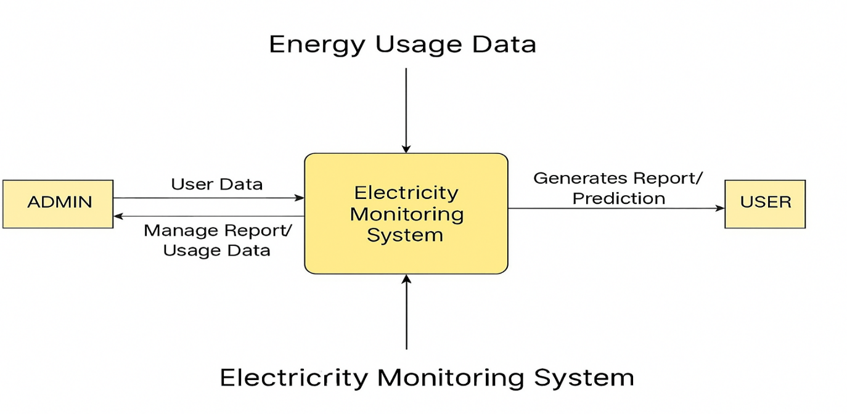
Fig.4.1 Context Level DFD
Level 1 DFD: This diagram expands the context-level DFD into detailed sub-processes such as order management and payment processing (if billing is integrated). It shows how user information, payment data, and report details are handled by the system and admin. This provides deeper insight into how data is processed and how different modules interact.
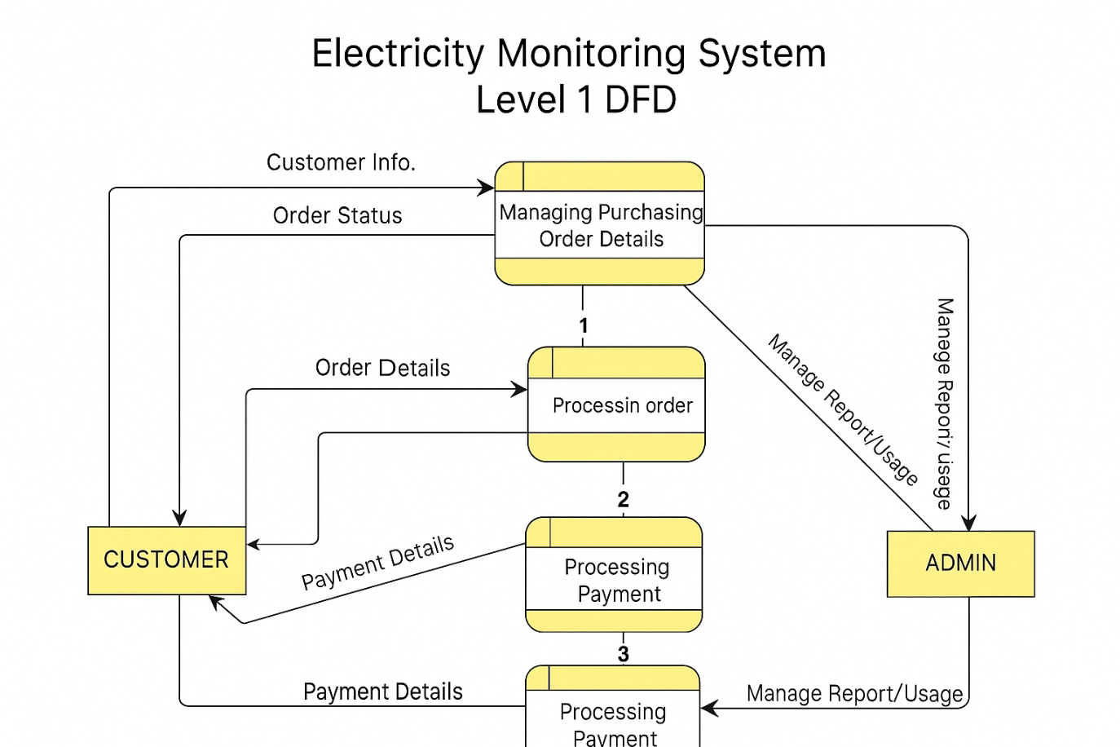
Fig 4.2 Level 1 DFD
Data Flow Diagrams (DFDs) are essential in depicting how data flows through the system and helps in understanding how input data is transformed into output data. The DFD for the AI-based electricity monitoring system is designed to provide a clear visualization of how energy consumption data is collected, processed, and presented to users.

4.2 Entity-Relationship (ER) Diagram
An Entity-Relationship Diagram (ERD) is used to illustrate the relationships between different entities in the database. The ERD for the electricity monitoring system highlights key entities like users, appliances, energy consumption data, and recommendations, and shows how they are related.
The ER diagram models the database structure by defining relationships between key entities such as users, appliances, energy consumption records, and personalized recommendations.
- Entities:
  - User: Represents the system’s end-users. A user can have multiple appliances and will have preferences or settings related to energy consumption.
  - Appliance: Each appliance has attributes such as appliance ID, type, power rating, and the data associated with its energy consumption.
  - Energy Consumption Data: This entity stores detailed information about energy consumption, including the time of use, duration, and amount of energy consumed.
  - Recommendation: The system generates personalized recommendations based on the energy usage patterns of the user. This entity stores these recommendations and their status (e.g., pending or accepted).
- Relationships:
  - A User can have many Appliances.
  - Each Appliance can generate multiple instances of Energy Consumption Data.
  - A User may receive many Recommendations, each corresponding to a specific appliance or energy-saving suggestion.

The ERD ensures that the database schema is well-structured and capable of efficiently handling relationships between various data points, ensuring the system functions smoothly and data integrity is maintained.

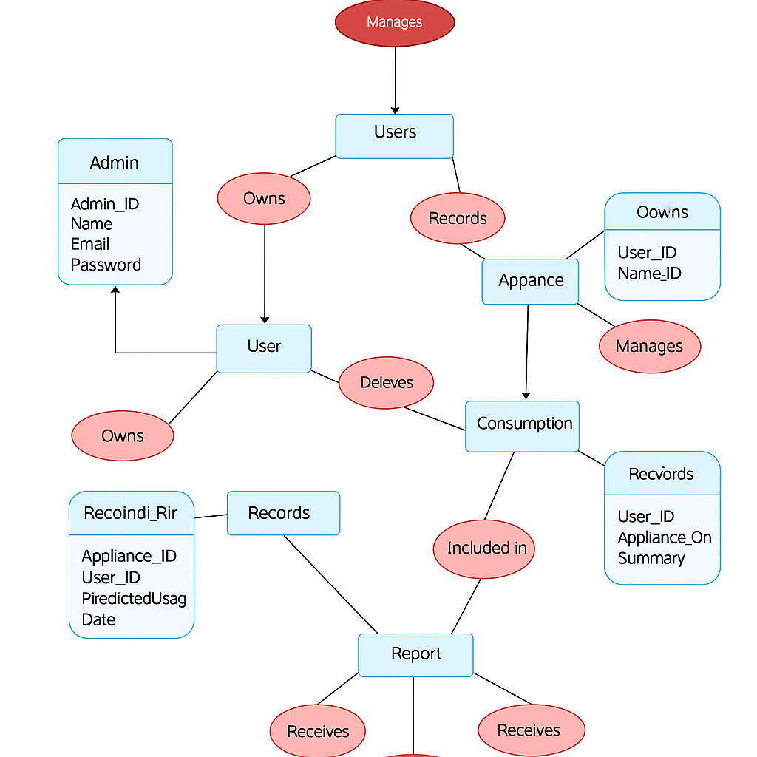

Fig 4.2 ER Diagram

4.3 Class diagram
The class diagram is a fundamental part of object-oriented software design, capturing the static structure of the Electricity Monitoring System. It outlines key system entities such as Admin, User, Appliance, Consumption, Prediction, and Report, and defines their attributes, behaviors, interrelationships.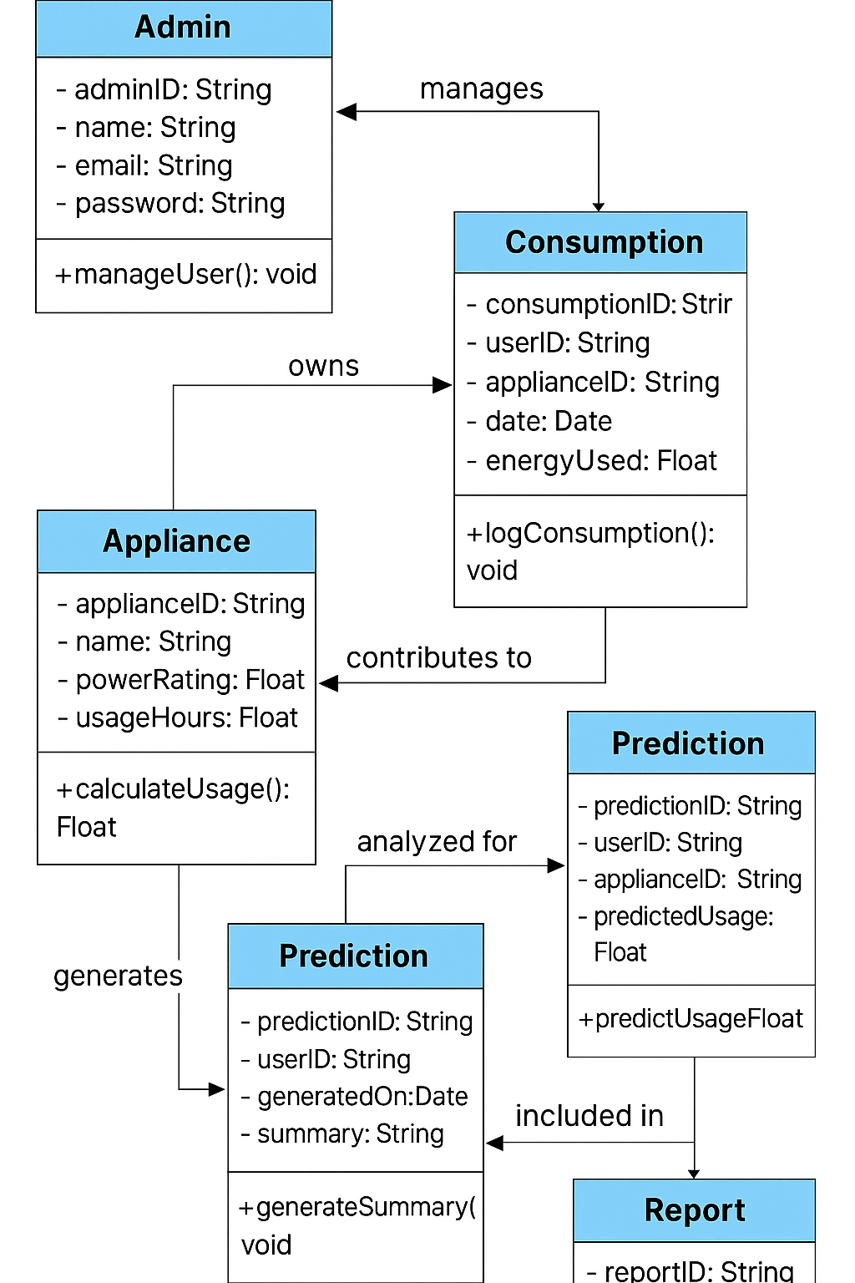
Fig. 4.4 Class Diagram
Each class represents a real-world concept within the system. For instance, the Admin class contains attributes like adminID, name, email, and password, and includes methods like manageUser() to oversee user activities. The User class owns one or more Appliance objects, and each Appliance is characterized by fields such as applianceID, powerRating, and usageHours, along with a method calculateUsage() to estimate energy consumption.
The Consumption class logs usage data for appliances, including the date and energyUsed. It connects appliances and users by storing records that reflect energy behavior over time. This data is fed into the Prediction class, which applies AI-based logic to anticipate future energy usage. It contains methods like predictUsageFloat and stores prediction details like predictionID, applianceID, and predictedUsage.
Lastly, the Report class compiles insights from the Prediction class and delivers summaries through methods like generateSummary(). Relationships such as “manages,” “owns,” “contributes to,” and “analyzed for” define how these entities interact, ensuring a cohesive data flow and logical operation within the system.
This structured design not only aids in efficient code development and maintenance but also ensures scalability by clearly separating responsibilities across system components.

4.4 Use Case Diagram

The use case diagram captures the various interactions users have with the system, including appliance registration, energy monitoring, receiving recommendations, and managing settings.
The Use Case Diagram is used to represent the system’s functionality from the user’s perspective, detailing the various interactions between users and the system. The main actors in this system include the User, the Smart Appliances, and the System itself. The system performs the following use cases:
- Register User: The user registers with the system to create an account and set up preferences.
- Add Appliances: The user adds appliances to the system for tracking energy consumption.

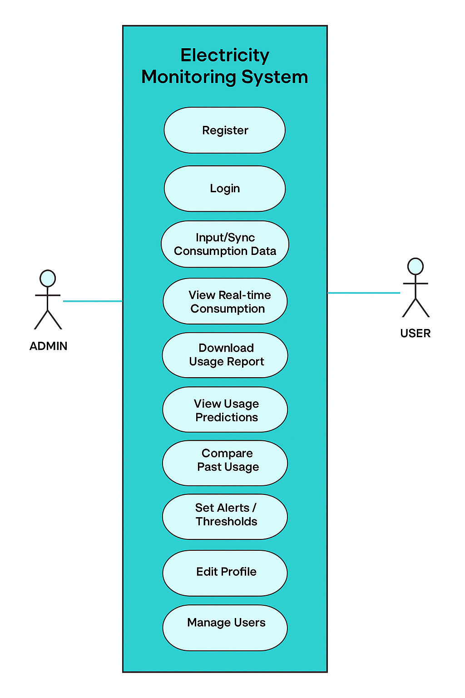

Fig. 4.5 Use Case Diagram
- Monitor Energy Consumption: The user views real-time energy usage of appliances on the system dashboard.
- Receive Recommendations: The user receives energy-saving recommendations based on usage patterns.
- View Energy Predictions: The user can view energy predictions for future usage based on historical data.
- Receive Alerts: The user is alerted when an appliance exceeds normal energy consumption levels.
- Integrate with Smart Devices: The system integrates with third-party smart home devices to automate energy-saving actions.
These use cases help in identifying the system's core functionalities and ensure that the design captures the critical operations required by the users.
4.5 Sequence Diagram:
The sequence diagram visualizes the time-order interaction between system components. It begins with the user logging into the Electricity Monitoring System (EMS), syncing data with the database, and requesting real-time usage information. The user can also request predictions, which are generated by the prediction engine. This helps in understanding how requests travel through the system in a linear time-based manner.
In the context of the AI-based Electricity Monitoring System, the sequence diagram captures how a User, Electricity Monitoring System (EMS), Database, Prediction Engine, and Admin interact over time to perform typical operations.
- Login Process
- Data Entry/Syncing
- Real-Time Usage Monitoring
- Requesting Predictions:
- Report Generation (Admin Interaction)
This sequence of operations ensures that users receive real-time and predictive insights while the admin maintains oversight of system activity. The diagram effectively visualizes how synchronous and asynchronous operations are handled across components.
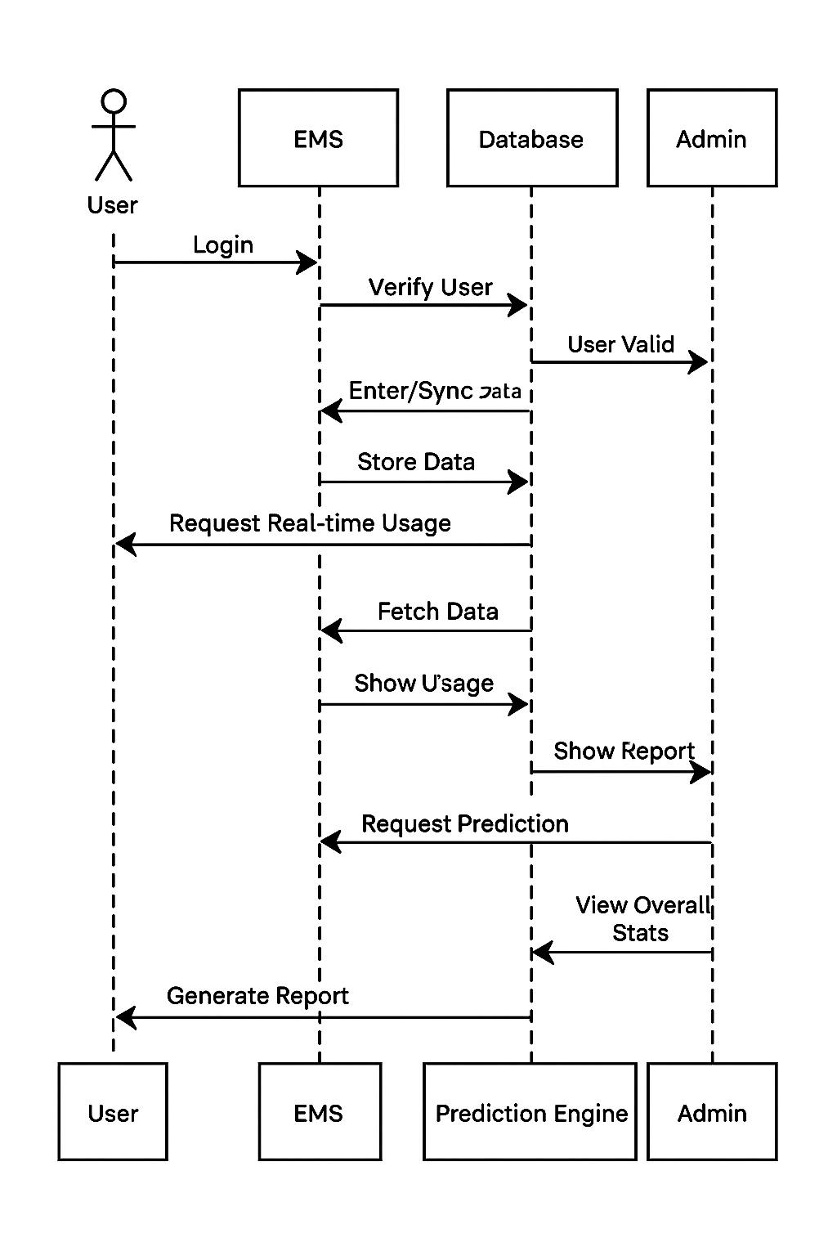
Fig.4.6 Sequence Diagram

4.6 Activity Diagram
An activity diagram is a type of behavioral diagram in the Unified Modeling Language (UML) used to model the flow of control or data from activity to activity within a system. It visually represents the dynamic aspects of the system, such as the workflows of user interactions and system responses.
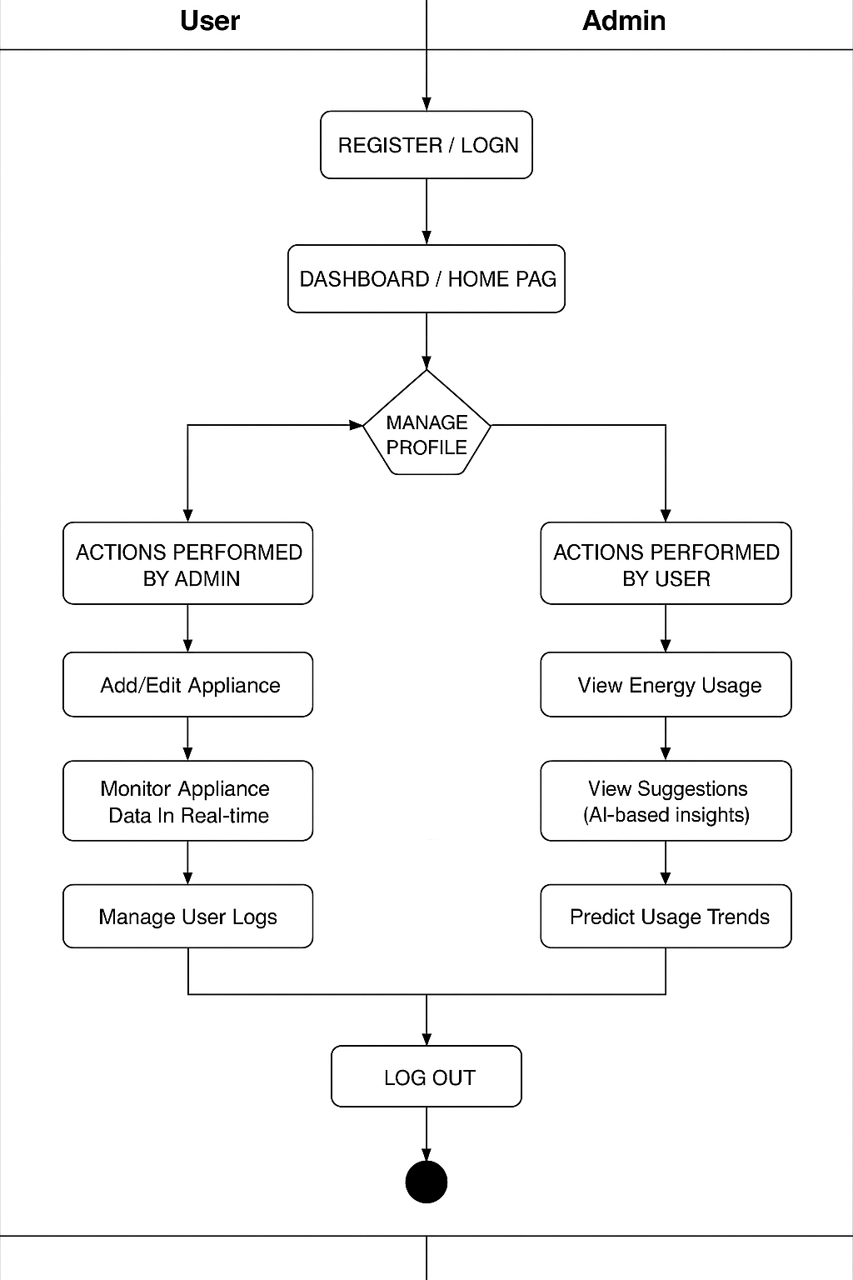
Fig. 4.7 Activity Diagram
This activity diagram outlines the sequence of actions taken by both the user and admin in the electricity monitoring system. It begins with the user or admin registering or logging into the system, followed by access to the dashboard or home page. From there, users and admins can manage their profiles and proceed to perform role-specific actions. Admins can add or edit appliance details, monitor real-time data, and manage user logs, whereas users can view energy usage, receive AI-generated suggestions, and predict energy trends. The diagram ends with the logout process. By mapping out these paths, the diagram clearly shows decision points and workflow transitions, helping developers understand system behavior and identify any process gaps or inefficiencies
- The Activity Diagram depicts the workflow of the system, detailing the sequential steps involved in key processes. For instance, the energy monitoring process might involve the following steps:
- Start: The user logs into the system.
- Data Collection: The system collects data from smart appliances.
- Preprocessing: The collected data is cleaned and formatted.
- Energy Prediction: The data is processed by predictive models to forecast future consumption.
- Display Results: The results are shown to the user on the interface, including real-time usage, forecasts, and energy-saving recommendations.
- End: The user interacts with the system to adjust energy-saving settings or receive alerts.
The activity diagram provides a clear, step-by-step view of the process flow, ensuring that all possible actions are covered and understood by the development team.

4.7 Architecture Diagram
The architecture diagram presents a high-level view of the system, showing how components such as the user interface, machine learning models, backend server, database interconnect.
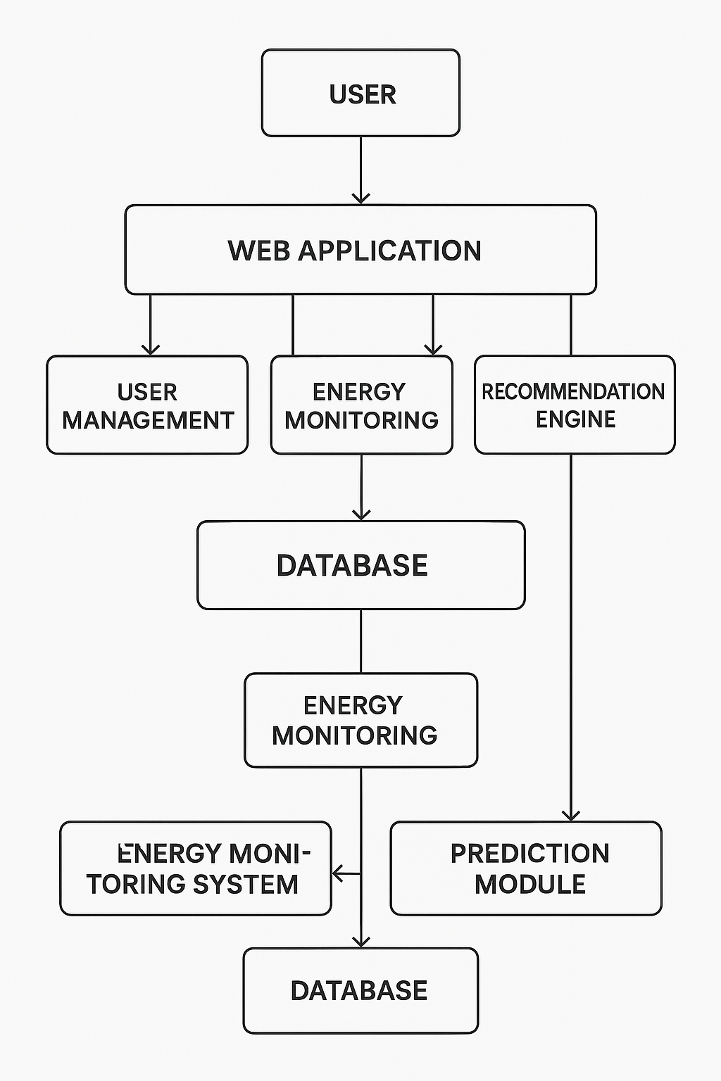
Fig .4.8 Architecture Diagram
The Architecture Diagram illustrates the high-level structure of the system, showing how different components interact and integrate with each other. The key components include:
- User Interface (Frontend): The user interface is responsible for displaying real-time data, predictions, and recommendations. It communicates with the backend to retrieve the necessary information.
- Backend (Server): The server processes data from smart devices, stores historical energy data, and executes predictive models. It communicates with the database and manages user interactions.
- Machine Learning Models: These models are responsible for analyzing the collected data, predicting energy usage patterns, and generating personalized recommendations.
- IoT Devices and Smart Appliances: These devices send real-time energy usage data to the system, providing the core input for energy consumption monitoring.
- Database: Stores user data, energy consumption data, appliance details, and recommendations, ensuring the data is easily accessible and secure.
The architecture diagram helps to visualize the overall structure and interconnections between components, ensuring that the system is scalable, reliable, and capable of handling real-time data processing efficiently.

Chapter 5

Implementation & Testing Plan
The implementation and testing plan outlines how the AI-based electricity monitoring system will be developed and tested. It ensures that the system is built according to the specified requirements, adheres to high standards of quality, and meets the needs of end-users. This section details the steps involved in the system’s implementation, the design of the graphical user interface (GUI), user navigation flow, and the comprehensive testing strategy to ensure robustness and reliability.

5.1 Implementation Plan
The implementation plan involves the stages and processes used to develop the system from start to finish. The following are the key phases:
- System Architecture Setup:
  - Setting up the server infrastructure (either cloud-based like AWS or on-premise if necessary) that will host the system.
  - Configuring the database for storing energy consumption data, user information, appliance details, and predictions.
  - Implementing the backend API for communication between the frontend and backend, ensuring secure and efficient data flow.
- Frontend Development:
  - Developing the user interface using technologies like HTML5, CSS3, and JavaScript, along with React.js to ensure an interactive, responsive, and user-friendly experience.
  - Integrating the frontend with the backend APIs to display real-time energy consumption data, energy-saving recommendations, and predictions.
  - Testing the frontend for usability, ensuring that users can easily navigate and interact with the system’s features.
- Backend Development:
  - Setting up Python-based backend with frameworks like Django or Flask, which will handle the business logic, data processing, and communication with the frontend.
  - Integrating machine learning models using TensorFlow or Scikit-learn for energy consumption prediction and recommendation generation.
  - Ensuring robust data handling by implementing efficient algorithms for data collection, storage, and retrieval.
- Integration of IoT Devices:
  - Configuring IoT devices like smart plugs, meters, and sensors that will communicate real-time data to the backend system.
  - Developing communication protocols to receive data from various smart appliances in real-time, ensuring data integrity and security.
  - Implementing a data processing pipeline to cleanse, filter, and analyze the incoming energy consumption data.
- Testing and Deployment:
  - Following an iterative approach, developing and deploying the system in stages to validate each component before moving to the next phase.
  - Regular testing to identify bugs, errors, or usability issues early in the development cycle, ensuring the system remains stable throughout.
  - Deploying the system to a cloud platform for scalability, ensuring that the system can handle an increasing number of users and devices efficiently.

5.2 Graphical User Interface (GUI) Design
The Graphical User Interface (GUI) is a critical part of the user experience, as it allows users to interact with the system and access essential features like monitoring energy consumption, receiving recommendations, and viewing predictions. The GUI must be intuitive, easy to navigate, and visually appealing. The design elements for the GUI include:
- Dashboard Layout:
  - The main screen displays a dashboard that summarizes the user’s current energy consumption and provides key insights at a glance. The dashboard includes graphs showing real-time consumption, a table with appliance usage, and buttons to access historical data and predictions.

- Real-Time Energy Usage:
  - A section of the interface will show real-time energy consumption data for each appliance, updated at regular intervals. The data will be presented as bar charts or line graphs to make it easy for users to interpret.
- Energy Predictions:
  - Users will have access to future energy consumption forecasts generated by machine learning models. These predictions will be displayed on the GUI as charts or tables, allowing users to plan energy-saving actions based on predicted data.
- Recommendations and Alerts:
  - The GUI will highlight energy-saving recommendations based on historical data and machine learning analysis. Additionally, users will receive real-time alerts if an appliance is consuming more energy than expected, along with suggestions for improvement.
- User Profile Management:
  - Users can manage their profile settings, including their energy-saving preferences, notification settings, and connected devices. The user management section will allow for easy modification of personal information an
  - d preferences.

5.3 Screenshots of the GUI
At this stage of development, the GUI will be iteratively designed and improved based on user feedback and usability testing. Screenshots of the GUI will be included in the final project report to give a visual representation of how users interact with the system. These screenshots will show:
- The login page, where users can enter their credentials to access the system.
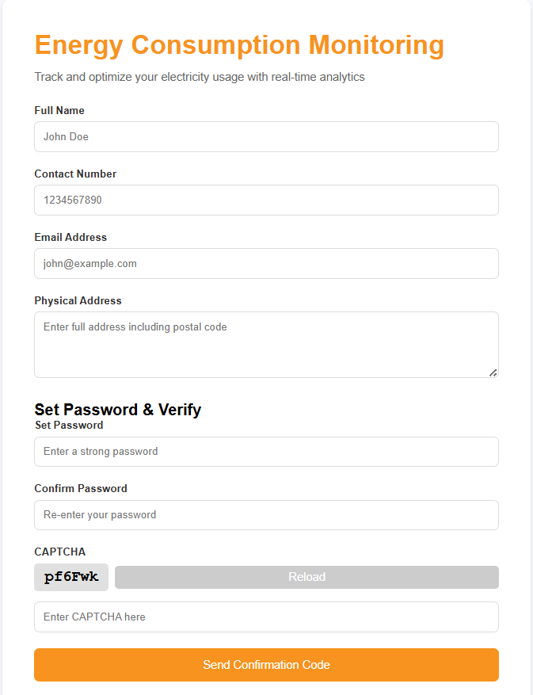
Fig. 5.1 Sign up Page

- The main dashboard, displaying key metrics like real-time energy consumption, energy predictions, and recommendations.

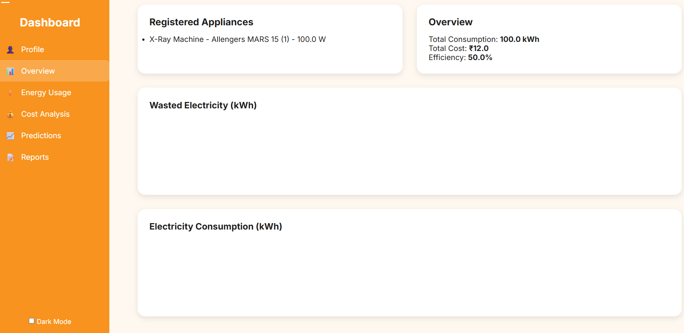
Fig. 5.2 Dashboard Page

- The appliance management page, where users can add or remove devices from their monitoring list.
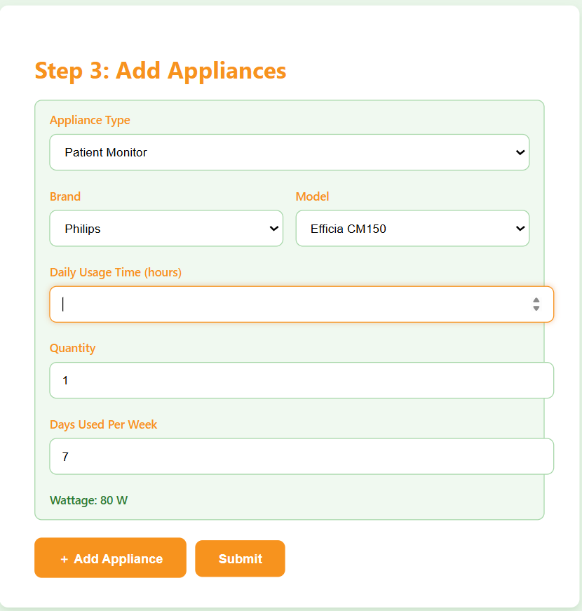
Fig. 5.3 Add Appliance Page
- A detailed view of energy consumption history, showing trends and usage patterns over time.
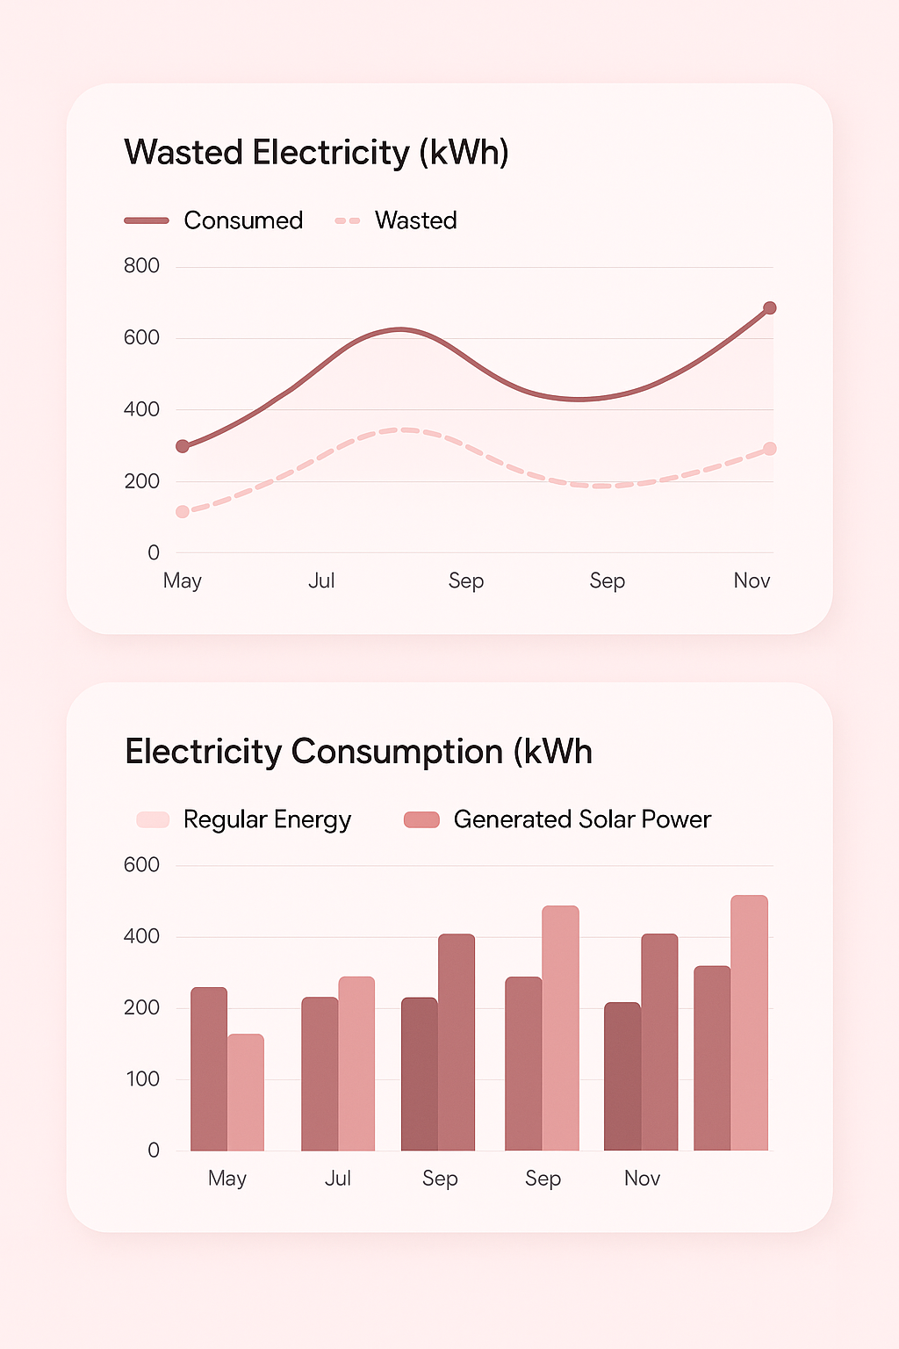
Fig 5.4 Charts Page

These screenshots will help visualize the user experience and demonstrate the system’s functionality.

5.4 User Navigation Flow
User navigation flow refers to the steps and paths a user follows within the system to complete tasks. The goal is to ensure that the navigation is intuitive and straightforward, reducing the time required for users to accomplish their goals. The flow includes:
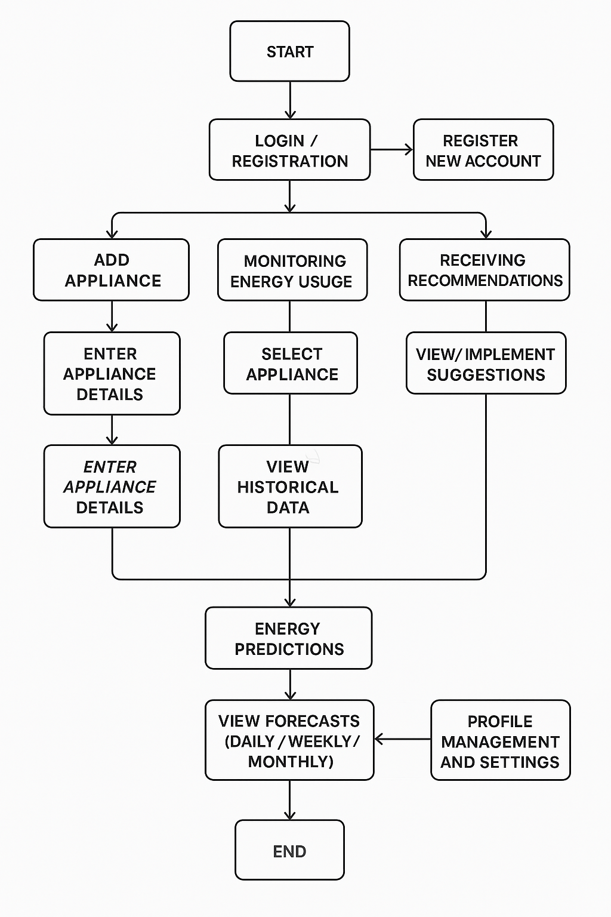
Fig. 5.5 User Navigation Flow
- Login/Registration:
  - Users begin by either logging into an existing account or creating a new one. The login page will require a username/email and password for authentication. Once logged in, users are directed to the main dashboard.
- Adding Appliances:
  - After login, users can add appliances to the system for monitoring. This process involves entering appliance details like name, type, power rating, and installation location. The user is then directed back to the dashboard.
- Monitoring Energy Usage:
  - Users can view the energy consumption for each appliance in real-time on the dashboard. Clicking on a specific appliance will show detailed usage data, including historical consumption.
- Receiving Recommendations:
  - The system generates energy-saving recommendations based on historical data. Users are notified via the dashboard, and they can choose to implement the suggestions directly from the recommendation panel.
- Energy Predictions:
  - Users can view future energy consumption forecasts by navigating to the prediction section. They can explore different time frames (e.g., daily, weekly, monthly) and adjust their energy-saving behavior accordingly.
- Profile Management and Settings:
  - Users can access their profile settings from the main navigation menu. This includes managing personal preferences, notification settings, and device connections.

5.5 Testing Strategy
Testing is crucial to ensure that the system is reliable, functional, and user-friendly. A thorough testing strategy will be implemented at various stages of the development process. This strategy will include the following types of testing:
- Unit Testing: Tests individual components (functions, queries) to ensure they behave
as expected.
- Integration Testing: Ensures that different parts of the system (e.g., cart, payment
gateway) work together smoothly.
- System Testing: End-to-end testing of the entire system to check for bugs and
functionality.
- User Acceptance Testing: Real users test the platform to provide feedback on its
usability and performance.

5.5.1 Customer Login Testing
Table 1: Customer Login Testing
Serial  No. | Condition To be Tested | Test Data | Expected Output | Remarks
1. | If the Email ID is empty | Email ID | Email ID should not be empty | SUCCESSFUL
2. | If the password is empty | Password | Password should not be empty | SUCCESSFUL
3. | If the entered Email ID and password are not valid | Email ID, Password | You have entered invalid login credentials | SUCCESSFUL
4. | If the entered Email ID and password are valid | Email ID, Password | Logged in successfully | SUCCESSFUL
5. | If the user image is not added | User Image | Add the user image | SUCCESSFUL

5.5.2 Admin Login Testing
Table 2: Admin Login Testing

Serial No. | Condition To be Tested | Test Data | Expected Output | Remarks
1 | If the Email ID is empty | Email ID | Kindly enter Email ID | SUCCESSFUL
2 | If the password is empty | Password | Kindly enter password | SUCCESSFUL
3 | If the entered Email ID and password are not valid | Email ID, Password | You have entered invalid login credentials | SUCCESSFUL
4 | If the entered Email ID and password are valid | Email ID, Password | Logged in successfully | SUCCESSFUL

Chapter 6

Conclusion and Future Scope

6.1 Conclusion
The AI-based electricity monitoring system represents a significant step forward in helping consumers better manage their energy consumption and reduce waste. The system’s primary goal is to provide users with accurate, real-time data on their electricity usage, along with actionable insights and recommendations on how they can conserve energy. By utilizing machine learning techniques, the system is able to predict future energy consumption patterns and offer tailored suggestions that encourage energy-saving behavior.
Throughout the development of this project, several key goals have been achieved:
- Accurate Energy Monitoring: The system is capable of tracking the energy consumption of individual appliances, providing users with precise insights into their energy usage. This empowers users to make informed decisions about which appliances to use and when, optimizing their energy consumption.
- Predictive Analysis: By leveraging machine learning algorithms, the system can predict future energy consumption, enabling users to anticipate their electricity usage and adjust their habits accordingly. This feature is particularly beneficial for users looking to avoid high utility bills and reduce their carbon footprint.
- Energy-Saving Recommendations: The system provides users with practical suggestions on how to save energy, such as adjusting appliance usage patterns or upgrading to more energy-efficient devices. These recommendations are personalized based on the user’s historical data, making them highly relevant and actionable.
- User-Friendly Interface: The system offers an intuitive and easy-to-use graphical interface that allows users to monitor their energy consumption, view predictions, and access recommendations without any technical expertise. The user experience is designed to be seamless, ensuring that users can quickly understand and utilize the system’s features.
- Integration with IoT Devices: The system successfully integrates with IoT devices such as smart meters and appliances, enabling real-time data collection and analysis. This integration enhances the system’s ability to provide up-to-date energy consumption data, offering a comprehensive view of the user’s electricity usage.
In conclusion, the AI-based electricity monitoring system provides an innovative solution for managing energy consumption and promoting sustainable practices. By offering accurate monitoring, predictive analytics, and energy-saving recommendations, the system plays a crucial role in helping users reduce their energy costs and environmental impact.

6.2 Future Scope
While the current version of the AI-based electricity monitoring system offers significant benefits, there are several areas where the system can be further improved and expanded to provide even more value to users. The future scope of the project includes:
- Expansion of IoT Device Integration:
  - Currently, the system integrates with a limited set of IoT devices. In the future, the system can be expanded to support a broader range of smart home appliances, such as refrigerators, heating systems, air conditioners, and lighting systems. This will allow users to monitor all of their household energy consumption from a single platform.
- Integration with Renewable Energy Sources:
  - As the adoption of renewable energy sources such as solar panels and wind turbines grows, integrating these energy sources into the system would be a valuable addition. The system could track both the energy produced by these renewable sources and the energy consumed from the grid, offering users insights into how they can optimize their energy mix for sustainability.
- Advanced Machine Learning Models:
  - The current system relies on basic machine learning models for energy prediction and recommendation generation. Future versions could incorporate more advanced models, such as deep learning, to improve the accuracy of predictions and the effectiveness of recommendations. These models could take into account additional factors such as weather conditions, appliance age, and usage patterns.

- Real-Time Energy Trading:
  - A potential future enhancement could be the integration of real-time energy trading. In regions where energy trading is allowed, users could sell excess energy generated by their solar panels or other renewable sources back to the grid. The system could provide a marketplace where users can trade energy and optimize their energy costs.
- Mobile Application Development:
  - Although the system’s GUI is currently designed for desktop use, a mobile application would allow users to access their energy consumption data on-the-go. The mobile app could send push notifications for energy-saving tips, alerts about high energy usage, and reminders to follow energy-saving recommendations.
- User Behavior Analysis:
  - The system could be enhanced by incorporating user behavior analysis to better understand how users interact with their appliances. By tracking usage patterns and analyzing behavioral trends, the system could offer even more personalized energy-saving recommendations based on specific habits and preferences.
- Smart Grid Integration:
  - In the future, integrating the system with smart grid technology could enable more dynamic energy management. The system could communicate with the smart grid to adjust energy consumption based on real-time demand and supply conditions, contributing to grid stability and efficiency.
- Community Sharing and Social Features:
  - A community sharing feature could be added to allow users to compare their energy consumption with that of similar households. This feature could provide motivation for users to improve their energy-saving behaviors by showing how they stack up against others and offering incentives for reaching energy-saving milestones.
- Energy Cost Forecasting:
  - Another useful feature would be the integration of energy price forecasting, where the system could predict future electricity prices based on market trends and weather conditions. This would allow users to plan their energy consumption more efficiently, avoiding peak pricing periods.
- Advanced Reporting and Analytics:
  - As the system evolves, the reporting and analytics capabilities could be enhanced to provide more detailed insights. This could include customizable reports on energy consumption, cost analysis, and environmental impact, giving users a comprehensive view of their energy usage and savings over time.

Chapter 7

REFERENCES
- All research for data and ML model - https://www.kaggle.com/
- Datasets- Opendata - U.S. Energy Information Administration (EIA)
- https://www.kaggle.com/datasets/uciml/electric-power-consumption-dataset?form=MG0AV3
- www.w3schools.com: An online resource for learning web development technologies such as HTML, CSS, JavaScript, and PHP.

