**PANDIT DEENDAYAL ENERGY UNIVERSITY**



**Lab Report**

**Natural Language Processing Lab**

**(21IC403P)**

**By,**

**Aashi Shah**

**Roll No: 21BIT269D**

**VII Semester**

**Submitted to,**

**Dr. Hiren Thakkar(For H1H2)**

**Information and Communication Technology (ICT) School of Technology**

**Pandit Deendayal Energy University  
School of Technology**

**Certificate**

This is to certify that **Aashi Shah**, Roll Number **21BIT269D**, has successfully completed the lab work for the course Natural Language Processing (21IC403P) as part of Semester 7, Batch H2, during the academic year 2024-2025.  
  
This lab work is in partial fulfillment of the requirements for the Bachelor of Technology (B.Tech) program in Information and Communication Technology, graduating year 2025.

Date: 9/11/2024

[Signature]  
Name: Dr. Hiren Thakkar

**Index**

|  |  |  |  |
| --- | --- | --- | --- |
| **Sr No.** | **Experiment Title** | **Page No.** | **Signature** |
| 1 | Write a Python script to read, write, and manipulate text files. Extract and process text from PDF files using Python libraries like PyPDF2 and Pdf Miner | 1 |  |
| 2 | Implement a Python program to search for patterns in text utilizing regular expressions. | 4 |  |
| 3 | Create a Python script to implement and compare ultra-fast tokenization techniques using libraries like NLTK, SpaCy, and FastText. | 6 |  |
| 4 | Develop a Python program to apply stemming and lemmatization to normalize text data. | 7 |  |
| 5 | Write a Python script to explore and implement various vocabulary matching techniques, including word embeddings and similarity measures. | 9 |  |
| 6 | Create a Python program to automatically tag parts of speech in raw text files using libraries like NLTK and SpaCy. | 11 |  |
| 7 | Implement a Python script to visualize POS tagging and NER using tools like SpaCy and Matplotlib. | 13 |  |
| 8 | Develop a Python program to implement text classification algorithms such as Naive Bayes, SVM, and neural networks, and evaluate their performance. | 14 |  |
| 9 | Write a Python script to apply Non-negative Matrix Factorization (NMF) for topic modeling and document clustering. | 17 |  |
| 10 | Create a Python program to implement and compare various NLP algorithms for tasks such as classification, clustering, and sentiment analysis. | 18 |  |
| 11 | Develop a Python script to perform sentiment analysis on text data using lexicon-based methods and machine learning models. | 19 |  |
| 12 | Write a Python program to apply deep learning models such as RNNs, LSTMs, or Transformers for NLP tasks, including experimenting with pre-trained models like BERT or GPT. | 20 |  |

**Experiment 1: Text and PDF File Manipulation with Python**

1. Write a Python script to read, write, and manipulate text files.
2. Extract and process text from PDF files using Python libraries like PyPDF2 and pdfminer.

**Objective:**

* Learn to read, write, and manipulate text files.

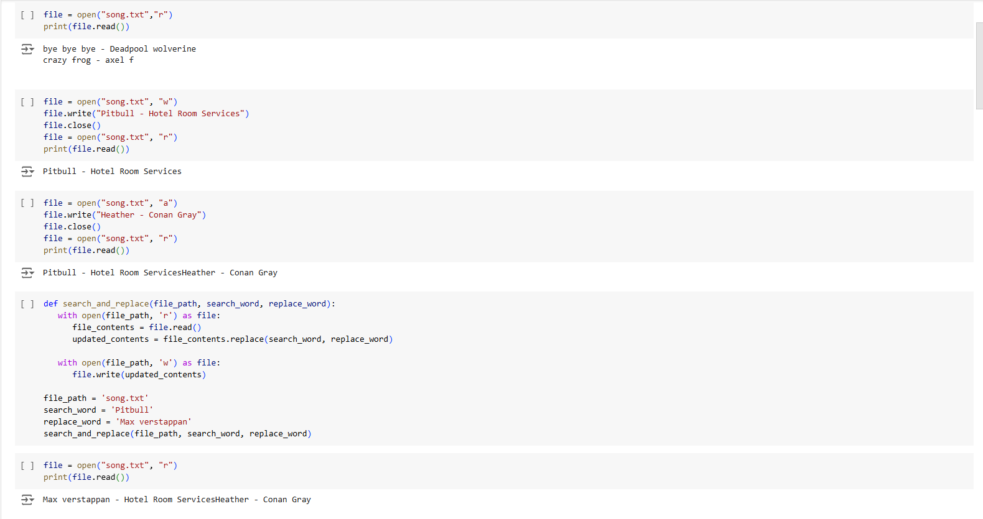

Extract and process text from PDF files.

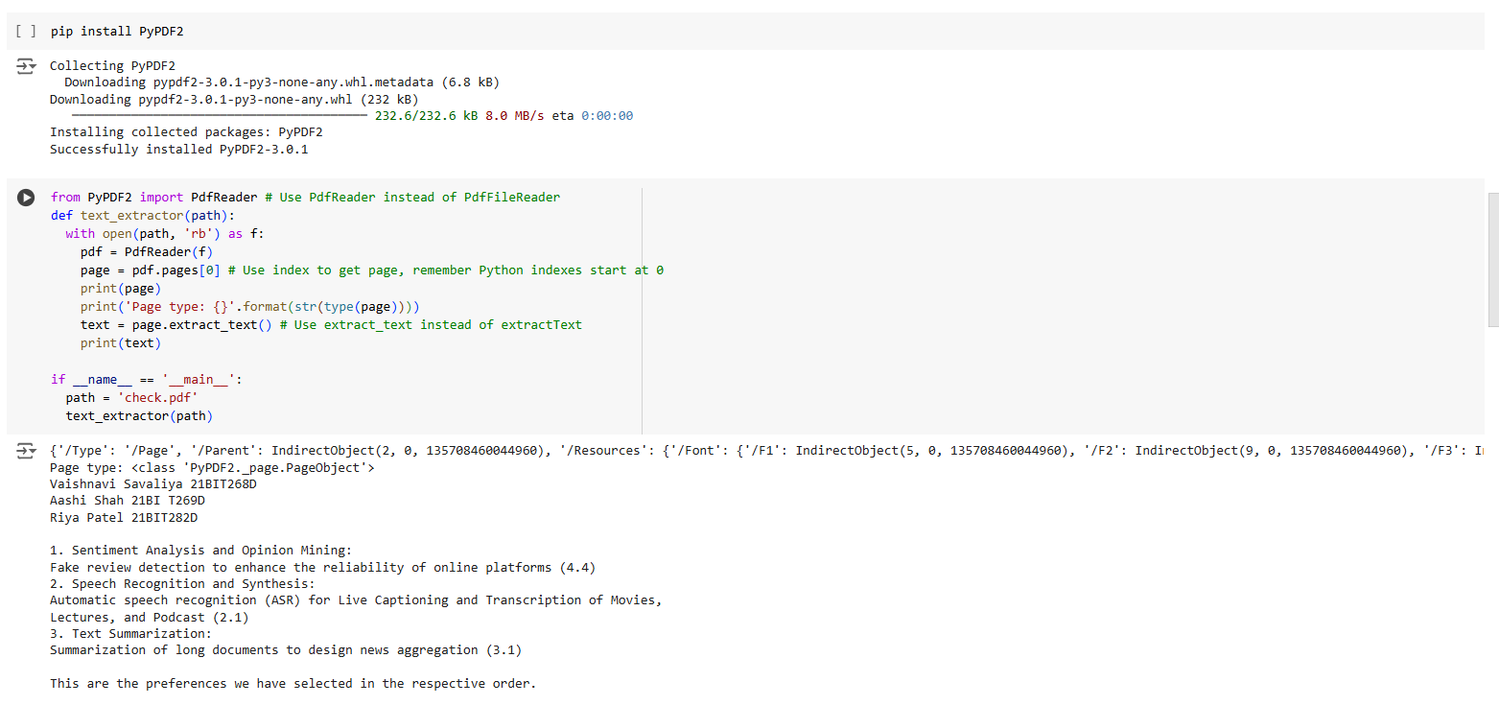

**Email Extraction:**

import imaplib

import json

import mailparser

# Your Gmail credentials (should use environment variables or a secure method)

username = "aashi12e@gmail.com"

password = secret-key

# Connect to the Gmail IMAP server

mail = imaplib.IMAP4_SSL("imap.gmail.com")

mail.login(username, password)

# Select the mailbox you want to use. Use 'INBOX' to read inbox emails.

mail.select("inbox")

# Search for all emails and get the latest one

status, messages = mail.search(None, "ALL")

if status == "OK":

    # Convert messages to a list of email IDs and get the last email ID

    email_ids = messages[0].split()

    latest_email_id = email_ids[-1]

    # Fetch the latest email by ID

    status, msg_data = mail.fetch(latest_email_id, "(RFC822)")

    if status == "OK":

        # Get the email content

        raw_email = msg_data[0][1]

        # Decode the email content

        for encoding in ['utf-8', 'latin-1', 'iso-8859-1']:

            try:

                raw_email_decoded = raw_email.decode(encoding)

                break

            except UnicodeDecodeError:

                raw_email_decoded = None

        if raw_email_decoded:

            # Parse the email using mailparser

            email_message = mailparser.parse_from_string(raw_email_decoded)

            # Store email details in a dictionary (only body is extracted)

            email_details = {

                "from": email_message.from_,

                "subject": email_message.subject,

                "date": email_message.date,

                "body": email_message.text_plain if email_message.text_plain else email_message.text_html

            }

            # Convert the email details to JSON format

            email_json = json.dumps(email_details, indent=4, default=str)

            # Print the JSON output

            print(email_json)

        else:

            print("Failed to decode the email content.")

    else:

        print("Failed to fetch the latest email.")

else:

    print("Failed to search emails.")

# Close the mailbox and logout

mail.close()

mail.logout()

**Output :**

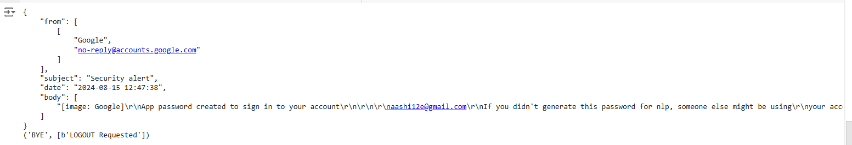

**Experiment 2: Pattern Searching in Text Using Regular Expressions**

1. Implement a Python program to search for patterns in text utilizing regular expressions.

**Objective:**

* Utilize regular expressions to find patterns in text.

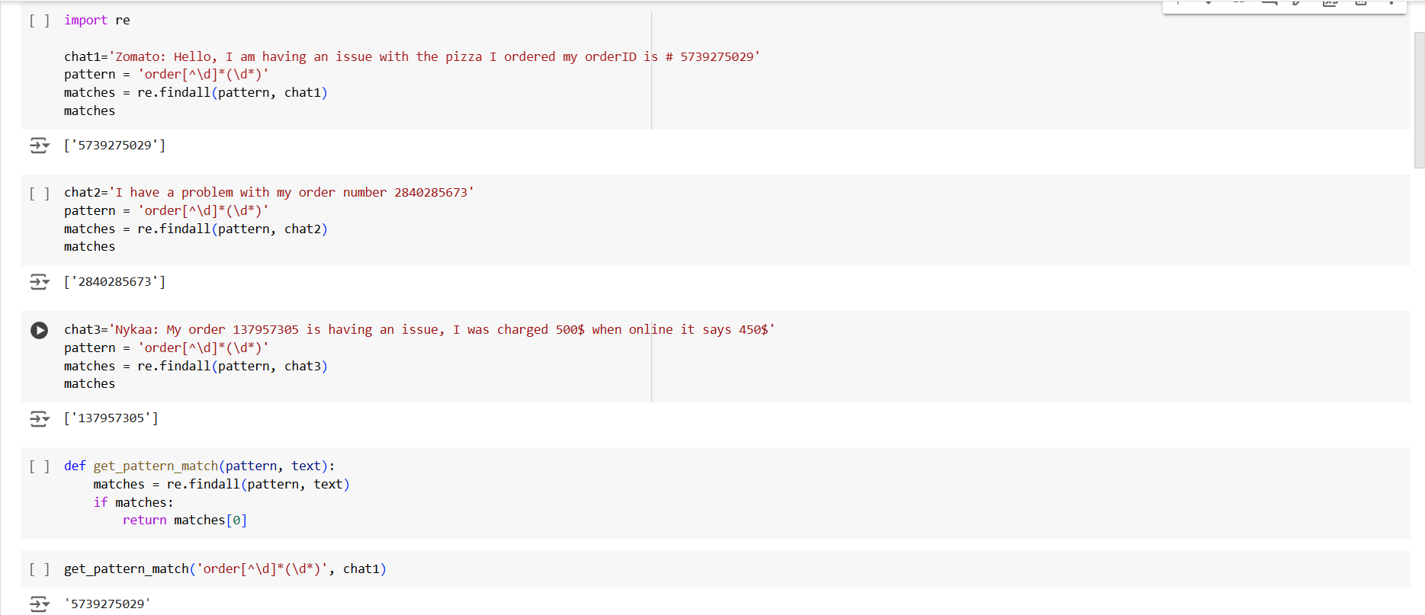

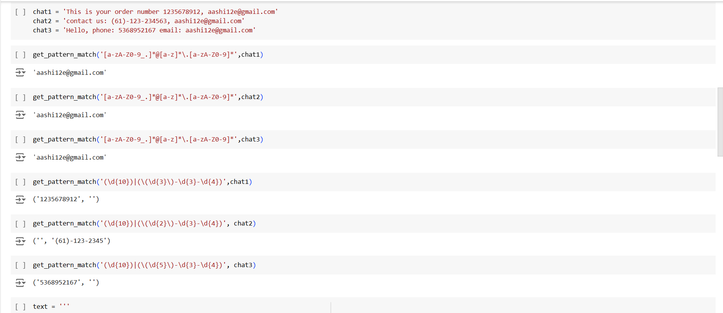

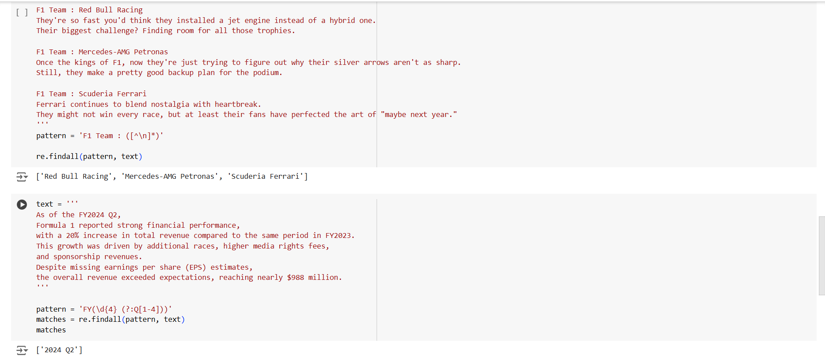

**Experiment 3: Ultra-fast Tokenization**

1. Create a Python script to implement and compare ultra-fast tokenization techniques using libraries like NLTK, SpaCy, and FastText.

**Objective:**

* Implement and compare different tokenization methods.

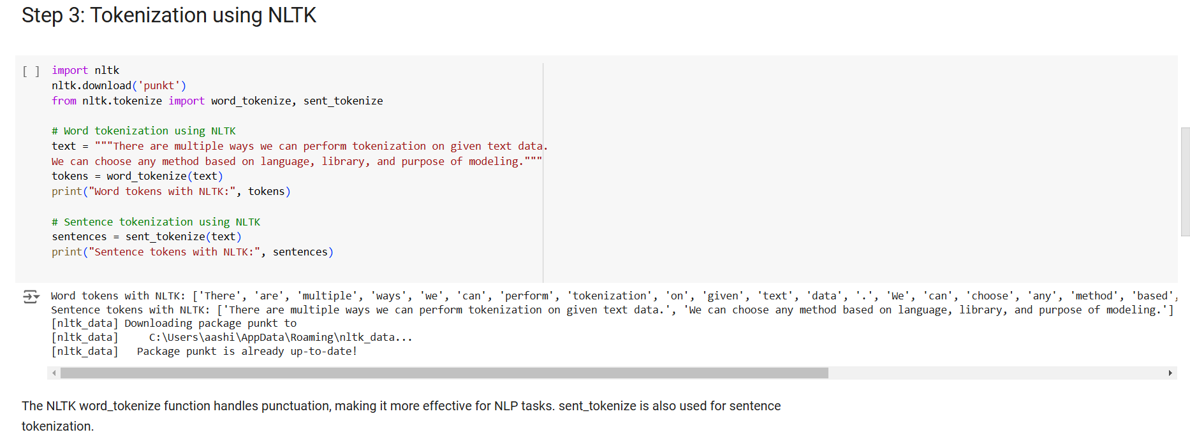

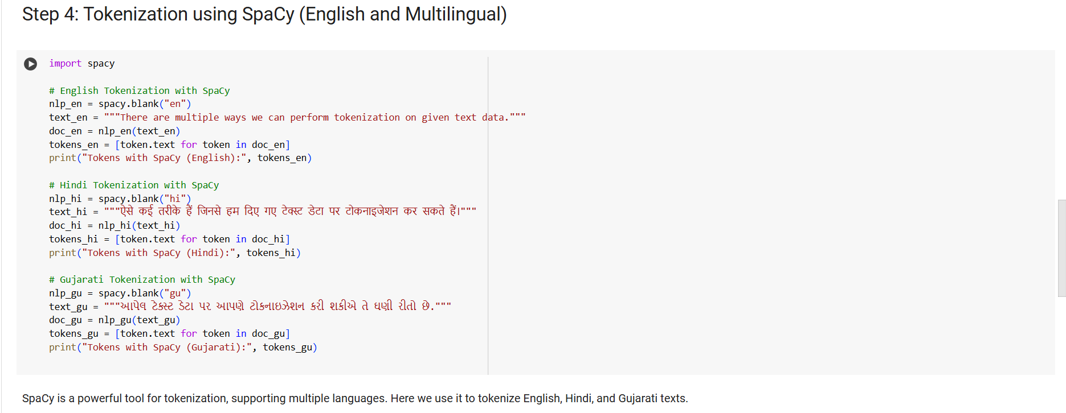

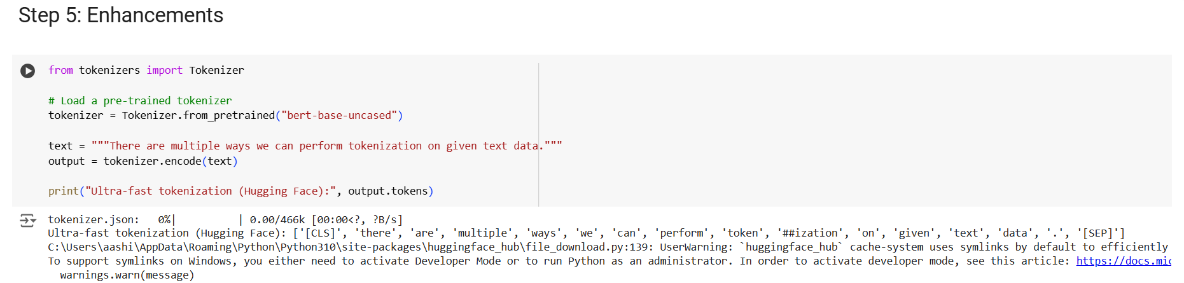

**Experiment 4: Stemming and Lemmatization**

1. Develop a Python program to apply stemming and lemmatization to normalize text data.

**Objective:**

* Apply stemming and lemmatization to normalize text.

# Stemming and Lemmatization Techniques in Text Preprocessing

import nltk

from nltk.stem import PorterStemmer, WordNetLemmatizer

from nltk.tokenize import word_tokenize

from nltk.corpus import wordnet

# Download required resources

nltk.download('punkt')

nltk.download('wordnet')

nltk.download('averaged_perceptron_tagger')

# Initialize stemmer and lemmatizer

stemmer = PorterStemmer()

lemmatizer = WordNetLemmatizer()

# Function to get WordNet POS tags for more accurate lemmatization

def get_wordnet_pos(word):

    tag = nltk.pos_tag([word])[0][1][0].upper()  # Get the first letter of POS tag

    tag_dict = {"J": wordnet.ADJ,

                "N": wordnet.NOUN,

                "V": wordnet.VERB,

                "R": wordnet.ADV}

    return tag_dict.get(tag, wordnet.NOUN)  # Default to NOUN if not found

# Function for stemming

def stem_words(text):

    tokens = word_tokenize(text)

    return [stemmer.stem(word) for word in tokens]

# Function for lemmatization (with POS tagging)

def lemmatize_words(text):

    tokens = word_tokenize(text)

    return [lemmatizer.lemmatize(word, get_wordnet_pos(word)) for word in tokens]

# Example text

text = """Formula 1 is the pinnacle of racing culture, where speed, strategy, and precision come together in a high-stakes blend of engineering and raw skill.

 With cars that push the limits of physics and drivers that embody relentless competitiveness, F1 captures the fascination of millions worldwide."""

# Perform stemming

stemmed_words = stem_words(text)

print("Stemmed Words:", stemmed_words)

# Perform lemmatization

lemmatized_words = lemmatize_words(text)

print("Lemmatized Words:", lemmatized_words)

# BONUS: Compare stemmed and lemmatized results side by side

print("\nComparison of Original, Stemmed, and Lemmatized Words:")

tokens = word_tokenize(text)

for i, token in enumerate(tokens):

    print(f"Original: {token} \t\t\t| Stemmed: {stemmed_words[i]} \t\t\t| Lemmatized: {lemmatized_words[i]}")

**Output :**

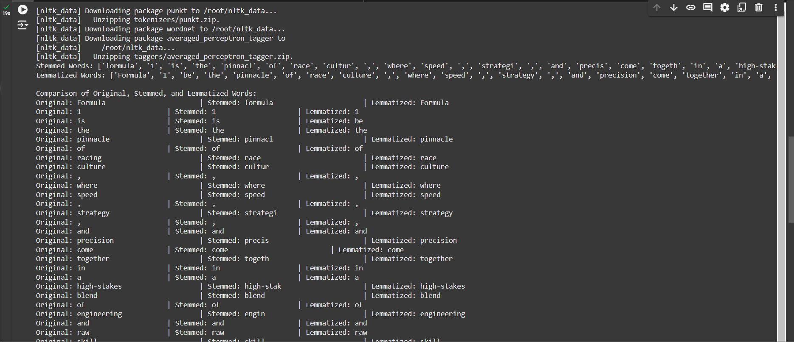

**Experiment 5: Vocabulary Matching Techniques**

1. Write a Python script to explore and implement various vocabulary matching techniques, including word embeddings and similarity measures.

**Objective:**

* Explore and implement various vocabulary matching techniques.

import Levenshtein

import gensim.downloader as api

from scipy.spatial.distance import cosine

# Load a pre-trained Word2Vec model

model = api.load("word2vec-ruscorpora-300")

def exact_match(word1, word2):

    """Check for exact match between two words."""

    return word1.lower() == word2.lower()  # Ignore case sensitivity

def levenshtein_distance(word1, word2):

    """Calculate Levenshtein distance between two words."""

    return Levenshtein.distance(word1, word2)

def jaccard_match(word1, word2):

    """Calculate Jaccard similarity between two words."""

    set1 = set(word1)

    set2 = set(word2)

    intersection = len(set1.intersection(set2))

    union = len(set1.union(set2))

    return intersection / union if union > 0 else 0  # Avoid division by zero

def cosine_similarity(word1, word2):

    """Calculate cosine similarity between two words using their word vectors."""

    try:

        # Get the word vectors

        vector1 = model[word1.lower()]  # Ensure lower case

        vector2 = model[word2.lower()]  # Ensure lower case

        # Calculate cosine similarity (1 - cosine distance)

        return 1 - cosine(vector1, vector2)

    except KeyError:

        return None  # Return None if the word is not in the model

# List of word pairs for comparison

word_pairs = [

    ("happy", "joyful"),         # Synonyms

    ("sad", "unhappy"),          # Related antonyms

    ("light", "dark"),           # Antonyms

    ("car", "automobile"),       # Synonyms

    ("teacher", "student"),      # Related roles

    ("fast", "quick"),           # Synonyms

    ("big", "large"),            # Synonyms

    ("cold", "ice"),             # Related concepts

    ("run", "running"),          # Different forms of the same word

    ("strong", "powerful"),      # Synonyms

    ("beautiful", "ugly"),       # Antonyms

    ("child", "adult"),          # Different life stages

    ("friend", "enemy"),         # Opposites

    ("smart", "intelligent"),    # Synonyms

    ("fish", "swim"),            # Related actions

    ("love", "hate")             # Opposites

]

# Evaluate each pair of words

for word1, word2 in word_pairs:

    print(f"Itr :: {word1} :: {word2}\n")

    print(f"Exact Match :: {exact_match(word1, word2)} ")

    print(f"Levenshtein Distance :: {levenshtein_distance(word1, word2)}")

    print(f"Jaccard Similarity :: {jaccard_match(word1, word2)}")

    cosine_sim = cosine_similarity(word1, word2)

    if cosine_sim is not None:

        print(f"Cosine Similarity :: {cosine_sim}")

    else:

        print(f"Cosine Similarity :: One or both words not in the model.")

    print("\n")

**Output :**

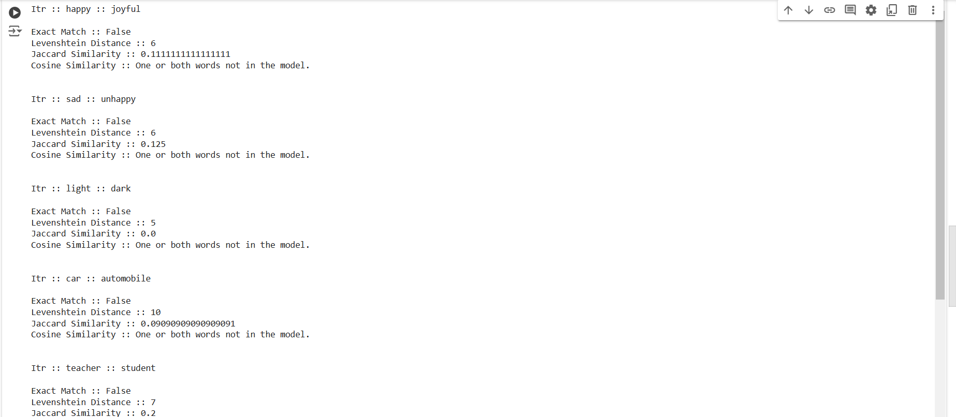

**Experiment 6: Part of Speech Tagging**

1. Create a Python program to automatically tag parts of speech in raw text files using libraries like NLTK and SpaCy.

**Objective:**

* Automatically tag parts of speech in raw text files.

import nltk

import spacy

nltk.download('punkt', quiet=True)

nltk.download('averaged_perceptron_tagger', quiet=True)

def pos_tag_nltk(text):

    words = nltk.word_tokenize(text)

    pos_tags = nltk.pos_tag(words)

    return pos_tags

# Function to perform POS tagging using spaCy

def pos_tag_spacy(text):

    doc = nlp(text)

    pos_tags = [(token.text, token.pos_) for token in doc]

    return pos_tags

# Function to read text from a file

def read_text_file(file_path):

    try:

        with open(file_path, 'r', encoding='utf-8') as file:

            return file.read()

    except FileNotFoundError:

        print(f"Error: The file '{file_path}' was not found.")

        return None

# Function to display POS tags

def display_pos_tags(pos_tags, library_name):

    print(f"\nPOS tagging using {library_name}:\n")

    for word, tag in pos_tags:

        print(f"{word} -> {tag}")

# Path to the raw text file

file_path = 'sample.txt'  # Replace with your file path

# Read the text from the file

text_content = read_text_file(file_path)

if text_content:

    # Perform POS tagging using NLTK

    nltk_pos_tags = pos_tag_nltk(text_content)

    display_pos_tags(nltk_pos_tags, "NLTK")

    # Perform POS tagging using spaCy

    spacy_pos_tags = pos_tag_spacy(text_content)

    display_pos_tags(spacy_pos_tags, "spaCy")

**Output :**

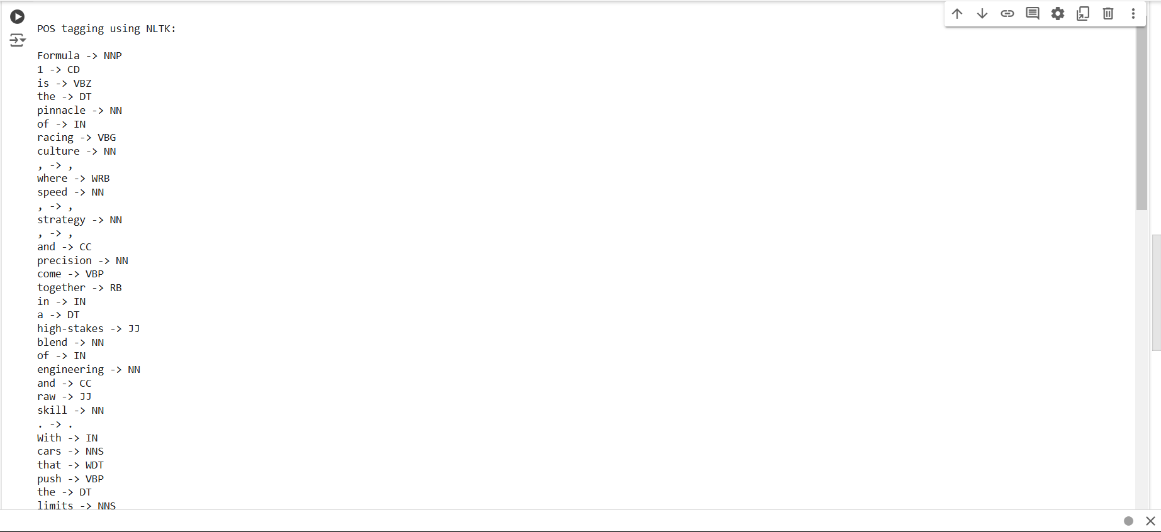

**Experiment 7: Visualizing POS and Named Entity Recognition (NER)**

1. Implement a Python script to visualize POS tagging and NER using tools like SpaCy and Matplotlib.

**Objective:**

* Create visualizations for POS tagging and NER.

import spacy

from spacy import displacy

# Load the spaCy model

try:

    nlp = spacy.load("en_core_web_sm")

except Exception as e:

    print(f"Error loading spaCy model: {e}")

def visualize_pos_and_ner(text):

    # Process the text

    doc = nlp(text)

    # Display Named Entity Recognition (NER)

    print("Named Entity Recognition:")

    displacy.render(doc, style='ent', jupyter=True)  # Use jupyter=True for Jupyter Notebook

    # Display Part-of-Speech (POS) tagging (dependency parse)

    print("Part-of-Speech Tagging:")

    displacy.render(doc, style='dep', jupyter=True)  # Use jupyter=True for Jupyter Notebook

# Sample text

sample_text = "Formula 1 captures the fascination of millions worldwide."

# Visualize POS and NER

visualize_pos_and_ner(sample_text)

**Output :**

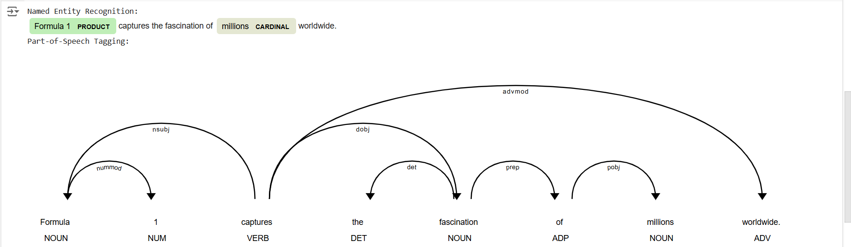

**Experiment 8: Text Classification Algorithms**

1. Develop a Python program to implement text classification algorithms such as Naive Bayes, SVM, and neural networks, and evaluate their performance.

**Objective:**

Implement text classification algorithms and evaluate their performance.

from sklearn.datasets import fetch_20newsgroups

from sklearn.feature_extraction.text import TfidfVectorizer

from sklearn.model_selection import train_test_split

from sklearn.naive_bayes import MultinomialNB

from sklearn.svm import SVC

from sklearn.metrics import accuracy_score, classification_report

from keras.models import Sequential

from keras.layers import Dense

from keras.utils import to_categorical

from sklearn.preprocessing import LabelEncoder

# Load and split dataset

newsgroups = fetch_20newsgroups(subset='all')

X = newsgroups.data

y = newsgroups.target

# Convert text to TF-IDF features

tfidf = TfidfVectorizer(stop_words='english', max_features=10000)

X_tfidf = tfidf.fit_transform(X)

# Split data into training and test sets

X_train, X_test, y_train, y_test = train_test_split(X_tfidf, y, test_size=0.2, random_state=42)

# Function to evaluate models

def evaluate_model(model, X_train, X_test, y_train, y_test):

    model.fit(X_train, y_train)

    predictions = model.predict(X_test)

    accuracy = accuracy_score(y_test, predictions)

    report = classification_report(y_test, predictions)

    return accuracy, report

# Model 1: Naive Bayes

print("Naive Bayes Model")

nb_model = MultinomialNB()

nb_accuracy, nb_report = evaluate_model(nb_model, X_train, X_test, y_train, y_test)

print(f"Accuracy: {nb_accuracy}")

print(nb_report)

# Model 2: Support Vector Machine (SVM)

print("Support Vector Machine Model")

svm_model = SVC(kernel='linear', C=1)

svm_accuracy, svm_report = evaluate_model(svm_model, X_train, X_test, y_train, y_test)

print(f"Accuracy: {svm_accuracy}")

print(svm_report)

# Model 3: Neural Network

print("Neural Network Model")

# Encode labels for neural network

encoder = LabelEncoder()

y_train_enc = to_categorical(encoder.fit_transform(y_train))

y_test_enc = to_categorical(encoder.transform(y_test))

# Define the neural network

nn_model = Sequential()

nn_model.add(Dense(512, input_shape=(X_train.shape[1],), activation='relu'))

nn_model.add(Dense(256, activation='relu'))

nn_model.add(Dense(y_train_enc.shape[1], activation='softmax'))

# Compile the neural network

nn_model.compile(optimizer='adam', loss='categorical_crossentropy', metrics=['accuracy'])

# Train the neural network

nn_model.fit(X_train, y_train_enc, epochs=5, batch_size=128, validation_split=0.1)

# Evaluate the neural network

nn_loss, nn_accuracy = nn_model.evaluate(X_test, y_test_enc)

print(f"Neural Network Accuracy: {nn_accuracy}")

**Output :**

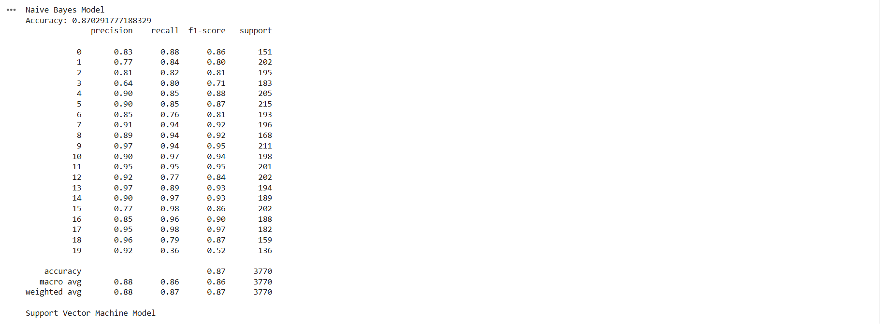

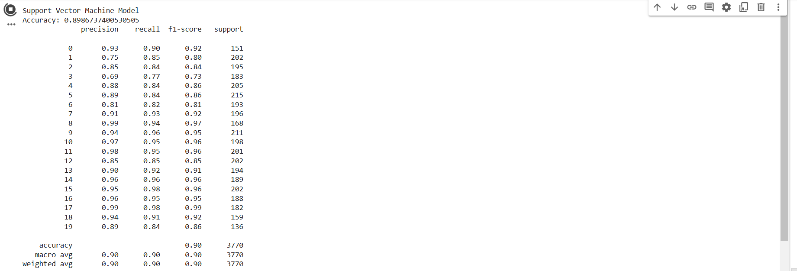

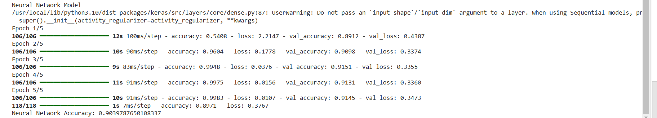

**Experiment 9: Non-negative Matrix Factorization (NMF) for Topic Modeling**

1. Write a Python script to apply Non-negative Matrix Factorization (NMF) for topic modeling and document clustering.

**Objective:**

* Apply NMF for topic modeling and document clustering.

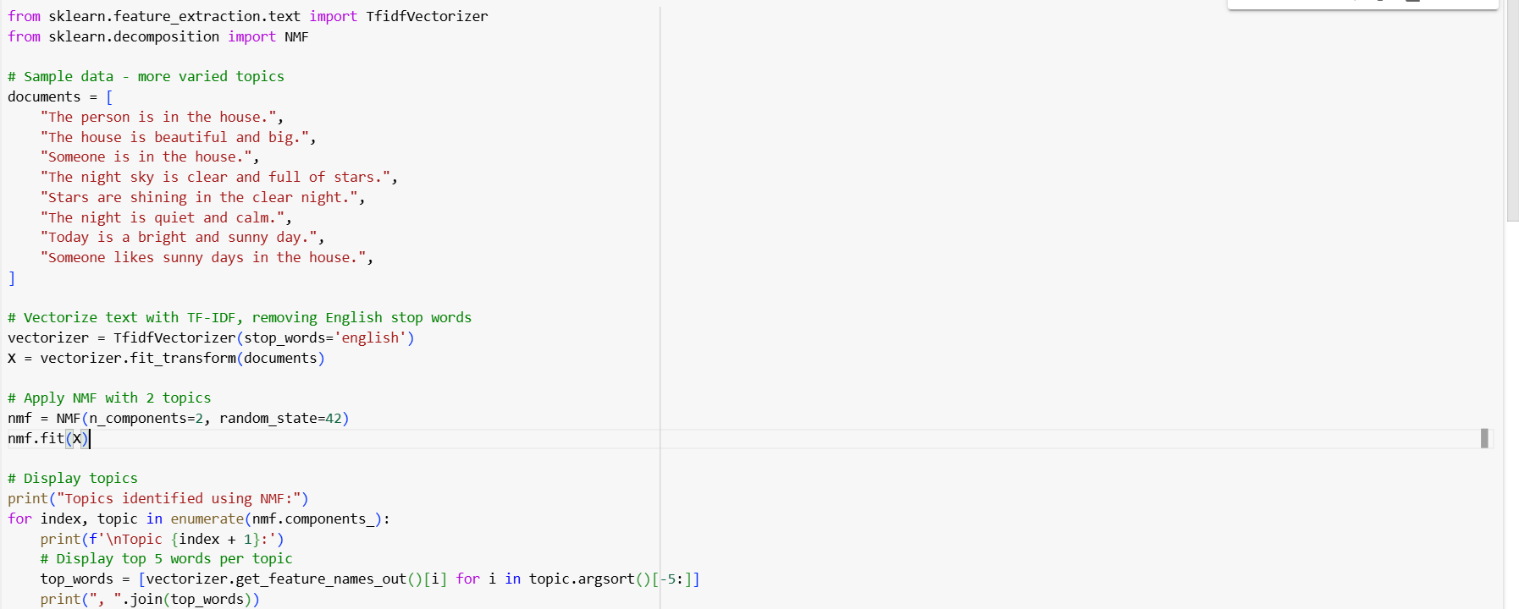

**Output :**



**Experiment 10: Exploring Different Algorithms**

1. Create a Python program to implement and compare various NLP algorithms for tasks such as classification, clustering, and sentiment analysis.

**Objective:**

* Implement and compare various NLP algorithms for tasks like classification, clustering, and sentiment analysis.

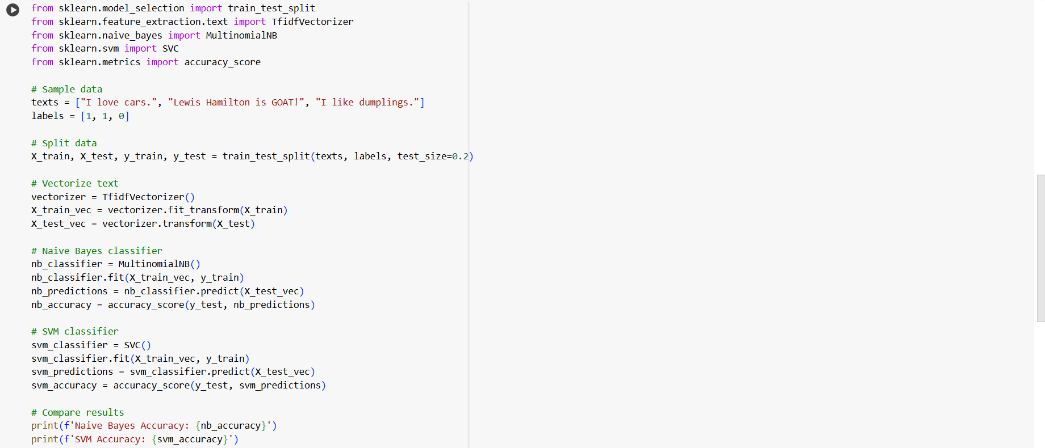

**Output:**



**Experiment 11: Sentiment Analysis**

1. Develop a Python script to perform sentiment analysis on text data using lexicon-based methods and machine learning models.

**Objective:**

* Perform sentiment analysis on text data using various methods.

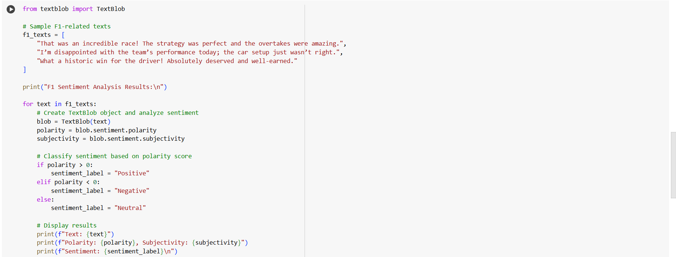

**Output :**

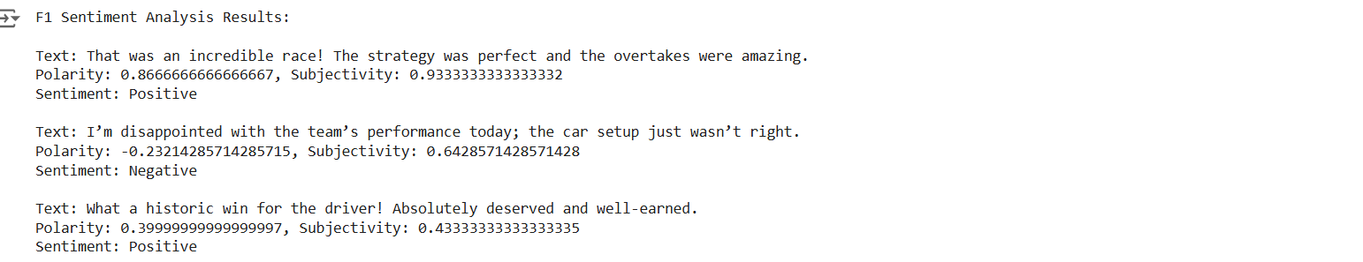

**Experiment 12: Deep Learning in NLP**

1. Write a Python program to apply deep learning models such as RNNs, LSTMs, or Transformers for NLP tasks, including experimenting with pre-trained models like BERT or GPT.

**Objective:**

* Apply deep learning models for NLP tasks.

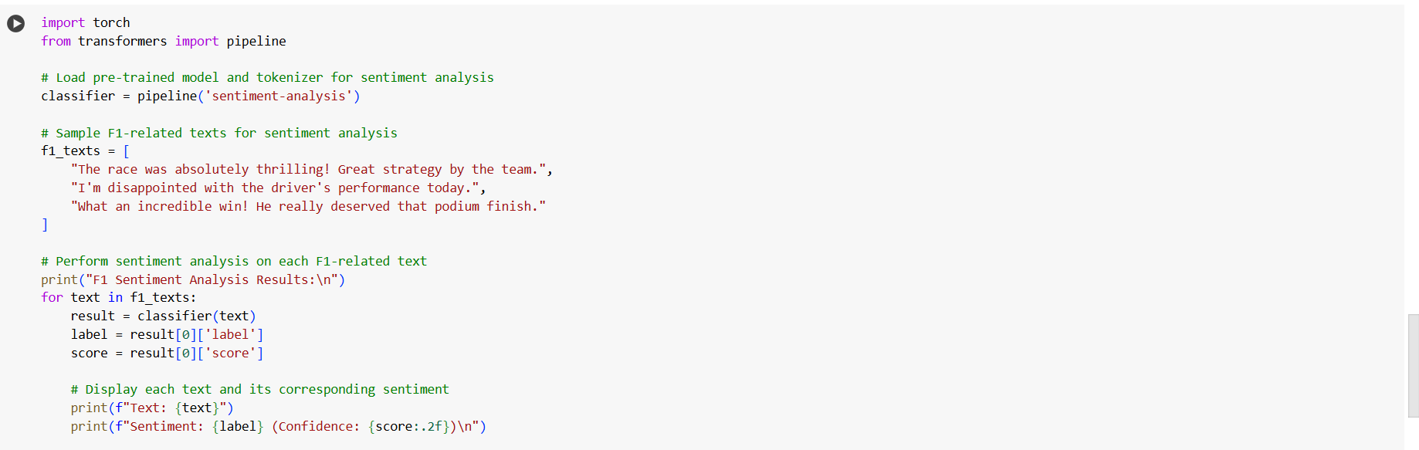

**Output :**

