*Health Equity Index: Trends and Recommendations for Medicare Advantage Plans*

*CMS has introduced the Health Equity Index (HEI) to evaluate health disparities among Medicare Advantage beneficiaries. Examine the methodology for calculating HEI and analyze trends in performance using publicly available data. Identify common factors contributing to low HEI scores and propose evidence-based strategies to improve equity outcomes across Medicare Advantage plans*.

**WHAT DO WE UNDERSTAND ABOUT THE PROBLEM?**

Problem statement:

* In 2023, 51 percent of all people with Medicare were enrolled in an MA plan (Ochieng et al., 2023). Enrollment in MA has increased rapidly in recent years, particularly among Black and Hispanic people 4 with Medicare (Meyers et al., 2021). Therefore, disparities in care in MA have taken on heightened significance. (https://www.cms.gov/files/document/national-stratified-final.pdf)
* addressing inequities in health outcomes among beneficiaries of Medicare Advantage (MA) plans, as captured by the CMS Health Equity Index (HEI)/ The **Health Equity Index (HEI)** is often used to assess how effectively healthcare systems or plans address disparities in healthcare access, outcomes, and service delivery across different demographic groups.
* low HEI scores indicate disparities in access, quality, and outcomes of care, often driven by social determinants of health (SDoH), systemic barriers
* goal is to analyze data to identify the root causes of low HEI scores and recommend evidence-based strategies to improve equity outcomes
* Instead of addressing the quality of care provided for beneficiaries with social risk factors, the HEI reward, as constructed, prioritizes the volume of beneficiaries with those risk factors. Qualifying for the reward becomes a numbers game, rather than measurable success at improving care outcomes for vulnerable beneficiaries. (https://achp.org/wp-content/uploads/Inequitable-Health-Equity-Index-FINAL.pdf)

**WHAT IS OUR APPROACH?**

Dataset: https://www.cms.gov/newsroom/fact-sheets/2025-medicare-advantage-and-part-d-star-ratings

To improve HEI scores, MA plans should enhance data collection on social risk factors, develop robust member engagement strategies, establish strong community partnerships, address social determinants of health, and provide culturally competent care. These steps can help reduce healthcare disparities and improve overall plan performance.

1. **Data Collection and Analysis**
   1. Utilize CMS datasets, including the 2025 Medicare Advantage and Part D Star Ratings[7](https://blog.arine.io/cms-health-equity-index).
   2. Focus on income and location aspects of HEI, analyzing their impact on healthcare disparities.
2. **Methodology Examination**
   1. Investigate the HEI calculation method, which consolidates a subset of Star Ratings measures[7](https://blog.arine.io/cms-health-equity-index).
   2. Analyze how plans receive scores between -1 and 1 based on performance for eligible patient populations[7](https://blog.arine.io/cms-health-equity-index).
3. Trend Analysis
   1. Examine historical data to identify trends in HEI scores across different MA plans.
   2. Correlate HEI scores with specific Star Ratings measures to uncover relationships[9](https://www.oliverwyman.com/our-expertise/perspectives/health/2024/march/medicare-advantage-plans-need-robust-health-equity-strategy.html).
4. **Root Cause Identification**
   1. Investigate factors contributing to low HEI scores, such as social determinants of health and systemic barriers[5](https://www.ncbi.nlm.nih.gov/books/NBK425845/).
   2. Analyze the impact of income and location on healthcare access and outcomes.
5. Strategy Development
   1. Propose evidence-based strategies to improve equity outcomes, focusing on:Enhanced data collection on social risk factors
6. Recommendations
   1. Develop actionable recommendations for MA plans to improve their HEI scores and overall equity performance.
   2. Address the challenge of balancing volume of beneficiaries with social risk factors and quality of care provided[1](https://achp.org/wp-content/uploads/Inequitable-Health-Equity-Index-FINAL.pdf).

## Problem We're Solving

* Medicare Advantage covers 51% of enrollees
* Growing diversity demands better healthcare equity
* Current system has hidden disparities

## Our Focused Approach

## Data Strategy

* Analyze CMS Medicare Advantage datasets
* Concentrate on income and location factors
* Trace health equity performance patterns

## Key Analysis Dimensions

* Understand HEI calculation methodology
* Identify correlation between location/income and health outcomes
* Map systemic barriers preventing equitable care

## Methodology

* Quantitative data analysis
* Statistical correlation studies
* Evidence-based recommendations

## Why This Matters

* Reveal hidden healthcare inequities
* Provide actionable insights for Medicare Advantage plans
* Potential to improve healthcare access for vulnerable populations

## Deliverables

* Comprehensive research report
* Data visualization
* Strategic recommendations

**WHAT DATA WOULD YOU USE? OUR PLAN TO PROCURE THAT DATA.**

**\*Cindy**

**WHAT IS OUR PLAN TO INTERPRET THE INSIGHTS FROM THE DATA?**

* Identify Key Factors
  + Analyze the factors most correlated with low and high HEI scores in Medicare Advantage plans using Pearson correlation.
* Assess Impact of Socioeconomic and Demographic Factors
  + Conduct subgroup analysis to uncover barriers to equity and disparities in care outcomes.
* Analyze Trends Tver Time and Regions
  + Examine HEI trends across regions and enrollment shifts
  + Use linear regression for over time trends
  + Use logistic regression to compare low vs. high HEI plans
* Develop Actionable Strategies
  + Provide evidence-based recommendations to improve equity outcomes and boost HEI scores.
  + Maybe use a tableau dashboard to show some of the trends
* Some possible tactics we might have to use due to limited data:
  + Use star ratings or SDoH measures
  + Maybe we have to develop a relative equity scores based on the trends in disparities, SDoH, and regions
  + We may have to stimulate HEI scores by creating a predictive model with simulated data.

**WHAT WOULD BE OUR DELIVERABLES AT THE END OF THE PROJECT?**

* 1. How is HEI calculated? <https://resources.aspenrxhealth.com/blog/cms-health-equity-index>
  2. https://file-epsilonregistration-com.s3.amazonaws.com/26/354/pres/Day2/J-An+Overview+of+CMS+Developed+Indicies/MaksutEtAl_An+Overview+of+CMS-Developed+Indices_508.pdf

**WHAT IS THE APPROXIMATE TIMELINE VIEW OF WHAT TASKS WILL WE COMPLETE AND BY WHEN?**Timeline

What is the relationship between a Medicare Advantage plan's Health Equity Index score and its performance on specific Star Ratings measures in 2024-2025?

Data

<https://www.cms.gov/medicare/health-drug-plans/part-c-d-performance-data>

<https://www.cms.gov/files/document/health-equity-fact-sheet.pdf>

<https://www.cms.gov/priorities/health-equity/grants-awards/data-access-program>

<https://www.aafp.org/about/policies/all/social-determinants-health-family-medicine-position-paper.html#:~:text=Definitions,live%2C%20work%2C%20and%20age.&text=Structural%20Determinants%20of%20Health%20Inequities,social%20class%20inequalities%20in%20society.&text=Health%20Equity:%20%E2%80%9CHealth%20equity%20means,environments%2C%20and%20health%20care.%E2%80%9D&text=Health%20Disparities:%20%E2%80%9CA%20type%20of,sensory%2C%20or%20physical%20disability.%E2%80%9D&text=Health%20Inequities:%20%E2%80%9CA%20difference%20or,%2C%20avoidable%2C%20and%20unjust.%E2%80%9D>

Disparities in Health Care in Medicare Advantage by Race, Ethnicity, and Sex <https://www.cms.gov/files/document/national-stratified-final.pdf>

<https://data.cms.gov/search?filter_Programs=Medicare%20Advantage&offset=10>

<https://www.cms.gov/data-research/files-for-order/limited-data-set-lds-files/health-outcomes-survey-hos>

<https://www.cms.gov/priorities/health-equity/minority-health/research-data/mapping-medicare-disparities-tool-mmd>

<https://www.cms.gov/files/document/hei-webinar-november-2024.pptx>

**MEASURES USED FOR MEDICARE STAR RATINGS:**

1. <https://www.cms.gov/files/document/2026-star-ratings-measures.pdf> **FOR 2026**
2. <https://www.cms.gov/newsroom/fact-sheets/2025-medicare-advantage-and-part-d-star-ratings> **FOR 2022-2025** (you will need to scroll down half way through the page to find the measures)

[Health Equity - National | Provider Data Catalog](https://data.cms.gov/provider-data/dataset/anfs-nlq7)

HEI Calculation is statistical mathematical formula to find the weighted mean:

https://www.statisticshowto.com/probability-and-statistics/statistics-definitions/weighted-mean/

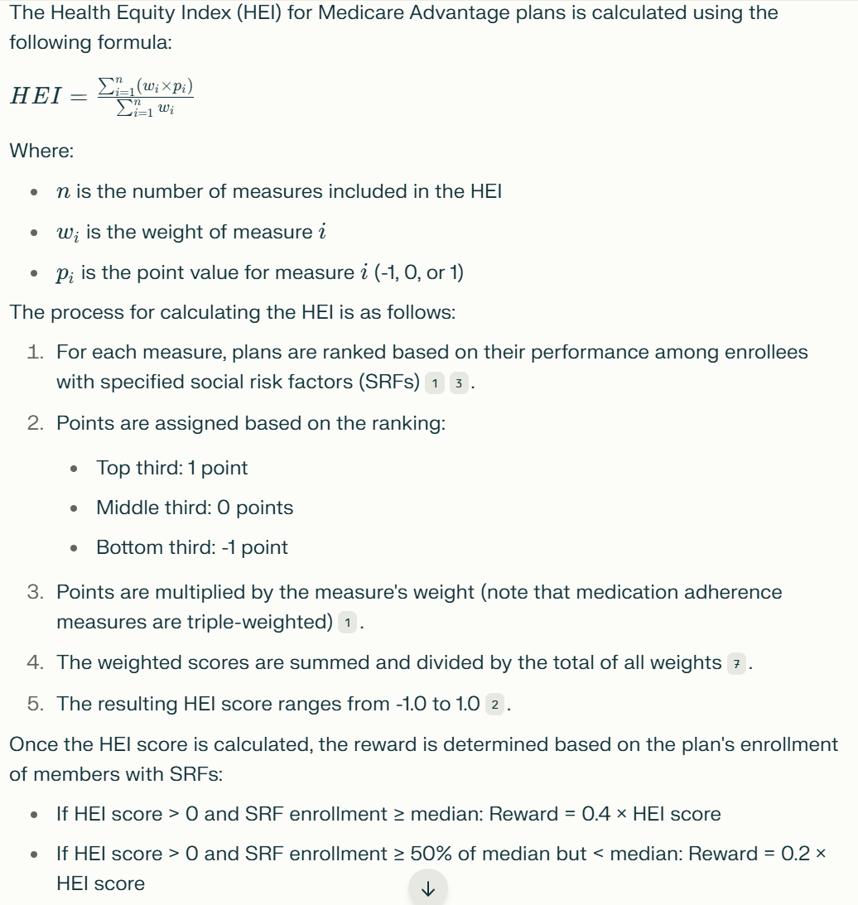

* If HEI score ≤ 0 or SRF enrollment < 50% of median: No reward[3](https://www.cms.gov/files/document/hei-webinar-november-2024.pptx)

The final reward is added to the plan's overall Star Rating before rounding to the nearest half star.

SPECIFIC TIMELINE

- **Week 1:**

- Define project objectives and scope.

- Conduct literature review and gather relevant background information.

- Identify data sources and requirements.

- Draft a data collection plan.

- **Week 2:**

- Begin data collection from primary and secondary sources.

- Organize and document collected data.

- Identify potential data quality issues (e.g., inconsistencies, duplicates).

- **Week 3:**

- Clean and preprocess data (e.g., remove duplicates, handle outliers).

- Standardize data formats and structures.

- Create a data dictionary for reference.

- **Week 4:**

- Validate data completeness and accuracy.

- Perform initial data exploration to identify trends or anomalies.

- Finalize dataset for analysis.

- **Week 5:**

- Conduct univariate analysis (e.g., summary statistics, distributions).

- Visualize key variables using histograms, box plots, etc.

- Identify missing data patterns and potential causes.

- **Week 6:**

- Perform bivariate analysis to explore relationships between variables.

- Use scatter plots, correlation matrices, and cross-tabulations.

- Begin addressing missing data (e.g., imputation, deletion).

- **Week 7:**

- Conduct multivariate analysis to identify complex relationships.

- Apply dimensionality reduction techniques (e.g., PCA) if needed.

- Continue resolving missing data issues.

- **Week 8:**

- Perform clustering or segmentation analysis (if applicable).

- Identify key insights and patterns from the data.

- Document findings and prepare for predictive modeling.

- **Week 9:**

- Validate exploratory findings with stakeholders.

- Refine data mining approaches based on feedback.

- Finalize data preparation for modeling.

- **Week 10:**

- Summarize exploratory data analysis results.

- Prepare a report on key insights and data quality improvements.

- Transition focus to predictive modeling.

- **Week 11:**

- Define hypotheses and modeling objectives.

- Split data into training, validation, and test sets.

- Select initial modeling techniques (e.g., regression, classification).

- **Week 12:**

- Build and train initial models.

- Evaluate model performance using metrics (e.g., accuracy, RMSE).

- Iterate on model design and feature selection.

- **Week 13:**

- Conduct hypothesis testing (e.g., t-tests, ANOVA, chi-square).

- Validate model assumptions and refine as needed.

- Compare multiple models to identify the best-performing one.

- **Week 14:**

- Perform comprehensive analysis of model results.

- Interpret findings in the context of project objectives.

- Prepare a draft report on modeling outcomes.

- **Week 15:**

- Design visualizations to communicate key insights (e.g., dashboards, charts).

- Create a storyboard for the final presentation.

- Draft sections of the final report (e.g., introduction, methodology).

- **Week 16:**

- Refine visualizations based on stakeholder feedback.

- Write detailed analysis and results sections of the report.

- Begin preparing slides for the presentation.

- **Week 17:**

- Finalize all visualizations and integrate them into the report.

- Complete the discussion and conclusion sections of the report.

- Rehearse the presentation and gather feedback.

- **Week 18:**

- Edit and proofread the final report.

- Incorporate any last-minute changes or updates.

- Finalize presentation slides and notes.

- **Week 19:**

- Conduct a dry run of the presentation with stakeholders.

- Address any final concerns or questions.

- Prepare for Q&A session.

- **Week 20:**

- Deliver the final presentation to stakeholders.

- Submit the final report and supporting materials.

- Conduct a project retrospective and document lessons learned.

**Deepseek**  
Using the refined prompt, here’s how you can **research datasets and align them with a specific problem statement** for your health analytics capstone project. This approach ensures your problem statement is data-driven, actionable, and grounded in available resources.

---

### **Step 1: Refine the Problem Statement Using the Prompt**

Based on the prompt, here’s a refined problem statement:

**"How do socioeconomic, demographic, and geographic factors influence Health Equity Index (HEI) scores in Medicare Advantage (MA) plans, and what evidence-based strategies can MA plans implement to improve equity outcomes for underserved populations, such as Black, Hispanic, and rural beneficiaries?"**

This problem statement is:

- **Specific:** Focuses on HEI scores, MA plans, and underserved populations.

- **Actionable:** Aims to propose strategies for improving equity outcomes.

- **Data-Driven:** Relies on socioeconomic, demographic, and geographic factors.

---

### **Step 2: Identify Key Research Questions**

To align your problem statement with datasets, break it down into research questions:

1. **What socioeconomic factors (e.g., income, education) are most strongly correlated with low HEI scores?**

2. **How do demographic factors (e.g., race, ethnicity, disability status) influence HEI scores?**

3. **What geographic trends (e.g., rural vs. urban disparities) exist in HEI scores?**

4. **What is the relationship between HEI scores and specific Star Ratings measures (e.g., preventive care, chronic disease management)?**

5. **What interventions or strategies can MA plans implement to improve HEI scores for underserved populations?**

---

### **Step 3: Research and Map Datasets to Research Questions**

Now, identify datasets that can help answer these questions. Below is a list of datasets aligned with each research question:

#### **1. Socioeconomic Factors and HEI Scores**

- **Datasets:**

- **CMS Medicare Advantage Data:** Includes Star Ratings and HEI-related measures.

- Source: [2025 Medicare Advantage and Part D Star Ratings](https://www.cms.gov/newsroom/fact-sheets/2025-medicare-advantage-and-part-d-star-ratings)

- **CDC Social Vulnerability Index (SVI):** Provides data on socioeconomic status, household composition, and housing.

- Source: [CDC SVI](https://www.atsdr.cdc.gov/placeandhealth/svi/index.html)

- **Census Bureau Data:** Income, education, and poverty levels by geographic region.

- Source: [Census Bureau](https://data.census.gov/)

#### **2. Demographic Factors and HEI Scores**

- **Datasets:**

- **Mapping Medicare Disparities (MMD) Tool:** Provides data on racial, ethnic, and gender disparities in healthcare outcomes.

- Source: [MMD Tool](https://www.cms.gov/priorities/health-equity/minority-health/research-data/mapping-medicare-disparities-tool-mmd)

- **Health Outcomes Survey (HOS):** Includes demographic and health outcome data for MA beneficiaries.

- Source: [HOS Public Use Files](https://www.hosonline.org/en/data-dissemination/research-data-files/)

- **CMS Medicare Enrollment Data:** Breakdown of MA enrollment by race, ethnicity, and disability status.

- Source: [CMS Program Statistics](https://data.cms.gov/summary-statistics-on-beneficiary-enrollment/medicare-and-medicaid-reports/cms-program-statistics-medicare-total-enrollment)

#### **3. Geographic Trends in HEI Scores**

- **Datasets:**

- **Mapping Medicare Disparities (MMD) Tool:** Geographic disparities in healthcare outcomes.

- Source: [MMD Tool](https://www.cms.gov/priorities/health-equity/minority-health/research-data/mapping-medicare-disparities-tool-mmd)

- **Rural Health Information Hub:** Data on rural health disparities and access to care.

- Source: [Rural Health Information Hub](https://www.ruralhealthinfo.org/)

- **County Health Rankings:** Health outcomes and factors by county.

- Source: [County Health Rankings](https://www.countyhealthrankings.org/)

#### **4. Relationship Between HEI Scores and Star Ratings Measures**

- **Datasets:**

- **CMS Star Ratings Data:** Includes measures related to preventive care, chronic disease management, and patient experience.

- Source: [CMS Star Ratings](https://www.cms.gov/medicare/health-drug-plans/part-c-d-performance-data)

- **HEI Methodology Documents:** Explains how HEI scores are calculated using Star Ratings measures.

- Source: [CMS Health Equity Index Overview](https://resources.aspenrxhealth.com/blog/cms-health-equity-index)

#### **5. Interventions and Strategies to Improve HEI Scores**

- **Datasets:**

- **CMS Health Equity Reports:** Best practices and case studies for improving equity outcomes.

- Source: [CMS Health Equity Fact Sheet](https://www.cms.gov/files/document/health-equity-fact-sheet.pdf)

- **ACHP Report on HEI:** Critiques of the HEI methodology and recommendations for improvement.

- Source: [ACHP Report](https://achp.org/wp-content/uploads/Inequitable-Health-Equity-Index-FINAL.pdf)

- **Peer-Reviewed Literature:** Evidence-based interventions for addressing SDoH and improving equity.

- Source: PubMed, Google Scholar.

---

### **Step 4: Align Datasets with the Problem Statement**

Using the datasets above, here’s how they align with your problem statement:

1. **Core Issue (HEI Scores):** CMS Medicare Advantage Data, HEI Methodology Documents.

2. **Population Affected (Underserved Groups):** Mapping Medicare Disparities Tool, HOS Public Use Files, CMS Enrollment Data.

3. **Key Factors (Socioeconomic, Demographic, Geographic):** CDC SVI, Census Bureau Data, MMD Tool, Rural Health Information Hub.

4. **Desired Outcome (Strategies to Improve Equity):** CMS Health Equity Reports, ACHP Report, Peer-Reviewed Literature.

---

### **Step 5: Finalize the Problem Statement**

Based on the datasets and research questions, here’s a **finalized problem statement**:

**"How do socioeconomic, demographic, and geographic factors influence Health Equity Index (HEI) scores in Medicare Advantage (MA) plans, and what evidence-based strategies can MA plans implement to improve equity outcomes for underserved populations, such as Black, Hispanic, and rural beneficiaries?"**

---

### **Deliverables**

1. **Data-Driven Insights Report:** Analysis of trends and correlations in HEI scores.

2. **Predictive Model:** Simulated HEI scores based on SDoH and Star Ratings measures.

3. **Interactive Dashboard:** Visualizations of HEI trends, disparities, and intervention impacts.

4. **Strategic Recommendations:** Evidence-based strategies for improving equity outcomes.

---

This approach ensures your problem statement is tightly aligned with available datasets and research objectives. Let me know if you need further assistance!