**Task 1:**

1.

Install Jupyter notebook and run the first program and share the screenshot of the output.

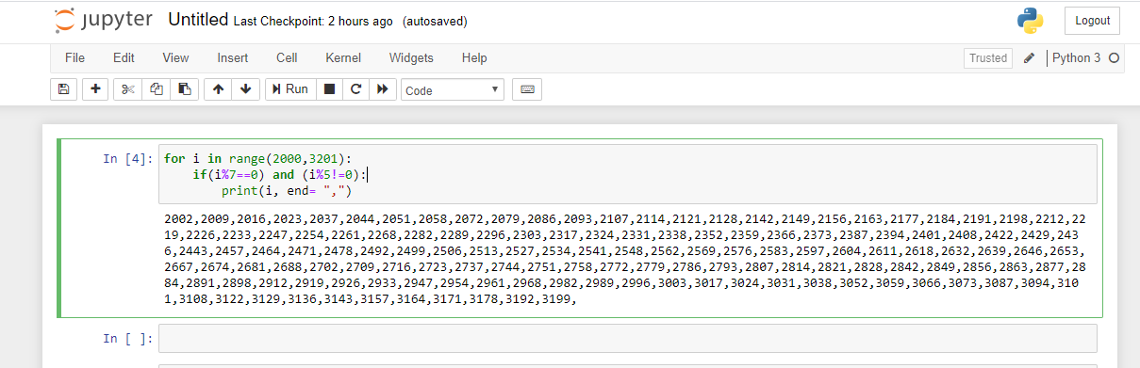

2.

Write a program which will find all such numbers which are divisible by 7 but are not a multiple

of 5, between 2000 and 3200 (both included). The numbers obtained should be printed in a

comma-separated sequence on a single line.

Code:

for i in range(2000,3201):

if(i%7==0) and (i%5!=0):

print(i, end= ",")



3.

Write a Python program to accept the user's first and last name and then getting them printed in

the the reverse order with a space between first name and last name.

Code:

firstName = input('enter first name: ')

lastName = input('enter last name: ')

fullname = firstName + ' ' +lastName

print(fullname[::-1])

words = fullname.split(' ')

print(" ".join(reversed(words)))

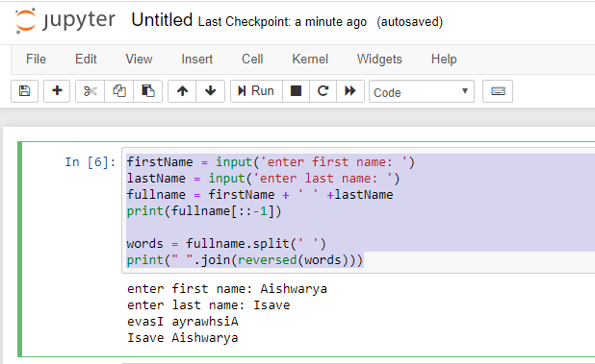

4.

Write a Python program to find the volume of a sphere with diameter 12 cm.

Formula: V=4/3 * π * r 3

import math

diameter = 12

r = diameter/2

volume = (4/3)*math.pi*((r)**3)

print(volume)

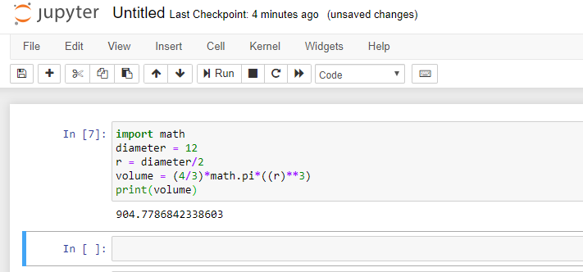

##Task 2

1.

Write a program which accepts a sequence of comma-separated numbers from console and

generate a list.

Code:

inputValue = input('Enter comma separated values:')

words = inputValue.split(',')

print(words)

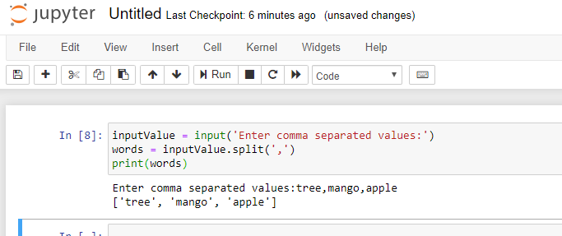

2.

Create the below pattern using nested for loop in Python.

*

* *

* * *

* * * *

* * * * *

* * * *

* * *

* *

*

Code:

end = 10

for i in range(1,end):

    half= end/2

    if i<=half:

        for i1 in range(1,i+1):

            print('*',end="")

    else:

        for i2 in range(i,end):

             print('*',end="")

    print("")

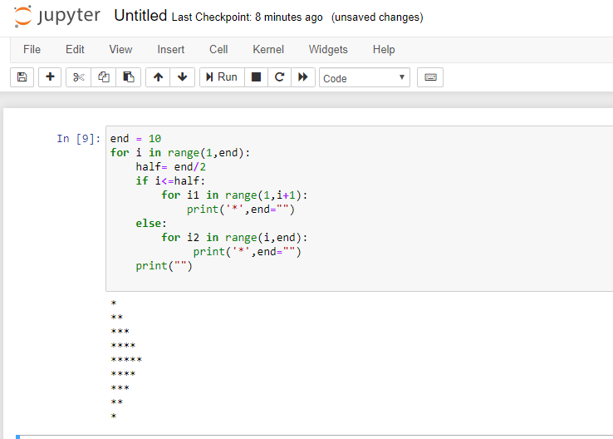

3.

Write a Python program to reverse a word after accepting the input from the user.

**Sample Output:**

Input word: AcadGild

Output: dilGdacA

Code:

word = input('enter any word:')

print(word[::-1])

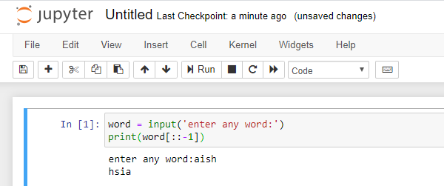

4.

Write a Python Program to print the given string in the format specified in the **sample output.**

WE, THE PEOPLE OF INDIA, having solemnly resolved to constitute India into a

SOVEREIGN, SOCIALIST, SECULAR, DEMOCRATIC REPUBLIC and to secure to all

its citizens

**Sample Output:**

WE, THE PEOPLE OF INDIA,

having solemnly resolved to constitute India into a SOVEREIGN, !

SOCIALIST, SECULAR, DEMOCRATIC REPUBLIC

and to secure to all its citizens

code:

para = '''WE, THE PEOPLE OF INDIA,

having solemnly resolved to constitute India into a SOVEREIGN, !

SOCIALIST, SECULAR, DEMOCRATIC REPUBLIC

and to secure to all its citizens '''

print(para)

