**“Simcha Ecommerce Website”**

**For**

**Simcha Shop**

**By**

**Aashif Maharjan**

**7-2-410-191-2020**

Prime college

*A Summer Project Report Submitted to*

**Faculty of Management, Tribhuvan University**

In partial fulfillment of the requirements for the degree of

**Bachelor of Information Management**

Kathmandu

June 2024

# STUDENT DECLARATION

This is to certify that I have completed the Summer Project entitled “Simcha” under the guidance of “**Mrs. Rolisha Sthapit**” in partial fulfillment of the requirements for the degree of **Bachelor of Information Management** at Faculty of Management, Tribhuvan University. This is my original work and I have not submitted it earlier elsewhere.

Date: June 2024 Signature:

Name: Aashif Maharjan

# CERTIFICATE FROM THE SUPERVISOR

This is to certify that the summer project entitled “**Simcha**” is an academic work done by “**Aashif Maharjan**” submitted in the partial fulfillment of the requirements for the degree of **Bachelor of Information Management** at Faculty of Management, Tribhuvan University under my guidance and supervision. To the best of my knowledge, the information presented by him in the summer project report has not been submitted earlier.

______________________ Signature of the Supervisor

Name: Er. Rolisha Sthapit

Designation: Lecturer

Date: June 2024

# ACKNOWLEDGEMENT

I would like to express my sincere gratitude to all those who have contributed to the successful completion of my summer project on "Simcha". This endeavor has been a significant learning experience, and I am grateful for the support and guidance I received throughout the process.

First and foremost, I extend my heartfelt thanks to **Mrs. Rolisha Sthapit** for her invaluable mentorship, constructive feedback, and continuous encouragement. Her expertise and insights have played a crucial role in shaping the project and enhancing its quality.

I am very thankful to our respected Program Co-Ordinator, **Mr. Rupendra Gopali** for helping and encouraging us in every aspect of my academic study. I would also like to thank **Prime College** for providing this wonderful environment for learning and completing this project.

I appreciate the willingness of my classmates who provided valuable insights, feedback, and moral support during the various stages of the project. Collaborating with them made the entire experience more enriching and enjoyable.

A special thank you goes to **Aavash Maharjan** and **Aasara Bade Shrestha** for their exceptional assistance and unwavering support. Their dedication, insightful suggestions, and encouragement were instrumental in overcoming challenges and achieving the project's objectives.

My gratitude extends to the people at Simcha who offered their help, both directly and indirectly, at various stages of my project. Their support and encouragement have been crucial in achieving this outcome.

This project would not have been possible without the collective efforts of all those mentioned above. I am truly grateful for the collaborative spirit and the positive environment that surrounded this undertaking.

**Aashif Maharjan (7-2-410-191-2020)**

**EXECUTIVE SUMMARY**

The project aimed to develop an "E-commerce Website" for Simcha shop, an online store specializing in handcrafted wooden products, to create a user-friendly platform that streamlines processes, reduces errors, and enhances the customer experience. By following a structured framework, including requirements gathering, system design, development, testing, and deployment, and utilizing HTML, CSS, PHP, and MySQLi within the XAMPP environment, the project ensured a robust and dynamic platform. The system automated processes such as product management, order processing, and payment handling. Continuous testing ensured quality and reliability, while the user-friendly interface and features aimed to improve the customer experience. The project successfully delivered a tailored solution to streamline Simcha's online sales and operational processes, enhancing business performance.

**Keywords:** E-commerce Website, User-friendly interface, Payment handling, Simcha shop.

# TABLE OF CONTENT

*TITLE PAGE…………………………………………………………………………………....i*

*STUDENT DECLARATION ii*

*CERTIFICATE FROM THE SUPERVISOR iii*

*ACKNOWLEDGEMENT iv*

*TABLE OF CONTENT vi*

*LIST OF FIGURES viii*

*LIST OF TABLES ix*

*ABBREVIATIONS x*

**CHAPTER 1****:****INTRODUCTION 1**

1.1 Background 1

1.2 Introduction of the Organization 2

1.3 Current Situation of the Organization 2

1.4 Issue of the statement 2

1.5 Objectives 2

1.6 Scope and Limitation 2

1.7 Methodology of the Study 3

1.7.1 Analysis of the problems 3

1.7.2 Data collection and Analysis 3

1.7.3 Tools Used 4

**CHAPTER 2** **:****ANALYSIS OF THE ACTIVITIES DONE AND PROBLEM SOLVED 5**

2.1 Analysis of Current System 5

2.2 Requirement Analysis 5

2.2.2 Use Case Diagram 7

2.3 Feasibility Study 9

2.3.1 Economic Feasibility 10

2.3.2 Technical Feasibility 10

2.3.3 Operational Feasibility 10

2.3.4 Schedule Feasibility 10

2.4 System Design 12

2.4.1 System Architecture 12

2.4.2 UML Class Diagram 13

2.4.3 Sequence Diagram 14

2.4.4 Activity Diagram 17

2.4.5 Database Schema 19

2.4.6 Component Diagram 20

2.4.7 Deployment Diagram 21

2.5 System Implementation 22

2.5.1 System Development Methodology Used 22

2.5.2 Modules Description 23

2.6 System Testing 24

2.6.1 Unit Testing with test cases 24

2.6.2 Integration Testing 27

**CHAPTER 3****:****DISCUSSION AND CONCLUSION 30**

3.1 Discussion 30

3.2 Conclusion 30

3.3 Lesson Learnt 30

3.3 Recommendation 31

**REFERENCES 32**

**APPENDIX a**

# LIST OF FIGURES

Figure 1: Use Case Diagram 7

Figure 2: Gantt chart for Schedule Feasibility of Simcha Shop 11

Figure 3: System architecture 12

Figure 4: Class diagram of Simcha Shop 13

Figure 5: Sequence diagram of Admin 14

Figure 6: Sequence Diagram of user 16

Figure 7: Activity of Admin 17

Figure 8: Activity Diagram of User 18

Figure 9: Database Schema of Simcha Shop 19

Figure 10: Component diagram of Simcha Shop 20

Figure 11: Deployment diagram of Simcha Ecommerce Website 21

# LIST OF TABLES

Table 1: Schedule Feasibility of Simcha Shop 11

Table 2: Test case for Register 24

Table 3: Test case for Login 25

Table 4: Test case for adding products to cart 25

Table 5: Test case for Payment 26

Table 6: Test case for Chatbox 26

Table 7: Integration Testing of Simcha Shop 27

# ABBREVIATIONS

**ADMIN** Administrator

**CSS** Cascading Style Sheet

**ERD** Entity Relationship Diagram

**HTML** Hypertext Markup Language

**HTTP**  Hypertext Transfer Protocol

**OOP** Object-Oriented Programming

**UI**  User Interface

**UML** Unified Modeling Language

# CHAPTER 1

# INTRODUCTION

## 1.1 Background

The general concept of Simcha E-commerce stands as a strategic and novel approach that provides a solution to the various obstacles major artisans encounter in marketing their wooden crafted earrings, notebook keyrings, and mobile holders in the market. Unfortunately, the typical ways of advertising such special pieces are quite problematic due to the limitations in geography and marketing scope which signifies that the group of potential consumers as well as the ability of local artists to expand their endeavors are both at a disadvantage.

The idea of Simcha is to challenge this reductive perspective and provide a more holistic solution by creating a multi-faceted online marketplace where, in addition to presenting the work of these artists, customers can also easily purchase their products and engage with them in a more meaningful way. The key aspects of the solution proposed by Simcha are situated in the ability to integrate efficient product management tools, user-friendly order processing procedures, and customer communication improvements. Through offering clients, a great interface and having as many options as possible for a client, including the option to pay online securely and customer support that has been tailored to a particular client, Simcha aims to support local artists and, in turn, make their work famous all over the world. It also helps the artisans to increase their sales and reach a wider audience and at the same time the customers get a variety of things with a specific demand of handmade products while browsing through the online platform. Furthermore, Simcha’s work is not just limited to contract-based actions; it aims to foster a spirit of that craft incorporating people who are keen on embracing and developing the craft. Simcha stands as a force of good by representing the local artisan and offering support and a highly developed op-platform to stand for more arts and craft brands and accelerate the shift from physical stores to penetrating the online market.

## 1.2 Introduction of the Organization

Established on March 12, 2019, Simcha is an online store offering beautifully crafted wooden notebooks, keyrings, and mobile holders. We pride ourselves on quality and sustainability, ensuring each product is both functional and eco-friendly. At Simcha, you can also customize your designs, making each item uniquely yours. Experience the elegance of wooden craftsmanship with Simcha.

## 1.3 Current Situation of the Organization

The organization uses Social Media to take orders and display their available products. The customer has to go to Simcha’s social media account to view the products and message them to give orders.

## 1.4 Issue of the statement

* **What** are the current limitations of handmade product sales?
* What order management issues exist?
* Where are the limitations in these sales methods?
* Where are craftsmen currently selling their products?
* When do problems with order management occur?

## 1.5 Objectives

* To deploy an online portal that enables customers to access a catalog, search for wooden handicrafts, notebook key rings, and mobile holders, as well as use their accounts to order products made by local artisans.
* To include a chat box feature, enabling customers to request and design customized products of their choice.

## 1.6 Scope and Limitation

**Scope:**

* The system will streamline the process of managing and ordering products, making it easy for users to check product availability and place orders online.
* Users can effortlessly register for customer accounts and track their orders through the system, eliminating the need for manual tracking.
* The system will feature an intuitive web platform designed for ease of use, ensuring a seamless experience for both customers and administrators.

**Limitations:**

* Basic security measures are implemented, but the system lacks advanced security features needed to protect against sophisticated attacks.
* As a student project, extensive user testing might not be feasible, which could affect the identification of all potential bugs and usability issues.
* The system lacks integration with a real payment gateway.

## 1.7 Methodology of the Study

### 1.7.1 Analysis of the problems

The organization is facing certain problems. The main problem of this organization is that there is no any digital system for product purchase. The Customers have to visit the social media account to purchase the products.

### 1.7.2 Data collection and Analysis

Data collection is a crucial aspect of developing the Simcha, involving various methods to gather information for analysis. The collected data serves as the foundation for understanding the organization's needs, processes, and challenges, ultimately informing the development and implementation of the system.

The data and information are collected from two major sources:

1. **Primary Data:** In this project, data have been collected directly through interview and observation. Direct interviews were conducted with the owner of the Simcha shop, Mr. James Maharjan, to gain firsthand insights into the organization's operations, challenges, and requirements.

### 

### 1.7.3 Tools Used

**Front End**

* **HTML:** Used for creating the overall fundamental structure for the web content
* **CSS:** Used to style the HTML structures, enhancing the visual appearance and user experience of the application.
* **JavaScript:** Used for validation and client-side scripting, adding interactivity and dynamic behavior to web pages.

**Back End**

* **PHP:** PHP was used for server-side scripting, managing functionalities such as user logins and interactions with the MySQL database.
* **MYSQL:** MySQL was used for managing databases and servers, storing essential information.
* **XAMPP:** XAMPP provided a local web server environment for testing and development.

# CHAPTER 2

# ANALYSIS OF THE ACTIVITIES DONE AND PROBLEM SOLVED

## 2.1 Analysis of Current System

The current market for selling handcrafted products is mostly physical, and this has some drawbacks that are a major disservice to local artists. These are factors such as limited coverage, low marketing capacity, poor management of orders, and poor interactions with the customers. They lack a platform where they can effectively promote their work and products and build a Client base that appreciates the effort that goes into the creation of these works of art. Further, the lack of a common system for organizing the product catalog and, managing orders and customer relations hampers productivity and implies wasted opportunities for development. These challenges can be countered by Simcha E-commerce utilizing the proposed online platform for extending the awareness of and easy access to handcrafted items; they also simplified order keeping and effective consumer relations.

## 2.2 Requirement Analysis

Requirement analysis focuses on the tasks that determine the needs or conditions to meet the new or altered product or project, taking account of the possibly conflicting requirements of the various stakeholders, analyzing, documenting, validating, and managing software or system requirements. The requirements can be classified as functional and non-functional requirements.

**2.2.1 Functional Requirements of Simcha E-Commerce**

* Users must be able to register on the platform by providing their name, email address, password, and other relevant details.
* Users must be able to log in to the platform by entering their registered email address and password.
* Users should be able to view product details by clicking on individual product listings.
* Users must be able to search for products using keywords related to product names, descriptions, or categories.
* Users must be able to add products to their shopping cart, view the contents of the cart, and update quantities or remove items as needed.
* Users must be able to place orders by providing necessary details such as shipping address, payment method, and contact information.
* Admins must have access to a comprehensive dashboard that provides an overview of platform activities, including new registrations, orders, and product listings
* Admins should be able to update product details, process orders, and handle customer inquiries from the dashboard

### 2.2.2 Use Case Diagram

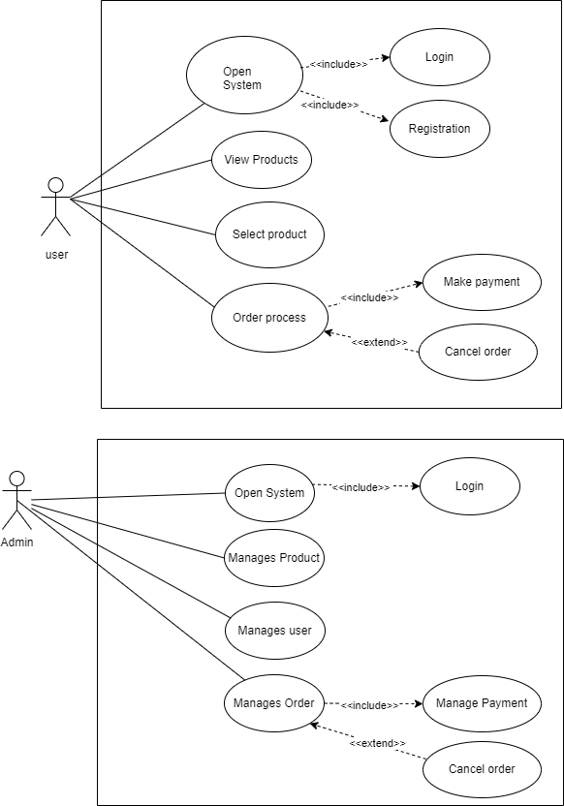

Figure 1: Use Case Diagram

The Figure 1 is use case diagram that illustrates the interactions of both the user and the admin. For users, the primary actions include opening the system, viewing products, selecting a product, and processing an order. The order process encompasses making a payment and optionally canceling the order. Logging in and registration are included steps necessary for the user to open the system. For admins, the key activities are managing products, users, and orders, alongside opening the system. Admin tasks also involve making payments and the ability to cancel orders. The admin's access to the system similarly requires logging in. This diagram effectively outlines the roles and responsibilities of users and admins within the e-commerce platform, highlighting the necessary steps and possible interactions in each role.

**2.2.3 Non-Functional Requirements of Simcha E-Commerce**

Non-functional requirements are requirements that are not directly concerned with the specific functions delivered by the system. They may relate to emergent system properties such as reliability, response time, and store occupancy. Alternatively, they may define constraints on the system such as the capabilities of I/O devices and the data representations used in system interfaces. The plan for implementing functional requirements is detailed in the system design. The plan for implementing non-functional requirements is detailed in the system architecture. Non-functional requirements are often called qualities of a system. Other terms for non-functional requirements are "constraints", "quality attributes", "quality goals", "quality of service requirements" and "non-behavioral requirements". Qualities, that are non-functional requirements, can be divided into two main categories: Execution qualities, such as security and usability, which are observable at run time.

**Security:**

* The platform should include robust security measures to protect user data, prevent unauthorized access, and ensure safe transactions.
* Security features should include encryption of sensitive information, secure authentication mechanisms, and regular security audits.

**Performance:**

* The platform should load pages and respond to user actions promptly, ensuring a smooth and responsive user experience.
* The system should be capable of handling a high volume of concurrent users and transactions without performance degradation.

**Reliability:**

* The platform should be reliable and available at all times, minimizing downtime and ensuring continuous operation.
* Backup and recovery mechanisms should be in place to prevent data loss and ensure quick restoration of services in case of system failures.

**Maintainability:**

* The platform should be designed with maintainability in mind, making it easy to update, modify, and extend functionalities as needed.
* The code base should be well-documented, and the system should include monitoring and logging features to facilitate maintenance and troubleshooting.

**Usability:**

* The platform should have an intuitive and user-friendly interface, making it easy for users to navigate, search for products, and complete purchases.
* The design should be consistent and visually appealing, providing a positive user experience across different devices and screen sizes.

**Scalability:**

* The platform should be designed to accommodate future growth, including an increase in the number of products, users, and transactions.
* The system architecture should support easy scaling of resources to meet changing demands.

## 2.3 Feasibility Study

A feasibility study is essentially an idea for a new project's physical examination. It helps assess whether the project is realistic and achievable.  This evaluation looks at factors like time, money, and resources to see if everything lines up for success. Feasibility studies are like a green light, showing if a project is worth pursuing further.

### 2.3.1 Economic Feasibility

An economic feasibility analysis serves the purpose of evaluating a project's financial viability. This analysis is positive for the proposed web application due to the cost-effective nature of the development tools. Notably, the utilization of free, readily available tools further enhances the project's economic feasibility.

### 2.3.2 Technical Feasibility

Technical feasibility constitutes a critical consideration during the development of an application system. It assesses the capability to construct and implement the system using existing tools, resources, and technology. In the case of the proposed application, a favorable assessment of technical feasibility has been reached. The application can be built and function within the constraints of readily available technology, operating seamlessly across a wide range of web browsers without requiring additional hardware or a high-performance processor.

### 2.3.3 Operational Feasibility

Operational feasibility analysis assesses a project's compatibility with existing resources and its alignment with the organization's strategic objectives.  The proposed web application demonstrates positive indications of operational feasibility.  Its development prioritizes user-friendliness and simplicity, ensuring straightforward adoption by employees, owners, and general users. However, a more in-depth analysis might be necessary to definitively confirm operational feasibility.  This could involve evaluating the application's impact on existing workflows, training requirements, and potential resource constraints.

### 2.3.4 Schedule Feasibility

The development timeline for the hotel booking system has been meticulously planned to ensure timely completion. Utilizing an Agile approach, the project is divided into manageable phases with clear milestones. This structured methodology facilitates timely progress and allows for iterative improvements based on feedback.

Table 1: Schedule Feasibility of Simcha Shop

|  |  |  |  |
| --- | --- | --- | --- |
| **Activities** | **Start Date** | **End Date** | **Days** |
| Initial Planning | 24-Jan | 31-Jan | 7 |
| Sprint 1: Analysis and Data Collection | 1-Feb | 7-Feb | 7 |
| Sprint 2: System Design (Initial) | 8-Feb | 21-Feb | 14 |
| Sprint 3: Frontend Development (Part 1) | 22-Feb | 7-Mar | 14 |
| Sprint 4: Backend Development (Part 1) | 8-Mar | 21-Mar | 14 |
| Sprint 5: Frontend Development (Part 2) | 22-Mar | 4-Apr | 14 |
| Sprint 6: Backend Development (Part 2) | 5-Apr | 18-Apr | 14 |
| Sprint 7: Testing and Debugging (Initial) | 19-Apr | 2-May | 14 |
| Sprint 9: Iterative Improvements (Cycle 1) | 17-May | 30-May | 14 |
| Sprint 10: Final Testing and Debugging | 31-May | 7-Jun | 7 |
| Documentation | 24-Jan | 10-Jun | 138 |

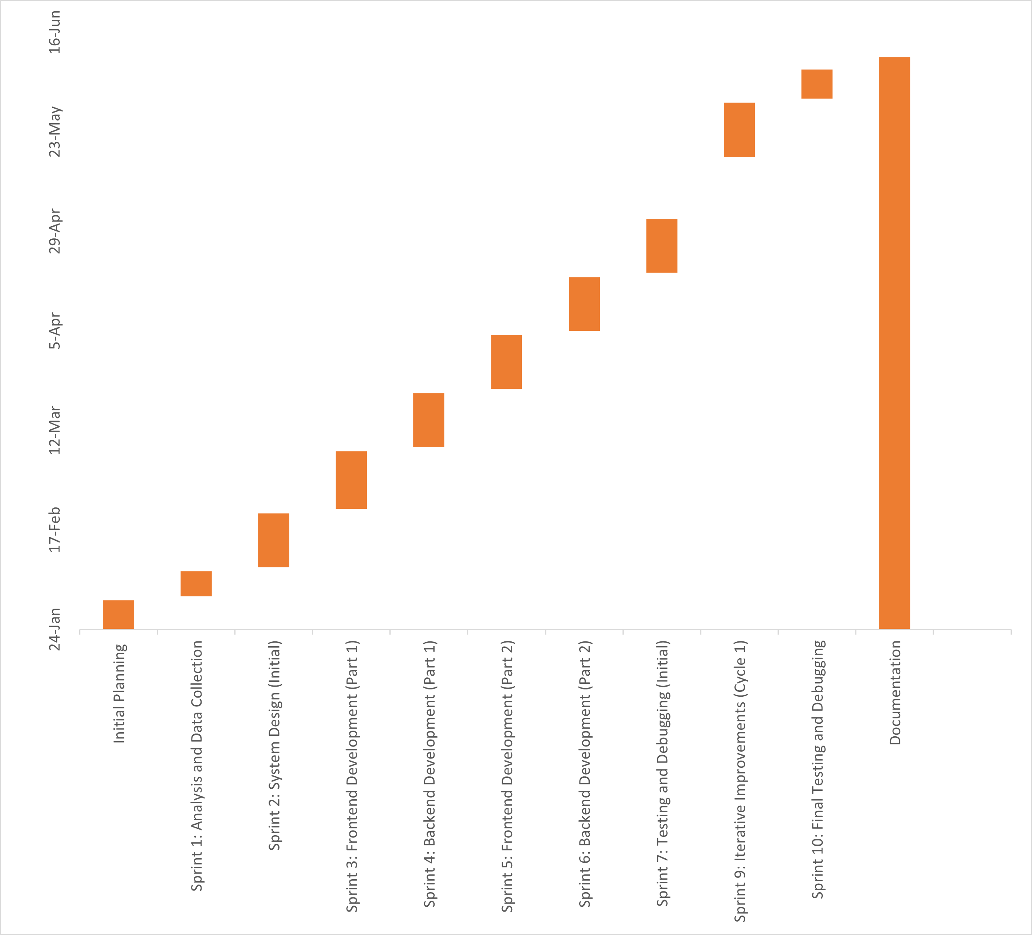

Figure 2: Gantt chart for Schedule Feasibility of Simcha Shop

## 2.4 System Design

### 2.4.1 System Architecture

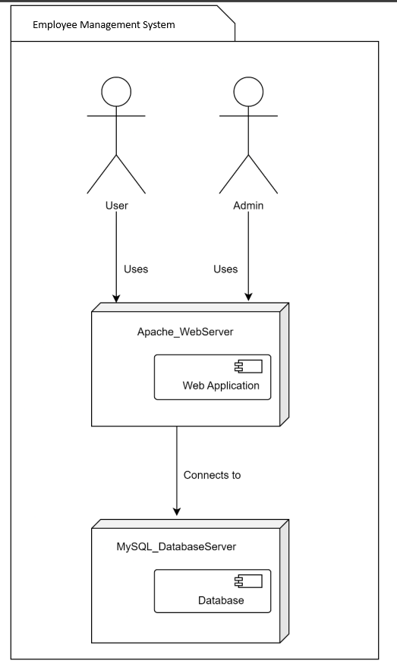

Figure 3: System architecture

The Figure 3 is System Architecture of Simcha Ecommerce Website. The system is accessed by two types of users: regular users and administrators. Both users interact with the system through a web application hosted on an Apache Web Server. This web server serves as the intermediary between the users and the backend services. The web application connects to a MySQL Database Server, which stores all the necessary data for the system. This architecture highlights the separation of concerns, where the web server handles the user interface and application logic, while the database server manages data storage and retrieval

### 2.4.2 UML Class Diagram

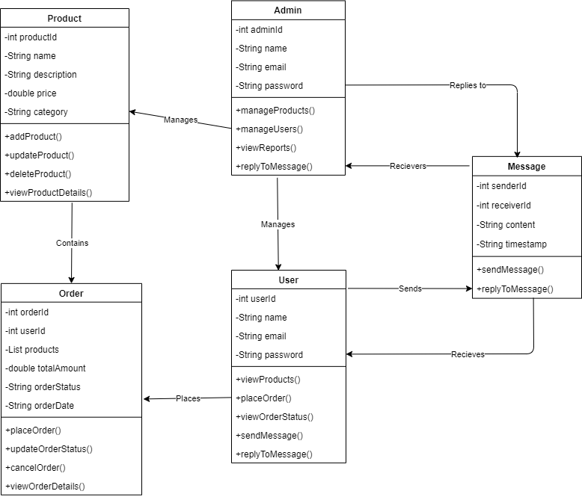

Figure 4: Class diagram of Simcha Shop

The Figure 4 is class diagram for the e-commerce website illustrates the relationships and functionalities between various entities: Product, Admin, User, Order, and Message. The `Product` class includes attributes like `productId`, `name`, `description`, `price` and `category`, and methods for adding, updating, deleting, and viewing products. The Admin class, with attributes `adminId`, `name`, `email`, and `password`, manages products, users, and messages, and can view reports. The `User` class has attributes `userId`, `name`, `email`, and `password`, and methods to view products, place and manage orders, and send messages. The `Order` class includes `orderId`, `userId`, `products`, `totalAmount`, `orderStatus`, and `orderDate`, with methods for placing, updating, canceling orders, and viewing order details. The `Message` class captures communication with attributes `senderId`, `receiverId`, `content`, and `timestamp`, and methods for sending and replying to messages. Admins manage users and products, users place orders, and both users and admins can send and reply to messages, reflecting a well-structured system for e-commerce operations.

### 2.4.3 Sequence Diagram

Sequence diagram of admin:

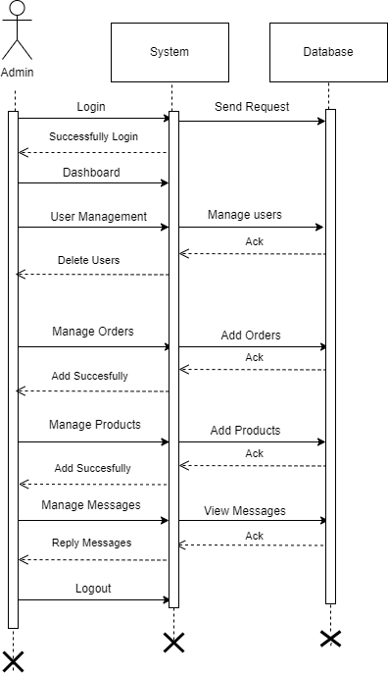

Figure 5: Sequence diagram of Admin

The Figure 5 is sequence diagram outlines the interactions between the admin, the system, and the database within an e-commerce website. The process begins with the admin logging in, prompting the system to send a request to the database. Upon successful login, the system displays the dashboard to the admin. From the dashboard, the admin can manage users, orders, products, and messages. When the admin chooses to manage users, they can delete users, and the system sends these commands to the database, which acknowledges the actions. Similarly, for managing orders and products, the admin sends requests to add orders or products, and the database acknowledges these additions. For managing messages, the admin can view and reply to messages, with the database sending acknowledgments for these actions as well. Finally, the admin logs out, ending the sequence. This diagram effectively captures the step-by-step interactions and data flow between the admin, the system, and the database, highlighting the key administrative tasks within the e-commerce platform

Sequence diagram of User:

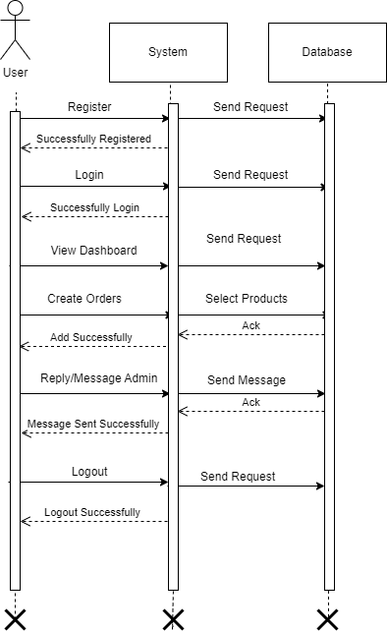

Figure 6: Sequence Diagram of user

The Figure 6 is sequence diagram illustrates the user-side interactions with the e-commerce website, detailing the communication between the user, system, and database. The user begins by registering and logging in, with the system sending authentication requests to the database, followed by accessing the dashboard. Users can create orders by selecting products, with the system ensuring these are added successfully. Additionally, users can send messages to admins, which the system forwards to the database. Finally, the user logs out, with the system confirming the successful logout through the database. This diagram highlights the key steps in user registration, login, order creation, messaging, and logout processes.

### 2.4.4 Activity Diagram

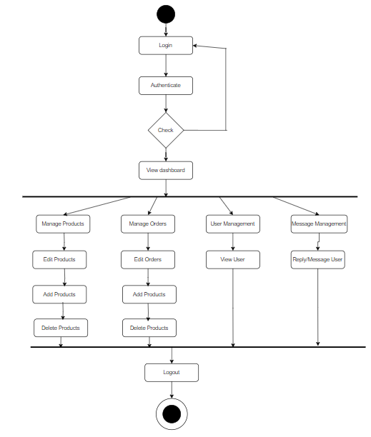

Figure 7: Activity of Admin

The Figure 7 is activity diagram illustrates the workflow of an admin managing an e-commerce website. The process begins with the admin logging in and the system authenticating their credentials. Upon successful authentication, a decision check is performed. If the authentication is valid, the admin gains access to the dashboard. From the dashboard, the admin has several management options. They can manage products, which includes editing, adding, and deleting products. They can also manage orders by editing, adding, and deleting orders. User management involves viewing user information, and message management allows the admin to reply to or message users. The workflow concludes with the admin logging out of the system. This diagram provides a clear overview of the various administrative tasks and their sequence within the e-commerce platform.

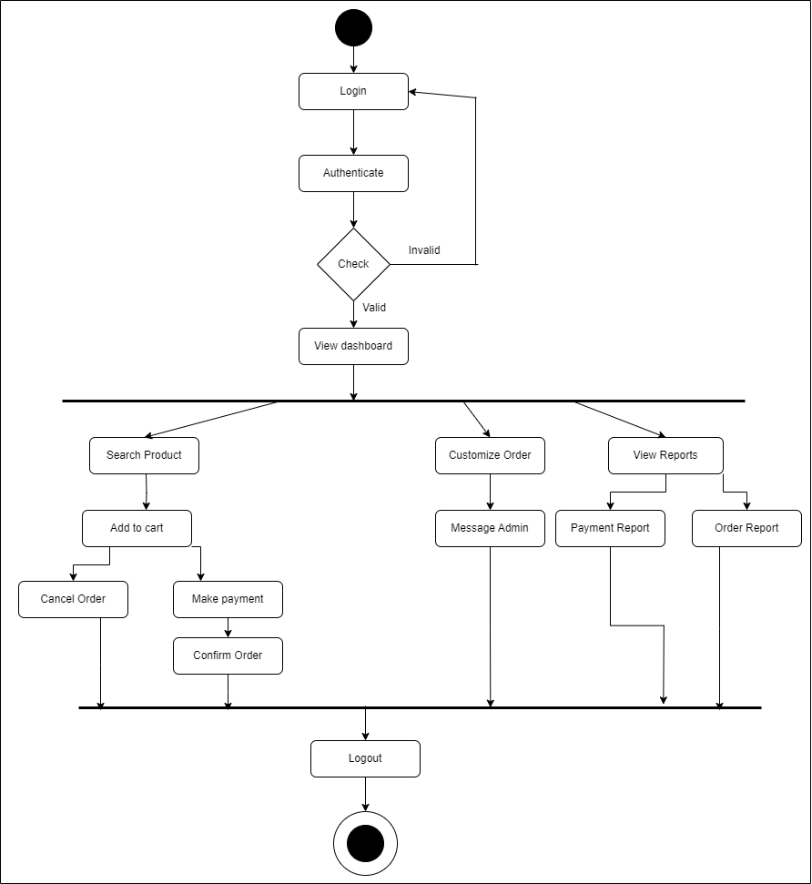

Figure 8: Activity Diagram of User

The Figure 8 activity diagram represents the user-side workflow for an e-commerce website. The process begins with the user logging in, followed by authentication. If the credentials are valid, the user gains access to the dashboard; otherwise, the process stops. From the dashboard, the user has several options. They can search for products, add items to their cart, and proceed to make a payment or cancel the order before confirming it. Users can also customize their orders and message the admin for assistance. Additionally, they have the ability to view various reports, such as payment reports and order reports, to keep track of their transactions. The workflow concludes with the user logging out of the system. This diagram provides a comprehensive overview of the user's interactions and options within the e-commerce platform.

### 2.4.5 Database Schema

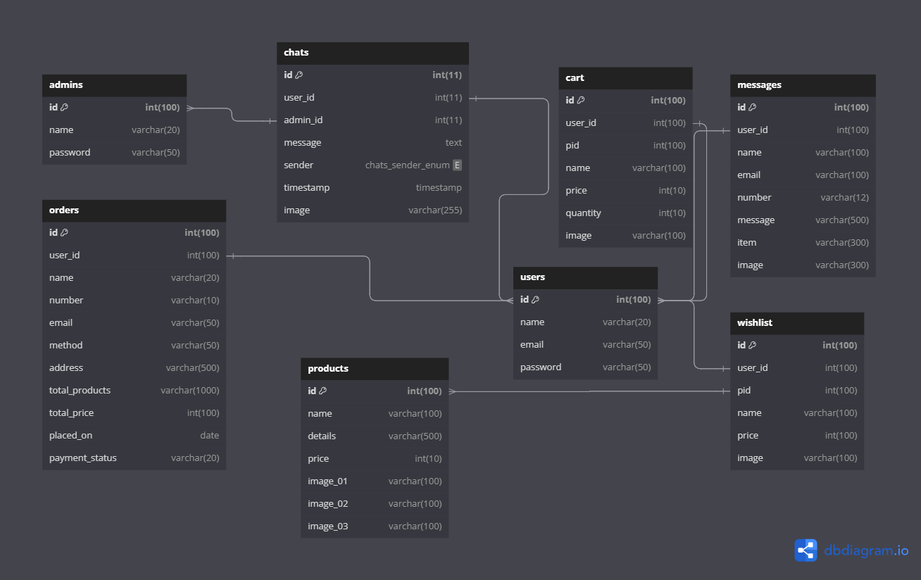

Figure 9: Database Schema of Simcha Shop

The Figure 9 is database schema diagram represents the structure of an e-commerce website's database, showcasing the relationships between various tables. The `admins` table holds information about the admin users, while the `users` table stores customer details, both of which are central to managing the site. The `products` table contains details about items available for purchase, including their descriptions and images. User activities are captured in several related tables: the `orders` table records order details linked to users, the `cart` table tracks items added to the shopping cart, and the `wishlist` table keeps track of items users wish to purchase later. Communication between users and admins is facilitated through the `chats` table, which logs messages exchanged between them, while the `messages` table stores user inquiries and feedback. The relationships between these tables are established through foreign keys, ensuring data integrity and efficient organization. This schema effectively supports the various functionalities of an e-commerce platform, from user management and product handling to order processing and customer communication.

### 2.4.6 Component Diagram

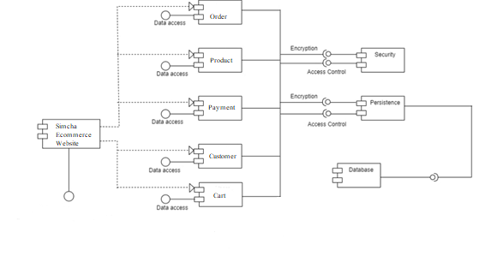

Figure 10: Component diagram of Simcha Shop

The Figure 10 is component diagram for the Simcha e-commerce website illustrates the key components and their interactions within the system. The central component, "Simcha Ecommerce," interacts with five primary components: Order, Product, Payment, Customer, and Cart, each responsible for specific data access and management functions. The Order component handles order-related operations, the Product component manages product information, the Payment component processes transactions, the Customer component deals with customer details, and the Cart component manages shopping cart functionality. These components interact with the Security and Persistence modules, ensuring encryption, access control, and data integrity. Finally, the database component, connected via a database connector, serves as the central repository for storing all system data, ensuring seamless and secure access to the necessary information for the e-commerce platform's operations.

### 2.4.7 Deployment Diagram

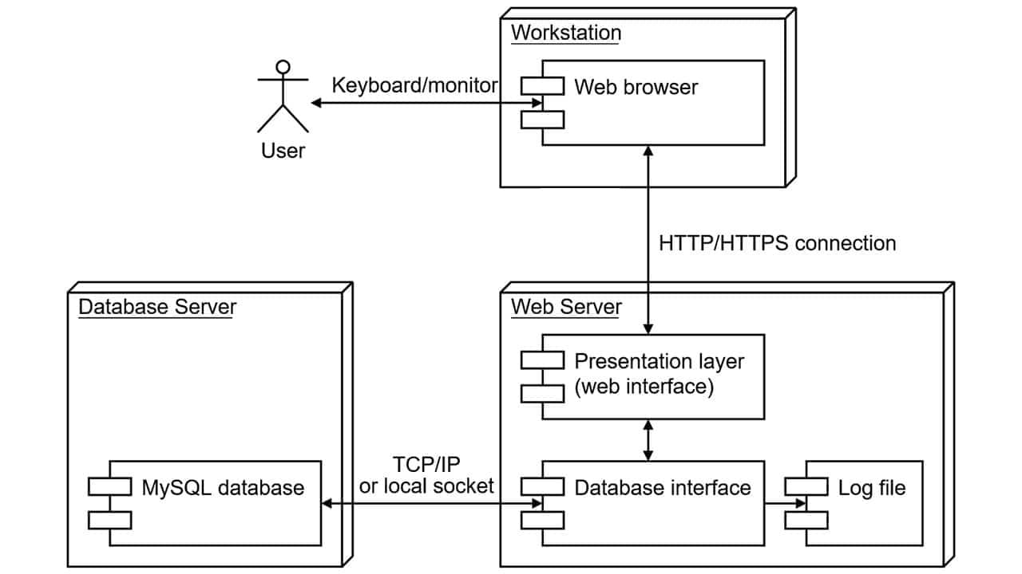

Figure 11: Deployment diagram of Simcha Ecommerce Website

The Figure 11 is deployment diagram represents the architecture of an e-commerce website, illustrating the interactions between the user, workstation, web server, and database server. The user interacts with the system through a web browser on their workstation, using a keyboard and monitor for input and output. The web browser communicates with the web server via HTTP/HTTPS connections, ensuring secure data transfer. The web server consists of two main components: the presentation layer (web interface) that handles user interactions and the database interface that manages database operations. The web server also logs activities in a log file for monitoring and troubleshooting purposes. The database server, which hosts a MySQL database, communicates with the web server through TCP/IP or a local socket connection. This setup allows the web server to retrieve and store data efficiently. Overall, the diagram provides a clear view of the system's deployment, highlighting the flow of data and the interaction between different components essential for the functioning of the e-commerce website.

## 2.5 System Implementation

### 2.5.1 System Development Methodology Used

**Agile Methodology**

The development of the hotel booking system adhered to an agile methodology. This approach facilitated continuous improvement and adaptation through iterative progress. The key characteristics of the systems’ agile approach included:

* **Continuous Requirement Gathering and Plan Adjustment:** Requirements were gathered iteratively and continuously throughout the development process. Adjustments to plans were made based on ongoing feedback and evolving understanding of user needs.
* **Incremental Delivery: T**he system was developed and delivered in small, manageable increments. This incremental approach allowed for regular feedback, ensuring that each part of the system met user expectations before progressing further.
* **Regular Meetings with Superior:** Meetings with superiors were held approximately once every one to two weeks. These sessions provided opportunities to review progress, gather feedback, and make necessary adjustments to the project plan.
* **Continuous Testing and Integration:** Testing was an integral part of the development process, conducted continuously to ensure that any issues were identified and resolved promptly. Code changes were frequently integrated and tested to maintain system stability and quality.
* **Frequent Reviews and Adaptation:** Regular reviews were conducted to assess the current state of the project. Feedback from these reviews was used to adapt plans and priorities, ensuring the project remained aligned with stakeholder expectations and requirements.

### 2.5.2 Modules Description

**Chat Box Module:**

Users must be able to access the chat box from the main interface of the platform. The chat box should provide a simple and intuitive interface for users to initiate conversations with an admin. Users should be able to send text messages, images, and other relevant files to the admin.

**User Management Module:**

This module enables users to create accounts securely. It includes feature such as registration forms.

**Product Management Module:**

The Product Management Module allows users to browse and purchase wooden notebooks, keyrings, and mobile holders. It includes functionalities for searching products, adding them to a shopping cart, managing the shopping cart, checking out, and viewing order history. Users can also manage their shipping addresses and payment methods within this module.

**Order Management Module:**

This module handles the lifecycle of orders placed by users. It includes features for order processing and order status tracking.

**Payment Management Module:**

This module handles payment processing for purchases. It integrates with payment gateways to securely process transactions.

**Admin Dashboard Module:**

The Admin Dashboard Module provides administrators with a centralized interface to monitor and manage various aspects of the system. It includes features such as user management (e.g., deleting users), product management (e.g., adding, updating, and deleting products), order management (e.g., viewing, updating order status), and inventory management.

## 2.6 System Testing

System testing is a crucial phase in the development of Simcha, where the complete and integrated e-commerce platform is rigorously tested. The primary objective of this testing phase is to ensure that the system complies with the specified requirements and functions as expected. Given the adoption of a flexible Agile methodology, testing of the application began early in the development process, with bugs being fixed as they were discovered. After each module of Simcha was completed, it underwent thorough testing to identify and correct any errors. This approach ensured that issues were addressed promptly, contributing to a robust and reliable final product that meets all specified requirements.

### 2.6.1 Unit Testing with test cases

Table 2: Test case for Register

|  |  |  |  |  |
| --- | --- | --- | --- | --- |
| **Test case** | **Test Scenario** | **Test Data** | **Expected Results** | **Status** |
| 1 | Registering user keeping field blank |  | Message Display “Please fill out this field.” | Pass |
| 2 | Register user entering incorrect data to a field |  | Message Display “Please include correct data” | Pass |
| 3 | Registering user with correct data |  | User will be Registered | Pass |

Table 3: Test case for Login

|  |  |  |  |  |
| --- | --- | --- | --- | --- |
| **Test case** | **Test Scenario** | **Test Data** | **Expected Results** | **Status** |
| 1 | Logging in with blank email id and password  field | Email Id=  Password= | Message Display “Please fill out this field.” | Pass |
| 2 | Logging in with invalid email id and password | Email Id= “user@gmail.com”  Password= “user” | User won’t be able to login | Pass |
| 3 | Logging in with correct email id and incorrect password | Email Id= “aashif77@gmail.com”  Password= “aas23” | User won’t be able to login | Pass |
| 4 | Logging in with incorrect email id and incorrect password | Username= “aashif77@gmail.com”  Password= “aashif” | User won’t be able to login | Pass |
| 5 | Logging in with valid username and password | Username= “aashif77@gmail.com”  Password= “123aas” | Redirect to home page | Pass |

Table 4: Test case for adding products to cart

|  |  |  |  |  |
| --- | --- | --- | --- | --- |
| **Test case** | **Test Scenario** | **Test Data** | **Expected Results** | **Status** |
| 1 | Adding product to the cart | Add to cart | Product will be added in the cart | Pass |
| 2 | Adding the same book again which is already in the cart | Add to cart | Product won’t be added again | Pass |
| 3 | Updating the quantity of books in cart | Update | Quantity will be updated according to user’s choice. | Pass |
| 4 | Keeping 0 in the shopping car | 0 in the cart | Message display “value must be greater than or equal to 1” | Pass |
| 5 | Deleting the book from cart | Remove | Selected product will be deleted | Pass |
| 6 | Deleting all the books from cart | Remove | No products will be displayed. | Pass |

Table 5: Test case for Payment

|  |  |  |  |  |
| --- | --- | --- | --- | --- |
| **Test case** | **Test Scenario** | **Test Data** | **Expected Results** | **Status** |
| 1 | Proceeding payment keeping any field empty | Continue to checkout | Message Display  “Please fill out this field” | Pass |
| 2 | Proceeding payment wrong data | Continue to checkout | Message Display  “Please include an valid address” | Pass |
| 3 | Proceeding payment with all correct data | Continue to checkout | Message Display “Order placed successfully!” | Pass |

Table 6: Test case for Chatbox

|  |  |  |  |  |
| --- | --- | --- | --- | --- |
| **Test case** | **Test Scenario** | **Test Data** | **Expected Results** | **Status** |
| 1 | User sending message to admin | Message | Message display in admin side (chat box) | Pass |
| 2 | User sending an image to admin | Message | Image displays in admin side (chat box) | Pass |
| 3 | Admin replies to user side | Reply message | Message display in user side (chat box) | Pass |

### 2.6.2 Integration Testing

Integration testing is another aspect of testing that is generally done in order to uncover errors associated with the flow of data across interfaces. The unit-tested modules are grouped together and tested in small segment, which makes it easier to isolate and correct errors. This approach is continued until we have integrated all modules to form the system as a whole. After the completion of each module, it has been combined with the remaining module to ensure that the project is working properly as expected.

Table 7: Integration Testing of Simcha Shop

|  |  |  |  |  |
| --- | --- | --- | --- | --- |
| **Test case** | **Test Scenario** | **Test Data** | **Expected**  **Results** | **Status** |
| 1 | New user registration | Username= “user”  Email= user01@gmail.com Password= “user1”  Confirm password=”user1” | User  Registered | Pass |
| 2 | User Login with valid details | Username= “user”  Password= “user1” | Login successful | Pass |
| 3 | User adds product | Add to cart | Product will be added in cart. | Pass |
| 4 | User places order | Name: Aashif  Number: 9800000000  Email: [aashif@gmail.com](mailto:aashif@gmail.com)  Payment method: Cash on delivery  City: Kathmandu  Province: Bagmati | Order will be placed | Pass |
| 5 | User sends message to admin | Message : “Hello” | Admin will receive the message | Pass |
| 6 | User sends image message to admin | Message: img | Admin receives the image | Pass |
| 7 | User views Notebook category | Click Notebook Category | Available notebook will be shown | Pass |
| 8 | Admin  Login | Username= “admin”  Password= “111” | Login successful | Pass |
| 9 | Admin delete user | Click delete button | User will be deleted | Pass |
| 10 | Admin add products | Click add product button | Product will be added | Pass |
| 11 | Admin manages orders | Updates the payment (completed/pending) | Payment will be updated | Pass |
| 12 | Admin delete orders | Click delete button | Order will be deleted | Pass |
| 13 | Admin replies to users message | Reply: “Hello sir/mam” | Message will be sent | Pass |
| 14 | Admin replies with image to user | Reply: “img” | Image will be sent to user | Pass |
| 15 | Logout | Click logout button | Logout  Successful | Pass |

# CHAPTER 3

# DISCUSSION AND CONCLUSION

## 3.1 Discussion

The main aim of this project was to design a web application for the Simcha. Despite encountering various difficulties, the project was successfully completed with assistance from different sources. Significant effort and time were invested to meet the specific requirements outlined by the organization.

Despite the challenges and problems, the project was completed within the specified duration. The system was tested by the owner of the organization and other stakeholders indirectly involved in the project.

## 3.2 Conclusion

Completing this project provided numerous valuable lessons. It offered firsthand insight into the challenges faced by organizations like Simcha and the strategies to address them. Unlike classroom learning, this project involved dealing with real-life situations, requiring a close examination of problems and the development of practical solutions. Various ideas were generated and implemented through the creation of the software, leading to the discovery of new ways to utilize the programming language. This project was an excellent opportunity for hands-on learning and developing innovative problem-solving approaches.

## 3.3 Lesson Learnt

During this summer project, a great deal was learned about web application development. Every effort was made to ensure the effectiveness of the Simcha project, implementing various views, ideas, and logic. Working on this project provided insights into current trends and demands in the IT industry and highlighted the importance of time management in project development. This practical exposure to a working environment underscored the significance of communication skills and technical expertise. It was a highly educational experience, offering substantial benefits for every student involved. Some of the key advantages include:

* It increases problem-solving skills.
* It enhances exploration and idea generation skills.
* It helps understand how tasks are performed in a real working environment.
* It emphasizes the importance of time management in a job.

## 3.3 Recommendation

Even though the project is finished and has addressed some issues, there are still areas where it could be improved in the future. Here are some ideas for future enhancements:

* The author could make the user interface more engaging and easier to use.
* Adding a feature to print inventory and sales reports could be helpful.
* Integrating online payment options.
* The author can also consider adding other necessary features to enhance the overall functionality of the Simcha project.
* Mobile application development: Developing a mobile application for the inventory and billing management system could improve accessibility and convenience.

# REFERENCES

Pressman, R. S., & Maxim, B. R. (2014). Software engineering: A practitioner's approach (8th ed.). McGraw-Hill Education.

Tuts+, Envato. (2020). *How to create a chat box with HTML, CSS, and JavaScript*. Retrieved June 13, 2024, from https://webdesign.tutsplus.com/tutorials/how-to-create-a-chat-box--cms-32111

CodePen. (n.d.). *Build a responsive chat box with HTML and CSS*. Retrieved June 13, 2024, from https://codepen.io/FlorinPop17/pen/vPKWjd

W3Schools. (n.d.). PHP tutorial. Retrieved June 13, 2024, from <https://www.w3schools.com/php/>

FreeCodeCamp. (n.d.). Learn to code — for free. Retrieved June 13, 2024, from <https://www.freecodecamp.org/>

# APPENDIX

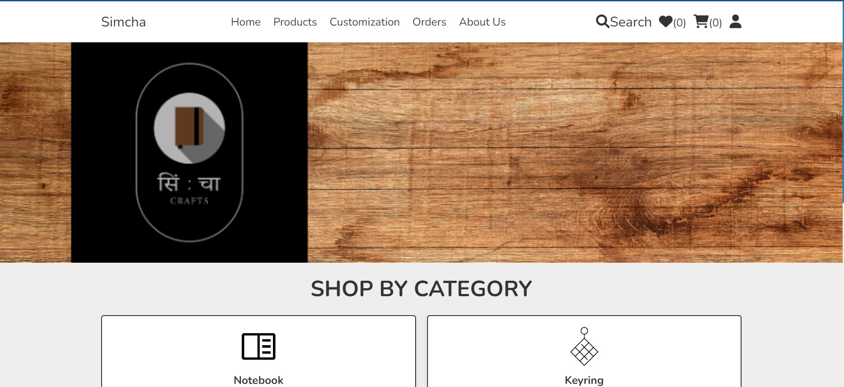

**Homepage of Simcha**

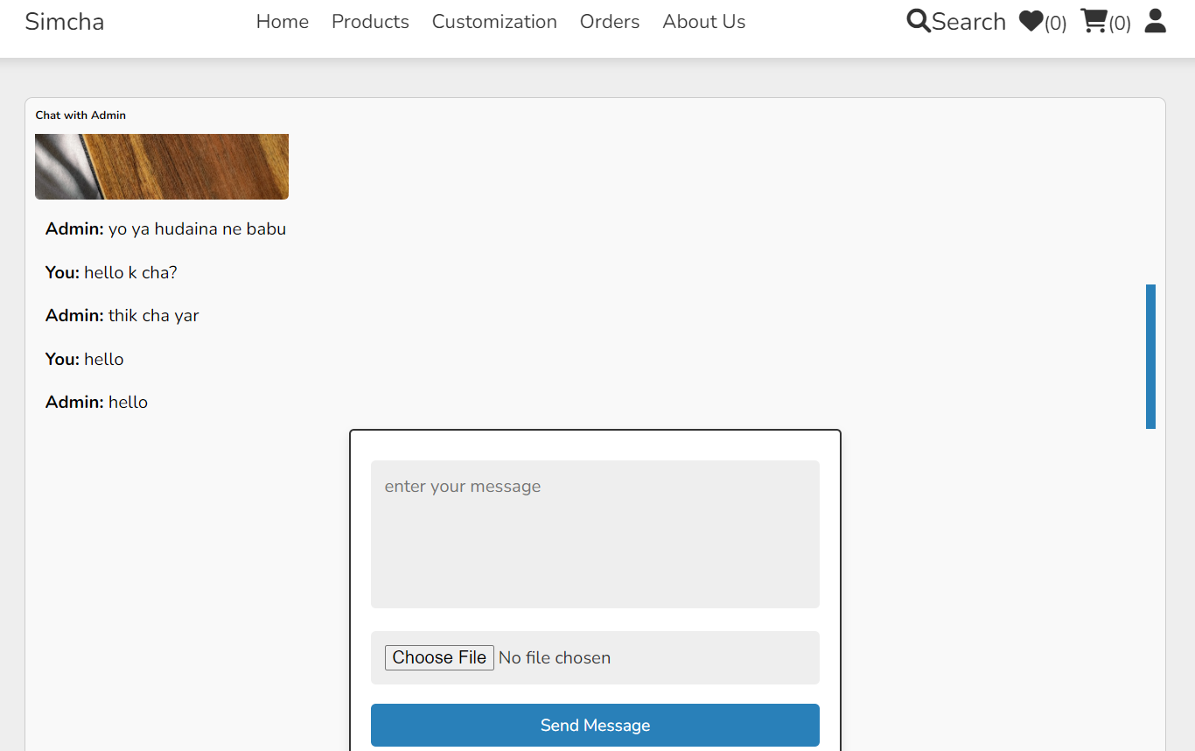

**Customization page (chatbox with admin)**

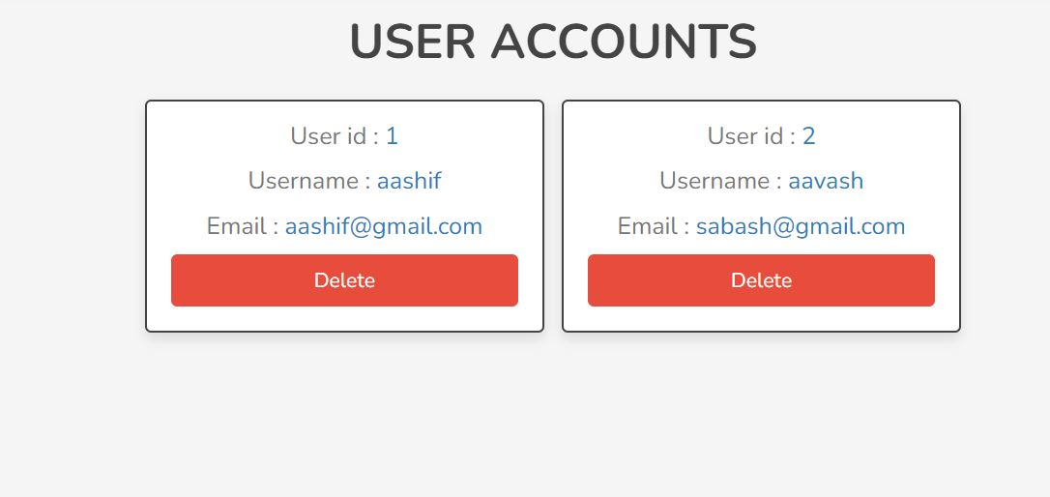

**User Displayed**

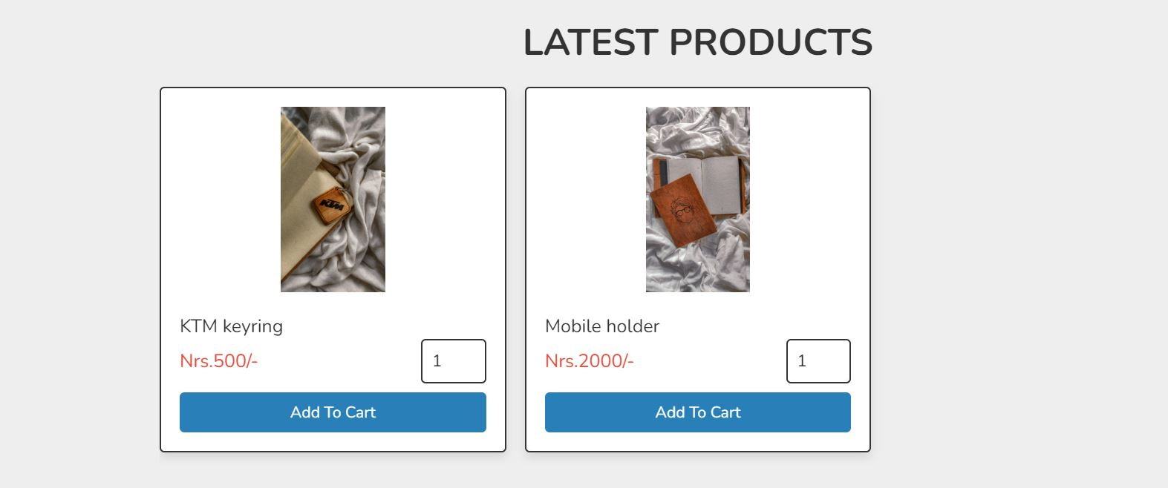

**Products Display**

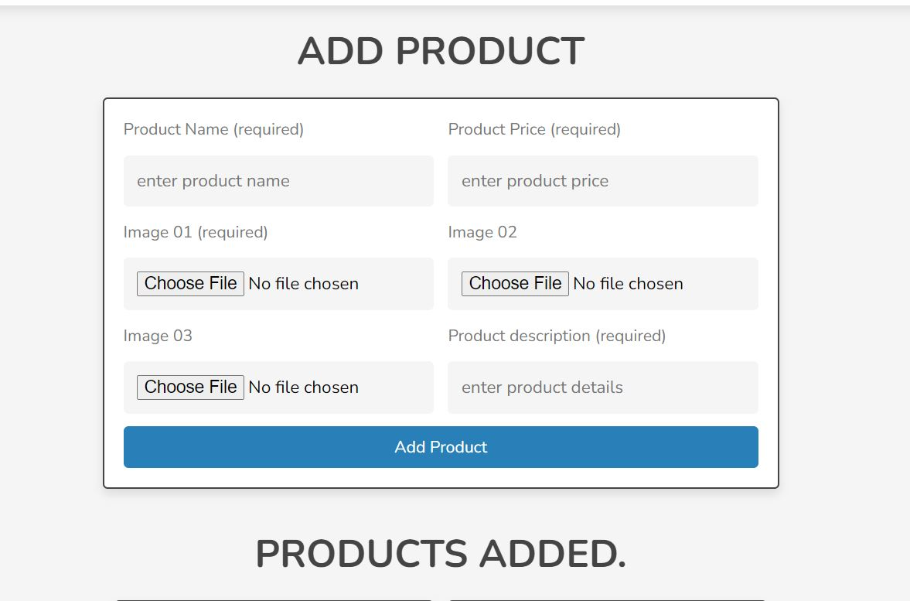

**Product add page**

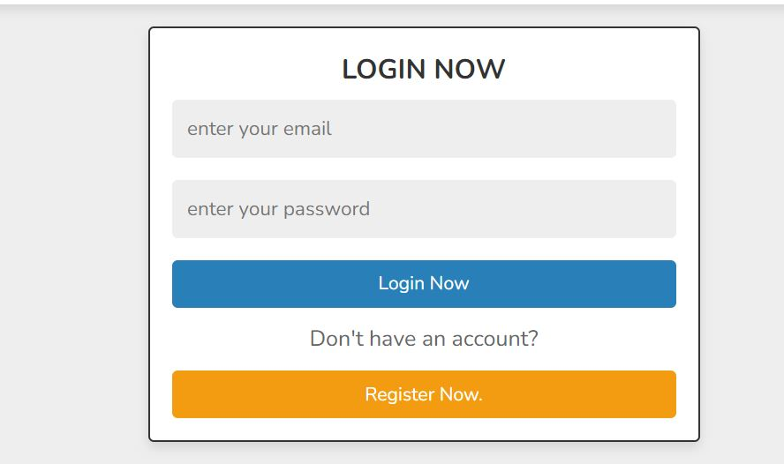

**Login page**

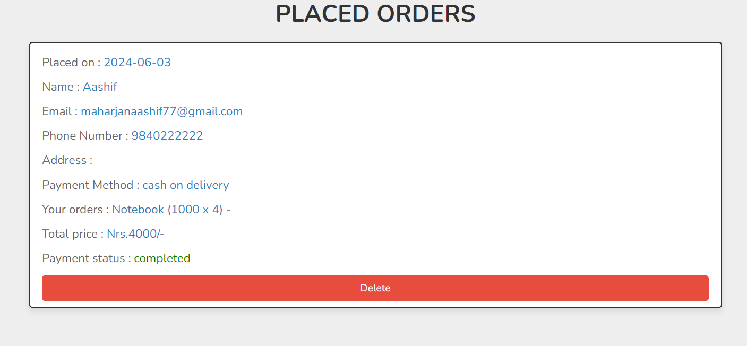

**Orders placed display**