What is a Buyer Centric Funnel?
Let us start our discussion with the very first question in our mind that what is an approach to deal with customers so that they are compelled to buy your products.

Various component of a buyer-centric funnel:
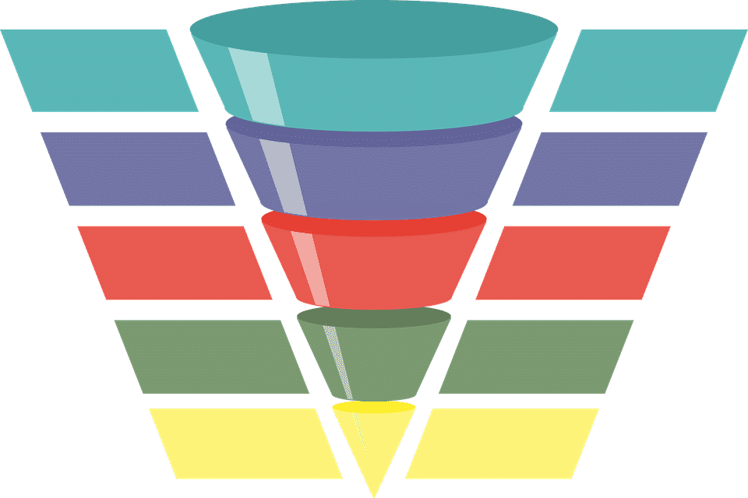
- Anchorage Data: Firstly you should look at your current marketing data. Based on these determine the dependency of your business on new customers compared to regular customers. This will give you an idea about the cost to acquire new customers against how much you are making from existing customers.

- Modify Customer Services: Your services should meet the expectations of new and modern customers. Consumers also have constant access to platforms to share their thoughts about their products.

- Identify Influencers: Find out people who can make or destroy your company. You should be aware of all the news related to your brand.

- Make your Customers Happy: Make your customers happy by rewarding them and giving them gifts. Customers like to feel understood, heard and important. Be sure that you are in contact with your customers.

- Win the Game: This is the last and final step. At this stage, you have won the trust of the customer. Now you can sell your end product to him/her.

How to Design a buyer-centric Funnel:

We can break a buyer's journey into the following 3 stages- Awareness, Consideration, and Purchase. The buyer's journey does not end with purchase it moves to post-purchase where customer retention is important to reduce the churn rate. This is achieved by providing good customer support and making delighted customers as our promoters and upsell them.
We should design a buyer-centric funnel after considering all these issues.

Effectiveness of Buyer-Centric Funnel: An effective buyer-centric funnel is about understanding the user’s behavior and accommodating that in your marketing approach. A Buyer-Centric funnel should seek to identify weaknesses in the customer’s journey and address those weaknesses with appropriate messaging or calls to actions. It is about understanding and accommodating behavior, rather than manipulating it.

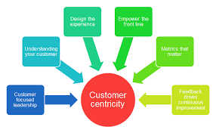

An effective buyer-centric funnel should include the following things:
- Stages in the user’s journey you can build the sales funnel around.
- References that the user interacts with that you should be addressing in your sales funnel.
- Actions that the user wants to take at each step of their journey.
- Objections that you will need to address to move users down the sales funnel.
- Weaknesses in the journey that need improving to prevent user’s ‘leaking’ out of the sales funnel.
For creating an effective funnel, we should make an effective road which the customer will follow. A typical road map must include the following steps:
- Discover a need.
- Research the options.
- Make a purchase.
- Receive the item.
- Post-purchase support.
A customer journey map contains information that can inform a buyer-centric funnel.
Next, for each step in the roadmap, we should identify four different pieces of information that will help inform the Buyer-Centric funnel. These are:
- What references we can use to reach our customers?
- What messages do we need to communicate at that point in their roadmap?
- What should we ask the customer to do next?
- How are we going to measure the success of this part of the funnel?
All these points will surely help you to design an effective buyer-centric Funnel.

Flip the Funnel
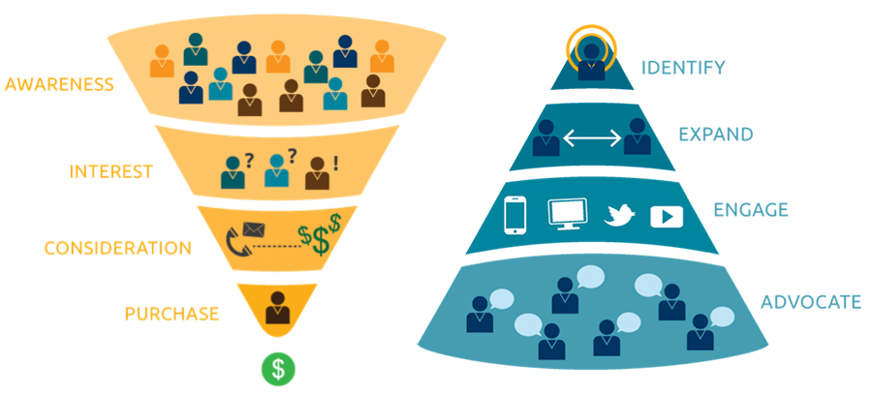
In today’s era companies are struggling to gather and maintain their customers. Funnels that are not designed with the customer at the center will always fail to deliver. The funnel has to be just right. The traditional sales funnel focuses on acquiring as many customers as possible.
The effort is invested in acquiring customers and existing customers fall by the wayside. The traditional sales funnel starts off wide, acquiring as many leads as possible with marketing campaigns and other wide-reaching.
The aim, at this point, is to push leads toward a purchase decision. Thereafter, the funnel starts getting slimmer as many leads ultimately decide to not become customers. Because of these drop-outs, effort and resources are wasted when they could have been utilized somewhere else. That is, to ensure existing customer retention.
Competition is getting tougher and tougher day by day. Companies find it hard to maintain their old customers. Companies are likely to run out of new people to reach, so then it becomes important to focus on the existing customers. Flipping the funnel means giving more preference to old customers.
Here flipping of funnel can be achieved by the following steps:
1. Look at the data.
2. Adapt to the new customer service rules
3. Recognize and reward outstanding customers
4. Identify influencers and outstanding customers
5. Convince management

For further study visit:
https://www.forentrepreneurs.com/launch-scale-2017/
https://www.marketingsherpa.com/article/interview/first-look-flip-funnel-joseph
Hope you find it helpful
By Aashi Gangrade

