Table of Contents

1 Introduction 6

1.1 Problem Statement 6

1.2 Rationale 7

1.3 Aim and Objectives 7

1.4 Scope 8

2 Literature Review 9

2.1 Search Process 9

2.1.1 Data Gathering 9

2.1.2 Research Questions 10

2.1.3 Search Strategy 11

2.1.4 List of Selected Papers 11

2.1.5 Chosen Datasets 13

2.2 SAMU 13

2.2.1 About SAMU 13

2.2.2 Divisions within Mauritius 13

2.2.3 SAMU Vehicle and Ambulance 14

2.2.4 Operational Structure 15

2.2.5 Data Flow 17

2.3 Intelligent Incident Management System 18

2.3.1 Existing Incident Management Systems 19

2.3.2 Tools and Technologies 22

2.4 Data Visualization Tools 27

2.4.1 R Studio 27

2.4.2 Power BI 28

2.4.3 Tableau 29

2.5 Machine Learning 29

2.5.1 Supervised Learning 30

2.5.2 Unsupervised Learning 30

2.5.3 Reinforcement Learning 31

2.6 Summary of Findings 31

3 Analysis 34

3.1 Challenges in the Existing SAMU System in Mauritius 34

3.1.1 Data Redundancy 34

3.1.2 Inaccurate Data 34

3.1.3 Poor Resource Allocation 35

3.2 Features to enhance SAMU Efficiency 35

3.3 Functional Requirements 36

3.3.1 Website 36

3.3.2 Incident Management System 37

3.3.3 Dashboard 38

3.4 Non-functional Requirements 38

3.4.1 Website 38

3.4.2 Incident Management System 38

3.4.3 Dashboard 38

3.5 Evaluation of Tools and Technologies 38

3.5.1 GIS 38

3.5.2 IDE 39

3.5.3 Software Deployment 39

3.5.4 Data Visualization Tools 39

3.5.5 Machine Learning 39

3.5.6 Conclusion on Tools and Technologies 39

4 Proposed System 41

4.1 Proposed Architecture 41

4.2 Database Design 42

4.3 System Design 43

4.3.1 Use Case Diagram for the Overall System 43

4.3.2 Signing Up 44

4.3.3 Logging In 46

4.3.4 Incident Reporting 47

4.3.5 Prioritising Incidents 48

4.3.6 Removal and Addition of Resources 49

4.3.7 Staff Scheduling 50

4.3.8 Resource Allocation 53

4.3.9 Updating Status 55

4.3.10 Dashboard 56

5 Implementation 57

5.1 Database 57

5.1.1 Configuration 57

5.1.2 SQL Commands 57

5.2 Data Input 58

5.3 JavaScript Functionalities 60

5.3.1 Form Validation 60

5.3.2 Incident Location 60

5.4 PHP Functionalities 60

5.4.1 PHP Session 60

5.4.2 Message Display 60

5.4.3 SMTP Server 60

5.4.4 Time and Date 60

5.4.5 Python Code 60

5.5 Machine Learning 60

5.6 Dashboard 60

5.7 Web Deployment 60

6 Testing 61

7 Evaluation 61

8 Conclusion 61

9 References 61

10 Appendix 61

List of Abbreviations

|  |  |
| --- | --- |
| Abbreviation | Definition |
| AI | Artificial Intelligence |
| BI | Business Intelligence |
| EP | Emergency Physician |
| FR | Functional Requirement |
| GIS | Geographic Information System |
| IDE | Integrated Development Environment |
| IMS | Incident Management System |
| IT | Information Technology |
| MFRS | Mauritius Fire and Rescue Service |
| ML | Machine Learning |
| MPF | Mauritius Police Force |
| RPA | Robotic Process Automation |
| RQ | Research Question |
| SAMU | Service d'Aide Médicale Urgente |
| WHO | World Health Organization |

# Introduction

Emergency services play a crucial role in saving lives and minimizing damage during critical situations. In Mauritius, emergency situations are handled by various agencies, including the SAMU. Established in December 1997 in Mauritius (Kassean and Poordil, 2011), SAMU is in charge of delivering emergency medical assistance whereby the response time, defined as the time between notification of an occurrence and the ambulance's arrival at the scene, is the main indicator of this service. However, with numerous individuals potentially requiring urgent assistance simultaneously, SAMU appears to be having a difficult time providing the public with efficient medical services. In addition, SAMU frequently receives criticism for its poor response rate. However, with the correct technological advancements such as AI, a centralized database system, and data analytics, SAMU can be given a more effective and efficient incident management system. All medical situations can be rapidly assessed and assigned using this system, which enables quicker interventions.

## Problem Statement

SAMU is an emergency medical service that obtains various types of complaints such as medical problems, traffic accidents, and catastrophic events. However, despite Mauritius being ranked 84th out of 191 nations in overall achievement for healthcare systems by WHO (Ramalanjaona and Brogan, 2009), SAMU is often criticised for the slow response rate, which can cause delays in delivering medical aid to individuals in need of assistance. The Ministry has invested more than Rs 65 million in capital and ongoing costs for IT systems in the healthcare industry (He@lth, 2015), yet the SAMU incident management system currently seems inefficient, causing delays and posing possible threats to the general public. Numerous things, such as poor communication, a lack of coordination across various departments, and the absence of real-time incident tracking, might contribute to these delays. Overall, these issues arise from the public sector's relatively delayed adoption of technological innovation. As an illustration, the majority of SAMU's administrative services continue to use the outdated filling system, which has several limitations including access time, editing, order, and data loss (Hamel, 2012). Additionally, with a population of 1,277,691 and a growth rate of 0.17% (Worldometer, 2022), it has become more challenging for SAMU to achieve the ideal response time of less than 8 minutes, as recommended by the WHO (Cabral et al., 2018), for the approximately 1000 calls they receive each day, as mentioned during the broadcast of Radio Plus on April 26, 2023.

## Rationale

Every individual in the world has the fundamental right to access an effective emergency medical assistance, and in an emergency situation, every second matters in preserving the patient's life. However, the delayed reaction time at SAMU is frequently criticized and can have detrimental effects on the patient's health. Additionally, because an emergency may be widespread, it is important to provide accurate and full information to enable the dispatcher to send the necessary personnel and equipment. Among various other reasons, data exchange across different departments lengthens reaction times, decreasing the effectiveness of the responders. Therefore, it is crucial to comprehend the causes of the low response rate and identify strategies for system improvement. In contrast to conventional ways, an automated and intelligent system will unquestionably aid in the transmission and management of information. This will save a lot of time because all the required departments will be able to gather the transmitted information in real time and act more quickly.

## Aim and Objectives

This project's main goal is to develop and deploy an intelligent incident management system for SAMU in order to address the aforementioned issue. The specific objectives of the project are to:

* Analyse existing studies on medical emergency services, with an emphasis on the incident management system.
* Compile information on the system that SAMU actually employs and the step-by-step process for handling an incident.
* Provide a new architecture design for SAMU which can shorten the response time.
* Implement the proposed intelligent system including real-time incident tracking.
* Include a webpage where citizens can input incident details
* Develop a dashboard to obtain more insightful analytical information on the incident management of SAMU.
* Assess the suggested system.

## Scope

The scope of this project includes designing and creating an intelligent incident management system that will track, handle, and record incidents that are reported to SAMU. The system will provide real-time incident tracking to enable SAMU to respond to issues more quickly and allocate resources more wisely. Moreover, a dashboard with visualisation tools will be available, giving SAMU employees improved visibility into incident management and resolution. Most importantly, the initiative won't affect SAMU's primary operational procedures; it will only focus on system enhancement.

# Literature Review

This chapter aims to understand the current SAMU organizational structure and how an intelligent incident management system might shorten SAMU's response times by utilizing relevant technology. Moreover, methods for data analysis and data prediction will be looked at. The research methodology will be an organized literature review.

## Search Process

For a proper search procedure, the steps below are being followed.

### Data Gathering

Data gathering can be defined as a method of obtaining and analysing data on relevant factors in an organized, systematic way that makes it possible to respond to inquiries, pose research questions, test hypotheses, and assess results (MINIOPOO, 2020).

There are several techniques which can be employed for the collection of information. Interviews and documentation are those which have been utilized, in this study, to obtain data about SAMU and the related technologies. Nevertheless, not all information was approved for publication owing to privacy and security concerns. These private materials comprise of the names of SAMU staff who were interviewed.

#### Documentation

Given that it can serve as a record of prior events, actions, and decisions, documentation can be a useful source of data for research or analysis. Document analysis is a research method that entails meticulously going through and analysing papers to find information and insights pertinent to a certain research question or goal. This technique was mostly used for a better understanding of the technologies available.

#### Interview

Due of its individualized approach, this is regarded as the most popular data collection method for qualitative research. When highly personalized data must be acquired, it can be considered as the best technique. The interviewer lets the interview's natural flow determine the questions to be asked next, therefore the majority of the questions are spontaneous and unplanned (Belyh, 2017). To learn more about the SAMU's function and how it responds to incidents, interviews with the SAMU department staff were undertaken. Details about the personnel were not mentioned because they preferred an anonymous interview.

### Research Questions

The technique for filtering the number and quality of articles is crucial during the data collection process. In order to accomplish this, RQ is introduced to organize the research process and gather particular data. The list of the RQs are as follows.

|  |  |  |
| --- | --- | --- |
| ID | Research Question | Objective |
| RQ1 | How does SAMU function in Mauritius? | To gain a better understanding of the structure and organization of SAMU in Mauritius, including the processes for responding to emergencies. |
| RQ2 | What are the main functionalities of existing intelligent incident management systems? | To gain an overview and define the primary characteristics and functions of existing incident management systems that use cutting-edge or intelligent technologies. |
| RQ3 | What technologies are available for incident management, task automation, data visualization, and incident prediction? | To detect and assess the various tools and platforms that can support effective and efficient incident management processes, including their ability to automate tasks, visualize data, identify patterns, and make predictions about future incidents. |

### Search Strategy

To find articles on a specific subject, a search strategy is employed to identify the optimal combination of keywords. The combinations of keywords are constructed using the search terms based on the RQs identified above together with the Boolean operators, AND and OR. By performing an in-depth searching, various qualitative and quantitative documents such as research and journal papers, as well as website articles, can be procured for analysis. Search engines such as Google Scholar, Research Gate, University of Mauritius Online Library and Google were utilized.

The following keyword combinations were utilized to refine the search process and retrieve relevant papers.

|  |
| --- |
| Keyword Combinations |
| “SAMU Mauritius” AND “organizational structure” |
| “functionalities” AND “existing incident management systems” |
| “incident management system” AND “technologies” AND “tools” |
| “technologies” AND (“automation” OR “prediction” OR “data visualization”) |

After examining the papers based on the three RQs, 15 papers were selected. Moreover, several websites were used for the research purposes.

### List of Selected Papers

|  |  |  |  |
| --- | --- | --- | --- |
| ID | Title | Author | Year of Publication |
| P01 | RStudio: integrated development environment for R | Allaire, J. | 2012 |
| P02 | Software Deployment Infrastructure for Component Based RT-Systems | Noriaki Ando, Shinji Kurihara, Geoffrey Biggs, Takeshi Sakamoto, Hiroyuki Nakamoto, and Tetsuo Kotoku | 2011 |
| P03 | Response time in the emergency services. Systematic review | Eric Lucas Dos Santos Cabral, Wilkson Ricardo Silva Castro, Davidson Rogério de Medeiros Florentino, Danylo de Araújo Viana, João Florêncio da Costa Junior, Ricardo Pires de Souza, Amália Cinthia Meneses Rêgo, Irami Araújo-Filho, Aldo Cunha Medeiros | 2018 |
| P04 | Introducing Visual Studio Code | Alessandro Del Sole | 2021 |
| P05 | REDUCING AMBULANCE RESPONSE TIME IN EMERGENCY MEDICAL SERVICES: A LITERATURE REVIEW | Mukesh Shyamkant Desai, A M Rawani, M I M Loya | 2019 |
| P06 | Combination of GIS with Different Technologies for Water Quality: An Overview | Nada Jasim Habeeb, Shireen Talib Weli | 2021 |
| P07 | Google Colaboratory : Tool for Deep Learning and Machine Learning Applications | Praveen Gujjar J., Naveen Kumar V. | 2021 |
| P08 | To me it’s just another tool to help understand the evidence’: Public health decision-makers’ perceptions of the value of geographical information systems (GIS) | Kerry Joyce | 2009 |
| P09 | AN INCIDENT MANAGEMENT SYSTEM FOR EMERGENCY RESPONSE SERVICES INTEGRATING BUSINESS ANALYTICS FOR POLICE FORCE | KASARY Chandrakshay Kumar | 2022 |
| P10 | Utilization of Emergency Medical Services in Mauritius | Hemant Kassean and M. Poordil | 2011 |
| P11 | ARCHITECTURE FOR THE POLICE FORCE INCIDENT MANAGEMENT IN AN EMERGENCY | MINIOPOO Ryan | 2020 |
| P12 | Dynamic workload driven data integration in tableau | Kristi Morton, Ross Bunker, Jock Mackinlay, Robert Morton, Chris Stolte | 2012 |
| P13 | Visualization of Information Flows and Exchanged Information: Evidence from an indoor fire game | Vimala Nunavath, Jaziar Radianti, T. Comes, Andreas Prinz | 2015 |
| P14 | EMS in Mauritius | Georges Ramalanjaona, Gerald X. Brogan | 2009 |
| P15 | Applied Microsoft Power BI : Bring your data to life! | Teo Lachev, E. Price | 2020 |

### Chosen Datasets

## SAMU

This section will address RQ1 (How does SAMU function in Mauritius) by concentrating on the SAMU's operating framework when an emergency is being handled.

### About SAMU

In an effort to provide pre-hospital emergency treatment to those who are in need, the Ministry of Health and Quality of Life and the Mauritian Institute of Health established the SAMU in Mauritius in December 1997 (Kassean and Poordil, 2011). The service is provided free of charge. The Medicare Ambulance Service, the only other available ambulance service, is a profit-driven business that is mostly utilized by large corporations and private clinics. Furthermore, a total of 253 vehicles, including ambulances, sedans, and mobile clinics, are part of SAMU's fleet, which is operational around-the-clock, seven days a week. First responder cars manned by first aid providers and paramedics with a driver are the standard for all public and private hospital-based ambulance services. For fire, police, and ambulance emergencies, Mauritius has a single national emergency free-call number (999). However, there are phone lines that are only to be used in case of medical emergency which are 114 for public ambulances that are available to everyone and 116 for subscriber-only private ambulances (Ramalanjaona and Brogan, 2009).

### Divisions within Mauritius

The health facilities are divided into five regions: Port Louis, Pamplemousses, Moka/Flacq, Grand Port/Savanne and Plaines Wilhems, each with a separate Health Advisory Council to provide guidance on service efficacy and health needs (He@lth, 2015). The figure below shows all the types of hospitals, clinics and health centres in the five different regions.

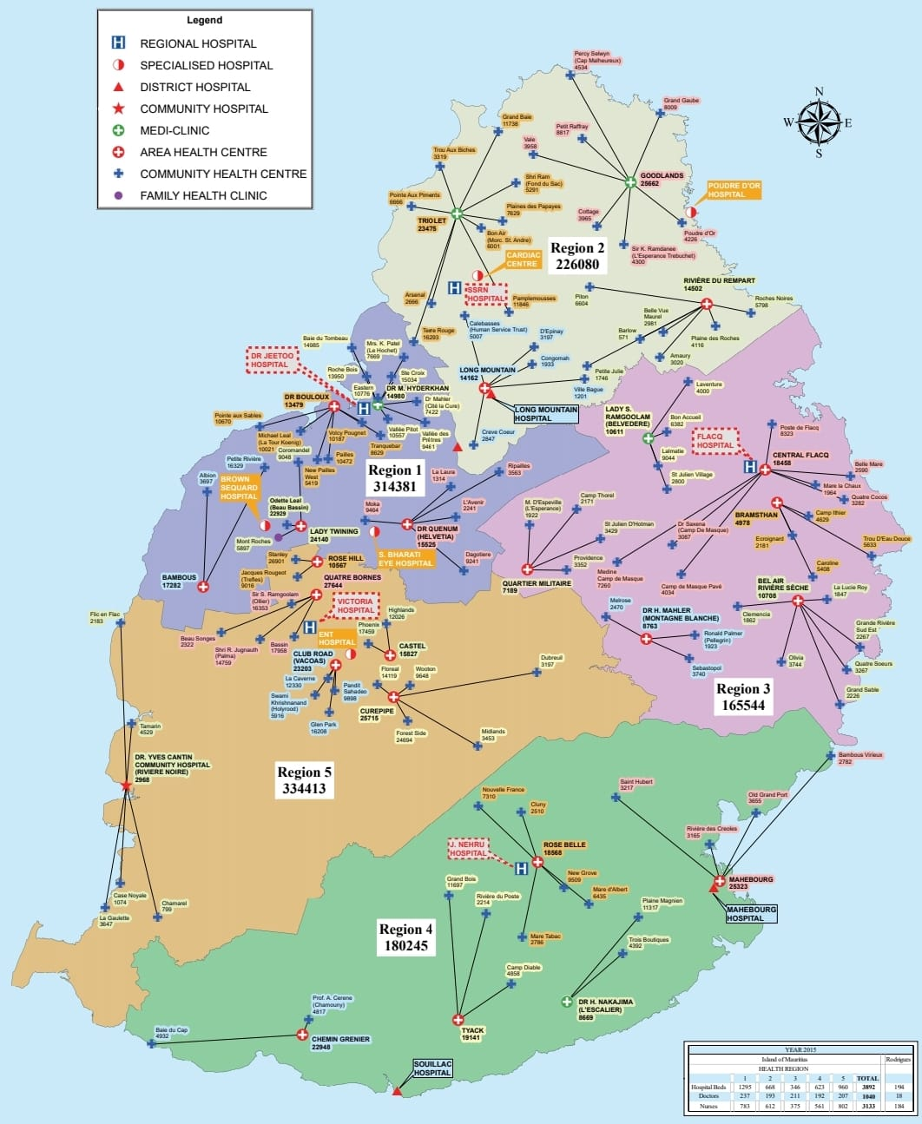

The six hospitals which provide the SAMU facilities on the island, consisting of five regional hospitals and one district hospital, are:

1. SSRN Hospital
2. Dr A. G. Jeetoo Hospital
3. Dr Bruno Cheong Hospital
4. Victoria Hospital
5. Jawaharlal Nehru Hospital
6. Souillac Hospital

### SAMU Vehicle and Ambulance

Both of these vehicles are used for the sole purpose of transporting patients who require medical care but the decision to use which vehicle for which incident is determined by the severity of the condition of the patients.

A SAMU vehicle is accompanied by an EP, two nurses and a driver and is also equipped with all the advanced medical equipment such as defibrillators, ventilators, and blood analysis machines. Each regional hospital has two SAMU whereby one of them operates for 24/7 and the other one works from 8 am till 4 pm, except for Dr Bruno Cheong Hospital, the other one operates from 8 am to 10 pm. Souillac Hospital has only one SAMU which functions nonstop.

A non-medicalized ambulance consists only of a driver, a helper and some basic equipment including a first-aid kit and a stretcher. These ambulances are stationed throughout the island in order to provide coverage for simple cases or for emergencies while the SAMU teams are attending to another patient. Each regional hospital has four ambulances which are associated with the SAMU services whereas Souillac Hospital has only one.

### Operational Structure

The goal of SAMU is to offer those who are having a medical emergency rapid medical care. The organization's services are organized through a dispatch centre at Victoria Hospital in Candos, which answers emergency calls and sends the right medical personnel to the scene of the emergency. All the calls are registered and retained for future use.

The steps listed below are followed when a person contacts SAMU from anywhere on the island:

1. A control officer attends the call and asks for details such as location, day and time of call, the reason called, severity of the case to fill in the following form:

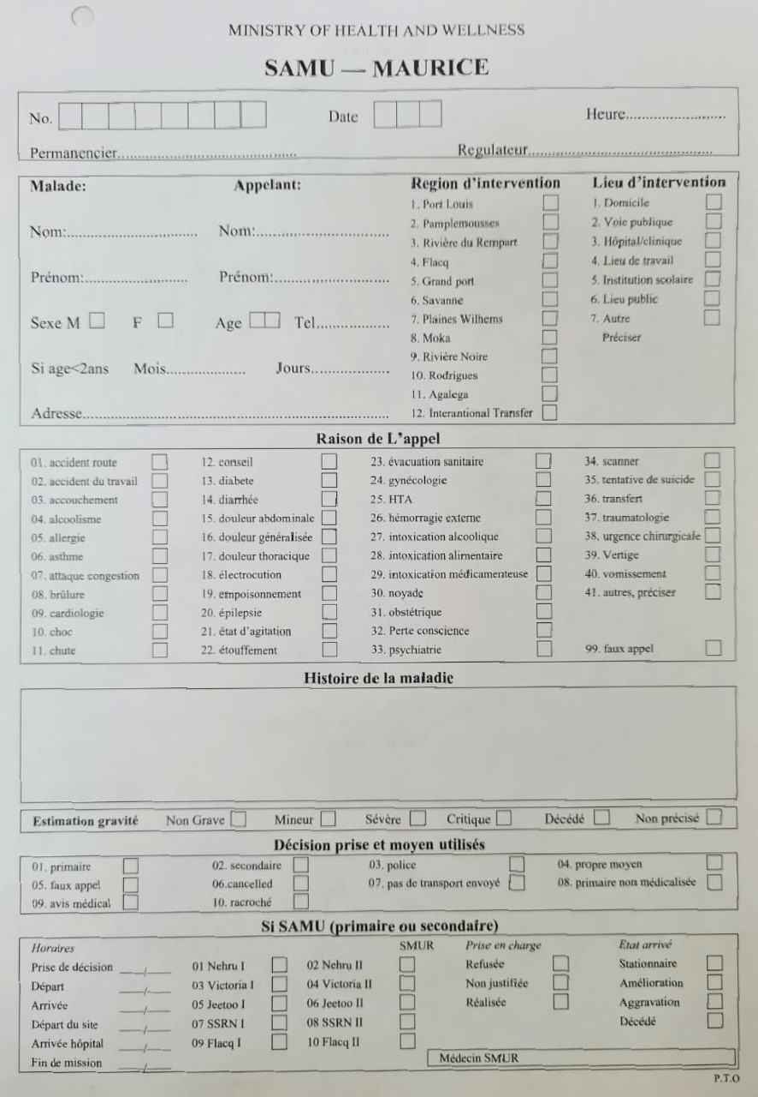

1. Once completed, the con passes the phone over to the EP, along with the form.
2. The EP assists the patient by informing him about the required first-aid depending on the conditions of the patient. There may be situations where the patient has already been treated with the help of the EP over the phone.
3. The EP will perform the triage and if this case has the highest priority at that time, the following steps will be carried out. Otherwise, this incident will be kept on waiting until it is the one with the highest priority.
4. After the first-aid, the EP has several options depending on its severity:
5. It is still an emergency case. Hence, SAMU is required where his treatment will start.
6. It is not an emergency case anymore but still requires medical help.
7. Check if the patient has any transport facility and wait for him to come to the hospital for further help.
8. If the patient has no transport facility, a non-medicalized ambulance is sent. So, his treatment will start in the hospital.

Now, the EP decides in which of these above-mentioned situations is the patient and then, informs the control officer to contact the hospital which is the nearest one to the patient’s location and ask for the required vehicle(s) if necessary. The officer will provide them with the location and the number of the caller.

1. If there is no SAMU available, the officer will contact the second hospital which is nearest to the patient.
2. Upon confirmation of SAMU, the EP in Victoria Hospital will contact the EP who will be in the SAMU to provide him with all the necessary details about the patient.
3. The EP can also contact the MPF or MFRS to help with the case if necessary.

### Data Flow

Data about the incident

Instructions from EP

Incident details if necessary

Incident details

Request and incident details if necessary

In an emergency situation, data flow is crucial. This is a diagram of the generic architecture for the SAMU incident management. Data is acquired at the emergency site and sent to the operation centre for analysis of data, presentation and decision-making and keeping for later use (Nunavath et al., 2015).

As previously illustrated, information is constantly transferred from one entity to another to alert them of the condition and the requirement of their presence at the emergency location. The four entities participating in the communication process and data sharing are the emergency site, dispatch centre, closest hospital, second-closest hospital, and MPF/MFRS.

Once the control officer at the dispatch centre is informed about the incident, he will provide the caller the with the first-aid instructions to help the patient and notify the closest hospital about the incident. If the hospital has no SAMU available at that very moment, the next closest hospital will be made aware of the required services. Nonetheless, the data flow does not stop here. After having assessing the situation, he will request the presence of MPF/MFRS if necessary.

## Intelligent Incident Management System

A platform known as an IMS is used by businesses to monitor and deal with emergencies, which are situations that have the possibility of interfering with routine activities, endangering people, damaging property, or causing an adverse effect on the environment.

An IMS typically consists of the different steps shown in the figure below:

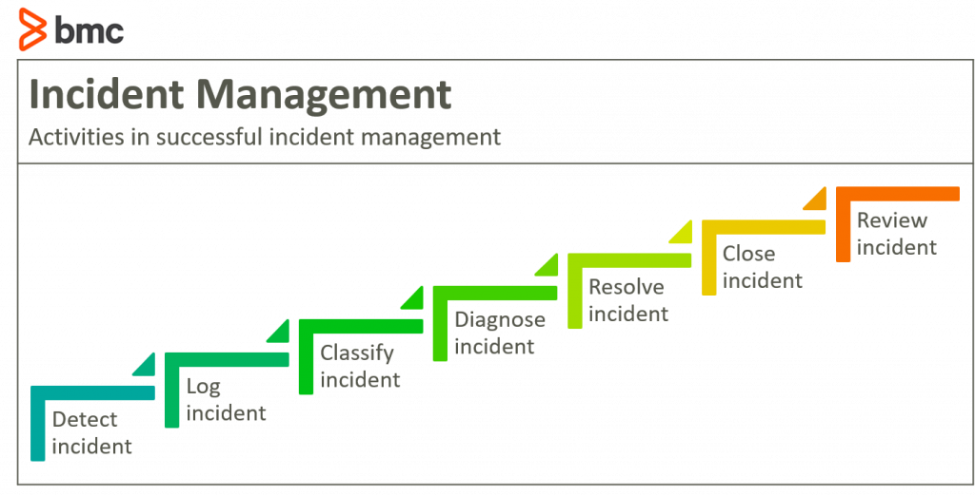

On the contrary, intelligent IMS uses cutting-edge technology and intelligent systems like automated processes, machine learning, and artificial intelligence to track, analyse, and react to occurrences in real-time in a more productive and effective manner. In addition to the aforementioned technology, thorough analytics and insights are produced to aid in better managing the situations in the future.

### Existing Incident Management Systems

Within this chapter, the RQ2: what are the main functionalities of existing intelligent incident management systems will be answered by studying the two existing systems mentioned below.

#### EMResource

##### Introduction

EMResource, currently being used in United States of America, is a web-based system which was created to offer communication and situational awareness in real time during medical emergencies. It makes it possible for hospitals, EMS, public health organizations, and other healthcare providers to collaborate and plan their emergency responses.

##### Technologies

The technologies used to create EMResource, developed by Juvare, include HTML, CSS, JavaScript, and Java. Any web browser can be used to access it because it is web-based. The system's scalability and adaptability enable it to be tailored to satisfy the unique requirements of various healthcare organizations. The capability of EMResource to integrate with various healthcare systems as well as platforms is one of its primary characteristics. This makes it possible for medical professionals to acquire real-time data from numerous sources, such as patient management systems, lab systems, and electronic health records (EHRs).

##### Functionalities

1. **Identify Resource Availability**

By recognizing resource availability and providing real-time data to assist decision-making, EMResource offers healthcare professionals the essential benefit of enhancing patient outcomes. In addition, with a centralized overview of all resources at the local, regional, and state levels, healthcare professionals can immediately identify areas of need and allocate resources accordingly, ensuring that patients receive the care they need without delay. In addition to enhancing patient outcomes, the system's real-time data on patient status, medical equipment, and bed availability aids healthcare professionals in selecting the hospital that will best serve incoming patients.

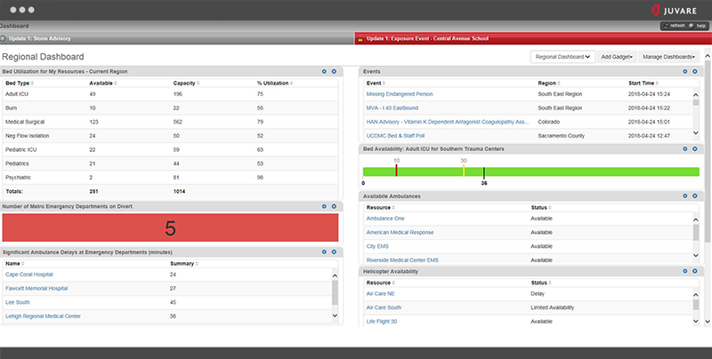

1. **Ensure Reliable Response**

One of EMResource's main advantages is the ability for users to create events. By entering crucial details like the event's location, its nature, the quantity of patients, and their conditions, users can create emergency scenarios or live events. The problem is assessed more quickly as a result of this characteristic, and the best line of action is therefore decided. When an emergency event is established, users of EMResource can use its notification system to alert those who need to be informed, such as medical personnel, first responders, and emergency management personnel. (Juvare, n.d.)

#### WebEOC

##### Introduction

It is a web-based crisis management technology which is intended to give emergency responders a centralized, real-time view of crucial information. It is widely utilized in many different parts of the world, including the United States, Canada, Europe, Asia, and Australia. It also works in a variety of organizations, including public institutions like hospitals and schools as well as private businesses. Authorized users can access crucial information from any location with an internet connection thanks to the platform's user-friendly layout.

##### Technologies

HTML, JavaScript, and CSS are among the web technologies used in the development of WebEOC. Users can access the system's user interface from any device with an internet connection because it can be accessed using a web browser. A relational database management system (RDBMS) is also used by WebEOC to store data. Resource requests, incident reports, and situational awareness updates are just a few examples of the incident-related data that is organized and stored using the RDBMS. To provide a complete picture of the occurrence, the system can also link with various data sources including social media feeds, weather information, and sensor data. Depending on the deployment configuration, WebEOC commonly uses ASP.NET or PHP as the server-side scripting language. Depending on the needs of the user, the system can be installed on-premises or in the cloud.

##### Functionalities

1. **Collaboration Promotes Faster Response**

WebEOC enables bi-directional data sharing and standard workflows across various agencies and locations, resulting in faster emergency response and more resilient communities. The platform also allows real-time situational awareness, resource availability, and event updates to be communicated across the public and private sectors, reducing duplication of effort and streamlining response efforts. Moreover, standardized workflows and practices fostered by the platform enhance overall preparedness and standardize response activities.

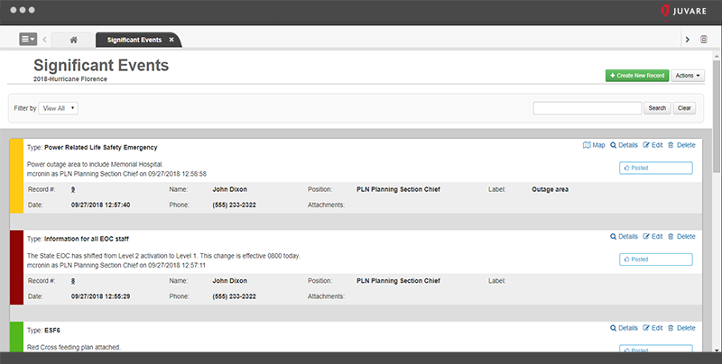

1. **Built for Any User, Any Skill Level**

Because of its simple user interface and process, WebEOC is simple to teach new users how to use. Even administrative users who lack technological expertise can quickly design forms and processes that can be tailored to their organization's unique requirements. This indicates that firms do not need to have a lot of technical know-how to quickly adapt to changing conditions and stay current with new practices. The platform's streamlined emergency response procedures, reduced errors, and increased productivity are made possible by its user-friendly design and customizable choices.

1. **Faster Alerting with Notifications**

Email, push notifications, and the control panel are just a few of the message delivery options provided by the WebEOC Alerts Plugin. Additionally, authorized premium channels like Microsoft Teams, Slack, voice calls, and SMS messaging can be used. Regardless of their location or preferred method of communication, this enables WebEOC users to swiftly and effectively communicate time-sensitive information to stakeholders and responders. WebEOC makes sure that crucial information reaches its intended recipients quickly and effectively by offering a variety of communication methods.

1. **WebEOC Mobile App**

The boards are mobile-friendly, making it simple to see and modify on both Apple iOS and Android devices. A seamless connection to the command or emergency operations center is made possible by the data input in the app being immediately accessible in WebEOC. As soon as network connectivity is restored, entries made in an offline form are retained in the app and synced with the system. (Juvare, n.d.)

### Tools and Technologies

As from this section, we will focus on the technologies and tools that can be utilized to regulate the process of managing an incident, hence responding to the RQ3: what technologies are available for incident management, task automation, data visualization, and incident prediction.

#### GIS

Compared to conventional geographic information systems, GIS is a powerful tool for evaluating and interpreting big data and remotely mapping geographic areas with more exact features and in real time (Habeeb and Weli, 2021). Moreover, when used in a multidisciplinary setting to promote the sharing of data, information, and skills across the public health landscape, GIS is probably most successful in decision-making (Joyce, 2009). GIS can also aid users in comprehending patterns, relationships, and geographic context.

Applications for GIS use both software and hardware. These applications could use digital, photographic, spreadsheet, or geographic data. Information about the locations of rivers, highways, hills, and valleys may be included in cartographic data, which are already presented as maps (education.nationalgeographic.org, n.d.).

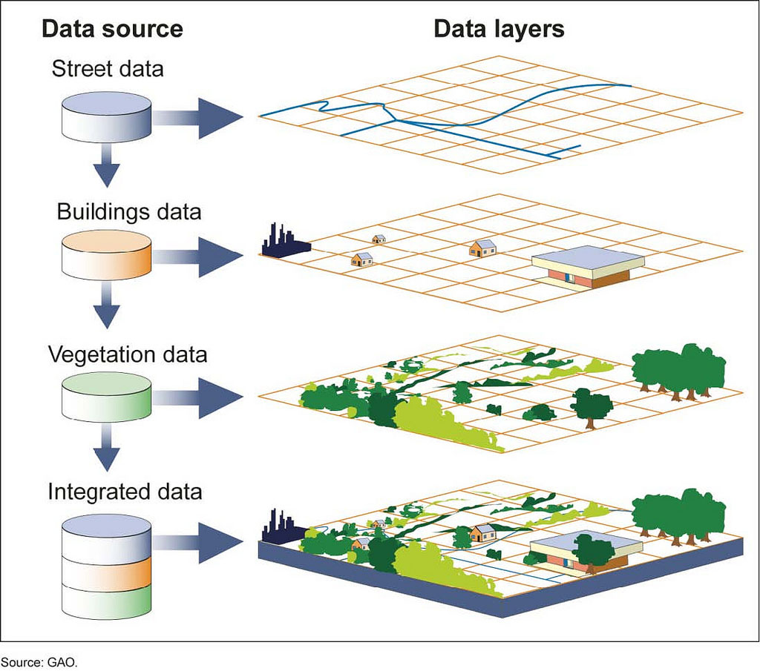

Some of the most common GIS software are ArcGIS, Google Maps and QGIS.

|  |  |  |
| --- | --- | --- |
| Tools | Pros | Cons |
| ArcGIS | * Large library of pre-built data sets and map templates | * Expensive * Steep learning curve |
| Google Maps | * Easy to use and integrate into web and mobile applications * Provides location search, directions, and street view | * Limited features compared to other GIS tools * Requires a license for commercial use |
| QGIS | * Free and open-source * User-friendly interface | * May not have as many advanced features as ArcGIS * User interface may not be as intuitive as Google Maps |

#### IDE

An IDE is a software package that combines the fundamental instruments needed to create and test software. During the writing, developing, and testing of software code, developers employ a variety of tools such as text editors, code libraries, compilers, and test platforms. Integrating all those tools into one framework can ease software development and code debugging. Additionally, there are both open source and paid options available for IDEs (SearchSoftwareQuality, n.d.).

Some popular IDEs are listed below:

1. **Visual Studio Code**

It is a highly effective code-focused development environment that was created specifically to make it simpler to write web, mobile, and cloud applications in languages that are supported by various development platforms. Moreover, it supports the entire lifecycle of application development with an integrated debugger as well as offers facilities such as the Git version control engine, syntax colorization and automatic indentation (Del Sole, 2021).

The programming languages supported by VS Code are as follows: C++, C#, CSS, Dart, Dockerfile, F#, Go, HTML, Java, JavaScript, JSON, Julia, Less, Markdown, PHP, PowerShell, Python, R, Ruby, Rust, SCSS, T-SQL, TypeScript.

1. **Google Colab**

It is merely a web-based version of Jupyter Notebook. Google Colab is a full-featured cloud software for Python coding, in contrast to Jupyter Notebook, which requires to be installed on a computer and can only access local machine resources. Google Colab is mostly used to implement machine learning and deep learning concepts (J. and V., 2021).

1. **MySQL Workbench**

This IDE is a single visual tool with numerous features, including:

* Data modelling which can be used to create complicated ER models

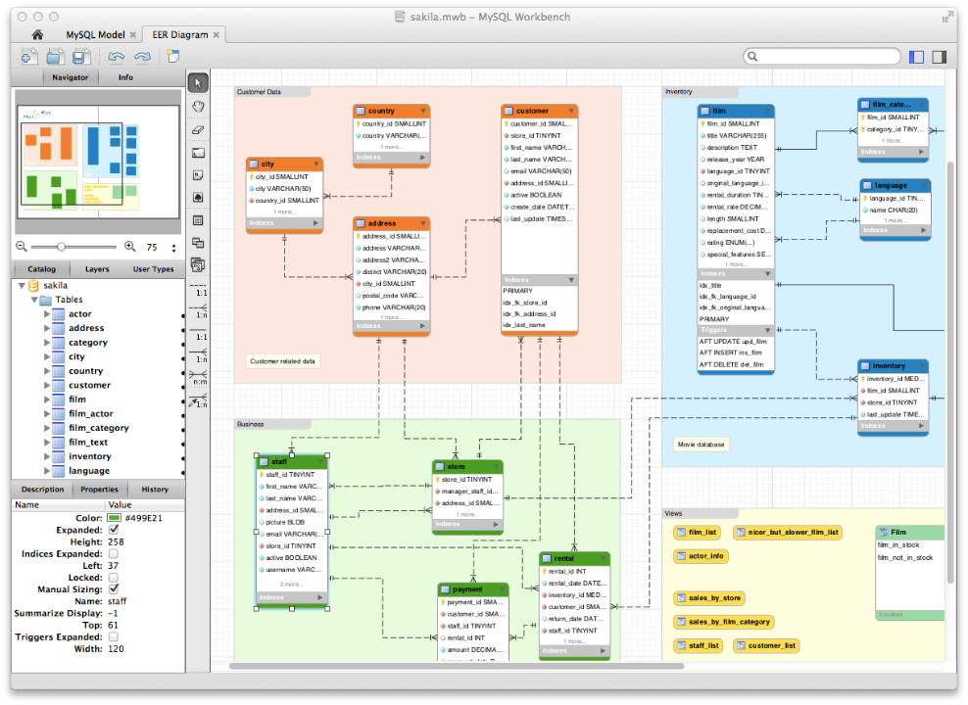

* SQL creation. The SQL Editor offers color syntax highlighting, auto-complete, the ability to reuse SQL snippets, and a record of SQL executions.
* Administrative tools for server configuration, user administration and backup

MySQL Workbench is supported by all Windows, Linux, and Mac OS X (www.mysql.com, n.d.).

#### Software Deployment

Deployment, the last stage of the software development life cycle, is the collective process of installing, configuring, and running software, including executable files and modules, on target machines (Ando et al., 2011). Some examples of deployment tools are Jenkins, Netlify and AWS CodeDeploy.

One of the most common types of deployment is the cloud deployment which refers to the process of deploying software to a cloud computing environment. The figure below shows the different types of cloud deployment.

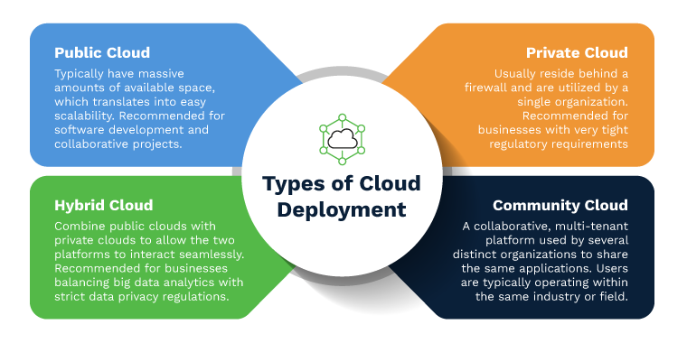

#### Robotic Process Automation

RPA is a software technology that simplifies the process of designing, deploying, and managing RPA bots. These software robots are designed to behave like humans when interacting with digital hardware and software (KASARY, 2022). They can therefore complete a variety of activities that have been predefined. Moreover, operations such as interaction with several applications that were previously carried out manually are now done automatically with the help of these RPA bots.

The figure below shows some benefits of RPA.

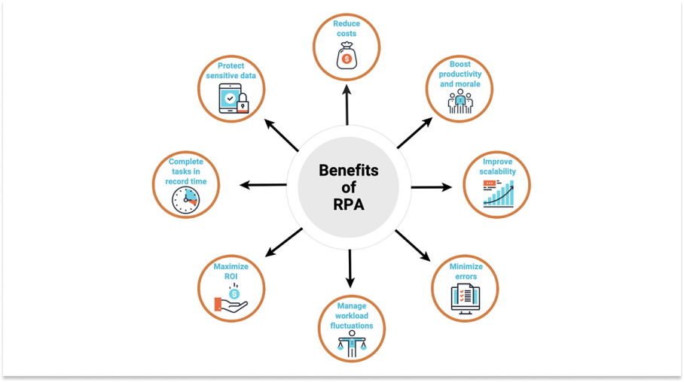

This table highlights the differences between UiPath and Automation Anywhere, two of the most popular RPA tools in the market (Besant Technologies, 2018).

|  |  |
| --- | --- |
| UiPath | Automation Anywhere |
| Web-based Orchestrator | Client server |
| Free community version | Trial version expires after 30 days |
| Easy to use | Basic programming knowledge is required |
| Good scalability with moderate execution speed | Limited scalability |

## Data Visualization Tools

Data visualization provides an easy way to understand large quantities of data quickly and accurately. Through the use of graphs, charts, maps, and more, it helps deliver insights in an intuitive manner. This technique is becoming increasingly popular as it helps make accurate decisions regarding the data at hand (GeeksforGeeks, 2020). Currently, there are a number of tools available for data visualization, as illustrated below.

### R Studio

RStudio is an open-source platform designed to integrate different functions of R such as console, source editor and graphs into one comprehensive and productive application. R has become the go-to language for many data scientists. It allows newbie users to make progress quickly and for more experienced users, it provides a range of tools that allow them to be productive. RStudio is designed to function on a range of operating systems such as Windows, Linux, and Mac OS X. It can also be used as a server to grant web access to R sessions hosted on external systems. This makes it even more useful and convenient for users (Allaire, 2012).

Furthermore, Flexdashboard which is an R package can be installed to implement interactive dashboard using R Markdown. As shown in the figure below, this feature helps in the quick creation of web pages with various components such as charts, tables, and maps, in a single dashboard.

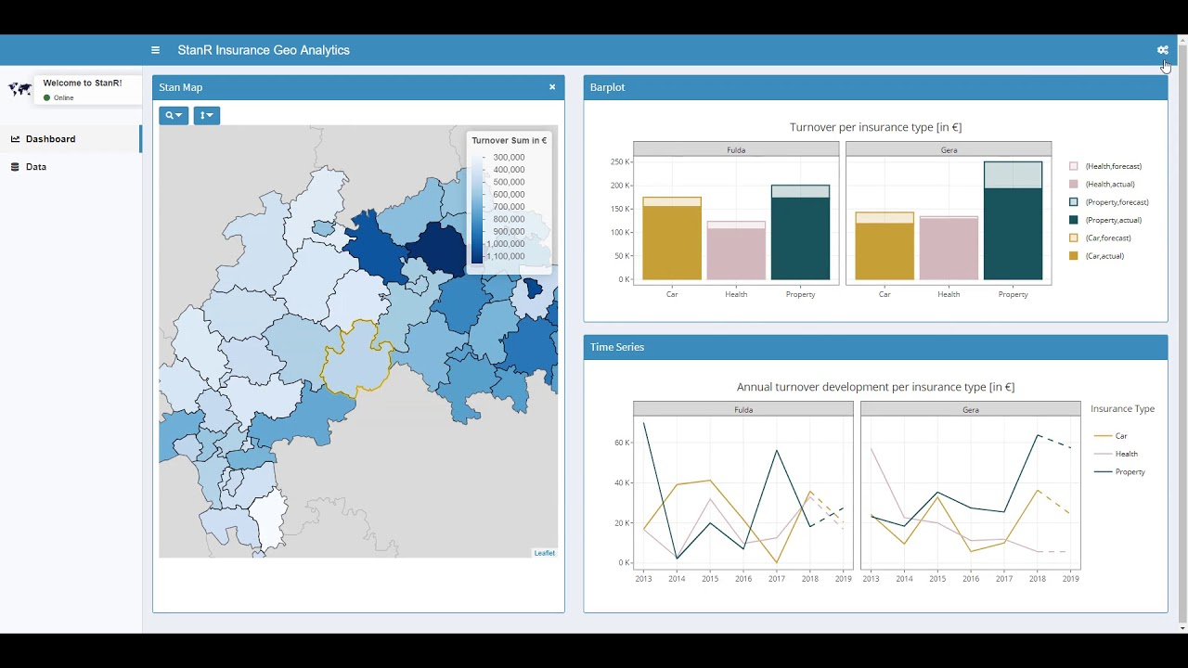

### Power BI

Microsoft Power BI is a cloud-based business intelligence and analytics tool that enables users to connect to numerous data sources, gain insights, and produce interactive reports and dashboards. It is a self-service platform that simplifies BI and makes it available to everyone, regardless of their level of technical skills. Since it does not require any advanced data analytics knowledge, it is appropriate for both BI experts and novices. Additionally, Power BI-centric solutions can be implemented for descriptive, real-time, and predictive analytics (Teo Lachev and Price, 2020).

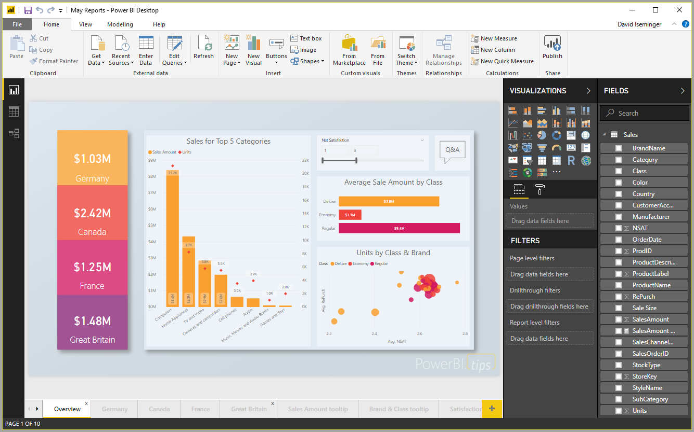

### Tableau

Tableau is a commercial BI software tool that enables interactive, visual analysis of data, helping a broad audience of end-users to obtain insight into their datasets. The user experience is a fluid interaction process in which exploring and visualizing data just requires a few straightforward drag-and-drop operations. No prior database or programming knowledge is required. Besides, with the help of the data blending feature, users may create visualizations that seamlessly combine data from several sources such as data warehouses, data marts, text files, spreadsheets, and data cubes (Morton et al., 2012).

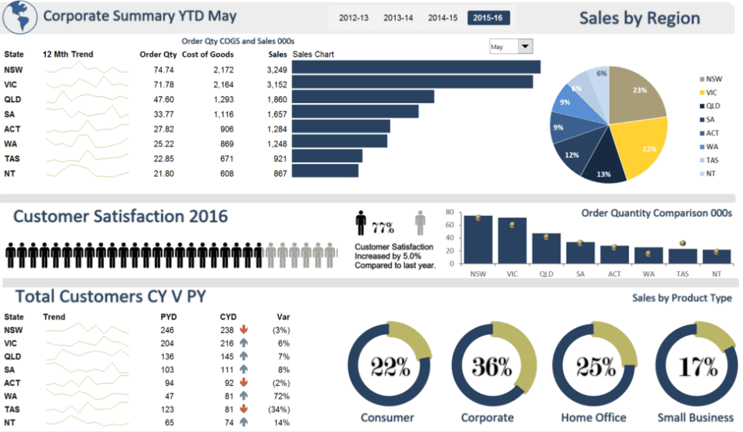

## Machine Learning

ML is a branch of AI that involves training machines to acquire information from data rather than being directly programmed. ML algorithms are generated to evaluate data, spot trends, and predict forthcoming events using data from the past (Phasinam et al., 2022). The figure below illustrates the life-cycle of ML within seven stages.

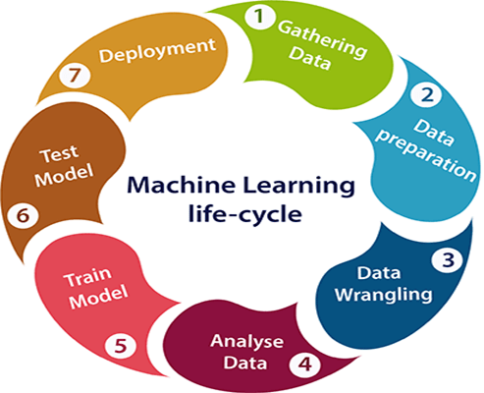

### Supervised Learning

In supervised learning, machine learning models are trained using labelled data. For each input in labelled data, the output is already provided. The model maps labelled inputs to the desired variable. The objective of the algorithm is to develop a mapping between the inputs and the results such that it can make precise predictions on a new dataset (Simplilearn.com, n.d.).

Supervised learning is mostly used for classification and regression problems.

Some of the supervised learning algorithms are as follows:

* Support Vector Machines
* Naïve Bayes Classifier
* K Nearest Neighbour
* Logistic Regression
* Random Forest Classifier

### Unsupervised Learning

Unsupervised learning is a sort of machine learning that trains computers using unlabelled data. Unlabelled data lacks an output variable. The model gains knowledge from the data, identifies its patterns and features, and then outputs the results. Therefore, in order to label the data, the model uses the characteristics of the data (Simplilearn.com, n.d.).

Clustering and association problems can be resolved via unsupervised learning.

The two most common unsupervised learning algorithms are K-means clustering and Hierarchical clustering.

### Reinforcement Learning

Reinforcement learning is a machine learning training which encourages desired behaviours while discourages undesirable ones. A reinforcement learning agent can typically understand and act in its surroundings, as well as perform actions and learn through trial and error (SearchEnterpriseAI, n.d.).

In order to create games, reinforcement learning methods are frequently utilized. Additionally, it is used to teach robots to carry out human duties.

## Summary of Findings

This section involves analysing the data gathered in the literature review with the sole purpose of answering the three RQs mentioned above.

1. **RQ1: How does SAMU function in Mauritius?**

For a better understanding of the structure and organization of SAMU in Mauritius, data was collected in two ways which are through interviews and by reading several papers such as P03, P10 and P14 and website articles. According to the data gathered, SAMU is a pre-hospital emergency treatment service established in Mauritius in 1997, provided free of charge by the Ministry of Health and Quality of Life and the Mauritian Institute of Health. The health facilities are divided into five regions and there are six hospitals that provide the SAMU facilities on the island. SAMU has two types of vehicles: SAMU vehicles that come with advanced medical equipment and a non-medicalized ambulance that has basic equipment. Both of them are operational around-the-clock, seven days a week.

After inquiring, I have gathered the following information. SAMU's services are organized through a dispatch center at Victoria Hospital in Candos. In an emergency situation, SAMU follows a specific operational structure where a control officer attends the call and the emergency physician assists the patient by providing the required first-aid. Then, triage is carried out depending on the severity of the case. If the case has the highest priority, the SAMU team is sent, and if not, the patient is either asked to come to the hospital or is provided with a non-medicalized ambulance.

1. **RQ2: What are the main functionalities of existing intelligent incident management systems?**

Incident Management System helps in identifying, evaluating, reacting to, and resolving incidents but there also exists Intelligent IMS that uses technology such as automated processes, machine learning, and artificial intelligence to manage incidents efficiently in real-time. It also provides detailed analytics and insights to handle situations better in the future. There are two IMS systems, EMResource and WebEOC, that are widely used across the world, including the USA and Europe. These web-based systems enable healthcare professionals and emergency responders to collaborate using centralized database management, plan efficiently with help of accurate incident information, and coordinate their emergency responses in real-time by providing crucial information from different sources. Both systems are built to be easily accessible and customizable. I have used their websites to learn about their functionalities.

1. **RQ3: What technologies are available for incident management, task automation, data visualization, and incident prediction?**

* From papers P06 and P08, it can be observed that GIS is a powerful tool for evaluating and interpreting big data and remotely mapping geographic areas. Some of the most common GIS software are ArcGIS, Google Maps, and QGIS.
* IDEs are software packages that combine the fundamental tools needed to create and test software. Popular IDEs include Visual Studio Code, Google Colab, and MySQL Workbench, as mentioned in papers P04 and P07.
* As shown in paper P02, deployment tools such as Jenkins, Netlify, and AWS CodeDeploy facilitate the process of installing, configuring, and running software on target machines. Cloud deployment is one of the most common types of deployment.
* Robotic Process Automation is a software technology that simplifies the process of designing, deploying, and managing RPA bots which has been explained in paper P09. UiPath and Automation Anywhere are two popular RPA tools in the market.
* Data visualization helps to understand large amounts of data quickly and accurately, and there are various tools available such as R Studio, Power BI, and Tableau. This information was extracted from papers P01, P11 and P12.
* Machine learning is a branch of AI that involves training machines to acquire information from data. Supervised learning uses labelled data to make predictions, while unsupervised learning uses unlabelled data to identify patterns and features. Some of the ML algorithms are Support Vector Machines, Naïve Bayes Classifier, K Nearest Neighbour, Logistic Regression, Random Forest Classifier, K-means clustering and Hierarchical clustering.

# Analysis

This chapter outlines the challenges in the current SAMU system as well as some features which can be used increase the efficiency of SAMU, based on the research from the literature review. Moreover, there will be the functional and non-functional requirements for the proposed system and this chapter will be ended with a comparison among the various tools and technologies needed for implementation.

## Challenges in the Existing SAMU System in Mauritius

With the help of some papers and the interviews carried out with some of the SAMU staff, I have clearly understood the existing system and how it operates during an intervention. After having thoroughly analysed the procedures involved, the following problems were encountered.

### Data Redundancy

Data redundancy is the process whereby the same data is kept in several locations simultaneously, and this problem seems to occur in the current system when the incident data is being transferred through phone calls by the control officer at the dispatch centre to several entities, such as the nearest hospital and other emergency services. In addition, at each end, the individual has to note down the information. These data transfers waste time as the data does not reach all the required entities at the same time. Apart from increasing response time, data redundancy also increases data upkeep expenses by requiring the maintenance of several copies of the same content (www.egnyte.com, n.d.).

### Inaccurate Data

Inaccurate data is defined as incorrect or incomplete information, which can come from various sources such as human error, technical problems, and criminal activity. In this case, the inaccurate data is the incident location, and the source is definitely human beings. Locating an event can be challenging for people in a variety of circumstances. For example, when they are in an unfamiliar area or experiencing fear or panic. In such situations, the location provided by the caller tends to be incomplete or even incorrect, which obviously will delay the SAMU. Furthermore, errors are not allowed because citizens' lives are at stake.

### Poor Resource Allocation

In order to ensure that a patient receives the necessary treatment as soon as possible, it is imperative to assign a SAMU or even an ambulance quickly. Unfortunately, the dispatch centre is not always updated regarding emergency vehicles' status and even the availability of the staff. This leads to some extra time before the arrival of the SAMU at the emergency site as sometimes, upon contacting the nearest hospital, it is found out that there is no SAMU available there. So, now, the second closest hospital should be informed of the situation.

## Features to enhance SAMU Efficiency

Response time is the key performance indicator to evaluate the performance of SAMU as it is directly related to people’s life (Desai, Rawani and Loya, 2019). Therefore, we have to reduce the response time in order to increase the efficiency of the department. After analysing the two existing systems, EMResource and WebEOC, we can see that the following features can be implemented to reduce or even eliminate the difficulties stated above that is to reduce the response time.

1. **Centralized Database Management System**

Data centralization has advantages such as increased data integrity and reduced data redundancy. Data portability is facilitated by combining data into a single source, which offers accuracy and reliability. Additionally, it minimizes data duplication, which lowers errors and makes information easier to obtain for anyone working with the same data collection (radarhealthcare.com, n.d.).

1. **Accurate Incident Information**

More accurate details will definitely lead to better decision-making process and more efficient response as the control officer can quickly assess the situation and take appropriate action. The intervention of the SAMU depends mainly on the location of the incident. With an accurate location, the SAMU can reach the incident location as soon as possible.

1. **Resource Allocation using Real-Time Data**

Real-time data offers current details about resource availability and utilization, allowing the control officer to allocate resources more effectively. Real-time data, for instance, can be used to dispatch the available team to the correct location with the necessary resources, speeding up response times.

1. **Collaboration of other Emergency Services**

It allows for coordinated emergency responses. By cooperating, emergency services can exchange incident details and resources, resulting in a quicker and more effective response.

1. **User-Friendly Interface**

It makes it possible for the control officers to rapidly and conveniently retrieve the data they require in a medical crisis. The sooner they receive the incident details, the faster the medical assistance is sent. Moreover, for new users, a user-friendly design can shorten their learning curve and lower their chance of making mistakes.

## Functional Requirements

The functional requirements for the complete proposed system are enumerated below. The FR is separated into different sections to facilitate understanding and monitoring of the FR during the implementation.

### Website

There are different types of users namely: public, control officers, unit managers, fleet managers, EP, nurses, helpers and drivers but all of them must be able to do the following:

1. create an account by signing up
2. log in and access the system through the website
3. have the option to log out of the website

The public must be able to:

1. report incidents by calling SAMU via the website
2. report incidents by filling in the digital form on the website
3. view all the incidents and their status
4. cancel any of the reported incidents which have not been assigned yet

The control officer must be able to:

1. view all the unassigned incidents sorted according to highest priority
2. choose the incident to be assigned
3. request the services of MPF or MFRS for any incident reported
4. report incidents by filling a digital form on the website when incidents are reported via call
5. view the dashboard consisting information about all the incidents as well as the hospital resources

The unit manager must be able to:

1. input the working schedule of all the SAMU staff on a weekly basis
2. change the working schedule for the particular week of any staff
3. remove staff from the database

The fleet manager must be able to:

1. switch the status of the vehicles between maintenance and available whenever required
2. add vehicles by inserting the necessary information
3. remove vehicles from the database

The SAMU staff must be able to:

1. update their status when they are on break or available
2. view their weekly working schedule
3. view the dashboard consisting information about the SAMU department in their hospital
4. update the status of the incident to resolving when they arrive on site
5. close the incident after filling in the required data digitally

### Incident Management System

The system must be able to:

1. open different types of accounts for the different types of users
2. notify users via email when they have signed up and reported an incident
3. store the information of the incidents, vehicles, hospitals and users
4. change some status of the incidents, vehicles and staff automatically
5. determine the level of severity of the incident
6. assign each incident to the closest hospital with the available resources
7. notify the control officer about the allocation of resources
8. alert all the staff assigned to an incident by sending all its details to them via email
9. inform the user about the status of the incident
10. change the status of the staff according to their working schedule

### Dashboard

1. The dashboard shall show all incidents that are currently being handled.
2. The dashboard shall include all the SAMU vehicles as well as information on their availability.
3. The dashboard shall display real-time visualizations and analytics of the incidents.
4. The information on the dashboard shall be able to be filtered by location, severity degree and category.

## Non-functional Requirements

### Website

1. The website should respond immediately to user input.
2. The website should be user-friendly and have an intuitive navigation.
3. The website must be compatible with various web browsers and operating systems.
4. The website should be responsive to multiple screen sizes.

### Incident Management System

1. The system should perform all the predefined tasks quickly upon user interaction.
2. The system should be easy and direct to use.
3. The system should be accessible at any point in time.
4. The system must be compatible with various web browsers and operating systems.

### Dashboard

1. The dashboard should be easily interpreted.
2. The dashboard must be compatible with various web browsers and operating systems.
3. The dashboard should load quickly.
4. The dashboard should be responsive to multiple screen sizes.

## Evaluation of Tools and Technologies

### GIS

There is several GIS software but I have carried out my research on only three of them which are ArcGIS, Google Maps and QGIS. Based on table, ArcGIS seems to offer the best set of tools and extensive support but it becomes a real issue when it comes to the cost of having these facilities. On the other hand, QGIS is a free, open-source software but it does not provide various advanced features. Then, we have Google Maps which is the most user-friendly one and being a first-time user of any GIS software, this will be very beneficial. Additionally, it has a free trial version of 90 days and although it offers limited features, it does have the functionalities which will be required for this project. Therefore, for any GIS service during this project, Google Maps shall be utilized.

### IDE

To set up the database for the system, I will use MySQL Workbench as it is quite user-friendly and has all the necessary features such as SQL creation and data modelling.

Initially, I had planned to use Google Colab for the implementation of the Python codes and Visual Studio Code to build the website which involves the programming languages like HTML, CSS, PHP, JavaScript. However, when I found out that Python codes can also be run on the Visual Studio Code platform, I have concluded to use it for Python as well because it is one of the most user-friendly and advanced IDE.

### Software Deployment

Jenkins, Netlify, CodeDeploy Deployment

### Data Visualization Tools

### Machine Learning

There are different sorts of ML, as was previously explained, and the application for which I will utilize it will determine which one I shall choose. As mentioned in the functional requirement, the system should determine the level of severity of the incident and this is an example of classification problems. The type of ML which should be utilized for this situation is the supervised learning algorithms and now, in order to figure out which of the supervised learning algorithms should be implemented, each one should be executed and their accuracies should be calculated.

### Conclusion on Tools and Technologies

The following table provides an overview on the tools and technologies which will be used for the implementation of the system.

|  |  |
| --- | --- |
| Implementation Section | Tool and Technology |
| Website development | HTMP, CSS, JavaScript and PHP on Visual Studio Code |
| Database | MySQL |
| GIS | Google Maps |
| Software deployment |  |
| Data Visualization |  |
| Machine learning | Supervised learning algorithms |

# Proposed System

In this section, there will be an overview of the architecture and design of the proposed system including the incident management system and the dashboard. It will also show how the different part of the system will interact with each other. The main process of this system starts as soon as an incident is reported and ends when a SAMU staff closes the incident on their arrival at the hospital.

## Proposed Architecture

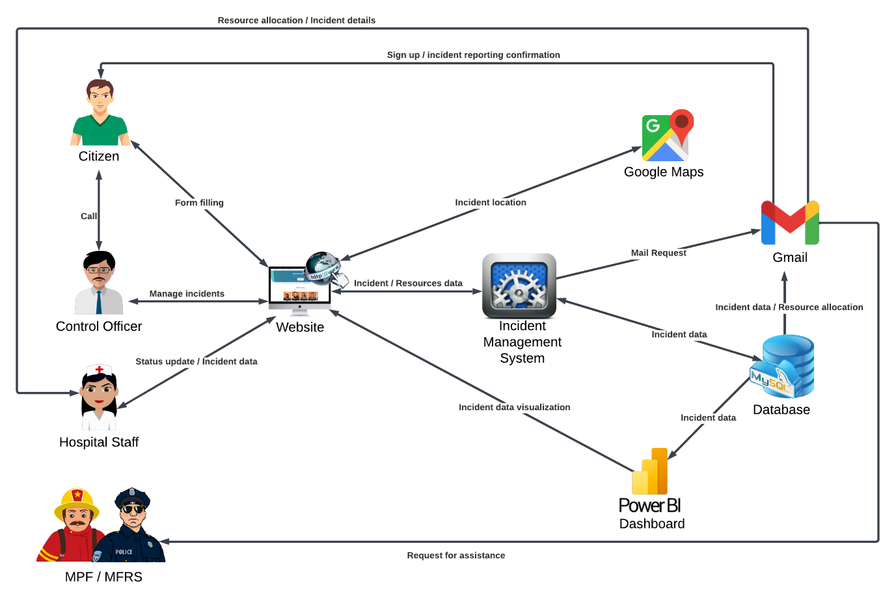

Figure shows the proposed architecture which comprises of the website, the incident management system and all the tools being used by the system. All the users have access to the system via the website. First of all, Google Maps is being used to display a map on the website whereby the citizen can select his location accurately. All the data is stored in MySQL database which is extracted later to be used for resource allocation, data visualization and sending mails. Moreover, the system makes use of the Gmail SMTP to inform the following:

* citizens to confirm their activities carried out on the website
* assigned staff to provide them with the incident details
* MPF or MFRS to request for their assistance if required

The user can report an incident by filling a form or by calling the control officer (114) who will therefore fill in the form. Additionally, the control officer can allocate the appropriate resources to each incident as well as have an overview of all the reported incidents through Power BI dashboard. Furthermore, the hospital staff can update the status of the incidents and the resources.

## Database Design

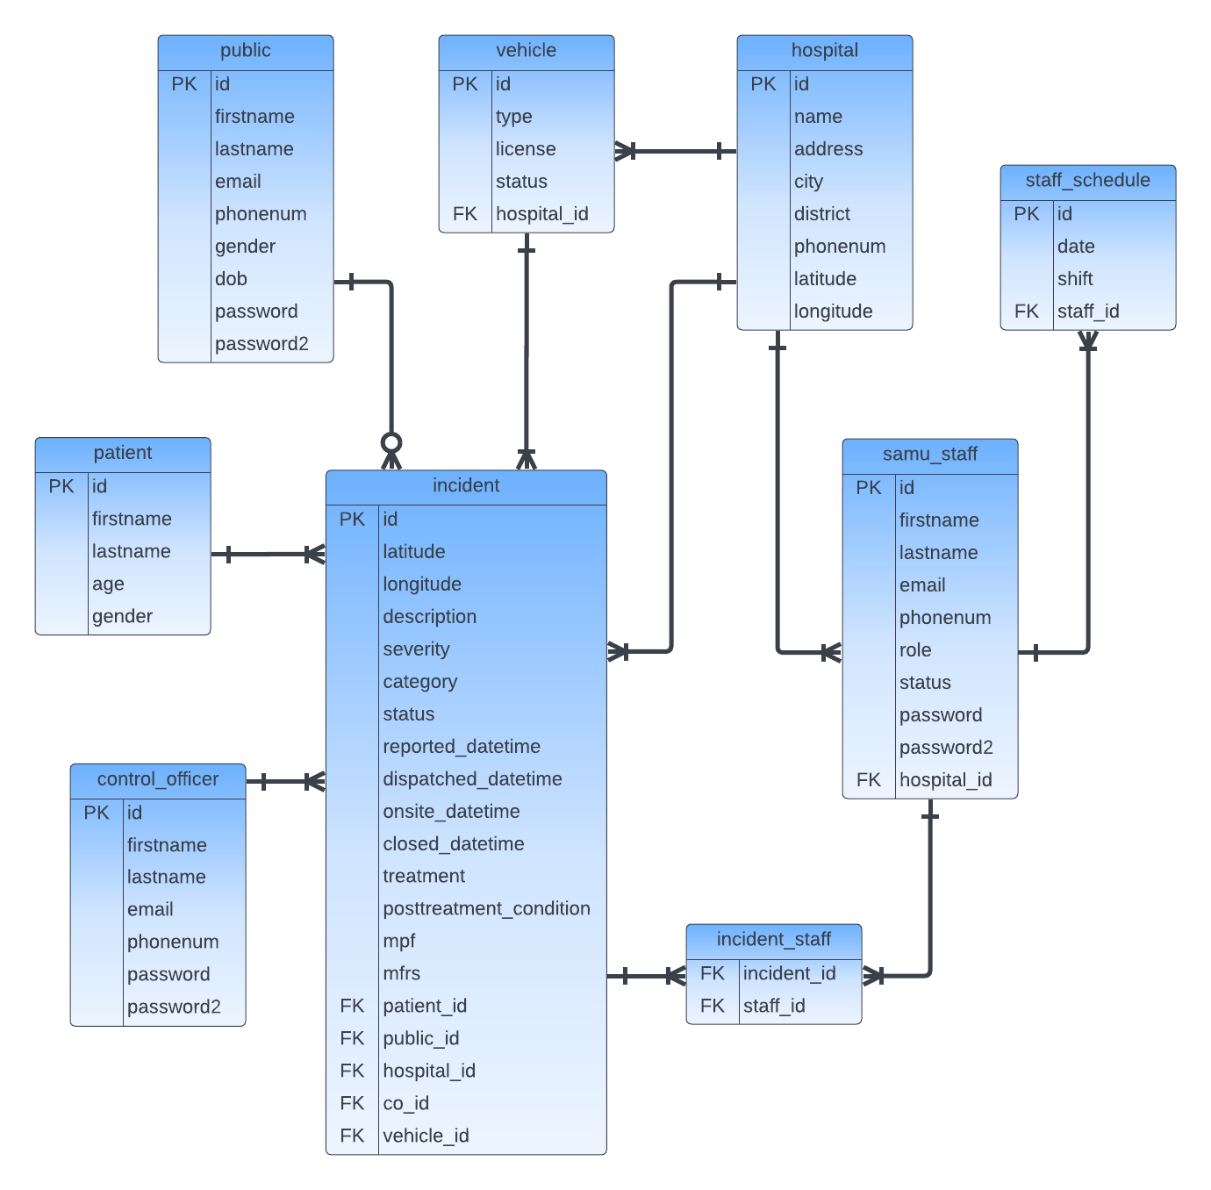

The figure above demonstrates the database schema of the system whereby we can see all the tables to be created on MySQL and all the attributes which are defined in each table. Furthermore, it also shows how the tables are related to each other as well as the primary keys (PK) and foreign keys (FK). All the data input by any user is stored in these tables.

## System Design

### Use Case Diagram for the Overall System

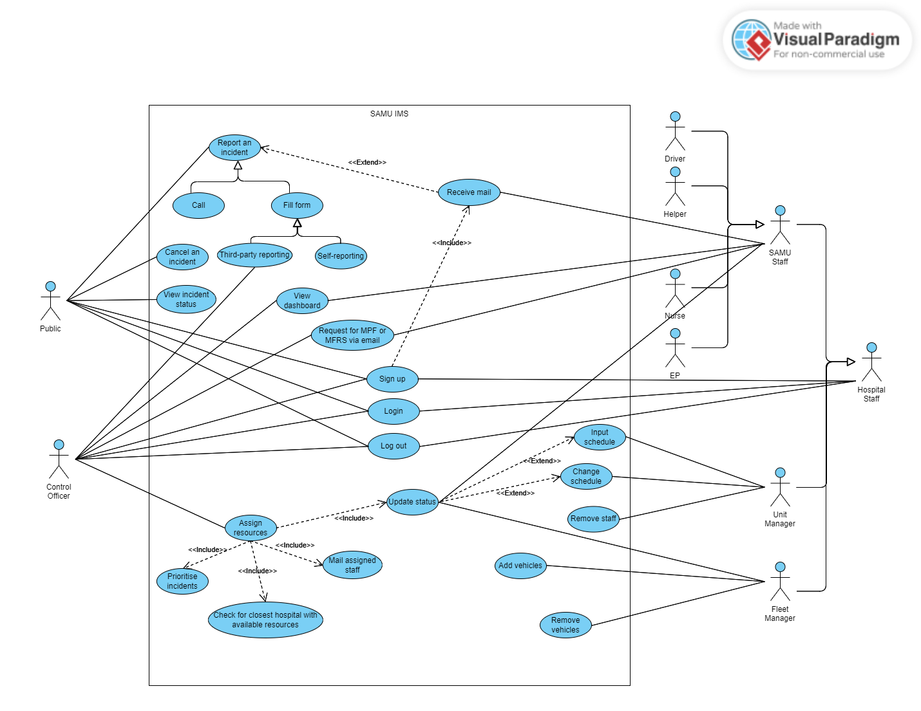

Figure shows an overview of the whole incident management system using use case diagram. It illustrates the interactions between the actors and the system itself, showcasing the functionalities provided by the system.

The actors involved are the public, control officers and hospital staff. The hospital staff can be subcategorised into unit manager, fleet manager and SAMU staff which can be furthermore divided into driver, helper, nurse and EP.

The system operates as follows:

1. All the users have to signed up or logged in first to use the system functionalities.
2. As soon as they sign up, a confirmation mail is sent to them.
3. The citizen reports an incident by either filling a form on the website or by calling 114.
4. Once the incident is reported, the citizen receives a confirmation mail.
5. The citizen can even cancel an incident.
6. On the home page, the citizen can view the incident status.
7. If the reporting is done by call, the control officer will fill the form on the website.
8. The control officer can assign the resources to each incident and this process involves prioritising the incidents, finding the closest hospital with the available resources, mailing the assigned staff and updating the status of the resources and incident.
9. The control officer or the SAMU staff can request the services of MPF or MFRS if required.
10. The control officer and the SAMU staff can view to dashboards about the reported incidents.
11. Once on site or at the hospital, the SAMU staff can update the incident status.
12. The unit manager can input or change the working schedule of each staff.
13. The unit manager can also remove staff.
14. The fleet manager can either add or remove vehicles.

### Signing Up

There are two different sign-up forms. The table below shows various components in the form. None of the components can be left blank when submitting.

1. For staff members

|  |  |
| --- | --- |
| Form Component | Description |
| First name | It can contain letters, spaces, apostrophes, and hyphens only |
| Last name | It can contain letters, spaces, apostrophes, and hyphens only |
| Email | It should be in the format: example@domain.com |
| Phone number | It should start with a 5 and be followed by 7 digits |
| Role | It is a dropdown list having options: Control Officer, Emergency Physician, Uni Manager, Fleet Manager, Nurse, Helper and Driver |
| Workplace | It is a dropdown list having options: Control Room, Sir S Ramgoolam National Hospital, Dr Bruno Cheong Hospital, J Nehru Hospital, Souillac Hospital, Victoria Hospital and Dr A G Jeetoo Hospital |
| Password | It must be at least 8 characters long and contain at least one uppercase letter, one lowercase letter, and one digit |
| Confirm password | It should match the password entered previously |

1. For the public

|  |  |
| --- | --- |
| Form Component | Description |
| First name | It can contain letters, spaces, apostrophes, and hyphens only |
| Last name | It can contain letters, spaces, apostrophes, and hyphens only |
| Email | It should be in the format: example@domain.com |
| Phone number | It should start with a 5 and be followed by 7 digits |
| Gender | It is a radio button having options: Male, Female and Other |
| Date of Birth | It cannot be a date in the future |
| Password | It must be at least 8 characters long and contain at least one uppercase letter, one lowercase letter, and one digit |
| Confirm password | It should match the password entered previously |

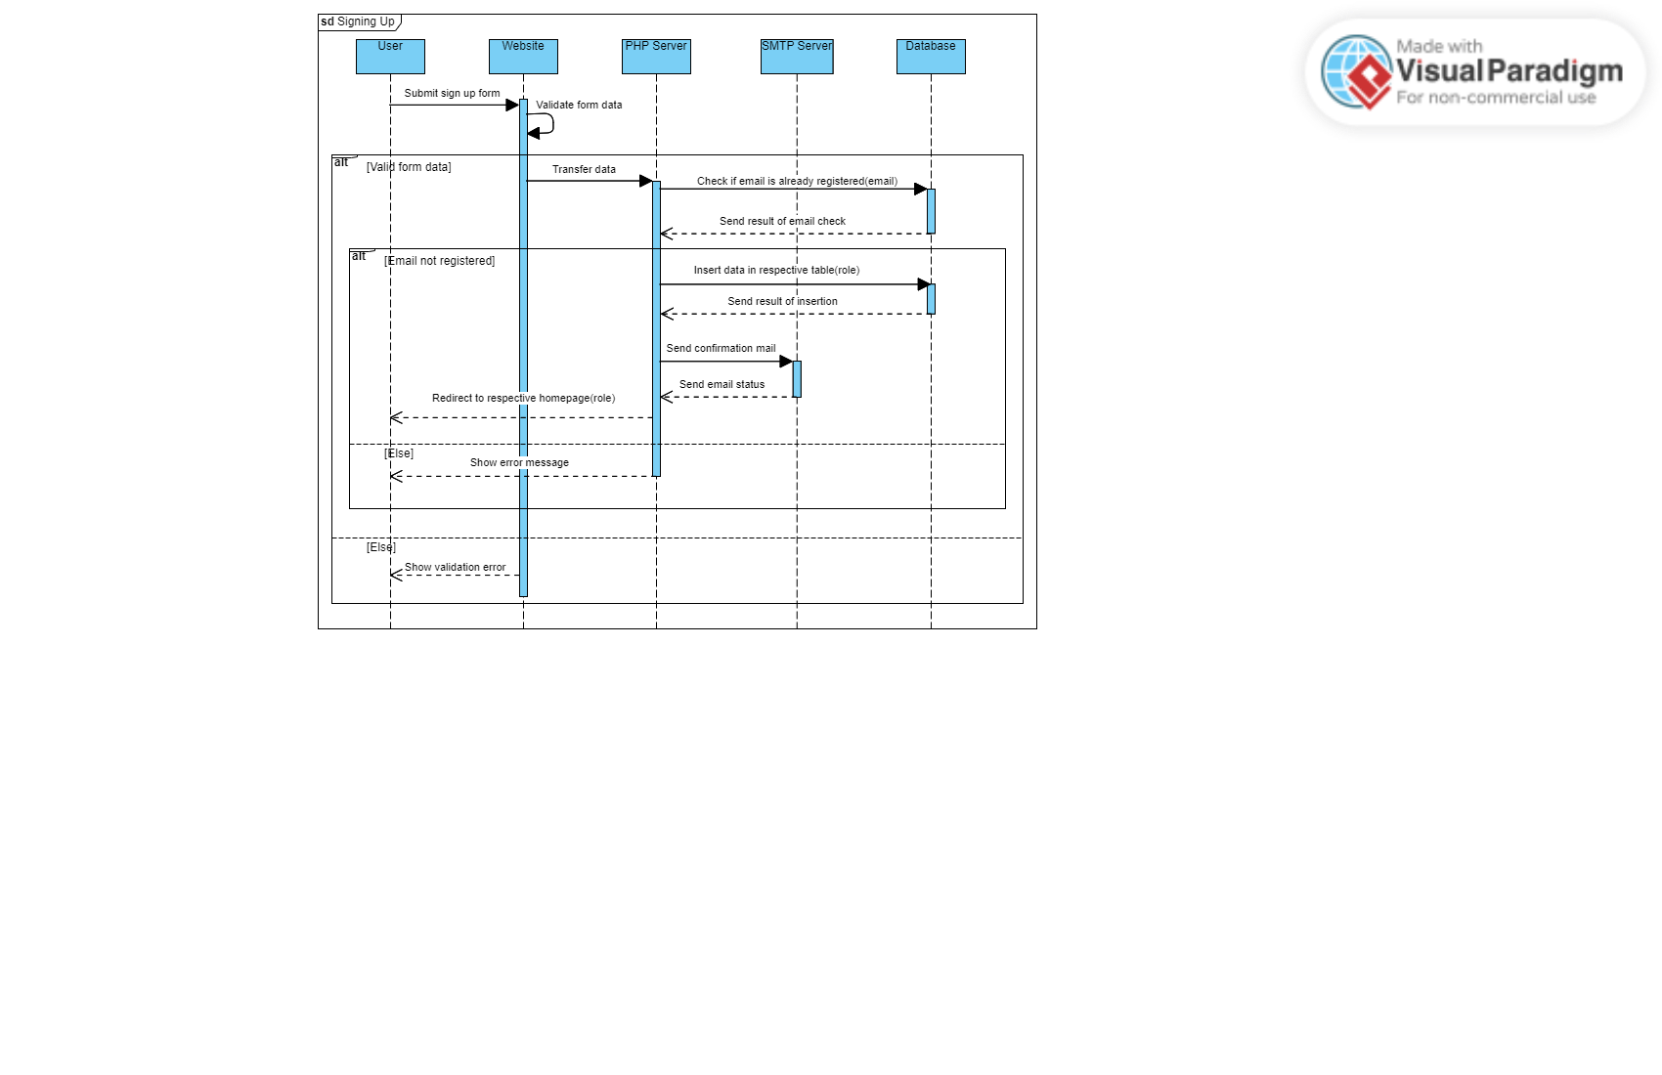

Figure illustrates the sequence diagram of the signing up process whereby all the data input in the form is stored in the database after validating and ensuring that the email address entered has not been registered yet. Upon registration, a confirmation mail is sent to the user after establishing SMTP connection. However, error message is displayed on the website if the email has already been registered.

### Logging In

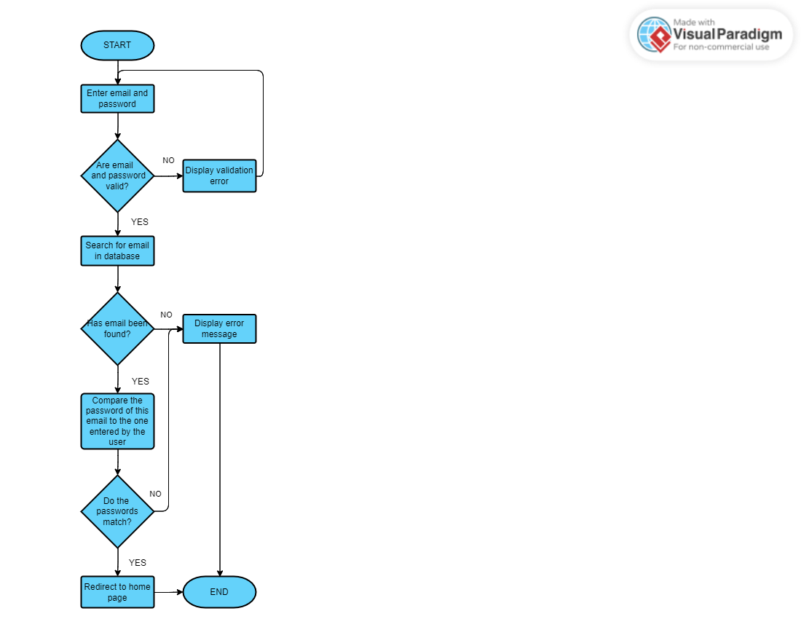

Figure shows the steps which take place during the login process. The user can access the home page only if the email address entered has already been registered and the password entered matches the password corresponding to the email address. This verification is done using the data stored in the database while signing up.

### Incident Reporting

An incident can be reported via two methods:

1. Form filling

There are two types of form which are self-reporting form and third-party reporting form.

1. In the self-reporting form, the patient is the one who is filling the form. So, all the information which was input while the user was registering into the system will be extracted and used automatically as the patient details. Additional details that should be input by the user are:

* Latitude and longitude of the incident location

This is done by just clicking on a button. Once clicked, the system will automatically fill the form with the current latitude and longitude of the user.

* Description of the incident

1. In the third-party reporting form, the following details are required:

* Personal details of the patient

Since these details such as first name, last name, age and gender may not be always known by the user, inputting them is not a requirement to submit the form.

* Latitude and longitude of the incident location

Since the user may not necessarily be present at the incident location, Google Maps JavaScript API has been utilized to extract the correct location whereby a function is called which initializes the map and sets up event listeners for searching and marking locations.

* Incident description

1. Call

When reporting is done by call, the control officer is the one who fills in the form. In addition to the information which is required while filling the third-party reporting form, the details of the caller such as first name, last name, phone number and email address (optional) should also be input.

After submitting the form, appropriate data validation is carried out before inserting the data into the public, patient and incident table and sending a confirmation mail to the user.

However, before an incident is assigned, the user has the right to cancel the incident from the home page itself and therefore, the status of the incident will be changed from ‘pending’ to ‘cancelled’.

Figure shows the process that occurs when an incident is reported.

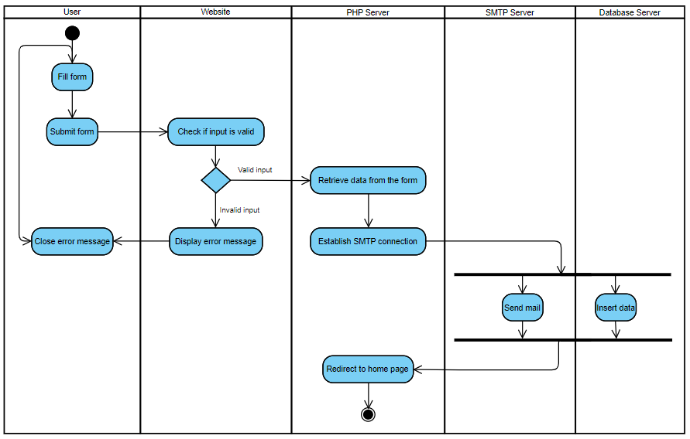

### Prioritising Incidents

As soon as an incident is recorded, along with the data input by the user, the following information is also stored in the incident table:

* Severity

There are three levels of severity:

|  |  |  |  |
| --- | --- | --- | --- |
|  | High | Medium | Low |
| Representation in Database | 1 | 2 | 3 |
| Representation in Website | Red | Yellow | Green |

The severity of the incident is determined using machine learning models. For this classification problem, dataset is being used. After pre-processing the latter, 80% of the dataset will be trained and the other 20% will be tested in order to check for accuracy. The dataset will be trained using several supervised algorithms and the one with the highest accuracy will be implemented for the system.

* Status

The initial status of any reported incident is ‘pending’.

* Date and time the incident is reported

Within the priority list, all the unassigned incidents are displayed starting from the one with the highest priority and in each separate priority section, they are organized starting from the earliest date and time they are reported. Each priority section will have different background colours.

### Incident Categories

Besides incident severities, all the incidents reported can be classified into different categories, leading to efficient incident management as it enables tracking and analysis of incident patterns and trends which can be used to make improvements to prevent future incidents. The categories are as follows:

* RTA (Road Traffic Accidents)
* Health problems
* Fire
* Violence and Abuse
* Other (This is for incidents that cannot be classified into the categories mentioned above.)

Similar to how incident severity is classified, this classification will be carried out with the aid of machine learning models using the same dataset.

### Removal and Addition of Resources

The resources required to solve an incident in this system are vehicles, that is SAMU vehicles and ambulances, and staff. The various staff roles are EP, nurse, helper and driver.

Other staff who are involved in the overall management of the system are control officers, unit managers and fleet managers.

|  |  |
| --- | --- |
| Role | Duty |
| Control officer | Manage incidents efficiently by assigning them with the required resources  Inform the assigned staff about the incidents to be handled |
| Unit manager | Manage the staff in the SAMU department in their respective hospital by:   * Providing them with their working schedule * Removing staff who were fired, retired or quit from the database |
| Fleet manager | Manage SAMU vehicles and ambulances in their respective hospital by:   * Removing the vehicles which are out of use from the database * Adding new vehicles into the database * Sending the vehicles for maintenance |

#### Staff

Staff are not added by the unit manager. So, they have to sign up to use the system or even work in the SAMU department.

To remove a staff member, the following is carried out:

1. When a unit manager logs into the system, he will have access to a webpage where the details of all the staff will be displayed.
2. To remove anyone, the manager can just select the staff or use the search bar to search for the name or ID of the staff.
3. Once, he clicks on the button, all the details of that particular staff will be removed from the SAMU_staff table.

#### Vehicles

To remove any vehicle, the procedure is the same as removing a staff member, except that to search for a particular vehicle, the fleet manager must enter its license plate number or ID.

To add a new vehicle, the steps are as follows:

1. The fleet manager has to gain access into the system where he will have to fill a form whereby the license plate number and type of the new vehicle will be input.
2. A new entry will be made in the vehicle table for this new one as soon as the button is clicked. The initial status of a vehicle is ‘available’.

### Staff Scheduling

This process is done by the unit manager. The main purpose of this process is to know the staff status which can switch between ‘available’ and ‘offduty’ depending on his schedule.

The system will display a table for each job role which will consists of the staff’s name and ID along with the shifts for each day of the week from the staff_schedule table in the database.

The manager can view the shifts for the whole week in the tables but he cannot change the shifts for the past dates. However, he can edit the shifts of the current and forthcoming dates by using a dropdown menu which comprises of the following shifts:

|  |  |  |  |
| --- | --- | --- | --- |
| Shift | Shift Value | Starting Time | Ending Time |
| Day | d | 08 00 | 17 00 (same day) |
| Night | n | 17 00 | 08 00 (next day) |
| Day + Night | dn | 08 00 | 08 00 (next day) |
| Off Duty | o | - | - |

The flowchart below shows the processes which takes place as soon as the manager enters or changes the shifts. It starts by checking if there is an entry in the staff_schedule table for each combination of staff ID and date retrieved from the input. According to this verification, either a new entry is made to insert the shift or the existing entry is modified.

Now, to update the current status of the staff, we will need:

* current date and time
* start and end time for the day and night shifts
* data rows in the staff_schedule table whose date matches the current and previous one

If the current shift of the staff is ‘offduty’, his status will be the same. Moreover, the status can be switched to ‘available’ only if it is ‘offduty’ and it will be ‘available’ in the following cases:

1. The staff had a night shift on the previous day and the current time is before the end of the night shift.
2. The current time is within the time range of his shift for the current date.

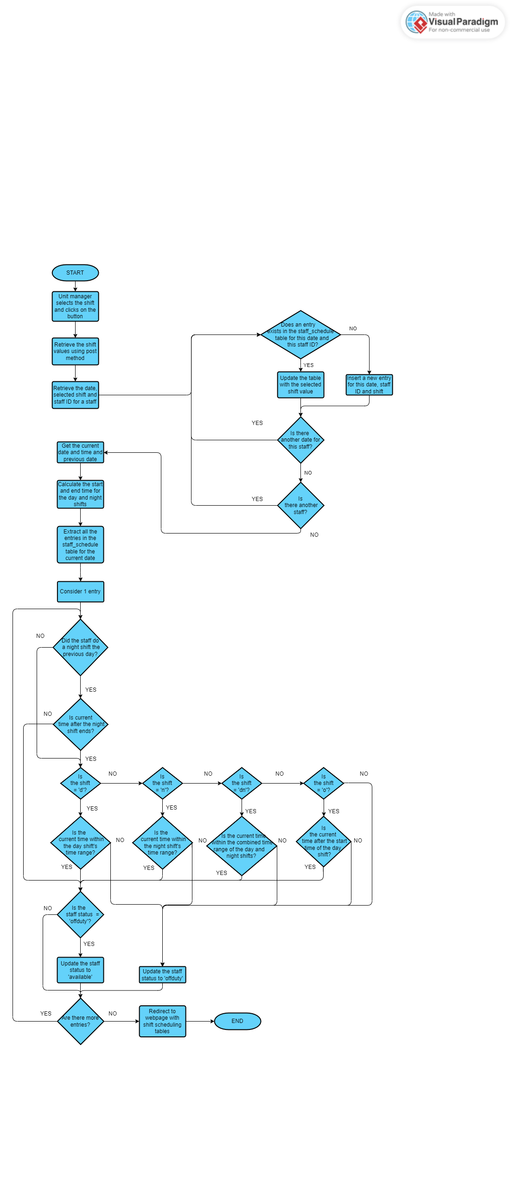

### Resource Allocation

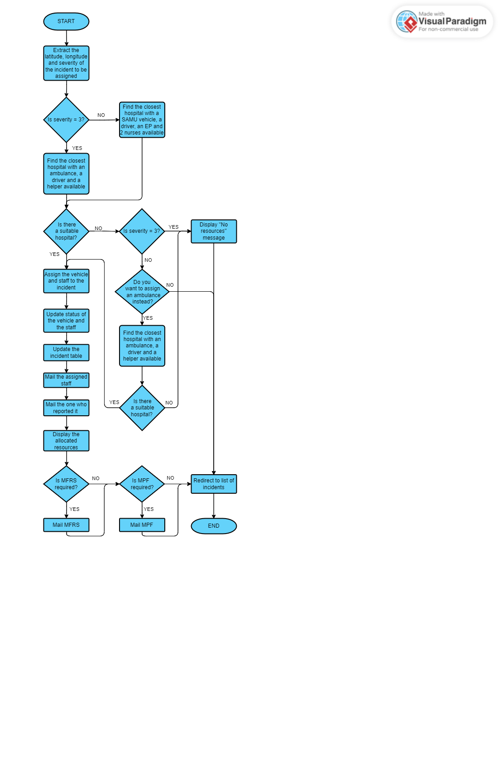

Figure illustrates how resources are allocated efficiently. The three elements required are the latitude, longitude and severity of the incident.

|  |  |
| --- | --- |
| Severity | Resources Required |
| 1 and 2 | * 1 SAMU vehicle * 1 EP * 2 nurses * 1 driver |
| 3 | * 1 ambulance * 1 helper * 1 driver |

The severity determines the resources required and to be more effective, the system has to find the closest hospital with the resources whose status are ‘available’. In case resources for severity 1 or 2 are not available, the resources for severity 3 can be assigned to the incident if the control officer agrees.

Once assigned, the next step involves:

1. Updating the tables in the database and the status of the resources and incident
2. Informing the assigned staff and the one who reported the incident via mail
3. Asking the control officer if the services of MPF or MFRS will be necessary

### Updating Status

This section demonstrates the changes in state for an incident, staff and vehicle using state diagram.

#### Incident

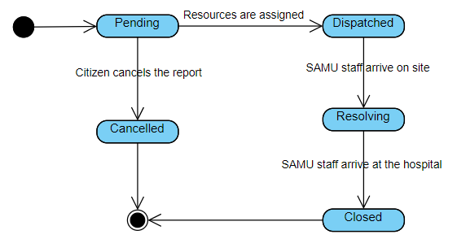

#### SAMU Staff

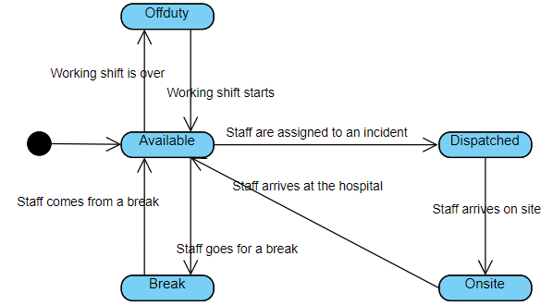

#### Vehicle

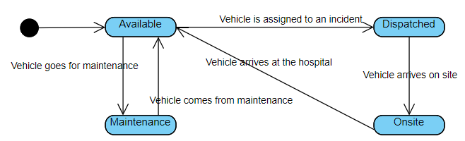

### Dashboard

# Implementation

Within this chapter, there are explanations and parts of programming codes which have been used to implement all the components of the proposed system.

## Database

### Configuration

To manage MySQL database, the interface tool which is being used is phpMyAdmin. After having installed and configured MySQL Community Edition, phpMyAdmin is configured to connect to MySQL server. Subsequently, the database can be accessed by using the URL <http://localhost/phpmyadmin> on any web browser and to connect to the database via a PHP file, the following code should be implemented whereby the hostname, username, password and database name are used as parameters. If the connection is established, the $db variable can be used to perform various database operations.

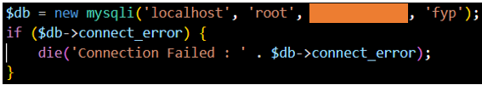

### SQL Commands

The various SQL commands which have been utilized during the implementation are:

1. SELECT
2. INSERT
3. UPDATE
4. DELETE

One example of executing a SELECT command is shown below:

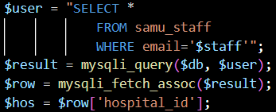

|  |  |
| --- | --- |
| Line Number | Explanation |
| Line 1 | It selects all the columns from table *samu_staff* where the column *email* is equal to the value stored in the variable *$staff*. |
| Line 2 | It executes the SQL command stored in *$user* using the database connection *$db*. |
| Line 3 | The fetched result is then stored in *$row*. |
| Line 4 | It assigns the value of the column *hospital_id* from *$row* to the variable *$hos*. |

From the above list of commands, only the SELECT command requires fetching data.

## Signing Up and Logging In

## Incident Reporting

## Incident Classification Using AI

### Dataset

The only information required to know the severity and category of any incident is the incident description. Therefore, the dataset to be used to train the models needs only three details: description, severity and category. With the help of a SAMU staff, I have created this dataset of 55 rows and 3 columns. Figure shows part of the dataset.

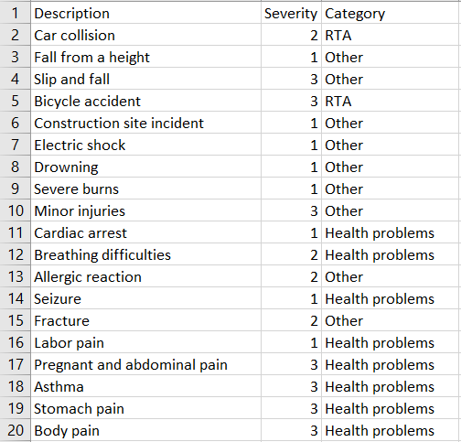

Several Natural Language Processing (NLP) techniques have been used for the upcoming processes. Since lack of data for training a model can result in lower accuracy and overfitting, data augmentation has been performed using the following techniques:

1. Synonym Replacement

It replaces words in a description with their synonyms using WordNet.

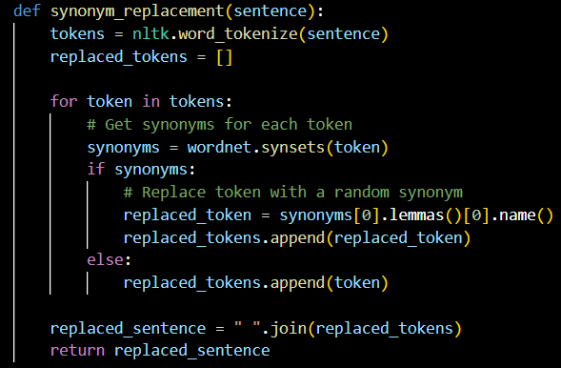

1. Back Translation

It translates a description to a random language (French) using the mtranslate library and then translates it back to the original language (English).

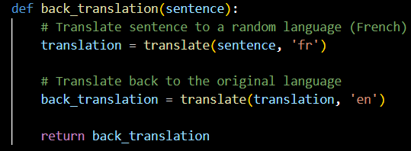

1. Character-level Augmentation

It randomly replaces a character in a description with a random letter. It can be useful in handling minor errors in data input.

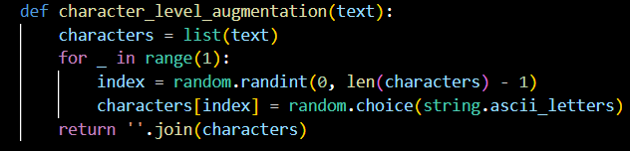

The data is to be augmented to 1000 rows. The process starts by randomly selecting a row from the original dataset using the sample method as well as an augmentation technique which is therefore applied on the selected row. The augmented description is stored along with its severity and category and once 1000 rows have been augmented, they are concatenated with the original dataset, as illustrated below.

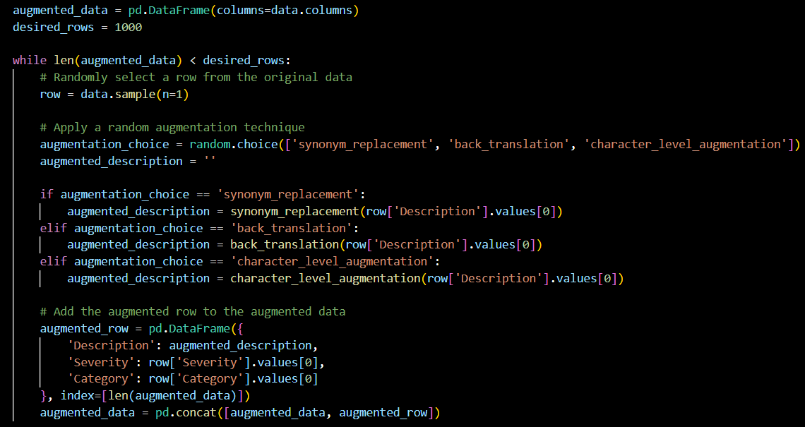

### Data Preprocessing

Data preprocessing is performed before training the model in order to improve the accuracy and interpretability of the model. The NLP techniques used to clean the text data involve:

1. Tokenization

The word_tokenize() function from the NLTK library is used to break down the text into meaningful units for further processing.

1. Lowercase conversion
2. Removal of stop words, punctuations and special characters

Stop words such as ‘the’, ‘is’ and ‘and’ are removed from the text using the stopwords corpus from the NLTK library, as shown below.

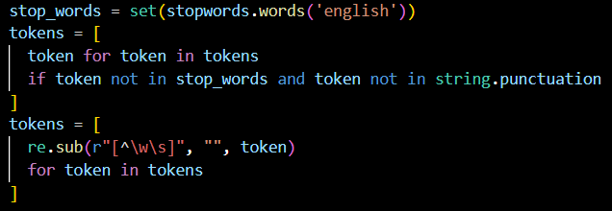

1. Lemmatization

The WordNetLemmatizer() function from the NLTK library is used to reduce each word to its base or dictionary form, leading to reduction in word variations for more effective analysis.

The above procedure is carried out on the column ‘Description’ on the whole dataset. Now, there are some preprocessing techniques that should be applied only on the training set.

1. Vectorization

The code utilizes CountVectorizer() to convert the descriptions into numerical feature vectors, representing the data in a format suitable for machine learning algorithms to process.

1. Check for data duplication

Using the drop_duplicates() method, duplicate data is removed to avoid bias in the model's learning process.

### Training and Testing

The pre-processed dataset is split into training and testing sets using the train_test_split() function from scikit-learn whereby 20% of the data will be used for testing and the remaining 80% will be used for training. Moreover, the random_state parameter ensures reproducibility of results.



Using the input feature (Description) and target variable (Severity or Category), the following 12 supervised models are trained and saved:

1. Multinomial Naïve Bayes
2. K Nearest Neighbors
3. Logistic Regression
4. Support Vector Machine
5. Decision Tree
6. Random Forest
7. Gradient Boosting
8. Multilayer Perceptron
9. AdaBoost
10. Linear SVM
11. SGD Classifier
12. Ridge Classifier

After vectorizing the test dataset, each saved model is loaded to be used to predict the severity or category of the incident.

### Model Evaluation

To determine which trained model performs best, the accuracy of the predictions from each model is calculated by comparing them with the actual target variables. The accuracy_score() function is utilized for this purpose.

|  |  |  |
| --- | --- | --- |
|  |  |  |
|  |  |  |

### Model Utilization

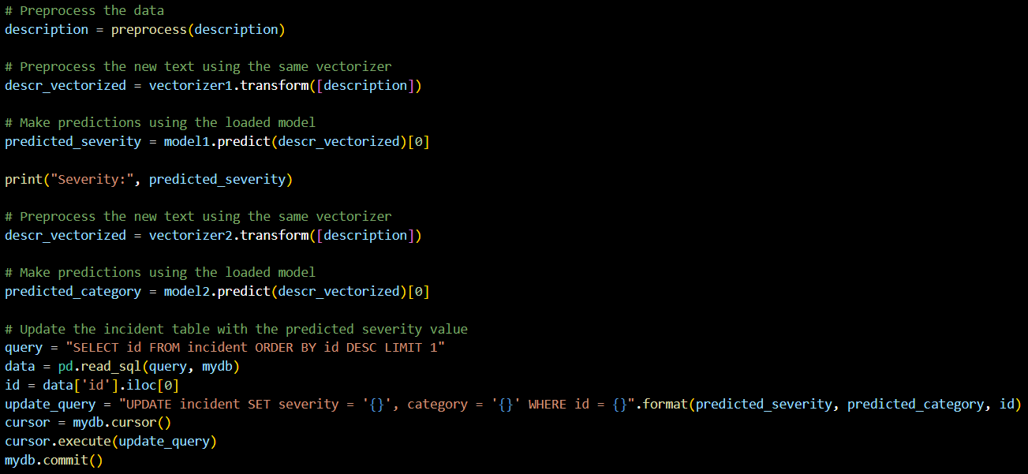

## Resource Management

## Resource Allocation

## Dashboard

## Web Deployment

## Data Input

Data has been input by the users in several ways namely:

1. Text input



1. Email input



1. Password input



1. Radio buttons

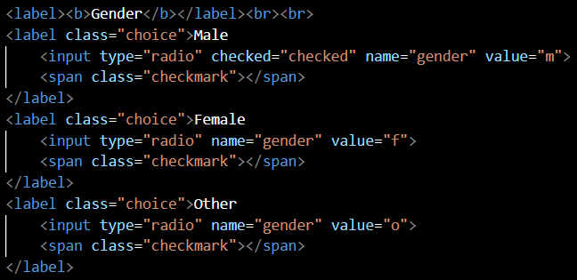

1. Dropdown selection

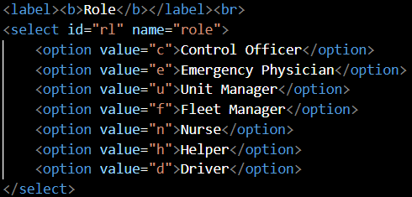

1. Date input



1. Textarea element



## JavaScript Functionalities

### Form Validation

### Incident Location

#### HTML Geolocation

#### Google Maps Geolocation

## PHP Functionalities

### PHP Session

### Message Display

### SMTP Server

### Time and Date

### Python Code

## Machine Learning

## Dashboard

## Web Deployment

# Testing

# Evaluation

# Conclusion

# References

# Appendix